**Proefschrift**

ter verkrijging van de graad van doctor aan de Radboud Universiteit Nijmegen

op gezag van de rector magnificus prof. dr. J.H.J.M. van Krieken, volgens besluit van het college voor promoties

in het openbaar te verdedigen op

door

**Aravindh Nivas MARIMUTHU**

geboren op 28 mei, 1995 te Tamil Nadu, India

This dissertation has been approved by the promotors.

Composition of the doctoral committee:

Prof. dr. Britta Redlich, Radboud Universiteit, *promotor*

Dr. Sandra Brünken, Radboud Universiteit, *copromotor*

*Manuscript committee:*

dr. Oskar Asvany Universität zu Köln prof. dr. Jana Roithova Radboud Universiteit

prof. dr. Melanie Schnell Universität zu Kiel and DESY

*Other members:*



*Keywords:* astrochemistry, molecular ions, cryogenic ion trap, vibrational spectra, rotational spectra, Renner-Tellar effects

*Printed by:*

*Cover by:* A.N. Marimuthu

Copyright © 2023 by A.N. Marimuthu ISBN 000-00-0000-000-0

This work is part of the research programme "ROSAA" with project number 740.018.010 and “HFML-FELIX: a Dutch Centre of Excellence for Science under Extreme Conditions” (with project number 184.035.011) of the research programme “Nationale Roadmap Grootschalige Wetenschappelijke Infastructuur”, which is (partly) financed by the Netherlands Organisation for Scientific Research (NWO).

*To my family and teachers.*

**CONTENTS**

1. TRODUCTION AND METHODS 1

1. Introduction 3

1.1. Measurements: A historical perspective 4

1.1.1. Measuring stars 4

1.1.2. Beyond stars 5

1.2. Molecules in space 6

1.2.1. Optical observation 7

1.2.2. Radio observation 7

1.2.3. Infrared observation 8

1.2.4. Current status 9

1.3. Spectroscopy 9

1.4. Cryogenic ion trap 13

1.4.1. 22-pole cryogenic ion trap 14

1.5. Action spectroscopy 15

1.5.1. Vibrational action spectroscopy 15

1.5.1.1. Tagging photodissociation ion spectroscopy 16

1.5.1.2. IR multi-photon dissociation (IRMPD) 17

1.5.1.3. Laser induced reactions (LIR) 19

1.5.1.4. Laser induced inhibition of He attachment (LIICG) . 20

1.5.2. Rotational action spectroscopy 20

1.5.2.1. Rotational LIR 21

1.5.2.2. Double resonance methods 21

1.5.2.3. ROSAA 22

1.6. This thesis 24

2. Experimental and theoretical methods 27

2.1. FELion instrument 28

2.1.1. Ion source 29

2.1.2. Ion trap and detector 31

2.2. Vibrational spectroscopy 32

2.2.1. Experimental method 32

VII

2.2.2. IR radiation source 33

2.2.2.1. FELIX 33

2.2.2.2. OPO/A 36

2.2.3. Data analysis 37

2.3. Rotational spectroscopy 38

2.3.1. Experimental method 38

2.3.2. THz radiation source 39

2.3.3. Determining the radiation power at the trap region 42

2.3.4. Determining the collisional ion temperature 44

2.3.5. Numerical simulation 46

2.3.5.1. Collisional process ((*R*)) 46

2.3.5.2. Spontaneous emission (*A* ) 48

2.3.5.3. Radiative process (*RB* ) 49

2.3.5.4. Attachment and dissociation process (*R*3 and *RC ID* ) 50

2.3.5.5. Solving rate equations 51

2.4. Theoretical methods 51

2.4.1. Molecular vibration 53

2.4.1.1. Diatomic molecules 53

2.4.1.2. Polyatomic molecules 55

2.4.1.3. Selection rules 55

2.4.2. Molecular rotation 56

2.4.2.1. Linear molecules 57

2.4.2.2. Non-linear molecules 58

2.4.2.3. Selection rules 60

2.4.3. Quantum chemical calculations 60

2.5. Technical details 61

2.5.1. Determining number density 61

2.5.2. Calibration of the hot-cathode ionization gauge (HIG) to SRG 64

1. RATIONAL SPECTROSCOPY 69

3. Laboratory gas-phase vibrational spectra of [C3H3]+ isomers and isotopologues by IRPD spectroscopy 71

3.1. Introduction 73

3.2. Methods 75

3.2.1. Experimental details 75

3.2.2. Computational details 78

3.3. Results and discussions 79

3.3.1. Cyclic isomer 82

3.3.2. Linear isomer 83

* + 1. Ne-effect 84
    2. Deuterated species 86
    3. Isomer quantification 93

3.4. Conclusion 97

4. Infrared predissociation spectroscopy of protonated methyl cyanide,

CH3CNH+ 99

4.1. Introduction 101

4.2. Methods 102

4.2.1. Experimental details 102

4.2.2. Computational details 104

4.3. Results and discussions 105

4.3.1. Vibrational spectroscopy of CH3CNH+ 105

4.3.2. Prediction of rotational spectroscopic parameters 111

4.3.3. Influence of the neon atom on vibrational band positions 112

4.4. Conclusions 115

5. A vibrational action spectroscopic study of the Renner-Teller and

spin-orbit affected cyanoacetylene radical cation HC3N+ 117

5.1. Introduction 119

5.2. Methods 120

5.2.1. Experimental methods 120

5.2.2. Theoretical approach 122

5.2.2.1. Ab Initio 122

5.2.2.2. Effective Hamiltonian 122

5.2.2.3. The HC3N+ ion 125

5.3. Results and Discussion 126

5.3.1. Stretching modes 126

5.3.2. Vibronic coupling effects 129

5.3.3. Influence of the rare-gas tag 132

5.4. Conclusions 134

1. TIONAL SPECTROSCOPY 137

6. Kinetics of CD+ with He buffer gas 139

6.1. Motivation 140

6.2. Kinetics measurements 140

6.3. Theory of association reactions 141

6.4. Rate equations 144

6.5. Rate loss channels 145

* 1. Deriving rate constants 147
  2. Influence of radiation 149
     1. CD+ rotational transition (*J* = 0 −1) 150
     2. Determining ion temperature 153
     3. Kinetics 154
  3. ROSAA Numerical simulation 155
     1. Collisional process 155
     2. Radiative processes 157
     3. Attachment processes 159
     4. Analysing numerical results 161
  4. Temperature dependence of rate coefficients 165
  5. Conclusion 169

7. The Zeeman effect in CO+ observed with rotational action

spectroscopy 171

7.1. Introduction 173

7.2. Experiment 174

7.3. Results and discussions 178

7.4. Conclusions 184

APPENDICES 185

1. Chapter 3 187
   1. Internal coordinates of c-C3H3+

. 188

* + 1. fc-CCSD(T)/ANO0 188
    2. fc-CCSD(T)/ANO1 188
    3. fc-CCSD(T)/ANO2 188
  1. Internal coordinates of H2C3H+ 189
     1. fc-CCSD(T)/ANO0 189
     2. fc-CCSD(T)/ANO1 189
     3. fc-CCSD(T)/ANO2 190

1. **Chapter 4** **197**
   1. Internal coordinates of CH3CNH+ 198
      1. fc-CCSD(T)/ANO0 198
      2. fc-CCSD(T)/ANO1 198
      3. fc-CCSD(T)/ANO2 199
      4. fc-CCSD(T)/cc-pVDZ 199
      5. fc-CCSD(T)/cc-pVTZ 200
      6. ae-CCSD(T)/cc-pwCV5Z 201
   2. Internal coordinates of CH3CNH+ -Ne 201
      1. fc-CCSD(T)/ANO0 201
      2. fc-CCSD(T)/cc-pVDZ 202
2. **Chapter 5** **211**
3. **Chapter 6** **223**
   1. CD+ + He rate coefficients 224
4. **Chapter 7** **227**

**Bibliography** **231**

**Summary and outlook** **255**

**Samenvatting en vooruitzichten** **259**

**Research data management** **265**

**Acknowledgements** **267**

**List of Publications** **269**

**Curriculum Vitæ** **271**

# I

#### Introduction and methods

1

## 1

### Introduction

3

* 1. MEASUREMENTS: A HISTORICAL PERSPECTIVE

**1**

*No science attains maturity until it acquires methods of measurement*

Logan Clendening

Science depends on measurement, and it lets us compare, for example, a foot and a mile or a gram and a pound. Our modern society’s technological and scientific development is a direct consequence of the evolution of scientific measurement methods.

* + 1. MEASURING STARS

STRONOMICAL observatories developed into significant resources during the nineteenth century enabling astronomers to work on massive projects such

A

as star catalogues. In the late 1830s, Bessel [1], Henderson [2], and Struve [3] were the first three people to perform parallax measurements, which provided the first direct evidence of the enormous distances to even the nearest stars [4]. The technological limitations of space travel have led many to believe that the composition of stars would remain a mystery forever. Nevertheless, the composition of the stars and the interstellar medium and also (exo-) planetary atmospheres is now well-researched (see Section 1.2).

Fraunhofer [5] used one of the first optics (the same optics that made parallax measurements possible see above) built in 1814 to reflect a ray of sunshine from a slit into a shutter onto a whitewashed wall. He noticed that the Sun’s light was not a continuous spectrum of colours as observed by Newton [6] (see Figure 1.1) but a series of dark lines. These lines would later become known as Fraunhofer lines. Fraunhofer investigated these lines further and recorded precise positions and intensities carefully. As a result, Fraunhofer recorded the first-ever high- resolution astronomical spectrum [7].

However, he could not determine the origin of the dark patterns he saw. When he conducted a similar experiment using light from the nearby red star Betelgeuse, he discovered that the dark lines he had observed before had significantly altered. Fraunhofer concluded that most of those characteristics were somehow connected to the nature of the object he was examining [7].

Nearly 45 years later, Gustav Kirchhoff and Robert Bunsen’s [8] (1860) experiments helped to understand Fraunhofer’s observations. They investigated the colour of the light emitted as metals burned. In certain conditions, they discovered, the wavelength of the produced light matched the Fraunhofer lines.

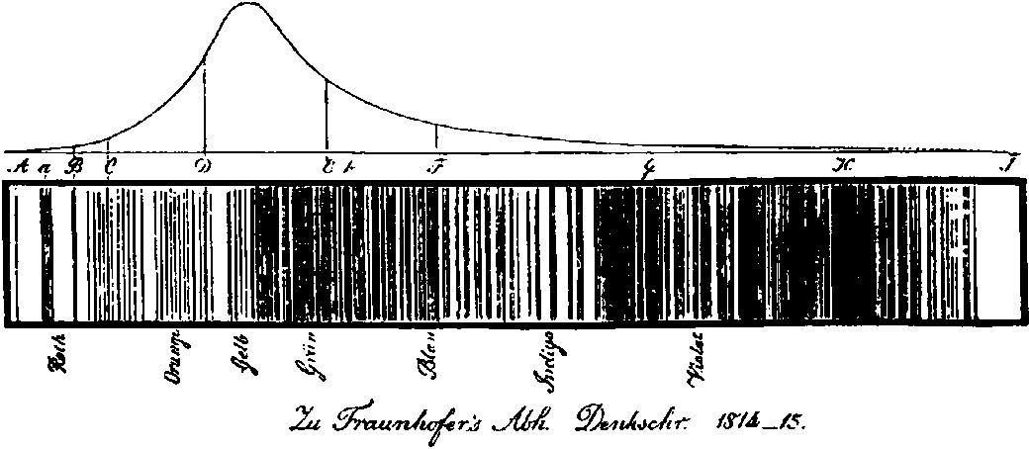

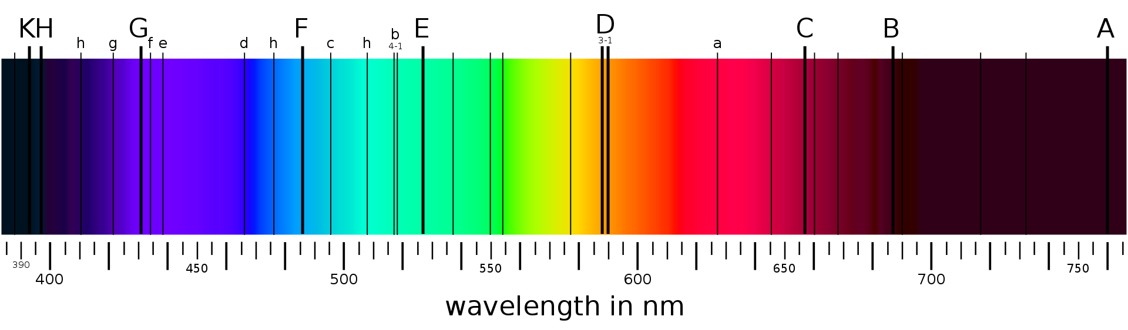(a)

**1**

(b)

Figure 1.1.: The optical spectrum of the sunlight. (a) is the original recorded spectrum (Credit: Fraunhofer [5]) while (b) is the same visible spectrum but coloured, from 380 nm to 710 nm (Credit: Wikimedia Commons).

These experiments demonstrated that the atomic constitution of the Sun is the origin of the observation of the Fraunhofer lines.

* + 1. BEYOND STARS

Until the mid-20th century, in the interstellar medium (ISM), the formation and stability of molecules and the efficiency of chemical reactions were assumed to be impossible. The intense radiation and high-energy particles present in space, as well as the extremely low densities (at maximum reaching 106 −107 cm−3) and temperatures (< 10 K) [9], were believed to prevent the formation and survival of molecules. For comparison, on Earth global average temperature is around ∼ 298 K and the number density (atmosphere) amounts to ∼ 1019 cm−3. Therefore, it was generally believed that most matter in space would appear in the form of atoms or amorphous dust grains rather than individual molecules.

Most astrophysical environments possess very low densities of gases. However, even if densities are high, H and He are the primary elements accessible for chemistry (see Figure 1.2), which was thought to limit the complexity of potential chemical reactions significantly. Fortunately, the emergence of telescopes,

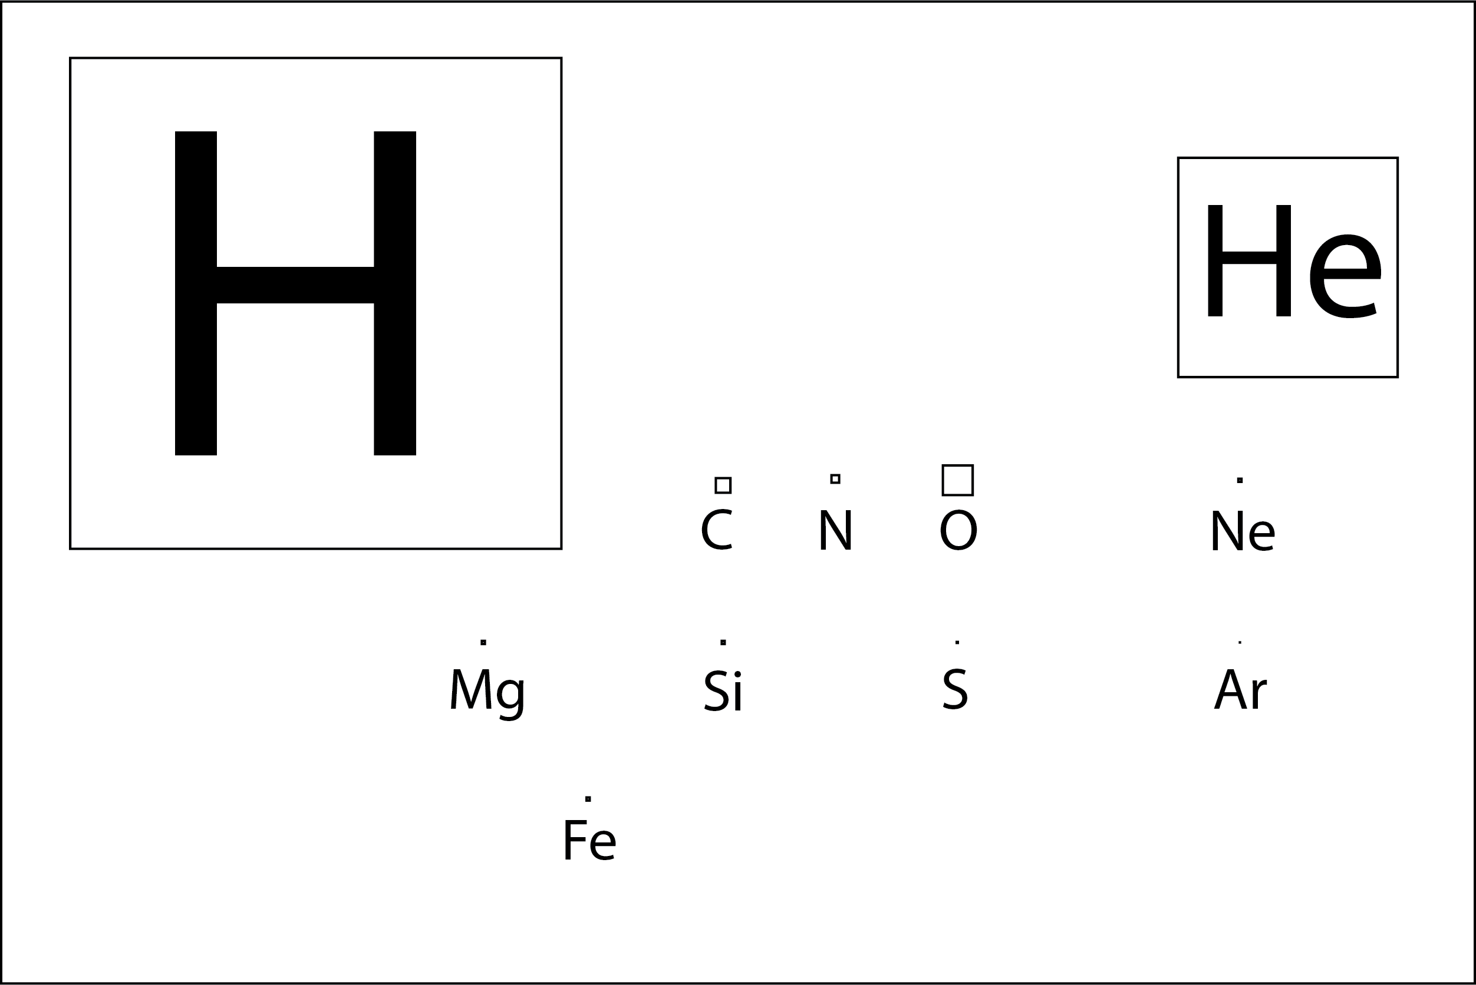

**1**

Figure 1.2.: The Astronomer’s Periodic Table, as it is referred to. This figure represents the elements by boxes with areas corresponding to their cosmic abundances. Figure adapted from McCall [10].

detectors, and spectrometers operating in the radio, infrared (IR), and ultraviolet (UV)/visible regions of the electromagnetic spectrum proved this consideration incorrect. Indeed, low densities and extreme temperatures (both high and low) in space frequently constrain chemistry, but the vast quantities of matter and long timescale compensate for it. Interstellar space represents a unique laboratory in which fundamental molecular processes can be investigated under conditions distinctly different from Earth’s.

In the following sections, a brief introduction is given to the discovery of molecules in space and the laboratory spectroscopic techniques that allow us to study molecular ions under interstellar conditions.

* 1. MOLECULES IN SPACE

*Somewhere, something incredible is waiting to be known*

Carl Sagan

Sir Arthur Stanley Eddington’s Bakerian Lecture on “*Diffuse matter in interstellar space*” [11] of 1926 may be a natural starting point for the discussion of molecules in the interstellar medium. The sharp calcium spectral line observed by Hartmann [12] in 1904 and the subsequent discovery of D-lines of sodium (Heger [13] in 1919) and H and K lines of calcium (Plaskett [14] in 1923) were the premises of Eddington’s discussion. These lines were not arising from absorption

in either the stellar atmosphere or Earth’s atmosphere. Since they were also unaffected by stellar motion, they were known as *fixed* or *stationary* lines. These lines were assumed to originate from interstellar space. Eddington pointed out in his lecture that “...it is difficult to admit the existence of molecules in interstellar space because when once a molecule becomes dissociated, there seems no chance of the atoms joining up again”.

**1**

* + 1. OPTICAL OBSERVATION

In the early 1930s, Merrill [15] identified several interstellar lines (much wider than interstellar atomic lines) of unknown origin. Russell [16] conjectured that the origin of these lines was molecular rather than atomic. Merrill [17] noted that “the chemical identification of these lines had not been made yet”, and remarkably, the chemical identity is unknown even today for these *diffuse interstellar bands* (DIBs). An exception is C+60 which is the only species identified as the carrier of two DIBs by Campbell *et al.* [18] only recently in 2015, based on laboratory action spectroscopic methods similar to the ones described in this thesis. However, hundreds of DIBs remain to be identified. Hence, it remains the oldest unsolved problem in astronomical spectroscopy. Nevertheless, it became clear that the interstellar absorption lines could not all be due to neutral or ionized atoms.

Later, in the late 1930s, Adams, Dunham and McKellar established the presence of CH, CN and CH+ molecular species in the interstellar medium based on four sharp absorption lines seen in the optical spectra of several distant stars using Mount Wilson Observatory (Dunham [19] 1937, Adams [20] 1937, McKellar

[21, 22] 1940) and laboratory data (Jenkins and Wooldridge [23] and Douglas and Herzberg [24, 25]). Three interstellar molecules were identified in four years, one of which was a positively charged ion. Detailed quantitative studies by Bates and Spitzer [26] in 1951, and its extension by Solomon and Klemperer [27] in 1972 and Herbst and Klemperer [28] in 1973, to understand the formation of these interstellar molecular species showed the crucial role of ion-molecule reactions.

* + 1. RADIO OBSERVATION

The hydroxyl radical (OH) molecule has a ground state of 2Π, resembling

CH. However, its optical resonance lines lie in the 3060 A˚

region, close to

the atmosphere’s edge of transmission. Due to interference from our own atmosphere’s ozone absorption bands, it is challenging to observe these lines. Weinreb *et al.* [29] (1963) observed the first lines of OH near radio frequency 1665 MHz, which represents a transition between the Λ doublet components of the lowest rotational level *J* = 3/2 of 2Π3/2 (hyperfine structure). The radio

detection of OH inspired many radio astronomers to consider the possibilities of detecting polyatomic molecule lines in the radio frequency range. Cheung *et al.* [30] succeeded in 1968 with NH3 and shortly after with H2O [31], both in emission. Snyder *et al.* [32] soon discovered formaldehyde (H2CO) in absorption; numerous new compounds have been discovered annually, a trend that has continued at a nearly linear rate ever since [33].

**1**

* + 1. INFRARED OBSERVATION

Gillett *et al.* [34], using ground observations, discovered three distinct emission bands in the 8 - 14 *µ*m spectra of two planetary nebulae (NGC), ushering in a new era in astrochemistry in the early 1970s [35]. Followed by Merrill *et al.* [36], detecting a broad emission band in NGC 7027. During this period, airborne observations became feasible for the first time, enabling the Kuiper Airborne Observatory (KAO) to identify two new powerful emission bands in NGC 7027 and an external galaxy (M82) [37, 38]. These characteristics were ubiquitous in space and closely related, forming the PAH family (PAH=Polycyclic Aromatic Hydrocarbons) [35]. Despite being widely observed, the precise nature of the carriers of these features remains elusive, and they are currently referred to as unidentified infrared emission (UIE) features. However, the hypothesis that PAH molecules serve as carriers have received significant support [39, 40]. The PAHs in ISM are postulated to be assembled by smaller molecules, and smaller molecular ions play an important role as an intermediate and the main driving force of interstellar chemistry [41–43].

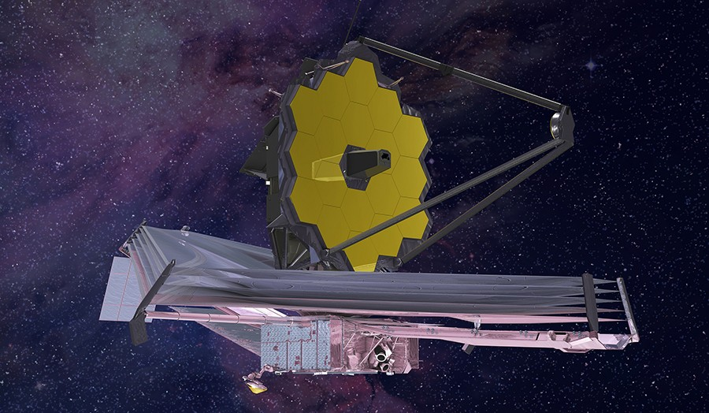

Figure 1.3.: James Webb Space Telescope - An infrared-optimized astronomical observatory (Credit: NASA)

Recently, the James Webb Space Telescope (JWST), as shown in Figure 1.3 was

launched in late 2021. It is an infrared-optimized astronomical observatory that will operate in near- (0.6−5 *µ*m) and mid- (5−28 *µ*m) infrared regions 1 to address a range of astrophysical and cosmological questions, including the role of PAHs.

**1**

* + 1. CURRENT STATUS

Astronomers are now aware of many additional diatomic and polyatomic molecules in the ISM. Furthermore, a large number of unknown species await their identification, such as the UIE and DIBs. As of late May 2022, about 270 molecules have been detected in the ISM or circumstellar shells (CDMS database2), and ∼ 12% of them are cationic species [33] see Figure

1.4. Interstellar molecules can be identified through their electronic (optical), vibrational (infrared), and rotational (radio) spectra as shown in Sections 1.2.1 through 1.2.3. However, most (∼ 80 %) of interstellar species are identified via their rotational transition [33] because of their low excitation temperature and distinct spectroscopic fingerprint. In conclusion, one can say that laboratory spectroscopic data are indeed vital in identifying these molecular species in space. This is difficult for highly reactive molecular ions, but their laboratory characterization and subsequent astronomical detection are important to understand the ion-molecule chemistry of the ISM. Therefore, in the next section, a brief introduction to spectroscopy followed by a detailed review of spectroscopic methods especially for studying molecular ions are presented.

* 1. SPECTROSCOPY

The Light of Knowledge is a common expression, but it fits especially in the spectroscopy context. Spectroscopy is the broad field of study that measures and interprets the interaction between matter and electromagnetic radiation as a function of wavelength or frequency. Most of our knowledge regarding atoms and molecules comes from examining their interactions with electromagnetic radiation; as a result, various parts of the electromagnetic spectrum supply different types of information (see Figure 1.5). The molecular transitions, such as rotational, vibrational and electronic excitation, are characterized via interactions in different regions of the electromagnetic spectrum, as shown in Table 1.1. Spectroscopic characteristics are like molecular fingerprints.

Spectrochemical analysis was invented in 1860 by Kirchhoff and Bunsen [8], but it saw limited use until the 1930s. Since the discovery of the first molecules in space by their optical spectra, i.e., CN and CH [19–22], spectroscopy has been

1<https://www.jwst.nasa.gov/content/observatory/instruments/index.html> 2<https://cdms.astro.uni-koeln.de/classic/molecules>

**1**



PAHs

Figure 1.4.: Percentage of different classes of known interstellar molecules. Many molecules fall into more than one of these categories *e.g.* most radical species have a net neutral charge. Data is computed using *astromol - A Database of Molecules Detected in Space* python library [44]

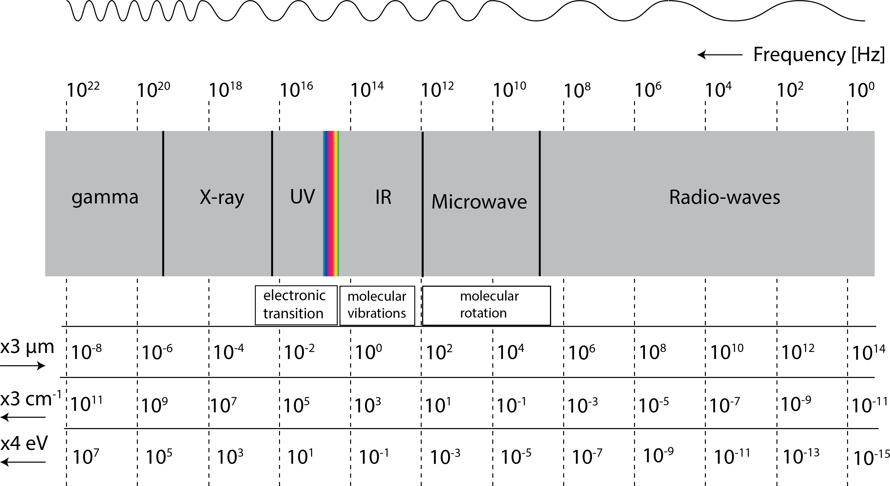

Figure 1.5.: Schematic diagram of the electromagnetic spectrum, the rainbow- coloured inset shows the visible spectrum. The vertical dashed line indicates a corresponding comparison to the different unit systems as labeled on the left, and “x3” and “x4” indicate that the scale value is multiplied by factors 3 and 4, respectively.

successfully used in astronomy to identify new molecular species and determine physical and chemical conditions such as gas excitation temperatures and

Table 1.1.: Dominant types of molecular transitions in each region of the electromagnetic spectrum

**1**

**Region of Spectrum Energy [cm**−1**] Molecular transitions**

*Ultraviolet (UV)*

far 106 − 50, 000

near 50, 000 − 26, 300

*Visible (Vis)* 26, 300 − 12, 800

*Infrared (IR)*

near 12, 800 − 4000

mid 4000 − 200

far 200 − 10

Electronic

Vibrational

*Microwave (THz)* 10 − 0.01 Rotational

chemical abundances. Over the past two decades, spectral data has significantly increased from astronomical observations ranging from the UV-vis to the *mm* and *cm* wavelength region. A direct comparison with astronomical data is made possible by laboratory spectroscopic investigations of gas-phase molecules, which has significantly aided the interpretation of astrophysical findings (see Figure 1.6).

Traditionally spectroscopic measurements of vibrational and rotational tran- sitions for molecules are recorded via direct absorption techniques to detect radiation absorption as a function of frequency or wavelength due to its inter- action with the molecule sample. Since all of the atoms and molecules have distinct and distinguishable energy levels, a measurement of the absorption lines from incident radiation permits the identification of the absorbing species. The absorption spectrum is the change in absorption intensity as a function of frequency (see Figure 1.7).

However, these conventional absorption techniques are very challenging to record spectra of gas-phase molecular ions, especially of highly reactive, open- shell species, since it is difficult to produce them in sufficient number density. Another complication arises from background contamination from other species during the formation process. Oka’s [45] search for the infrared spectrum

of CH5+ using a discharge through a CH4−H2−He mixture is a well-known

illustration of this challenge. Despite these limitations, it is possible to overcome

**1**



Observation

IR, submm

VIS, UV, X−rays Radio

Models

Chemical network, Excitation process, Chemical abundances, etc.,

Laboratory

Spectroscopy, Collision rates, radiatiave association,

ion−molecule reactions etc,.

Figure 1.6.: The triangular approach of observations, models, and laboratory studies is necessary to address astrochemistry questions. Examples for every category are provided in smaller fonts with respective boxes. “Laboratory” implies both experimental and theoretical work. The blue coloured box indicates the area focused on in this thesis.

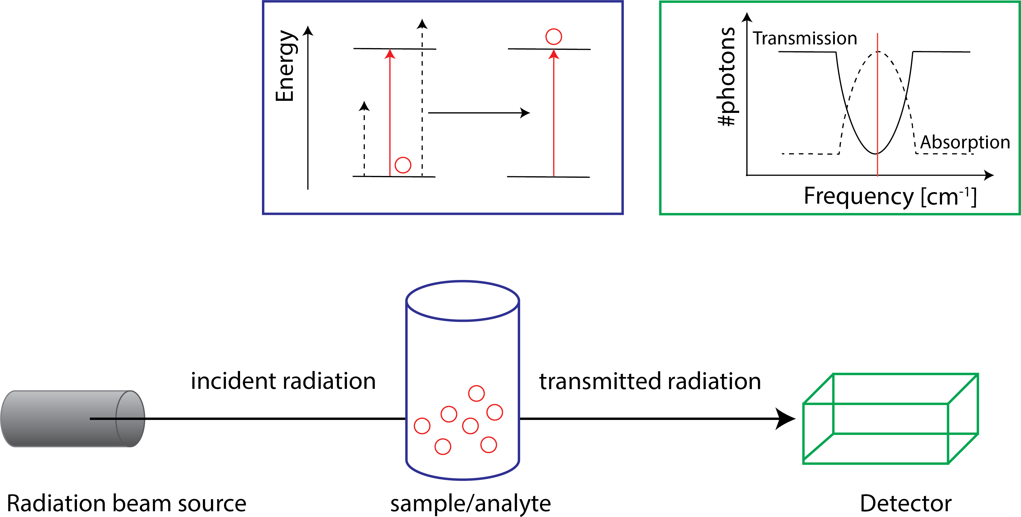

Figure 1.7.: Schematic diagram to describe the principle of absorption spectro- scopy.

them by employing action spectroscopic techniques that use sensitive mass spectrometry. These techniques measure changes in the chemical composition

of ions when they interact with resonant radiation light instead of the absorption of photons by molecular ions. Asvany *et al.* [46] successfully employed one such technique in a cryogenic ion trap to record the infrared spectrum of the elusive CH5+ molecular ion (see Section 1.5.1.3 and 1.5.1.4).

**1**

Action spectroscopy can offer several advantages, such as mass selection and storage in a cold ion trap, leading to uncontaminated spectra and narrow line widths. In the next section, we shall discuss the cryogenic ion trap techniques to isolate and confine molecular ions before continuing to action spectroscopy techniques.

* 1. CRYOGENIC ION TRAP

An electric field exerts a force on a charged particle, such as an atomic or molecular ion. Earnshaw’s [47] theorem states that it is impossible to maintain stable confinement (i.e., trapping) of charged particles by static electric fields. However, it is possible to trap ions in stable confinement using time-varying (rf - radiofrequency) electric fields. Since the ions are confined in a fast oscillating rf electric field, it is also known as radiofrequency ion trapping.

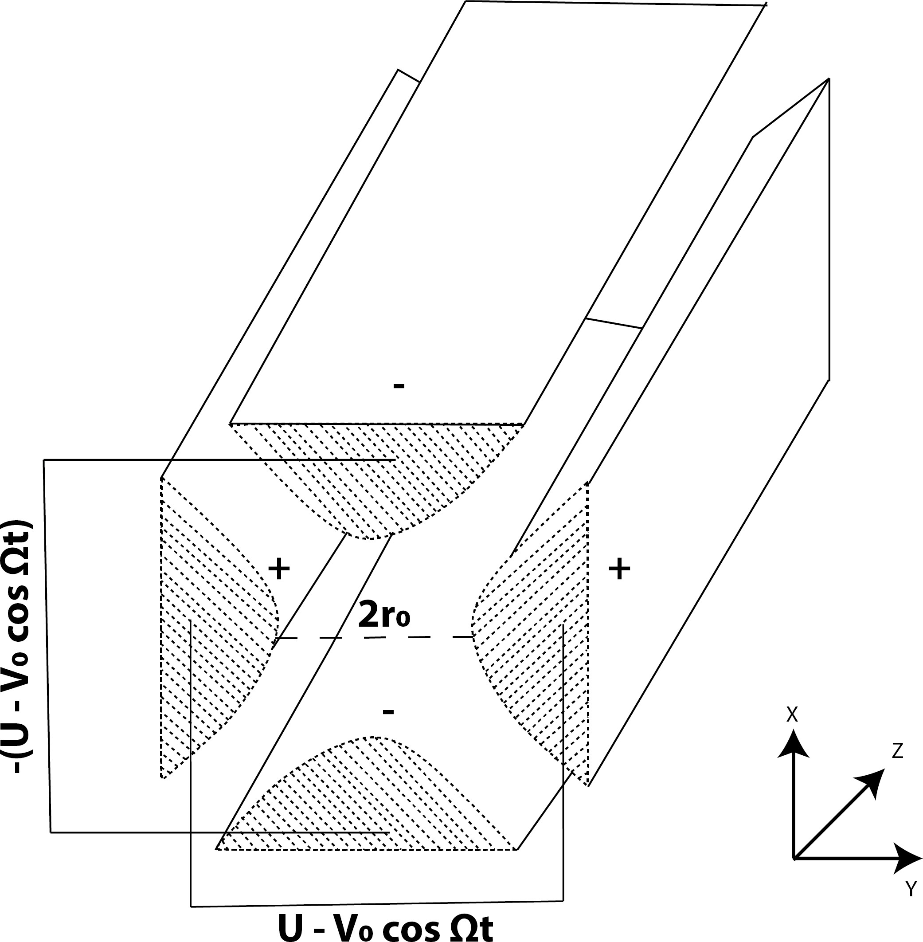

Figure 1.8.: Schematic diagram of a quadrupole mass filter. Ions enter and move along the z-axis as they oscillate in the x-y plane. The oscillation is regulated by applying DC (U) and radio frequency (RF) (V) potentials to each set of rods. Only ions with stable paths at the chosen U and V values will pass through the quadrupole mass filter.

Paul *et al.* [48] had developed the most basic electric field geometry known as the Paul or quadrupole ion trap. He also developed the quadrupole mass filter

technique [49] (see Figure 1.8). Using the combination of mass filter and ion trap, one can isolate and trap desired molecular ions with a specific mass-over- charge ratio (*m*/*z*). As a result, molecular spectroscopy in ions trap is routinely employed using action spectroscopic techniques [50–52], as discussed in more detail in Section 1.5.

**1**

The trapped ions are usually cryogenically cooled to allow low temperatures experiments. Ion spectroscopic techniques typically employ collisional cooling with neutral buffer gas [53, 54]. In the next section, we shall discuss the advantage of using a higher-multipole order ion trap, the 22-pole ion trap developed by Gerlich [55], and further improved by Asvany and Schlemmer [56] for low-temperature experiments under interstellar conditions.

* + 1. 22-POLE CRYOGENIC ION TRAP

As discussed in Section 1.2.1, since the 1950s, ion chemistry under interstel- lar medium conditions has gained interest in exploring ion-molecule reactions at low temperatures and low-density [41, 57]. Cryogenic ion trap experiments are commonly used to investigate laboratory ion-molecule reactions relevant to astrochemistry, and many astronomical objects have temperatures as low as 6 K [9]. However, in quadrupole traps, it is difficult to achieve low temperatures (kinetic and internal ion temperature) below < 10 K [58]. Therefore, higher-order multipole traps with large field-free zones are required for low-temperature as- trochemical experiments.

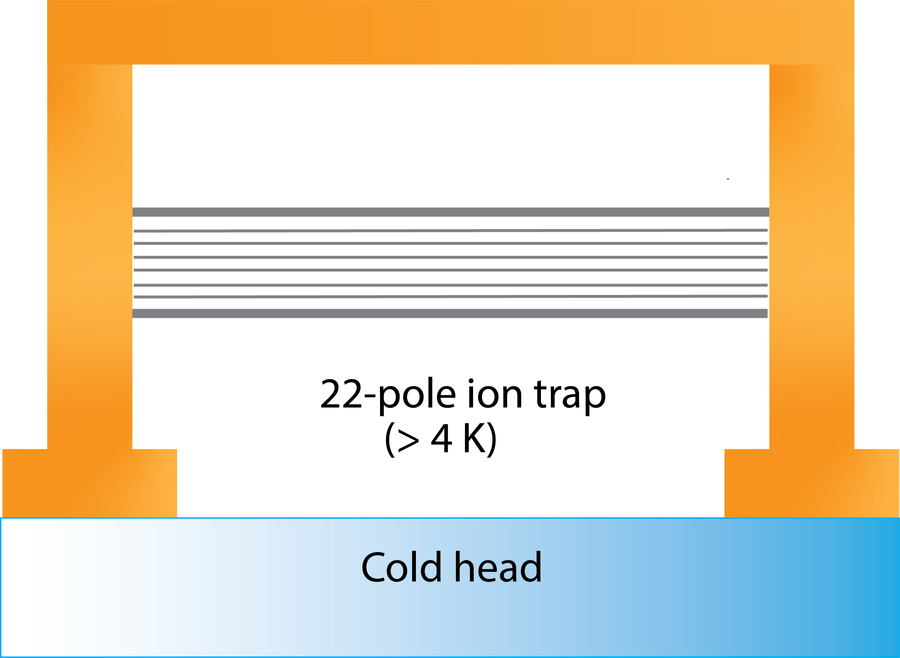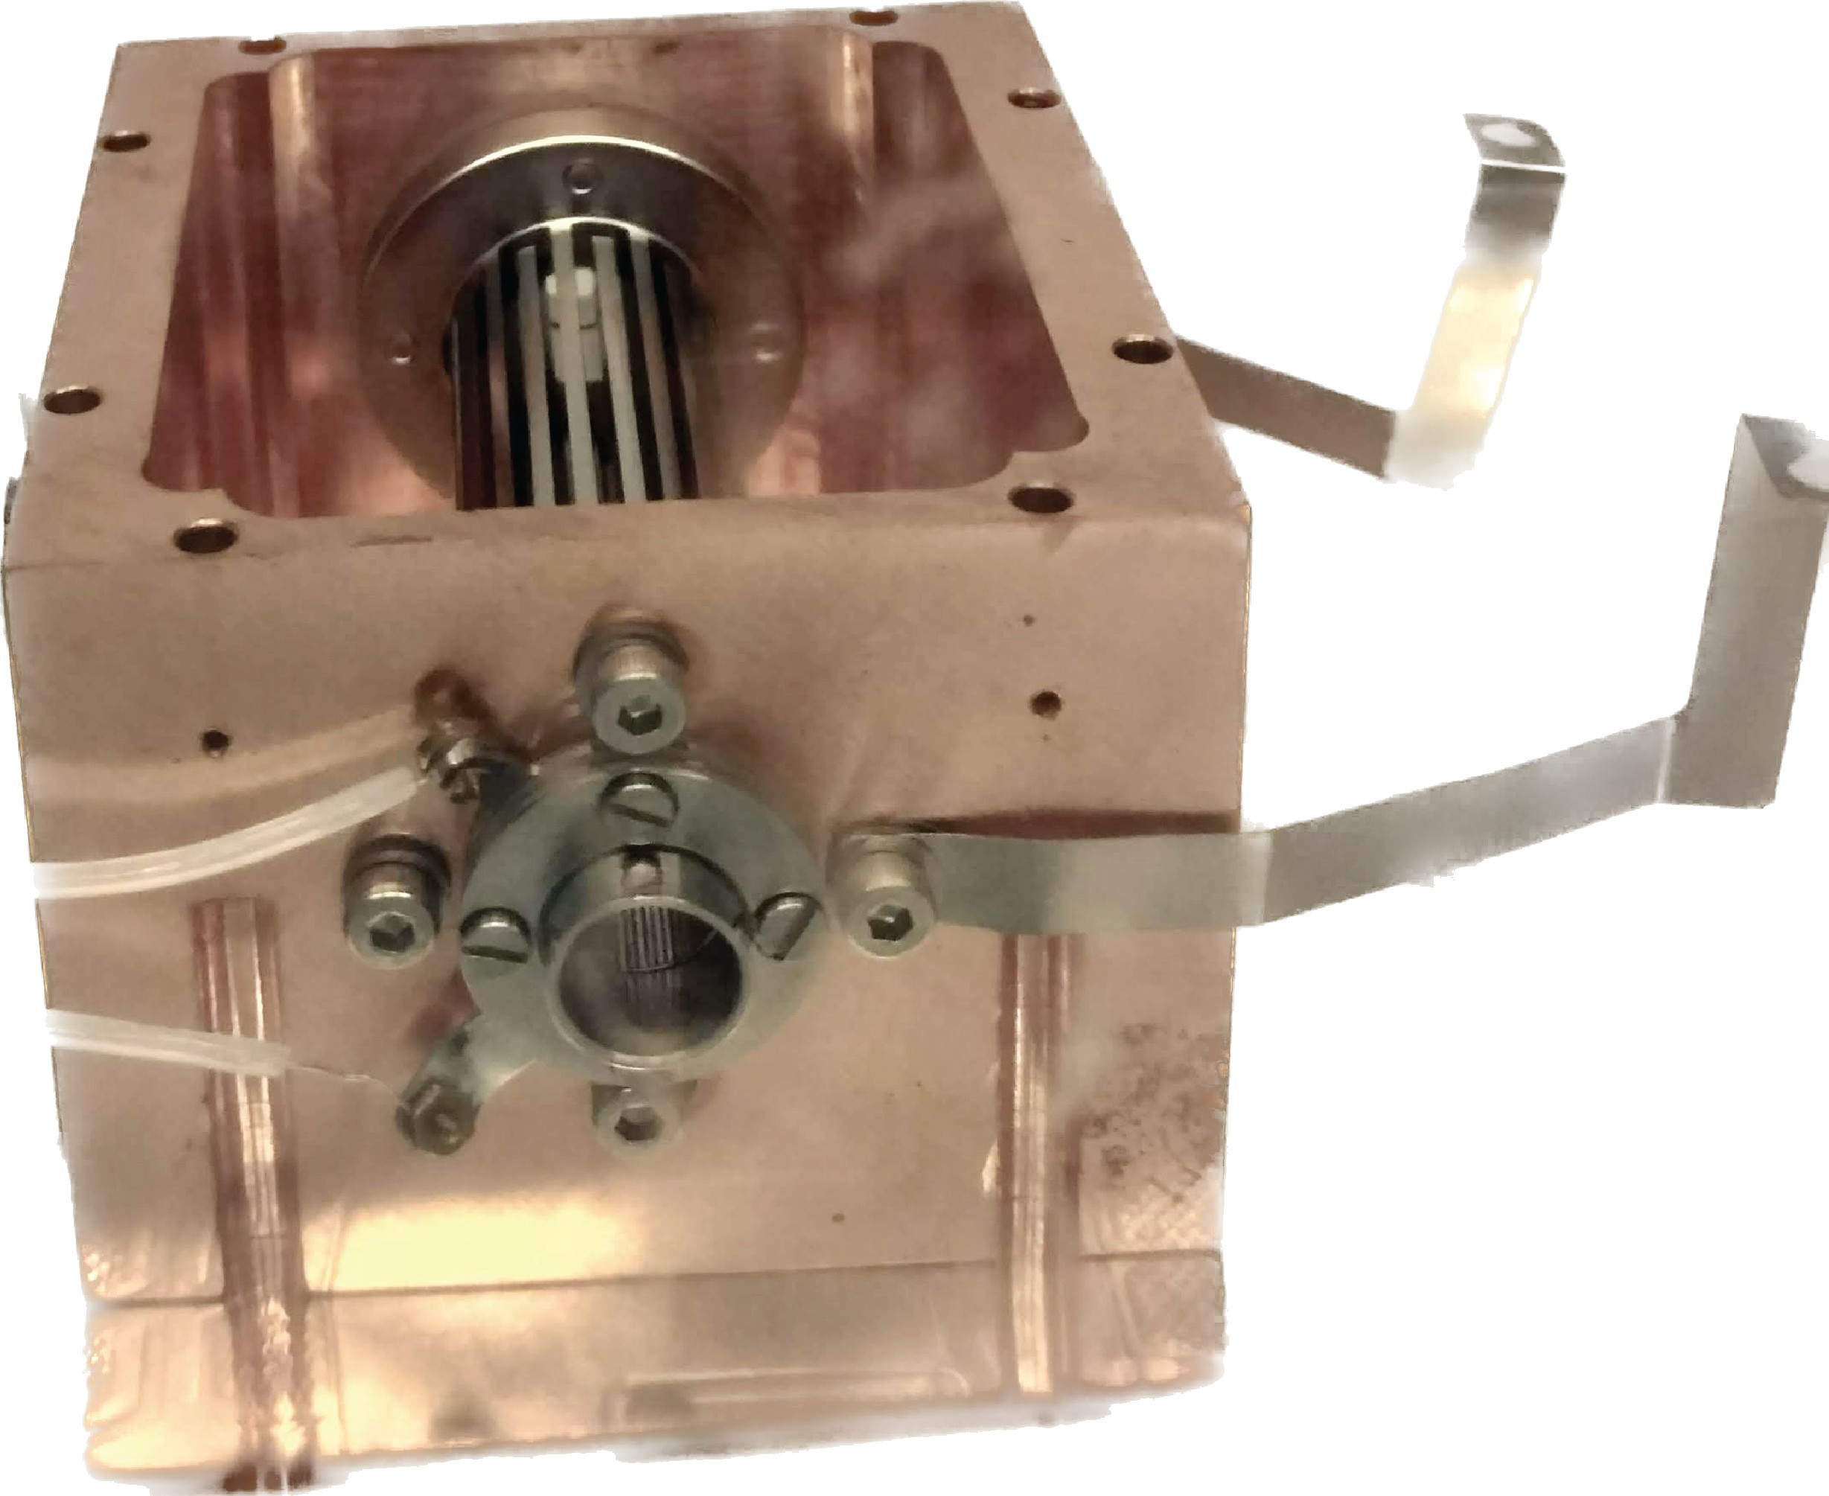

(a) (b)

Figure 1.9.: (a) Schematic drawing of the 22-pole cryogenic ion trap (grey) in copper housing (orange) mounted onto cryogenic coldhead. (b) A photograph of the 22-pole ion trap mounted inside copper housing.

In a seminal report by Gerlich [58] titled *Inhomogeneous rf fields: a versatile tool for the study of processes with slow ions*, the techniques such as ion guiding and trapping using higher-order multipole traps have been described in great detail. Most notably, Gerlich [55] also pioneered the development of the 22- pole ion trap (see Figure 1.9a) for studies of ion-molecular reactions. The sensitivity and efficiency at low density and low temperature in 22-pole ion trap experiments is a major advantage over ion-molecule reaction studies at 300 K using other well-established techniques such as flowing afterglow (FA) [59], ion cyclotron resonance (ICR) ion traps [60], and selected ion flow tube experiments (SIFT) [61]. With the development of the cryogenic 22-pole ion traps, significant advancements have occurred in studying low-temperature processes such as radiative association and three-body collisional processes in molecular complex formation [57, 62, 63].

**1**

The 22-pole cryogenic ion trap is also employed for high-resolution molecular spectroscopy of electronic [18, 64], vibrational [46] and rotational [65] transitions

(see Section 1.5.1 and 1.5.2), including the first laboratory confirmation of C+60 as the carrier of two DIBs by Campbell *et al.* [18], using a 22-pole ion trap. It has

gained even more popularity during the past two decades as a tool for research- ing ion-molecule interactions, and molecular ion spectroscopy [66–70].

The following section will discuss the action spectroscopic techniques devel- oped in cryogenic ion traps for high-resolution molecular ion spectroscopy.

* 1. ACTION SPECTROSCOPY

As discussed in Section 1.3, in contrast to absorption spectroscopy, which detects the effect molecules have on light, action spectroscopy measures effect of light on molecules. Ions are the optimum choice for action spectroscopy methods because of their charge, which makes it easy to guide, mass select and trap them efficiently. This section will focus only on vibrational and rotational gas-phase action ion spectroscopy.

* + 1. VIBRATIONAL ACTION SPECTROSCOPY

One of the most straightforward gas-phase action spectroscopic techniques is the photo-dissociation/fragmentation of molecular ions at a resonant frequency. Furthermore, the ion counts of formed products of dissociation or the loss of the parent ion are subsequently recorded as the signal. In 1973, Dunbar [71] first investigated photodissociation in the visible spectral range. Soon after, Okumura *et al.* [72] studied photodissociation in the infrared region, yielding vibrational spectra.

Generally, a single infrared photon’s absorption is insufficient energy to promote the breakdown of covalent bonds. However, several ways to circumvent this constraint are described in the following sections.

**1**

* + - 1. TAGGING PHOTODISSOCIATION ION SPECTROSCOPY

The most straightforward technique to overcome the limitation is to utilize a loosely bound “tag” to the molecular ion that detaches upon absorption of a single IR photon. The tags are chosen to have minimal effect on the structure of the ion core, i.e., they should be very weakly bound. Therefore, rare gas atoms such as He, Ne or Ar are preferred tagging agents.

The formed weakly bound complexes are dissociated due to the resonance photon absorption, as shown in Figure 1.10, and the vibrational spectra are recorded as a function of IR frequency, as shown in Figure 1.11. This process is known as “photo-dissociation” or “pre-dissociation”. The very well-known technique using this approach for measuring vibrational transitions is called “**I**nfra**R**ed **P**hoto-**D**issociation” (IRPD) spectroscopy.

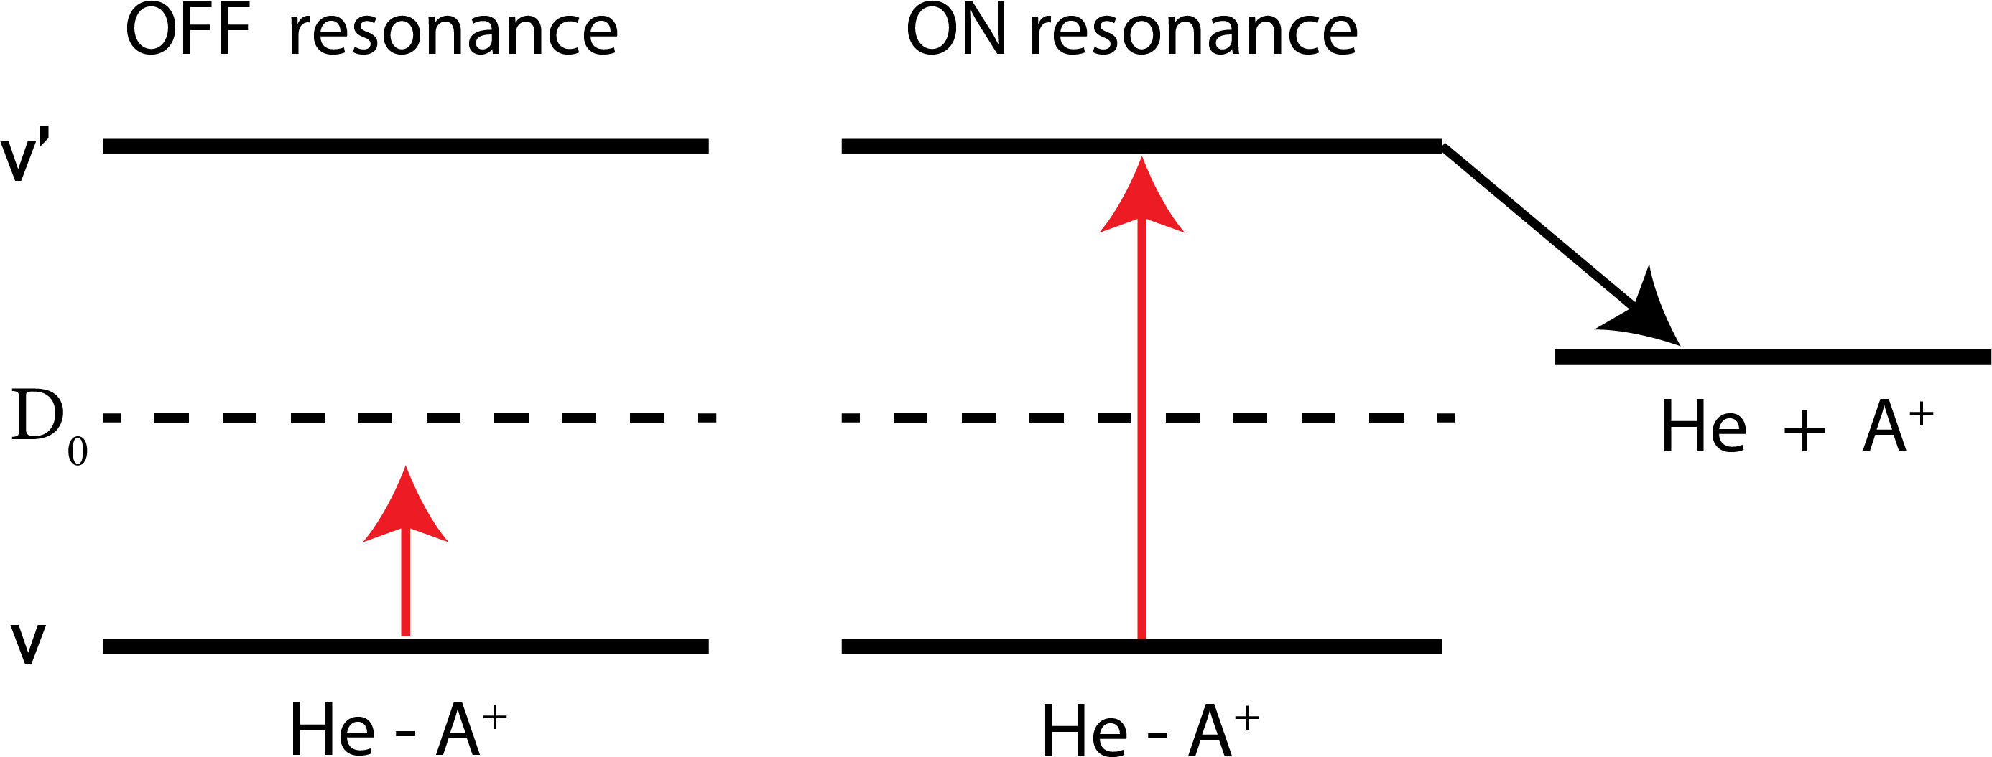

Figure 1.10.: Schematic drawing of the IRPD method. He−A+ represents the weakly bound helium complex of molecular ion A+, and D0 indicates the complex dissociation limit.

Yuan T. Lee demonstrated the first IRPD action spectroscopy technique [72] for hydrogen cluster ion, which several groups further developed [73–75] using molecular beam experiments. However, in the molecular ion beam, the small interaction time between the ion and tag and ion and photons ( ∼ *µ*s range, flight time of ions) is a disadvantage for efficient complex formation and dissociation, respectively.

Cryogenic ion trap experiments overcome these restrictions [69, 76–79] by storing for a longer duration (≥ 1s) and by using cryogenic cooling to relax the molecular ion to its vibrational and electronic ground state. The low tempera-

**1**

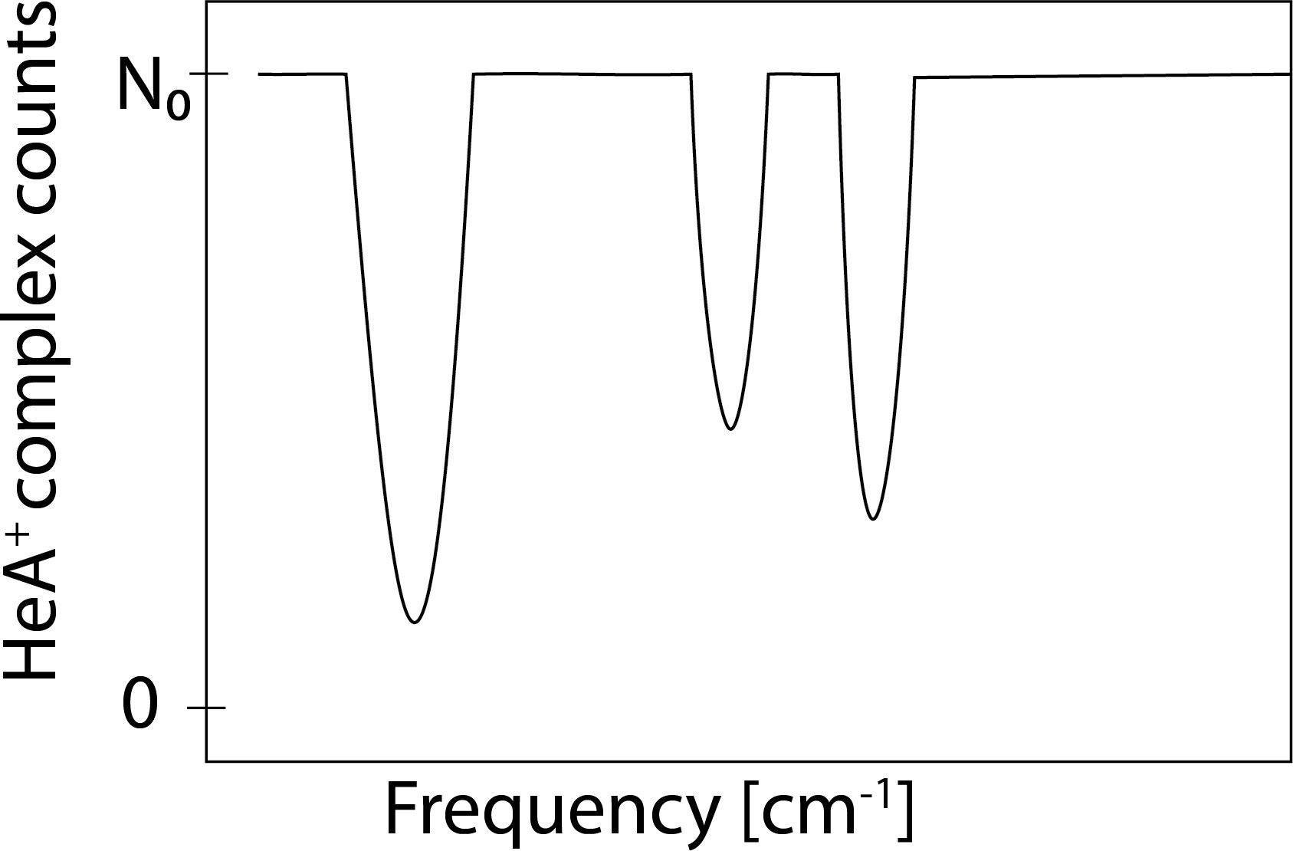

Figure 1.11.: Schematic IRPD spectrum measuring complex counts as a function of frequency. N0 indicates the initial background counts, while the counts drop due to the dissociation of the complex at the resonance frequency.

tures in the ion trap (> 4 K) also result in a high tagging efficiency even for weakly bound complexes [80, 81], which is an important factor since the tagging method is predicated on the notion that the binding of the tag does not significantly al- ter the structure of the original ion. Consequently, the perturbation due to the attachment of tag on the bare ion spectra can be computationally corrected (see Chapters 3 and 4).

The IRPD technique is employed in this thesis to characterize vibrational transitions of the molecular ion. Section 2.2 discusses the integration of this technique into our 22-pole cryogenic ion trap instrument (Section 2.1). The following sections discuss several other methods developed for vibrational action spectroscopy.

* + - 1. IR MULTI-PHOTON DISSOCIATION (IRMPD)

As discussed above, the energy of a single infrared (IR) photon is insufficient to cause dissociation in the majority of untagged ions. However, numerous photons can be absorbed when employing high-power light sources. The combined sum of the absorbed energy thus overcomes the dissociation energy limit, as shown in Figure 1.12.

In 1973, Isenor and coworkers [82] were the first to notice this IRMPD effect when they exposed SiF4 vapour to powerful CO2 laser pulses. This study was quickly replicated in laboratories worldwide, and it was later shown that

many different types of molecules could undergo infrared multiple-photon dissociation or isomerization [83–85]. However, it was not until the 1990s that widely tunable free electron IR laser sources with adequate pulse energies became available, launching a new infrared ion spectroscopy area. Oomens *et al.* [86] and Lemaire *et al.* [87] demonstrated the potential of a widely tunable infrared free-electron laser (FEL) in the study of the IR spectroscopy of mass- selected ions in an ion trap.

**1**

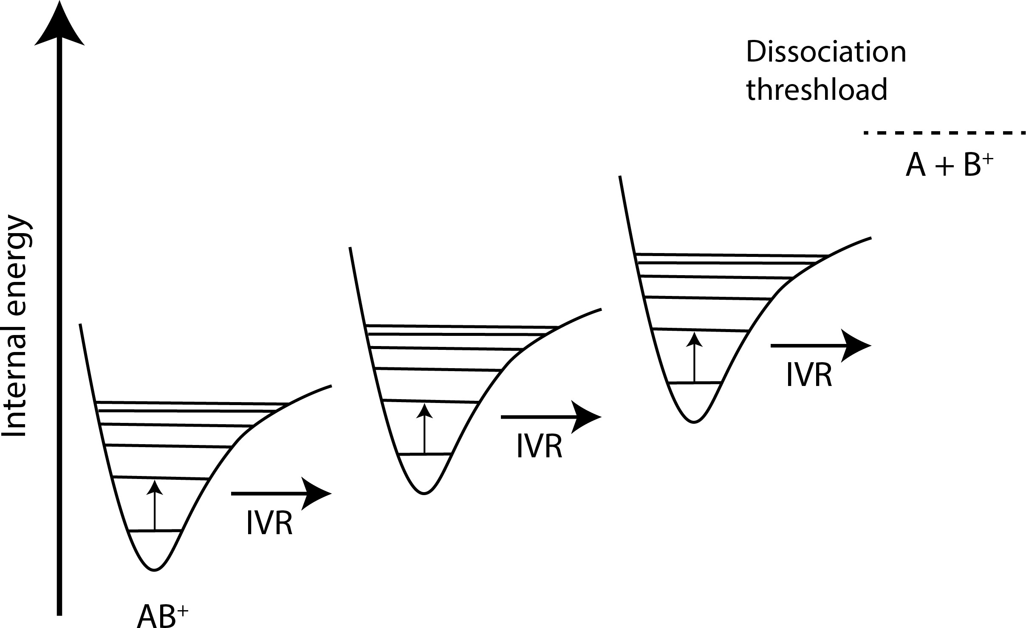

Figure 1.12.: Schematic drawing of the Infrared multi-photon dissociation (IRMPD) spectroscopy. AB+ represents molecular ion consisting of A and B chemical fragments. Figure adapted from [88].

Extensive experimental and theoretical research investigated the fundamen- tals of IR multiple-photon excitation in polyatomic molecules [89–92]. IRMPD is a low-energy fragmentation method that requires absorbing many photons of IR radiation before dissociation occurs. Vibrational potentials are inherently anhar- monic, and absorption of tens to hundreds of photons occurs in a non-coherent manner. This effect is often referred to as the anharmonicity bottleneck [93]. Be- fore the subsequent photon is absorbed, intramolecular vibrational redistribu- tion (IVR) swiftly spreads the energy stored in the excited vibrational coordinate over all other vibrational degrees of freedom. The molecule is slowly heated, and dissociation typically follows the lowest-energy fragmentation pathway.

However, this poses a difficult challenge to investigate small molecular ions using IRMPD because the method requires a high density of vibrational states, which guarantees that there are always a lot of vibrational eigenstates such that

the IVR is feasible. Therefore IRMPD is typically well-suited for larger molecular ions. In this thesis, only smaller molecular ions (≤ 7 atoms) are investigated; hence IRPD is employed, as mentioned in the previous section.

**1**

* + - 1. LASER INDUCED REACTIONS (LIR)

LIR combines the benefits of trapping molecular ions in a cryogenic ion trap with the idea of using a chemical reaction to determine the ion’s internal state. In the late 1990s, Schlemmer *et al.* [94] developed LIR for spectroscopy by measuring

the vibronic N2+ (A 2Π*u* ← X 2Σ*g* ) spectrum by excitation with visible laser

photons to overcome the endothermic energy of a charge-transfer (CT) reaction

as shown in equation 1.1. Counting the laser-induced product ions as a function of laser frequency yields the spectroscopic signal (see Figure 1.13).

N2+ +Ar → Ar+ +N2 (1.1)

C2H2+ +H2 → C2H3+ +H (1.2)

CH5+ +CO2 → CH4 +OCOH+ (1.3)

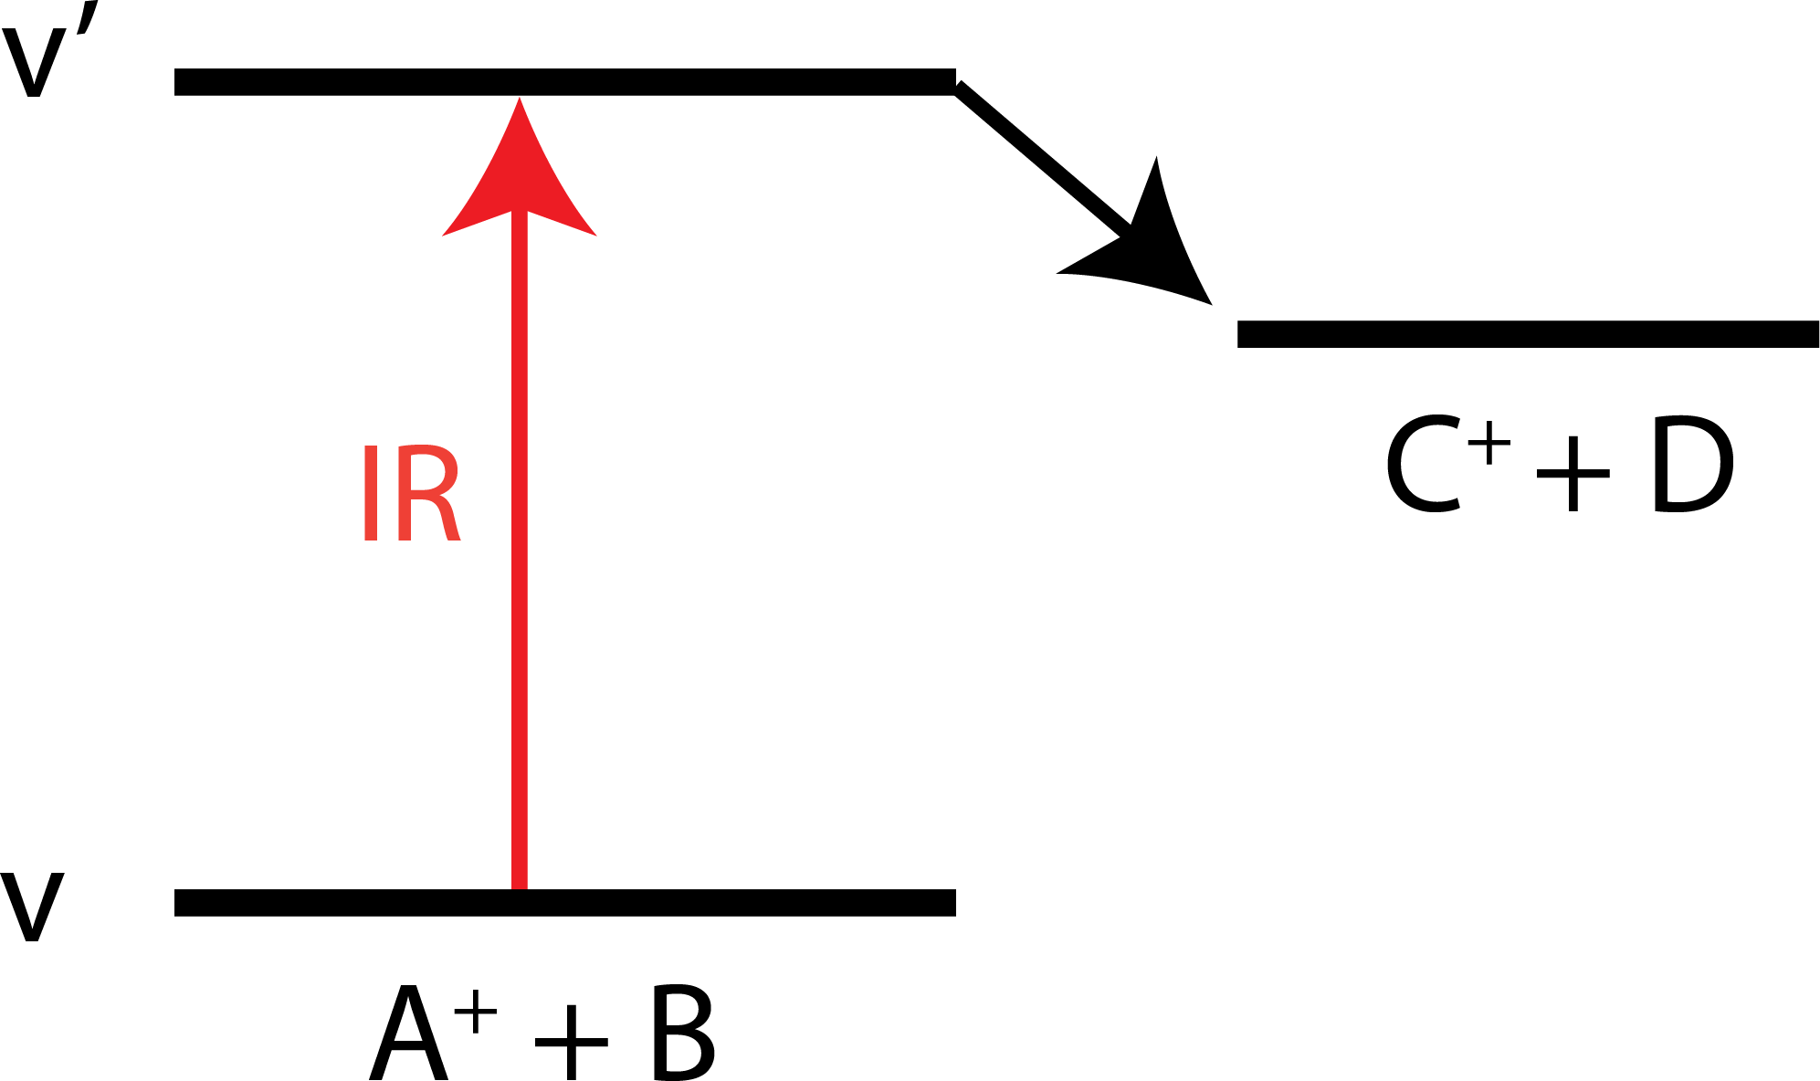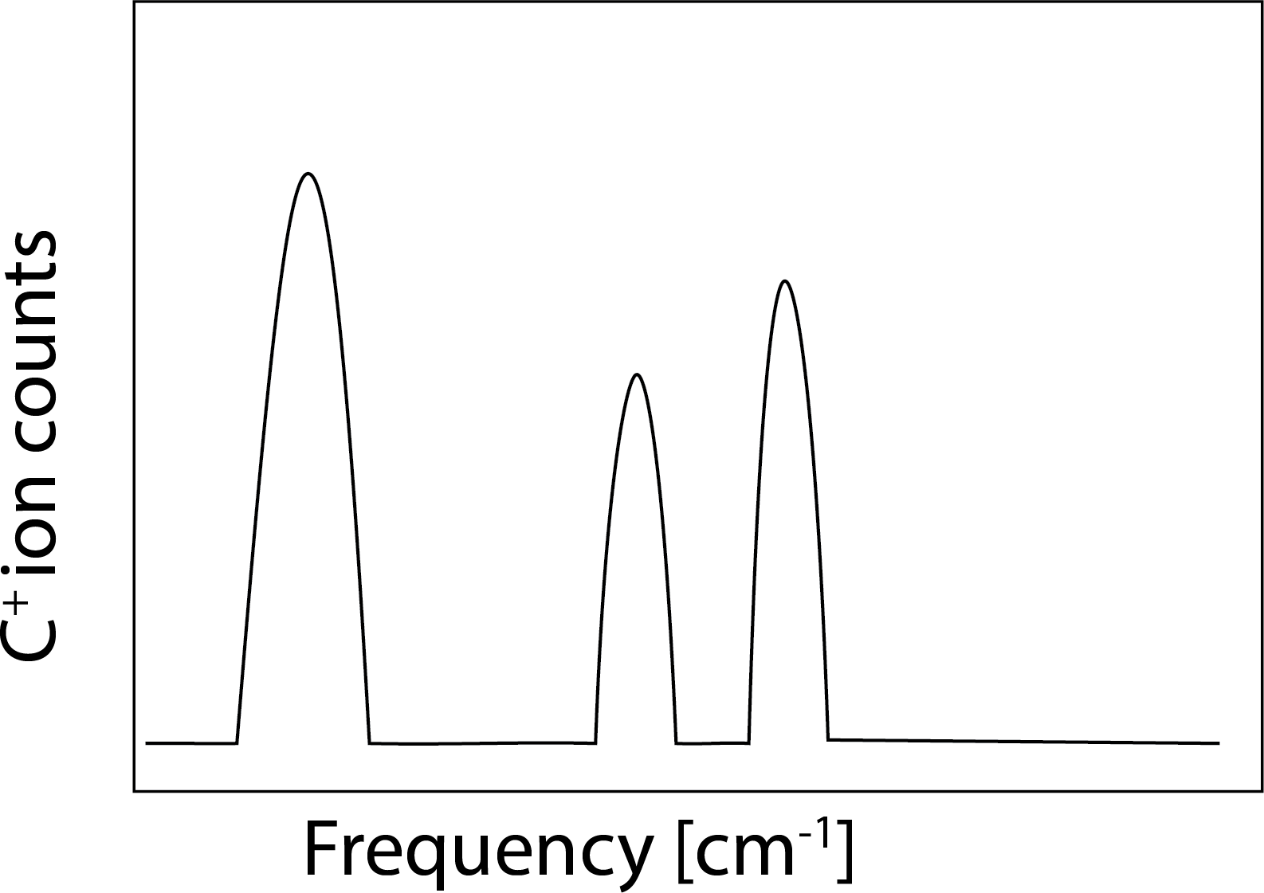

(a) (b)

Figure 1.13.: Schematic description of (a) bimolecular reaction initiated by laser excitation suitable for LIR spectroscopy, (b) LIR signal as a function of frequency detected by monitoring the product counts.

Several endothermic reaction systems have been studied with the LIR method for bimolecular reactions, such as hydrogen abstraction and proton transfer (see Eq. 1.2 and 1.3), to record vibrational transitions of reactant C2H2+ [95–97] and CH5+ [46], respectively, by detecting the laser-induced products C2H3+ and OCOH2+, respectively.

* + - 1. LASER INDUCED INHIBITION OF HE ATTACHMENT (LIICG)

**1**

The requirement for an endothermic chemical reaction with a neutral reaction partner is a well-known limitation of the LIR method. Acquiring endothermic energy for chemical reactions is challenging, especially for highly reactive molecular ions [52]. Also, the endothermicity cannot be too high since it needs to be overcome by the absorption of a single infrared photon. Another limitation is that since the cryogenic trap has very low temperatures, the reaction partner should not condense in the trap. These conditions limit the use of LIR.

LIICG takes advantage of the fact that the excitation of molecular ions can inhibit the ternary attachment of He atoms. Maier and Gerlich [64] pioneered this method by measuring the electronic transition of N2+ (A 2Π*u* ← X 2Σ*g* ) using a 22-pole cryogenic ion trap.

Asvany *et al.* [67] was the first to demonstrate the use of LIICG for rovibrational transitions of CH5+ molecular ion by forming CH5+−He complexes and observing an on-resonance decrease in the number of CH5+−He due to laser-induced inhibition of helium attaching to CH5+ (not via destruction of CH5+−He as in IRPD). The vibrational LIICG has been employed to record many other molecular ions such as O2H+ [77], CH+ [98], H3+, H2D+ and D2H+ [99], CD2H+ [100], CH2NH2+ [101], CN+ [102]; HHe2+ and HHe3+ [78].

Interestingly, the ternary rate coefficient for He attachment can be affected by rotational excitation, even though rotational photons only carry a fraction of energy compared to vibrational photons. Section 1.5.2.3 describes how to use this phenomenon to our advantage to measure high-resolution molecular ions’ rotational spectra.

* + 1. ROTATIONAL ACTION SPECTROSCOPY

Action spectroscopy for measuring rotational transitions is very challenging since the rotational transition energies are much lower than vibrational or electronic states (see Table 1.1). While vibrational and electronic action spectroscopic methods have been available for trapped ions and ionic clusters since the 1980s, the first rotational action spectroscopic methods appeared only a decade ago from Schlemmer’s group [103].

This section briefly summarises the detailed review by Asvany and Schlemmer

[52] but focuses only on rotational action spectroscopic methods. Figure

1.14 shows the summary of rotational action spectroscopic methods schematic diagrams.

* + - 1. ROTATIONAL LIR

**1**

Schlemmer and coworkers showed the first realization of pure rotational action spectroscopy in a cryogenic trap using a direct-LIR method (as discussed in Section 1.5.1.3) [103]. Using this approach, they measured the lowest- lying rotational transitions *para-*H2D+ and *ortho-*D2H+, two astronomically important molecular ions that exhibit large rotational energy spacing (1.37 THz and 1.48 THz for the ground state transitions, respectively). The on-resonance laser-induced reactions of H2D+ and D2H+ held in a cold ion trap increases the reactivity (producing H3+ and H2D+, respectively) with a neutral H2 reaction partner. Therefore the rotational transitions of the investigated ions are reflected in the yield of the reaction products as shown in Figure 1.14a.

* + - 1. DOUBLE RESONANCE METHODS

As discussed in Section 1.5.1.4 there are limitations to the direct-LIR technique. Therefore further rotational action spectroscopic techniques were later developed to generalise the scheme for a wide range of molecular ions, such as using a double resonance approach. A vibrational action spectroscopy scheme can be used to perform high-resolution rotational spectroscopy by double resonance. In other words, if a molecule has a vibrational action spectroscopy scheme with a rotational resolution, the spectroscopy can easily be extended into the rotational domain by a double resonance approach; the possibilities are as follows:

***via* LIR**: As shown in Figure 1.14b, this method uses a combination of infrared (IR) and Terahertz (THz) radiation to irradiate ions. The frequency of the IR photon is kept fixed on a rovibrational transition. The signal is monitored by counting the number of the product ions produced as a function of the THz frequency [104, 105]. The signal can be depletion or gain depending on whether the IR is fixed at a rotational ground or excited state.

***via* predissociation:** Predissociation is another effective vibrational action spectroscopic technique (see Section 1.5.1.1). Based on prior IR predissociation work by Dopfer and collaborators [106], the vibrational-rotational predissocia-

tion via double resonance approach (see Figure 1.14c) has been shown for the first time for the He−CH3+ complex [107].

***via* electron detachment:** This high-resolution rotational action spectroscopy via double resonance schemes method is suitable for molecular anions. Wester and coworkers [108] devised an action scheme using state-selective electron photodetachment via fixed “visible” (vis) frequency radiation (see Figure 1.14d), and demonstrated it by measuring the two lowest rotational transitions of OD−. The molecular anion counts are monitored as a function of frequency (rotational

photon). On rotational resonance, the radiation populates the initial state probed by a fixed-vis laser which subsequently increases the electron photo- detachment, thereby decreasing molecular ion counts (depletion signal).

**1**

***via* LIICG:** In LIICG, excitation of the bare cation can inhibit He-attachment in a ternary collision process at 4 K (see Section 1.5.1.4), and this is utilised in this method. The IR laser is fixed at a rovibrational transition; the He-cation molecular ion complexes are monitored as a function of THz frequency (see Figure 1.14e). The depletion in complex counts on the rotational transition

resonance frequency of the bare cation is the signal. It has been demonstrated for protonated methenamine, CH2NH2+ [101].

* + - 1. ROSAA

The rotational high-resolution rotational action spectroscopy technique em- ployed in this thesis is ROSAA which is an abbreviation of to **RO**tational **S**tate- dependent **A**ttachment of rare gas **A**toms. This method exploits that the ternary attachment of neutral atoms (typically He) depends on their rotational quantum state since the ternary attachment of He is only hindered (or changed, see Fig- ure1.14f) instead of inhibited as discussed in LIICG (see Section 1.5.1.4). Brünken *et al.* [109] demonstrated it by measuring four pure high-resolution rotational transitions for C3H+ (2Σ).

The fact that helium atoms can theoretically be attached to any cation at low temperatures (< 15 K) is a significant advantage of this approach. Several mole- cular cations have been studied in the laboratory for the first time with the state- dependent He attachment approach. High-resolution pure rotational transition frequencies have been measured using this technique for l-C3H+ [109], CF+ [110], SiH+[111], HCO+ [112], CD+[65], CH+ and 13CH+[98], NH3D+[110, 113],

NH2D2+ and NHD3+ [113], CN+[114], CH2NH2+[101], CH3NH3+[115], NO+ [116],

CCl+[117] and CO+ with resolved Zeeman components from earth magnetic field [65, 118] (see Chapter 7).

As mentioned above, the ROSAA technique is employed in this thesis for characterising the rotational transition of molecular cations. More detail and in-depth analysis of ROSAA action spectroscopic schemes are explored using numerical simulations (Section 2.3.1 and 2.3.5) for CD+ (see Section 6.7 and 6.8

) and CO+ (see Chapter 7) ions.

**1**

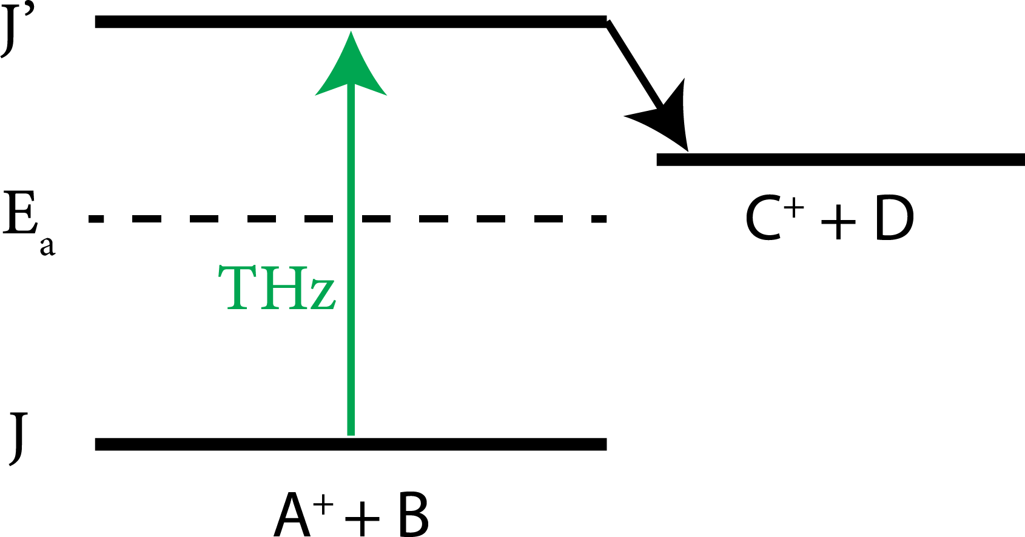 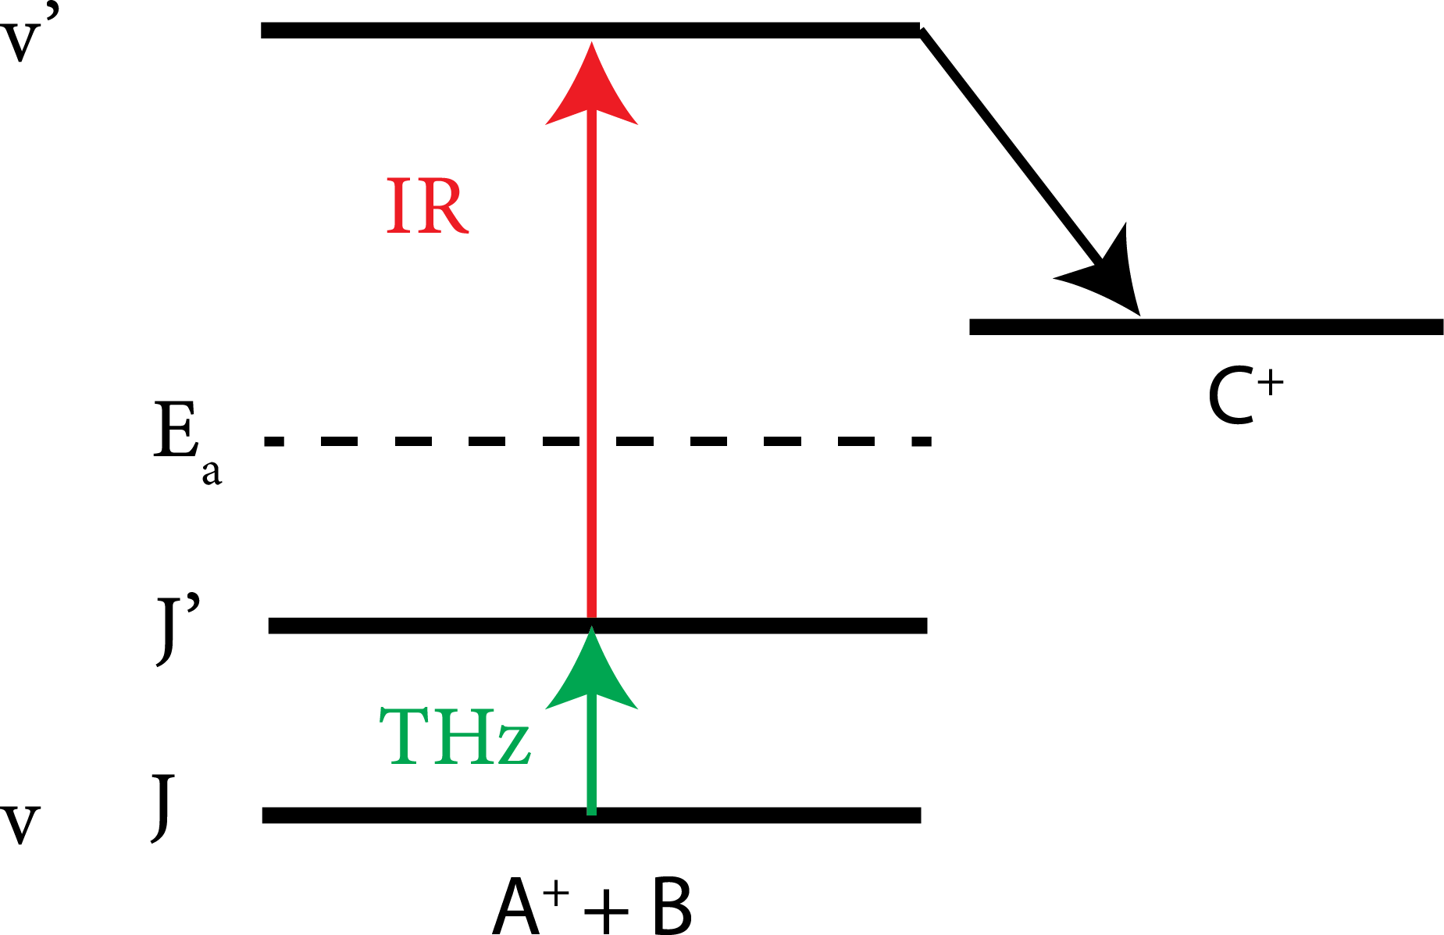 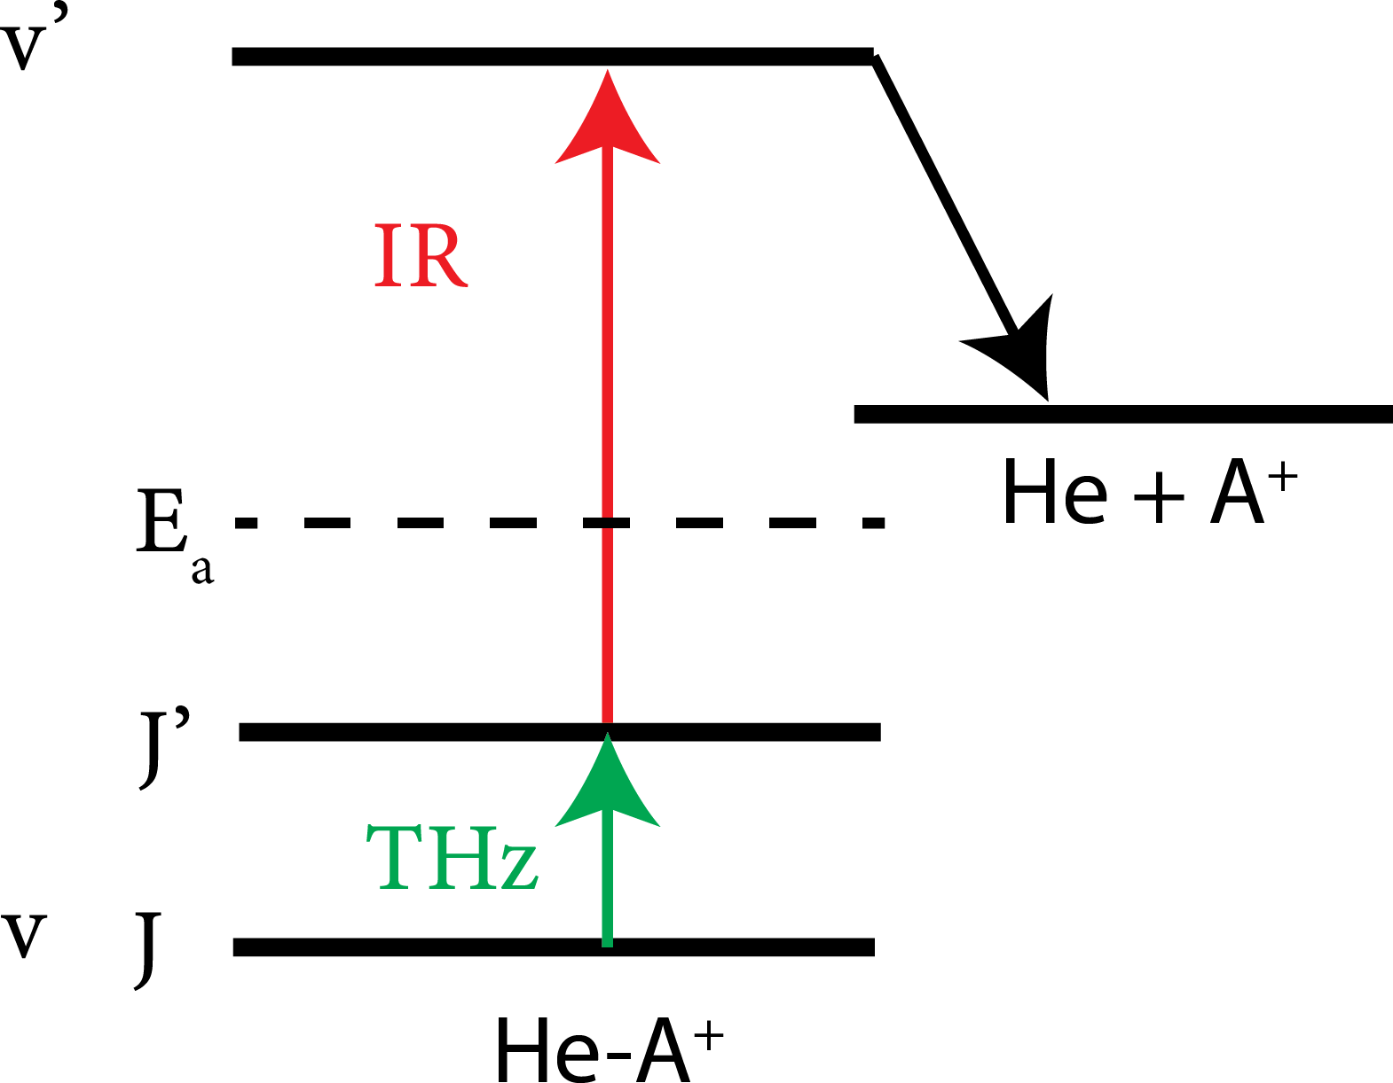

(a) LIR (b) DR *via* LIR (c) DR *via* predis.

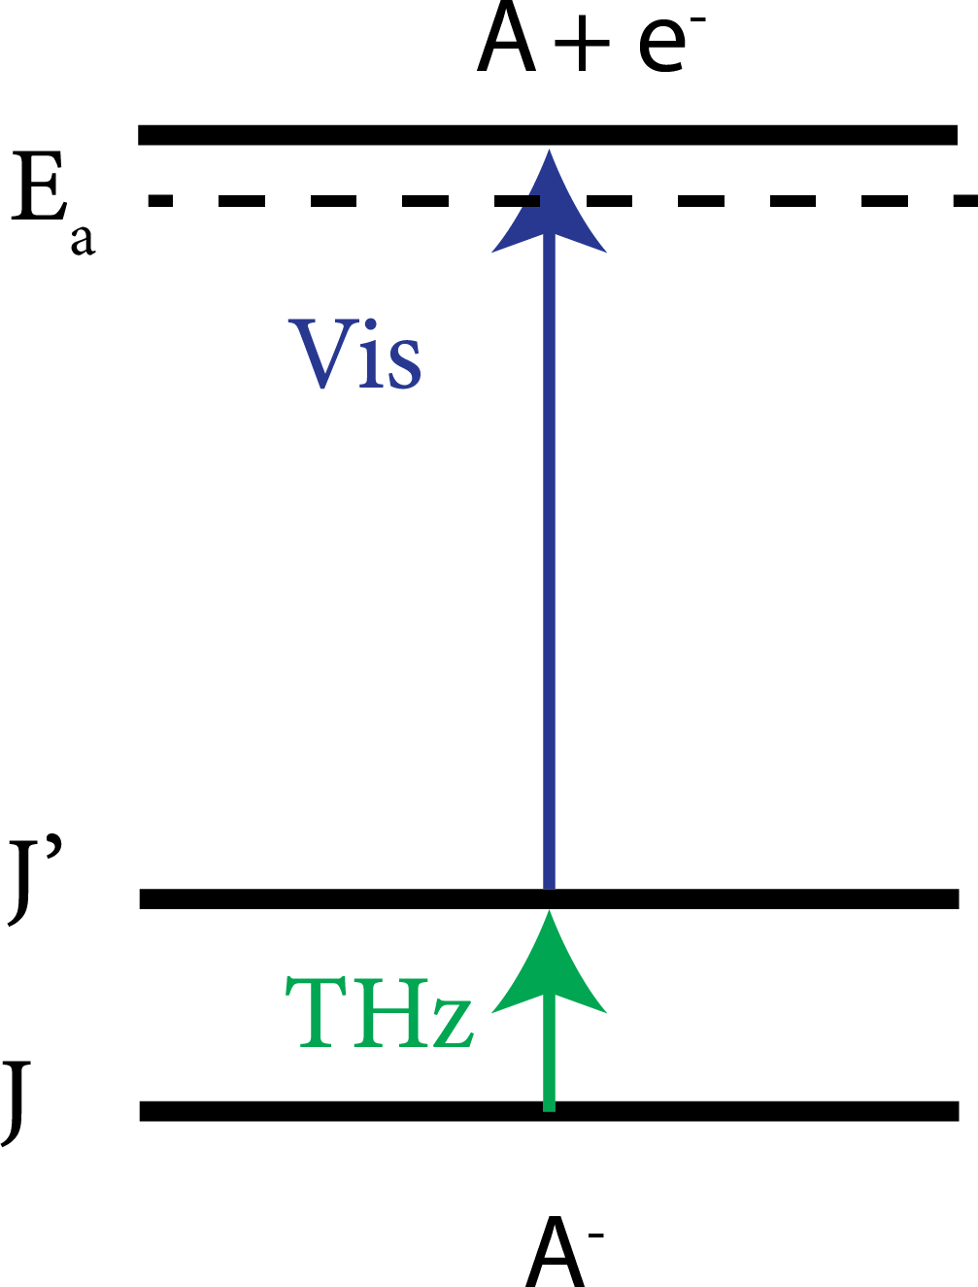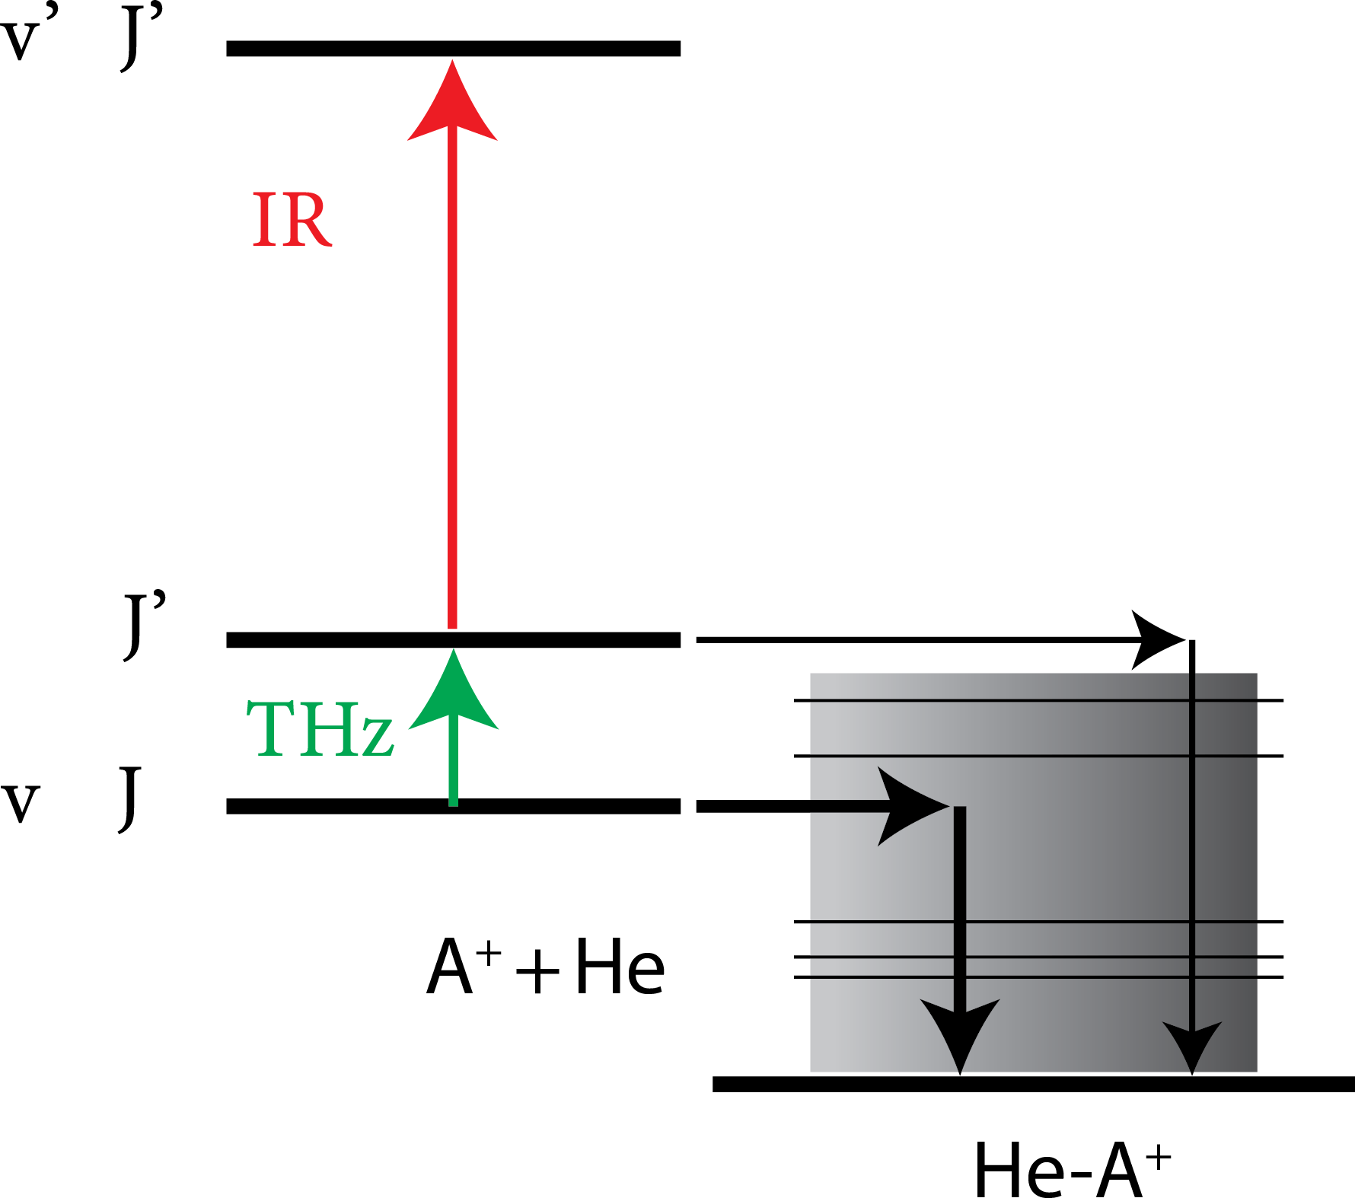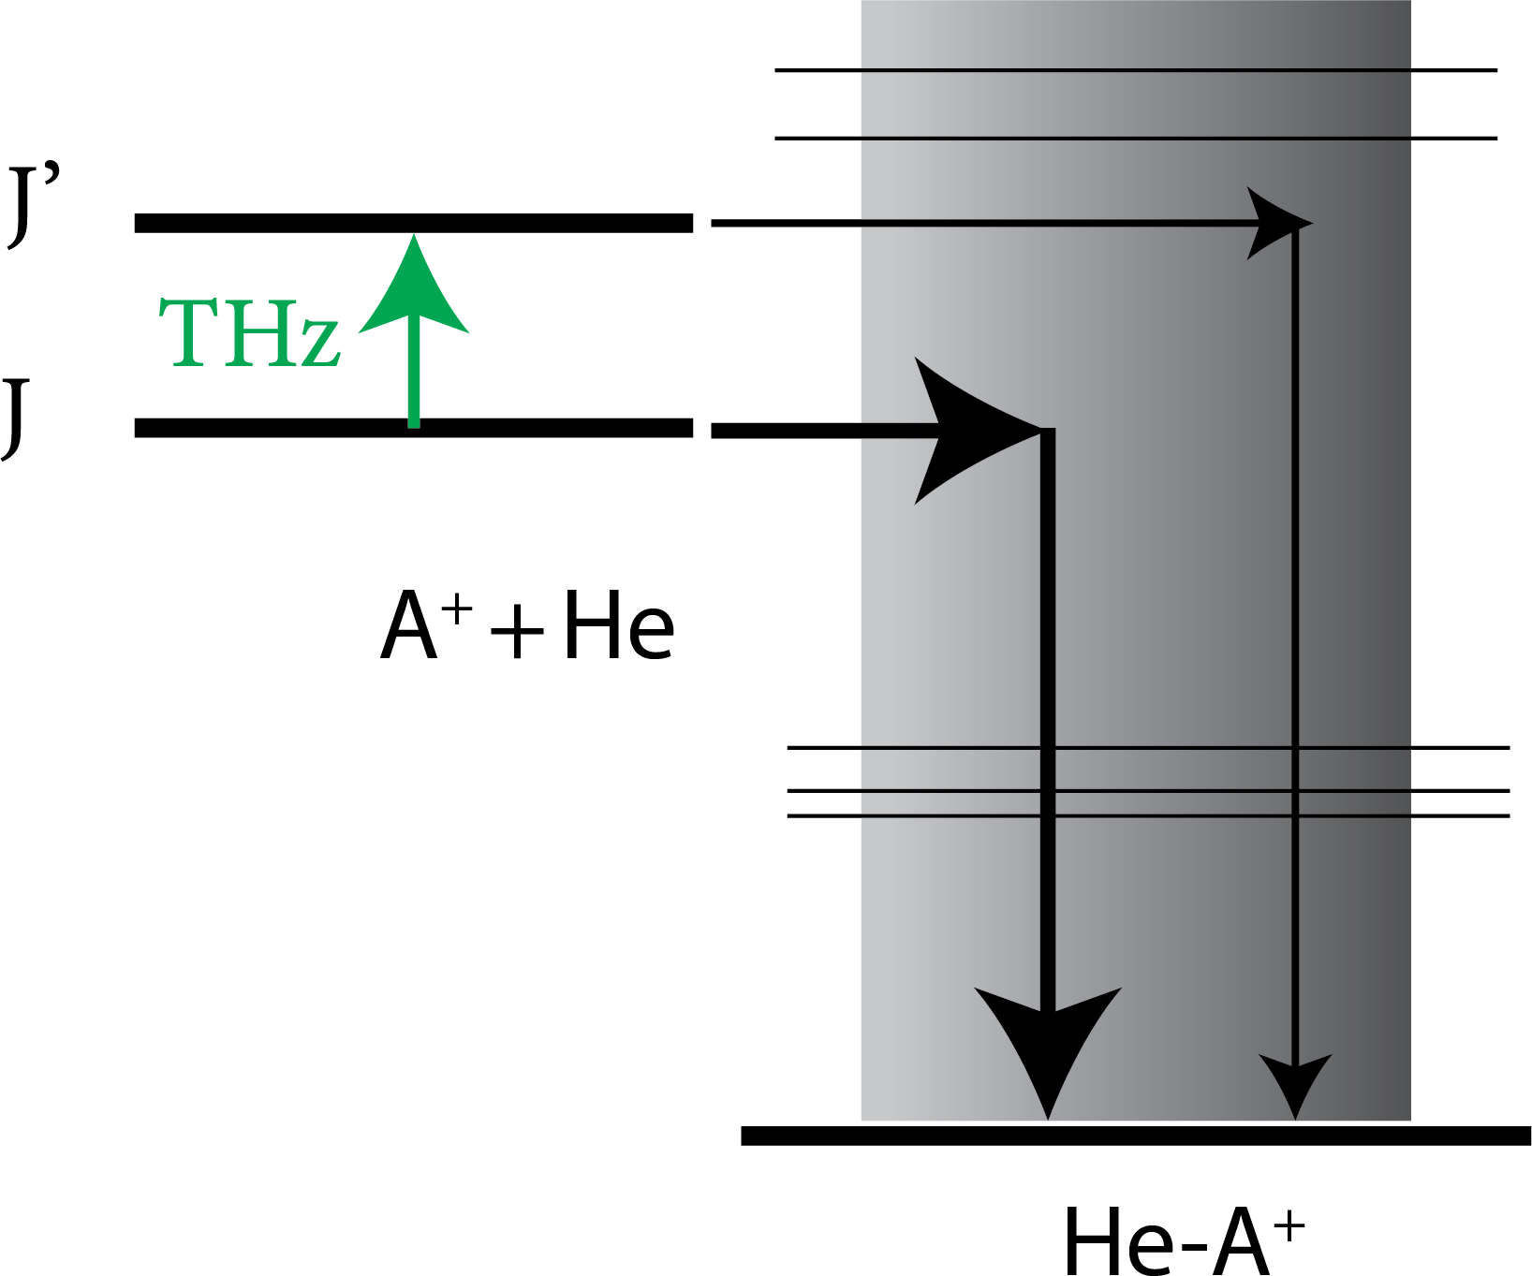

(d) DR *via e*− det. (e) DR *via* LIICG (f) ROSAA

Figure 1.14.: Schematic diagrams of rotational action spectroscopic methods. The captions indicate the corresponding name of the method. DR stands for double resonance. “predis.” and “det.” in (c) and

(d) correspond to “predissociation” and “detachment”, respectively. The symbol A and B indicates molecular species while superscript (such as A+) indicates molecular cations. He indicates a helium atom while He-A+ indicates a weakly bound helium-ion complex.

* 1. THIS THESIS

**1**

This thesis titled “Rotational and vibrational action spectroscopic studies on cold molecular ions” discusses action spectroscopic techniques employed to charac- terize molecular ions in a cryogenic ion trap spectroscopically. Molecular ions relevant to astrochemistry, especially in the interstellar medium and planetary atmospheres, are mainly focused on and are discussed in respective chapters.

**Chapter** **2***“Experimental and theoretical methods”*: gives an overview of the experimental setup used in this study, including the ion source, cryogenic trap and detector. A detailed description of the action spectroscopic methods em- ployed in this thesis to characterize molecular ions’ rotational and vibrational transitions is discussed. Technical details such as determining number density with uncertainty, calibration of instruments and instrument setup are discussed in detail.

**Chapter** **3***“Laboratory gas-phase vibrational spectra of [C*3*H*3*]*+ *isomers and isotopologues by IRPD spectroscopy”*: In this chapter, we investigated broad- band gas-phase Ne-IRPD spectra of both linear and cyclic forms of [C3H3]+ and reported the first gas-phase IR spectra of the corresponding [C3D3]+ isomers. Various high-level coupled-cluster methods are benchmarked. We also investi- gated the isomeric ratio quantification of [C3D3]+ produced with different ion source conditions and precursors. The results and analysis of this chapter’s con- tents are published [119].

**Chapter** **4***“Infrared predissociation spectroscopy of protonated methyl cyanide, CH*3*CNH*+ *”*: In this chapter, we present a comprehensive experimental and quantum chemical study of the vibrational spectrum of Ne-CH3CNH+. A focus is on the influence of the weakly-bound neon atom on the infrared pre-dissociation experiments. We also demonstrated an efficient computational approach to pro- vide accurate estimates of anharmonic vibrational frequencies of the bare ion and complex. The results and analysis of this chapter’s contents are published [120].

**Chapter** **5***“A vibrational action spectroscopic study of the Renner-Teller and spin-orbit affected cyanoacetylene radical cation HC*3*N*+*”*: In this chapter, we present the investigation of the vibrational transitions of HC3N+, an open shell linear molecular ion. The breakdown of the Born-Oppenheimer approximation due to the Renner-Teller (RT) effect (vibrational coupling) is analysed using an effective Hamiltonian approach. The influence of the tag in IRPD, especially on the bending modes of RT-affected open-shell, is discussed in detail. The results

and analysis of this chapter’s contents are published [121].

**1**

In these first chapters, the vibrations transitions on the potential candidates of interstellar molecular ions are experimentally and theoretically investigated in detail, and discussed from various perspectives, such as isomer quantifica- tion, the influence of tag on smaller molecular ions and RT-affected open-shell species. In the following chapters, the investigation focuses on high-resolution pure-rotational action spectroscopy. Rotational transitions provide distinct molecular fingerprints, and importantly, due to their low excitation tempera- ture, most interstellar species are identified through their rotational transitions. The molecular ions discussed above are potential interstellar and also (exo-

)planetary candidates. Based on their vibrational characterization, rotational characterization will be followed in the future. Therefore, the following two chapters discuss the implementation and investigation of a novel rotational ac- tion spectroscopic technique (ROSAA), which utilizes a change in rare-gas atoms attachment rates for measuring pure rotational transitions of bare ions. The method is illustrated for a closed and for the first time, an open-shell molecular ion.

**Chapter** **6***“Kinetics of CD*+ *with He buffer gas”*: In this chapter, we report a systematic study and detailed analysis of the CD+ reaction with helium buffer gas atoms with and without the presence of radiation resonant with the *J* = 0 − 1 rotational transition of CD+ ion. This is important in investigating the ROSAA signal intensity (i.e., measured rotational transition intensity) processes using numerical simulation. Consequently, a robust numerical simulation model was developed to predict the intensity of the rotation transition of the molecular ions of interest.

**Chapter** **7***“The Zeeman effect in CO*+ *observed with rotational action spec- troscopy”*: In this chapter, the high-resolution rotational transition of CO+, an open-shell molecular ionic species, is investigated using the ROSAA technique. In addition to an unpaired electron fine structure splitting, a (partly) resolved hyperfine Zeeman splitting is observed due to Earth’s magnetic field. The mea- sured signal intensity is investigated using the developed numerical simulation model. The results and analysis of this chapter’s contents are published [118].

## 2

### Experimental and theoretical

##### METHODS

27

* 1. FELION INSTRUMENT

The various spectroscopic and kinetics experimental studies reported in this thesis have been performed using the 22-pole cryogenic ion trap instrument (referred to as FELion), which has been built in the Cologne Laboratory Astrophysics group and installed permanently at the widely tunable “Free Electron Lasers for Infrared eXperiments” (FELIX) [122] in Nijmegen, The Netherlands. As shown in the schematic diagram (Figure 2.1), the FELion instrument consists of an ion source, quadruple mass filters, an ion trap and a detector. A detailed description of the FELion instrument has been given by Asvany *et al.* [67], Kluge [123] and Jusko *et al.* [69]. This section will provide a brief

**2**

ION TRAP



RADIATION SOURCE

BENDER

+ → +

> 4K

ION

+

Q2 DETECTOR

Molecule

+

Rare gas (RG) atom

Q1

(He, Ne, mixture of He:Ne, etc.)

+ Complex

e- +

ION SOURCE

Figure 2.1.: Schematic drawing of the FELion ion trap setup. The 22-pole ion trap is coupled in-between two quadrupole mass filters (Q1 and Q2). The ions are guided into the trap from Q1 via quadruple bender (labelled BENDER). The trap contents are extracted after irradiation from the radiation source into Q2 to filter desired product molecular ions and then guided into a Daly type detector to be counted.

discussion focusing on the FELion instrumental apparatus used in this study.

* + 1. ION SOURCE

One of the main challenges when studying highly reactive molecular ions is their production. The primary molecular ions are produced in the ion source using electron ionisation (EI), where an energetic electron (typical 20 − 70 eV) interacts with molecules. Dempster [124] first demonstrated this process for the solid phase and later Bleakney [125] for the gas phase molecules. The ionisa- tion process produces dissociative and non-dissociative products, i.e., ionised fragments and ionised parent molecules, respectively. A short pulse of produced ions is then extracted into the first quadrupole (Q1) by applying an adjustable pulse on the exit electrode (referred to as B0, see Figure 2.2). This section will discuss the types of ion sources coupled to the FELion instrument.

**2**

S1 S2 S3

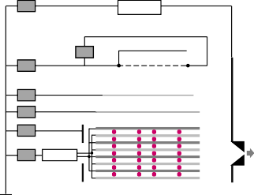

B0 DC

pulse

Repeller

filament DC

DC

e- energy -

+

DC focus

DC

DC B-1

DC RF

source

end-plate

Repeller

**QI**



DC Filament DC

DC Repeller

+

Grid **QI**

DC Grid

DC B1

DC B0

B2

**Macor**

- **sealing**

pulse

(a) (b)

Figure 2.2.: Schematic drawing of the ion sources. The various components are labelled, and the corresponding connections are indicated by solid lines for (a) storage source and (b) non-storage (S1, S2 and S3 are grounded base plates for support). The pink circles represent ruby balls for insulation between connected electrodes. The labelled Macor sealing ring on top of the B0 electrode is placed to seal the ion source chamber and prevent any accidental contact between B0 and the Q1 rods.

**Storage source:** One type of ion source is a radiofrequency storage source, developed by Gerlich and Horning [57]. The primary ions are generated and stored (∼s) in this source using an in-homogeneous RF field and DC potentials. The benefit of storing the ions in the source is that the produced molecular ions can undergo collisions with the background neutral gas or gas mixtures

(typically at pressures of 10−6 −10−5 mbar and a temperature of ∼ 400 K), leading to the production of secondary ions via chemical reactions and de-excitation and thermalization of the ions.

As depicted in the schematic diagram (Figure 2.2a), the storage ion source consists of a stack of eight “double H-shaped” molybdenum plates (1 mm thickness), which are connected and electrically insulated by ruby balls (1 mm diameter). Four of the eight plates are connected alternately, and a typical 50 − 280 V RF voltage is applied. The filament wire (rhenium 99.97%, 0.2 mm diameter) is covered by the “repeller” and the “focus”, which are made up of 0.5 mm thick molybdenum plates. The filament typically operates around ∼ 5 V and

**2**

2.8 A and is held on a negative potential corresponding to the electron energy. The repeller is connected to the negative end of the corresponding filament. The DC voltages applied to the “focus” and “repeller” help to focus and accelerate electrons into the source. The B0 and B-1 are mounted at the front and back of the source apertures, respectively. This combination helps to confine the ions in the axial direction of the source by applying corresponding DC-potentials. The B0 can be pulsed to generate a short pulse (typically 10-100 ms) of ions for the experiments.

**Direct EI source:** The other type of ion source is called “direct EI”, which produces primary ions by “direct electron ionisation” but they are not stored. This source is a simple combination of repeller, grid, filament and lens, as shown in Figure 2.2b. The filament wire is made up of a 0.25 mm Rhenium wire mounted in a circular arrangement around the grid covering 270 deg arc length. The filament’s power supply (∼ 5 V / 2.8 A) is floated to 10 − 70 eV and, together with the grid voltage (1 − 4 V), acts as an electron gun which accelerates the electrons to provide the necessary energy to ionise molecules in the grid region. The repeller (typically operated around −5*to* − 15 V) is mounted on a grounded base plate with ceramic insulators and helps to focus and accelerate electrons into the grid region. The einzel lens (electrodes) set up towards the end consists of B0, B1 and B2 electrodes (insulated by ruby balls) to confine the ions in the axial direction of the source by applying corresponding DC-potentials.

Depending on the nature of the study, storage and direct EI sources can be used accordingly. The storage ion source provides the benefit of storing the formed ion for a few seconds, thereby often quenching ions to the most stable isomeric form and the electronic ground state by undergoing (reactive) collision with the background gas. Additionally, the storage source can produce secondary ions via reactions with the background gas, e.g., protonation reactions. An efficient protonation process is, for example, discussed in more detail in chapter 4. On the other hand, the direct EI source allows us to produce also energetically higher-lying isomeric forms of ions and to characterize, for

example, their formation routes via dissociative ionization. In Chapter 3, a detailed investigation of two different isomers (cyclic and linear form) are discussed using both direct EI and storage ion source.

Once the ions are formed in the source, a short pulse of ions is extracted into the first quadrupole mass filter (Q1). Adjusting the RF and DC potential voltages can further isolate and guide the molecular ion of interest into the trap, as will be discussed in the following section.

**2**

* + 1. ION TRAP AND DETECTOR

The heart of the FELion instrument is a 4 K cryogenic 22-pole ion trap coupled in-between two quadrupole mass filters (Q1 and Q2). The Q1 and Q2 are perpendicularly angled. Therefore, the produced mass-filtered target ions from Q1 are guided into the trap by passing via a quadrupole bender, as shown in Figure 2.1. The 22-pole ions trap’s design details are described by Asvany *et al.* [56]. The trap RF is generated using amplified output (10 W amplifier) of a direct digital synthesizer (DDS) and operated at the trap resonance of around ∼ 18.3 MHz.

The ion trap is mounted inside a copper housing and directly onto a cold head (Sumitomo RDK-408D2), allowing to cool it down to a minimum temperature of around 4 K using a He cryostat (see Figure 2.3). The FELion instrument’s 1 Hz machine cycle is synchronized with the cold head and FELIX laser (see Section 2.2.2) for infrared experiments. The temperature can be varied between 5 − 40 K using a thermo-strip (Kapton material, providing up to 40 W heating power) and monitored using an attached Si diode (Lakeshore DT-470-CU-13). The ions are kinetically and internally cooled by collisions with buffer gas atoms such as He or He:Ne mixture. However, it should be noted that the ion temperature is typically higher than the nominal trap temperature [126] (see Section 2.3.4). The buffer gas is admitted directly into the trap region at high number densities (1014 − 1015 cm−3, see Section 2.5.1 for number density measurements inside trap) either continuously or via a pulsed piezo valve depending on the experimental methods.

The ions can be stored in the trap for up to 10 s (depending on the experiment) and then extracted from the trap. Subsequently, the parent or possible product ions are mass-selected with a second quadrupole mass filter (Q2) into a single- ion counting Daly type detector [127] for analysis. The pulses generated by the detector are amplified and discriminated (Phillips Scientific model 6906, 300 MHz) and counted with a gated 100 MHz counter (Ortec model 996).

In the next section, we shall discuss the spectroscopic methods employed in the 22-pole cryogenic ion trap (FELion instrument) for vibrational and rotational transition measurements of molecular ions.

* 1. VIBRATIONAL SPECTROSCOPY
     1. Experimental method

The action spectroscopic method employed to record the vibrational transitions of the molecular ions in this study is the well-known “infrared predissociation (IRPD)” spectroscopy, as introduced in Section 1.5.1.1.

**2**

In our IRPD experiment, the primary target ions are formed in the ion source and mass filtered into the 22-pole ion trap. A short He or He:Ne mixture pulse (50-100 ms) is introduced into the trap (typically at 5-9 K range). The molecular ion can form a weakly bound complex at low temperatures (< 10 K) and high number density (1015 cm−3) via three-body collisions, as discussed in more detail in Section 6.7.3. The tagging efficiency in forming the complex depends on the interaction strength between the molecular ion and the tag (He or Ne). This study typically obtains > 10% tagging yield; more details on different molecular ions are described in their respective chapters. For tagging partners, the neon atom is often preferred, although the helium is better suited for IRPD studies due

300

5.0

4.8

4.6

1.0

1.5

2.0

250

200

Temperature [K]

150

100

50

0

0.00 0.25 0.50 0.75 1.00 1.25 1.50 1.75 2.00

Time [hour]

Figure 2.3.: Cool-down behaviour of the 22-pole cryogenic ion trap from room temperature using a He cryostat. The inset shows a detailed view of temperatures below 5 K.

to its lower polarizability, lower binding energy, and thus minimal perturbation on the ionic vibrational frequencies. However, for the same reason, since the He-complex is very weakly bound, it dissociates due to trap heating from a high-power radiation source, such as the free-electron laser employed in this study. The influence of the Ne tag on bare ion vibrational modes is discussed in corresponding chapters.

**2**

The trap contents are stored in the ion trap for about 1-2 s while being irradiated with pulsed IR radiation as a function of frequency, and the formed complexes are then mass filtered and counted. The dissociation of the complex at resonance transition yields the signal in the form of a depletion. The IR radiation source and data normalising procedures are described in the following sections.

* + 1. IR RADIATION SOURCE

The IRPD measurements for characterising the infrared signature of ionic complexes in this study are performed with two types of infrared (IR) radiation sources, the free-electron lasers FELIX and an optical parametric oscillator/amplifier (OPO/A) system. In this section, we shall briefly describe the interface of the FELion ion-trap instrument with these IR radiation sources.

* + - 1. FELIX

FELIX stands for “Free Electron Lasers for Infrared eXperiment”; as the name suggests, it is a free-electron laser (FEL) facility, and the FELion instrument is located in its user-stations [69]. This section briefly introduces the operating principles of an FEL, followed by a detailed description of the FELIX laser system coupled to the FELion instrument used in this study for infrared experiments.

**Operating principles:** In a conventional laser device, the laser light is generated through optical amplification based on the stimulated emission of electromagnetic radiation from e.g. an atomic or a molecular excitation. A free- electron laser system however employs relativistic electrons as a gain medium. As shown in Figure 2.4, an electron accelerator provides a beam of relativistic electrons followed by an undulator (periodic arrangement of magnets with alternating poles) in which the electrons perform a transverse oscillation and travel along the axis of the undulator. Two highly reflective mirrors form an optical laser resonator in which the radiation is amplified. By adjusting the electron beam’s energy or the magnetic field strength of the undulator, the wavelength of the radiation emitted, *λr* can be easily tuned and is given by [122]:

**2**

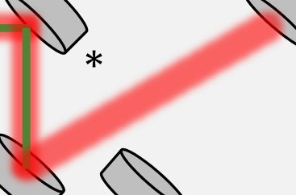

Gun electron accelerator

electron

dump

Undulator magnet

N S N S

Vacuum

beamline

Mirror

S N S N

FELIX

KRS-5 window

OPO

OPA

λ/2

N2

Nd:YAG BS Attenuator

OPO/A (LaserVision)

* periscope mirror

FELion

N2

N2 region flushed with nitrogen gas

*

Not to scale

Figure 2.4.: Schematic drawing of FELIX and OPO/A system interfaced with FELion user-station. The blue and green coloured lines represent the FELIX and OPO/A output laser beam paths, respectively. Only one system, FELIX or OPO/A, is operated at a given time.

*λu* µ

*λr* = 2*γ*2

1 +

*K* 2 ¶

2

where *λu* is the undulator wavelength (spatial period of the magnetic field), *γ* is the relativistic Lorentz factor, and *K* is the dimensionless parameter describing undulator magnetic strength.

The *γ* and *K* are defined as:

1

*γ* = ✓1 −(*v*

*K* = *eBuλu*

*z*

2*πmec*

/*c*)2

where *vz* is the velocity of the electron in the direction of the undulator, *c* is the speed of light, *me* is the mass of the electron, *e* is the elementary charge, and *Bu*

is the applied magnetic field strength.

**FELIX laser system:** Currently, the FELIX laboratory consists of four laser systems, FEL-1, FEL-2, FELICE, and FLARE, each producing their range of wavelengths, and together, they provide a tuning range of 3-1500 *µ*m. The FELion instrument is interfaced with the FEL-1 and FEL-2 pulsed IR laser system via an evacuated beamline with a wide tunable frequency range of 30-150 *µ*m (330-66 cm−1) and 3-45 *µ*m (3330-220 cm−1), respectively. FEL-2 delivers > 2000 cm−1 in 3*rd* harmonic operation mode (FEL-2 was updated in 2022 after the experiments reported in this thesis have been concluded). The IR pulsed FELIX laser has a repetition rate of 10 Hz with a typical macropulse length of ∼ 10 *µ*s and for the experiments reported here a 1 GHz micro-pulse structure (see Figure 2.5) has been used.

**2**

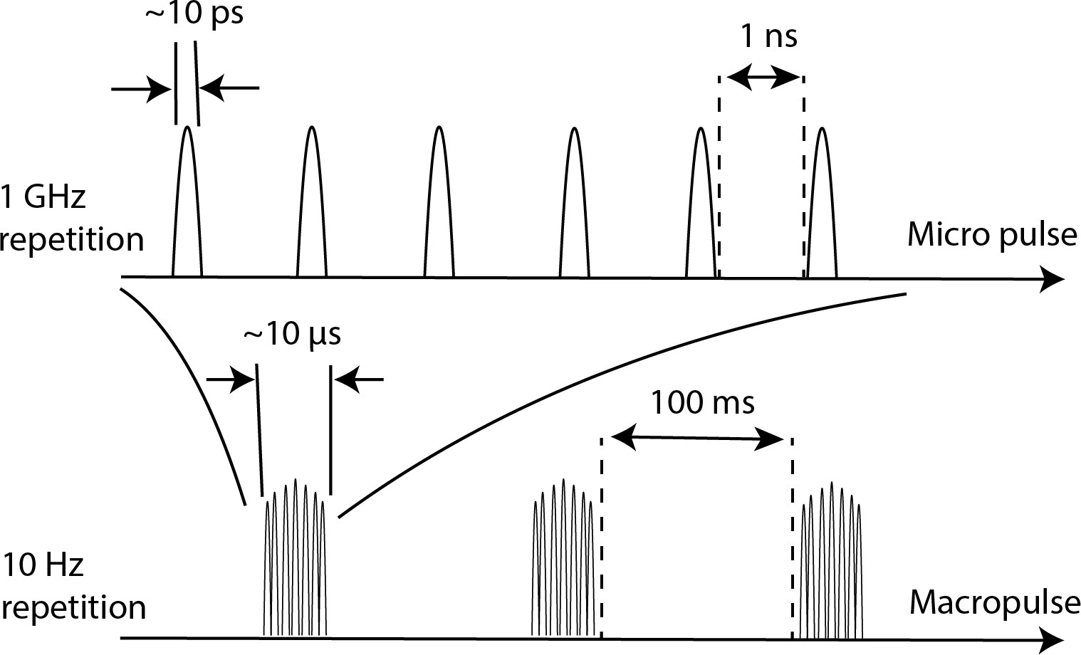

Figure 2.5.: Schematic diagram of the FELIX laser micro and macro pulse structure.

The maximum macro pulse output power reaching the user station is > 50 mJ. The full-width half maxima (FWHM) of radiation is Fourier-transform limited and can be on the order of ∆*ν* = 5 cm−1 at 1000 cm−1. The schematic drawing of the free-electron laser (FELIX) interfaced with the FELion user station is shown in Figure 2.4. At the FELion user station, the IR radiation from FEL-2 is coupled into the FELion via two mirrors (one of them focuses the laser beam into the trap region) and two vacuum windows KRS-5 which permit photons down to 250 cm−1 with 75% transmission. The KRS-5 windows are replaced with a PPE (beamline exit) and a CVD diamond window (FELion entrance) when FEL-1 is used. The region between the FELIX beamline and FELion is flushed with N2 gas

to avoid absorption in air.

* + - 1. OPO/A

**2**

In addition to the FELIX laser system, the FELion instrument is coupled to a tunable OPO/A system (LaserVision, Narrowband OPO/A model).

**Operating principles:**

The OPO/A system uses an optical parametric oscillator (OPO) and amplifier (OPA) instead of stimulated emission for optical gain. Hence, it consists of an optical resonator and non-linear crystals. It relies on two non-linear optical processes: second harmonic generation (SHG) and difference frequency generation (DFG).

The 1064 nm laser source (pump) input is split using a beam splitter, and one part (1/3*rd* ) is directed to the OPO stage and the other part (2/3*rd* ) to the OPA stage. Before entering the OPO stage, the 1064 nm input is frequency doubled via SHG to provide 532 nm input for OPO. In OPO, the input laser beam of frequency *wp* is split into two new lower energy photons via DFG using KTP crystals, called signal and idler, with frequency *ws* and *wi* , respectively, such that *wp* = *ws* + *wi* . The wavelengths of *ws* and *wi* can be tuned by phase-matching conditions (i.e., by changing the angle between the incident pump laser and optical axes of crystals).

While in OPA, in addition to the initial 2/3*rd* of 1064 nm pump beam input (*wp* ), the idler output (*wi* ) from OPO acts as a signal input beam for OPA. The signal and pump beam is then directed into the non-linear KTA crystals of OPA. Subsequently, using DFG, generating high energy output beam with a tunable wavelength in the intermediate/mid-infrared region.

**Setup:**

The OPO/A system coupled to the FELion instrument is shown as a schematic diagram in Figure 2.4. This is a multi-stage nonlinear device designed to convert the fixed-frequency output of a seeded 1064 nm Nd:YAG pump laser (operated at 10Hz) into tunable radiation in the intermediate and mid-infrared, using the combination of a 532 nm pumped OPO followed by a 1064 nm pumped OPA. The system produces a tunable output (MIR Idler) from 2.218-5 *µ*m, i.e., 2000- 4500 cm−1 frequency range with a maximum pulse energy of up to 25 mJ and line bandwidth of ∼ 0.1 cm−1 (seeded).

* + 1. DATA ANALYSIS

This section will discuss the data processing, including calibration, normaliza- tion, and averaging process of the obtained spectra from the FELion instrument combined with FELIX. During the PhD work, an analysis software package based on Python 3 was developed 1.



**2**

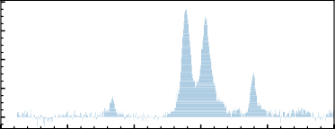80

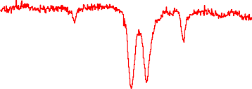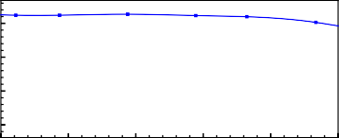

Relative Depletion [%]

4000

60

3000

Counts

40

2000 20

1000

300 350 400 450 500 550

0

300

350

400

450

500

550



Wavenumber [cm 1] (not calibrated) Wavenumber [cm 1]

(a)

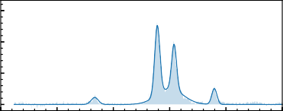15

Norm. Intensity

10

5

0

300 350 400 450 500 550

Wavenumber [cm 1]

(b)

(c)

Figure 2.6.: Data processing (for Ne-HC3N+ IRPD spectrum using FELIX): (a) is the raw data obtained by directly measuring the depletion counts of formed complex ions in IRPD schemes at varying frequencies. The blue line corresponds to a possible baseline to account for ion count fluctuation. (b) is the first processed spectrum with baseline correction from (a). (c) is the final normalised spectrum (see text) and the solid line corresponds to fitting the spectrum with a multi- component Gaussian function.

**Baseline correction:** The formed ion complex is monitored and counted in the IRPD experiments reported in this thesis. Figure 2.6a shows the measured raw data. Each data point is typically an average of 4 iterations. This spectrum should be baseline corrected for ion count fluctuation. Since even slight changes in the experimental condition, such as temperature, number density, and change in tagging efficiency due to laser heating, etc., can induce a non-linear shift in an otherwise constant background signal. As shown in Figure 2.6a, the solid blue line is the constructed baseline via a cubic spline interpolation and can be man-

1<https://felion-docs.vercel.app/>

ually adjusted. In addition to baseline correction, the raw spectrum needs to be frequency calibrated against the actual frequency output from the radiation source, i.e., using a grating spectrum analyser (FELIX) and manual wavenumber corrections based on a wavemeter (HighFinesse WS - Series) reading (OPO/A system).

**2**

**Normalisation and fitting:** Initially, baseline corrected data is a relative depletion (*D*) of complex ions and is given by:

*D* 1 *NON* (*ν*)

= −

*NOFF*

where *NOF F* is the baseline value and *NON* (*ν*) is the depleted value of the number of complex ions that are observed upon resonant vibrational excitation as shown in Figure 2.6b.

To account for variations of the laser pulse energy *E* , pulse number *n*, and for saturation effects, the signal is normalised (*I* ) as given below:

*I* [per J] −*ln*(*NON* (*ν*)/*NOF F* )

=

*E* [in J]

where *I* is the intensity in units of relative cross-section per Joule.

One can obtain a relative cross-section per photon by multiplying *I* with the wavenumber. Figure 2.6c shows the final normalised spectrum. The measurements are repeated in the same frequency range for averaging, i.e., the final spectrum is obtained by averaging using statistical binning with a typical bin size of 1.5-2 cm−1 of all normalised data. Line parameters such as band positions, intensities, and line widths (fwhm) are then obtained with statistical errors by fitting a multi-component Gaussian function to the experimental data. Figure 2.6c shows the final normalised spectrum.

* 1. ROTATIONAL SPECTROSCOPY
     1. Experimental method

The ROSAA action spectroscopic technique is employed in this work to record pure rotational transitions. In this section, we shall discuss this technique in detail.

Initially, the primary target molecular ions are produced from an ion source (see Section 2.1.1) by electron ionization from a neutral precursor using either storage or non-storage ion sources. A short pulse of the isolated molecular ion of interest is injected into the trap and stored for a specified time, typically

∼ 600 ms for rotational action spectroscopic experiments, with continuous

inflow of either pure He or He:Ne mixture buffer gas for collisional cooling and complex formation. At low temperatures (around 5-6 K and 6-15 K trap ambient temperature for helium and neon tag, respectively) and high number density

∼ 1014 cm−3 of gas inflow, the buffer gas atoms will readily attach to the target ion by ternary association and can dissociate by collision-induced dissociation.

**2**

The ROSAA technique utilises the change in the rare gas atoms’ attachment rate to a molecular ion (M+) depending on its internal excitation, i.e., ions with a specific rotational quantum number *J* have different attachment rate coefficients for forming HeM+ clusters with Helium (see Section 2.3.5). The ternary association and collision-induced dissociation rate coefficients can be experimentally measured by following corresponding reactants and products ion counts as a function of trap time. These rate coefficients are a weighted averaged rate coefficient over the thermal population of rotational levels, i.e., the Boltzmann distribution close to the nominal trap temperature, reached by He collisional excitation rates of the order of ∼ 104 s−1 at the typical number densities (∼ 1014 cm−3) used in these experiments. Upon resonant excitation, the thermal equilibrium distribution is disturbed by competing radiative processes (typically with comparable rates of ∼ 105 s−1 for the M+ rotational transitions), leading to a change in the attachment rate and thus the number of formed complexes. Hence, the measured signal intensity (*S*) is given as the observed change (in %) of the number of He-M+ complexes formed between the set frequency (*ION* ) and a fixed reference frequency (*IOF F* , offset about 3 ∼ GHz from scanning range), and scaled by *IOF F* , i.e., *S* = (*IOF F* − *ION* )/*IOF F* , after storing for a fixed time of typically ∼ 600 ms in the trap at each data point (see Sections 2.3.2 and 2.3.3 for radiation source details). The spectra are measured in typically 10 ∼ kHz steps.

* + 1. THZ RADIATION SOURCE

A continuous wave Signal Generator Extension (SGX) Module (VDI - Virginia Diode, Inc. WR9.0-SGX) has been used to measure pure rotational transitions of molecular ions. The SGX covers the frequency range from 82.5 - 1100 GHz using different frequency doubler or tripler combinations. Table 2.1 provides the configurations used in this thesis. The microwave signal generator (R&S ® SMB100A up to 40 GHz) drives the SGX and is disciplined by an atomic clock (Stanford Research Systems - FS740), such that the intrinsic radiation linewidths are better than 1 kHz, and the relative frequency accuracy is specified to be better than 1·10−13. The WR9.0 SGX was placed directly in front of a ∼ 0.6 mm thick CVD diamond window (Diamond Materials GmbH) with a conical/diagonal horn antenna and directed into the trap region. Figure 2.7 shows the power output measured using a high sensitivity thermal sensor (3A-P-THz Ophir photonics)

for configuration WR9.0 and WR2.2 SGX.

Table 2.1.: WR9.0M-SGX configuration details at standard RF input mode. Designation Frequency [GHz] Configuration N*

**2**

|  |  |  |  |
| --- | --- | --- | --- |
| WR9.0 | 82.5-125 | WR9.0SGX | 9 |
| WR4.3 | 170-250 | WR9.0SGX + WR4.3X2 | 18 |
| WR2.2 | 340-500 | WR9.0SGX + WR4.3X2 + WR2.2X2 | 36 |

* N indicates the multiplier for signal generator (R&S ® SMB100A) frequen- cies.

27.50

25.00

Power [mW]

22.50

20.00

17.50

0.35

0.30

Power [mW]

0.25

0.20

15.00 0.15

12.50

80 90 100 110 120

Frequency [GHz]

320 360 400 440 480

Frequency [GHz]

(a) WR9.0 (b) WR2.2

Figure 2.7.: Power curves measured with Virginia Diodes, Inc. (VDI) WR9.0 Modular SGX Modules in (a) WR9.0 and (b) WR2.2 configuration as described in Table 2.1.

The maximum radiation output power can be regulated using “User Controlled Attenuation (UAC)”. The UCA voltage reduces the SGX module’s output power. Figure 2.8 shows the WR9.0 SGX module output power as a function of UAC voltage from 0 − 5 V using a DC power supply (0 V = no attenuation, 5 V = full attenuation). The maximum output power reaching the trap centre region is discussed in the following section 2.3.3.

19.54

19.52

Power [mW]

19.50

19.48

19.46

19.44

19.42

117.680 117.685 117.690 117.695 117.700

Frequency [GHz]

(a)

20.43

20.40

20.38

Power [mW]

20.35

20.32

20.30

20.27

118.090 118.095 118.100 118.105 118.110

Frequency [GHz]

(b)

20

15

Power [mW]

10

5

0

117 GHz

118 GHz

0 1 2 3 4 5

Attenuation [V]

(c)

**2**

Figure 2.8.: Power curves measured with Virginia Diodes, Inc. (VDI) WR9.0 Modular SGX Modules in WR9.0 configuration, for the frequency ranges (a) 117.68 − 117.70 GHz and (b) 118.09 − 118.11 GHz. (c)

shows the user-controlled attenuation power output for (a) and (b) as labelled 117 and 118 GHz, respectively.

* + 1. DETERMINING THE RADIATION POWER AT THE TRAP REGION

The radiation power reaching the trap region is determined by the geometry of the trap and the intensity profile of the laser beam. In this section, we discuss the estimation of the radiation power reaching the trap region for a given laser beam frequency and intensity profile.

**2**



2w0

ZA

Length

Figure 2.9.: Schematics of the nominal feed horn antenna are shown. Z*A* is defined as the location of the beam waist radius (w0) with respect to the horn aperture. The upward arrow (orange solid line) indicates the polarisation direction of the electric field.

The feed horn antenna’s electric field radiation emitted/propagated is shown in Figure 2.9. The propagation of the emitted Gaussian beam radius (*w*(*z*)) from a horn antenna is given by:

*w*(*z*) = *w*0 ∗

1. *z*

µ

¶

2

s +

*ZR*

(2.1)

where *ZR* is the Rayleigh length (or Rayleigh range) for Gaussian beams.

*ZR* is determined by the waist radius *w*0 and the wavelength (*λ*) as shown below:

0

*ZR* =

*π* · *w*2

*λ*

The Gaussian beam propagation simulation for a frequency ∆*ν* = 453 GHz is shown in Figure 2.10, using a diagonal horn antenna (VDI waveguide band WM-

4

CVD window bender

trap

2.39

1.89

3

w(z) : Beam waist radius [cm]

2

**2**

1

0

1

2

3

4

0 5 10 15 20 25

Beam Propagation [cm]

Figure 2.10.: Gaussian beam (for a frequency of *ν* = 453 GHz) propagation from a beam waist radius of 0.15 cm produced from diagonal feed horn antenna. The solid lines - orange and green indicates the position of FELion instrument entrance window (CVD diamond window, 3 cm from antenna, 2 cm aperture radius) and bender (10.4 cm from window, 0.43 cm aperture radius), 22-pole ion-trap (14 cm from window, 0.3 cm aperture radius). respectively.

570) of length, aperture diameter and beam waist radius of 36, 3.6 and 1.5 mm, respectively

As the Gaussian laser beam propagates, the waist radius increases in size and the corresponding intensity profile of the electric field is given by:

*I* (*r* ) = *I*0 · *exp*

−2

*r* 2

*w*(*z*)

(2.2)

2*P*

= *πw*(*z*)2 · *exp*

−2

*r* 2

*w*(*z*)

where *I*0 is the peak irradiance at the centre of the beam, r is the radial dis- tance away from the propagation axis, w(z) is the radius of the laser beam where the irradiance is 1/e2 (13.5%) of *I*0, z is the distance propagated from the plane where the wavefront is flat, and P is the total power of the beam.

Figure 2.11 shows the intensity profile using Eq. 2.2, when the beam waist

1.0 1.0

w(z) = 2.5 cm; r = 0.0 cm

19% of total power

w(z) = 2.5 cm; r = 1.5 cm

9% of total power

0.8 0.8

Intensity [W/cm2]

Intensity [W/cm2]

0.6 0.6

**2**

0.4 0.4

0.2 0.2

0.0 0.0

4 2 0 2 4

r [cm]

4 2 0 2 4

r [cm]

(a) (b)

Figure 2.11.: The radiation intensity profile distribution is shown in the blue line. The shaded orange region indicates the fraction of output power at a 3 cm beam radius, i.e., inside trap region as shown in Figure 2.10. The position of the orange region *w.r.t* the x-axis represents the part of the propagating Gaussian beam reaching the trap region when (a): aligned and (b): 1.5 cm offset *w.r.t* beam centre.

radius, *w*(*z*) = 2.5 cm, is at the trap entrance (see Figure 2.10). Since the ion-trap aperture diameter is 0.3 cm which is much narrower compared to the incoming beam radius (2.5 cm), one needs to consider an offset for the Gaussian beam centre reaching the trap centre. Therefore, the figure 2.2 also features the orange marked region, which indicates the actual power estimated to reach the trap depending on its alignment, *r* (*z*), *w.r.t* the propagating Gaussian beam centre, *r*0(*z*). If we assume that in our experiment, *r* (*z*) = 0 − 1.5 cm, then the final radiation power reaching the trap, for ∆*ν* = 453 GHz frequency is 9-19 % of the peak power (250 *µ*W), i.e., 35(12) *µ*W.

* + 1. DETERMINING THE COLLISIONAL ION TEMPERATURE

In the spectroscopic experiment to investigate pure rotational transitions, the ions are cooled down in the trap by collisions with a buffer gas atom such as He, Ne or He:Ne mixture. The collisional ion temperature (Tcoll), i.e., translational or kinetic temperature of the ions in the trap, which corresponds to mean collisional energy between the partners, thus the neutral buffer gas and the molecular ion, is an important factor to be determined especially for the models described in Section 2.3.5 . This temperature cannot be measured directly but can be estimated by:

T mHe · Tion +mion · THe

coll =

mHe +mion

(2.3)

where “m” is mass and “T” is temperature, and the subscript “He” and “ion” indicates the corresponding buffer gas atom used (helium in this case) and the molecular ion of interest, respectively. The nominal trap temperature measured is assumed to be THe. However, it has to be noted that the ion temperature (Tion) is often higher than the nominal trap temperature [126]. Furthermore, Tion can be measured via the Doppler width estimated from the recorded full-width half maxima (FWHM) of a rotational transition at a given power. The measured rotational line profile corresponds to the Voigt profile, which is a convolution of a Gaussian profile (due to the kinetic energy distribution of the ions) and a Lorentzian profile (caused by power broadening). The FWHM of the Gaussian ( *fG* ) and Lorentzian ( *fL*) profile can be derived as follows:

**2**

*fG* = *ν* · ; 8 · k*b* · T*ion* · ln(2) = C*G* · ✓T*ion* (2.4) where *ν* corresponds to the central line frequency of the profile and C*G* is the

m*ion* · *c*2

Doppler proportionality constant, and by:

I2

*fL* = 2 · *π* · Ω*R*

substituting angular Rabi frequency of the transition, which is defined as, Ω*R* =

*µ*·E 2, we get

ℏ

*f* = I2 · *µ* · E

*L*

1. · *π* ℏ

= J

Substituting electric field strength, E 2·*I*

*c*·*ϵ*0

where *I* is the intrinsic intensity

*I* = 1 · *c* · *ϵ*0 · E2 = *P* , we get the final expression for Lorentian FWHM, f*L*:

2 *Atrap*

2 · *µ* ; *P*

*f* = = *C* · I*P* (2.5)

*L P*

*h Atr ap* · *c* · *ϵ*0

where *P* is the output radiation power in W, *Atr ap* = 5 · 10−5cm2 is the trap area and *CP* is a power-broadening proportionality constant.

2*µ* is transition dipole moment, and E is the electric field, hence dividing the energy term (*µ* · E) by ℏ gives angular frequency

The Voigt profile is given by:

*V* (*x*; *σ*, *γ*) = *Re*[*w*(*z*)]

**2**

*σ*I2*π*

(2.6)

where *σ* is the standard deviation in Gaussian profile, *γ* is the half-width half maxima of Lorentzian profile and *Re*[*w*(*z*)] is the real part of the Faddeeva function.

*fG*

*σ* = 2I2 · *ln*(2) (2.7)

*fL*

*γ* = 2 (2.8)

*x iγ σ*I2

*z* = +

The FWHM of Voigt profile can be approximated with an accuracy of 0.02% by [128]:

*fV* = 0.5346 · *fL* +J0.2166 · *f* 2 + *f* 2

*L*

*G*

(2.9)

To determine Tion, the experimentally measured rotational spectrum is fitted with the Voigt profile (Eq. 2.6); subsequently, line parameters *σ* and *γ* are obtained. Using *σ*, one can compute *fG* using Eq. 2.7 and finally, Tion from *fG* using Eq. 2.4.

* + 1. NUMERICAL SIMULATION

The ROSAA action spectroscopic technique, as described in Section 2.3.1 utilises the change in attachment rate of rotation-specific energy levels to record the pure rotational spectrum. As depicted in Figure 2.12 there are several competing processes involved in affecting the molecular ions population distribution on different rotational levels, and consequently affecting the obtained signal intensity. Therefore, in this section, we discuss a kinetic numerical model approach to understanding the ROSAA signal intensity.

* + - 1. COLLISIONAL PROCESS ((*R* ))

As hot molecular ions (M+) enter the trap (typical ambient trap temperature

∼ 4.5 K) from the ion source (room temperature, 300 K or higher), they are collisionally cooled down by buffer gas atoms. The population distribution of rotational levels reaches a new equilibrium corresponding to the kinetic/collisional temperature (*Tcoll* ) of the system, which can be derived from

J higher rot. states

**2**

0

*k*3 1

M+ + 2He

He – M+ + He

CID1

*k*JJ’[He]

1

*k*3 (1) [He]2

1

*R*B 01

*R*B

*k* [He]

01

10

A10

*k*10[He]

*k* (0) [He]2

0

3

1

*k*CID [He]

1

*k*3 [He]2

2

M+ + 2He

*k*CID 2[He]

He – M+

He2 –M+

-300

E [cm-1]

Figure 2.12.: Schematic kinetic model of the ROSAA action spectroscopic technique. The coloured labels and arrows indicate several competing processes for the reaction between the molecular ion M+ and the neutral He atom. The typical rates for collisional (blue) and radiative process (red) are in the range of 104 −105 s−1, effective binary complex formation (orange) is > 0.01 s−1 and the collision- induced dissociation (violet) is > 0.1 s−1 at a given number density of > 1 · 1014 cm−3. The spontaneous emission is labelled A10, and rates are typically in order of > 10−4 s−1. Figure adapted from Brünken *et al.* [65].

the ion temperature (*Tion*) as described in Section 2.3.4. The rotational level- specific population ratio is given by:

*d Mi*+ *dt*

Ã !

*coll* .

= *Rf i f* ̸=*i*

* *M f*+ − *Ri f*
* *Mi*+

(2.10)

where *i* and *f* represents rotational states with rotational quantum numbers J= i, f, *i f* indicates initial |*i* 〉 state transitions into final | *f* 〉 state and *Ri f* corresponds to collisional rates [s−1] for *f i* transition and given by

X

*Ri f* = *ki f* · [*He*]

where *ki f* and [*He*] indicate collisional rate coefficients and buffer gas (gener- ally He gas) number density, respectively.

**2**

The rate coefficients can be derived from a quantum dynamical investigation using a closed coupling *M* +−He rotational cross-section calculation method within a rigid body approach. However, in this study, no such investigations have been undertaken; the rate coefficient values (*ki f* ) have been retrieved from the available literature. The fundamental detailed balancing relation is given as:

*ki f*

*kf i*

*Gf*

= *Gi e*

∆*E* /(*kB T* )

(2.11)

where *gi* indicates statistical weight of corresponding |*i* 〉 state (*GJ* = 2*J* + 1), *kB* is the Boltzmann constant, *T* is the temperature of the system, and ∆*E* is the difference between final state energy (*ϵf* ) and initial state (*ϵf* ) energy, i.e.:

∆*E* = *ϵf* − *ϵi*

At a given *T* (actually *Tcoll* ), if only the collisional process is involved, solving equation 2.10, equilibrium values are reached typically in few 100 ∼ *µ*s at [*He*] ∼ 1014 cm−3leading to a distribution equal to the Boltzmann population at *T* , i.e.:

+ *Gi* · *eϵi* /(*kB T* ) *Gi* · *eϵi* /(*kB T* )

*Mi* = *N*

L

*G*

*j* =1 *j*

* *eϵj* /(*kB T* ) =

*Z* (2.12)

where *N* is the given system’s total number of accessible rotational quantum levels, and *Z* is the molecular partition function.

* + - 1. SPONTANEOUS EMISSION ( *A* )

It is the process in which a quantum mechanical system transits from an excited energy state to a lower lying energy state (e.g., its ground state) and emits a quantized amount of energy in the form of a photon. An initial state |*i* 〉 with energy *ϵi* can decay to a final state | *f* 〉 with energy *ϵf* via spontaneous emission of a photon with frequency (∆*ν*). The Einstein A-coefficient gives the spontaneous emission rate [in photons per s]:

2*ν*3

*Af i* = 3*ϵ*0*hc*3 · *µf i*

where *ϵ*0, *h*, *c* and *µf i* are vacuum permittivity, Planck’s constant, speed of light and transition dipole moment, respectively. Including this emission process into Equation 2.10 gives us the following relations:

*d Mi*+

*dt coll* .+*Spont* .

*d M f*+

= *d Mi*+

*d Mi*+

*dt*

*coll*

+ *Af i*

(2.13)

**2**

*dt* =

*coll* .+*Spont* .

*dt coll*

− *Af i* (2.14)

The spontaneous rates are derived from the effective Hamiltonian fitting of a given molecular species using a program such as Pgopger [129]. Typically, spontaneous emission rates are in the order of 10−4 s−1which are smaller than collisional rates (103 − 105 s−1) at high number density (> 1014 cm−3). Since the collisional processes dominate the spontaneous emission rates, for simplicity, the label *coll* . + *Spont* . will just be referred as *coll* ..

* + - 1. RADIATIVE PROCESS (*RB* )

In the presence of radiation, the population is re-distributed again due to stimulated absorption (*Bi f* ) and emission (*Bf i* ), described by the Einstein- B-coefficients. Both absorption and emission coefficients [m3J−1s−2] can be derived from corresponding Einstein A-coefficient (*Af i* ):

*c*3

*Bf i* = 8*πhν*3 · *Af i*

*Gf*

*Bi f* = *Gi* · *Bf i*

The rate of stimulated absorption, *RB* [in s−1], is given by:

*i f*

*RBf i*

*P*

= *Bf i* · *Atrap* · *c* · V(*x*; *σ*, *γ*)

where *Atr ap* = 5·10−5 m2 indicates the area of 22-pole ion-trap, P corresponds to radiation power [in J· s−1], and V(*x*; *σ*, *γ*) corresponds to Voigt profile lineshape (Eq. 2.6) for the rotation transition profile (x) with central frequency ∆*ν*.

Including the radiative process in Equation 2.13 gives us the following rate equation:

*d Mi*+ *dt*

*coll* .+*Rad* .

*d Mi*+

*dt coll* .

=

− *RBi f*

* *Mi*+ + *R*

*Bf i*

* *M f*+

(2.15)

**2**

* + - 1. ATTACHMENT AND DISSOCIATION PROCESS (*R*3 AND *RC ID* )

The ternary association (*R*3) and collision-induced dissociation (*RC ID* ) rates [s−1] should also be included to complete the kinetic model scheme as shown in Figure 2.12 (read Section 6.3 for more detail on attachment process). The attachment process rates can be experimentally derived but only as a weighted average of all rotational population levels for a given molecular ion of interest (M+). However, a rotational-specific rate is required for numerical simulation. The ratio of formation rate coefficients for the undergoing transitions is called *k*31 ratio and will be referred to as “*a*”:

*a k*31 ( *f* )

=

*k*31 (*i* )

(2.16)

The final master equation for numerical simulation of ROSAA technique involving *Coll* . + *Rad* . + *Att* . for rotational transition from ground state |*i* 〉 to excited state | *f* 〉, and *M* + 2He attachment process is given by:

*d Mi*+ *dt*

*d M f*+

*coll* .+*Att* .+*Rad* .

= *d Mi*+

*d M f*+

*dt*

*coll* .+*Rad* .

− *R*31

′

* *Mi*+ + *R*

+

*C ID*1

* He*M* + · *p*

+

*dt* =

*coll* .+*Att* .+*Rad* .

*dt*

*coll* .+*Rad* .

− *R*31 · *Mf* + *RC ID*1 · He*M*

· (1 − *p*)

where *R*31 and *R*′

31

correspond to state-dependent first-complex formation

rates for ground and excited state, respectively. These rates can be expressed in terms of corresponding rate coefficients (*k*) (read Section 6.3 for more detail). “*p*” represents the collision-induced dissociation (CID) branching-ratio, *i.e.,* the ratio of population transitions back to ground state from first complex (He*M* +) via CID process.

The rate equations for the formation of the first two complex ions are given below (higher-order complexes can be treated accordingly):

*d* He*M* +

*dt* =+ *R*31

+ *R*

′

31

* *Mi*+ − *RC ID*1
* *M* + − *RC ID*

*f*

1

* He*M* + · *p*
* He*M* + · (1 − *p*)

**2**

− *R*32 · He*M* + + *RC ID*2 · He2*M* +

*d* He2*M* +

*dt* = +*R*32

* He*M* + − *RC ID*2
* He2*M* +
  + - 1. SOLVING RATE EQUATIONS

The processes involved in these numerical simulations are in widely varying timescales, as will be discussed in the corresponding chapters (see Chapter 6 and 7). These rate equations are known as “stiff equations”. A stiff equation is a differential equation for which specific numerical methods (explicit) for solving the equation are numerically unstable unless the step size is taken to be extremely small [130]. Therefore all of the ODEs discussed in this section are solved using the implicit Runge-Kutta method of the Radau IIA family of order 5

[131] using SciPy library [132].

* 1. THEORETICAL METHODS

In this study, the vibrational and rotational spectroscopic investigations are sup- ported and complemented by quantum chemical calculations. Therefore, this section briefly describes the quantum theory of molecular vibration and rotation using a quantum mechanical approach.

In classical mechanics, the system’s total energy, which includes kinetic (*T* ) and potential (*V* ) energy, is known as the Hamiltonian (*H* ), such that

*H* = *T* + *V* (2.17)

Schrödinger postulated the form of Hamiltonian (operator) in quantum mechanics, as given below

ℏ2 2

*H* = − 2*m* ∇ + *V* (*r* ) (2.18)

where *m* is mass, *r* represent the coordinates, ∇2 is the Laplacian operate, and the corresponding Schrödinger wave equation using *ψ*, the wavefunction of the quantum state:

*Hψ*(*r*, *t* ) *i* ℏ B*ψ*(*r*, *t*)

=

B*t*

(2.19)

One can derive a final time-independent Schorödinger equation by substitut- ing Eq. 2.18 in Eq. 2.19

*Hψ*(*r* ) = *Eψ*(*r* ) (2.20)

**2**

where *E* is the eigenvalue of operator *H* , corresponding to the system’s total energy.

In quantum mechanics, any molecular state can be fully described by a num- ber of different degrees of freedom, each of which has a corresponding coordi- nate system. In three dimensions, there is the rotational and vibrational motion of the nuclei and the motion of the electrons. Nuclear and electron spin variables could also exist.

A fundamental idea underlying the description of the quantum states of molecules is the Born-Oppenheimer (BO) approximation [133], i.e., the nuclei’s (*N* ) motion and electrons’ motion can be separated since nuclei are much heavier than the electrons. Under BO approximation, the total wavefunction (*ψ*) of the molecular system is separable into nuclear (*ψn*) and electronic (*ψe* ) parts, that is

*ψ* = *ψn*(*R*)*ψe* (*r*, *R*)

where *R* represents an inter-nuclear separation coordinate for each pair of atoms and *r* represents the internal coordinates.

The wave function *ψN* can be further factorized into a vibrational (*ψv* ) and rotational (*ψr* ) part:

so that

*ψn* = *ψv ψr*

*ψ* = *ψv ψr ψe*

The total energy (*E* ) of the system corresponds to the sum of the contributions from vibrational, rotational and electronic parts, as given below:

*E* = *Ev* + *Er* + *Ee*

If the molecule possesses net nuclear or electron spin, it is added and factorised to *E* and *ψ*, respectively.

However, the BO approximation does not hold true in all cases. For example, the coupling between electronic and vibrational modes (Renner-Teller effect, vibronic coupling) is observed for open-shell linear molecular systems (see chapter 5 for treatment of this case).

* + 1. MOLECULAR VIBRATION

A simple ball and spring harmonic oscillator model from classical mechanics can explain molecular vibrations. However, principles from quantum mechanics are required to describe vibrational energy levels and transitions between them.

**2**

Atoms are the basic unit of molecules, and covalent bonds hold them together. The distance between atoms or the length of chemical bonds is not fixed. Therefore, molecules can vibrate when excited to a higher energy state by absorbing a resonant photon of electromagnetic radiation in the infrared region.

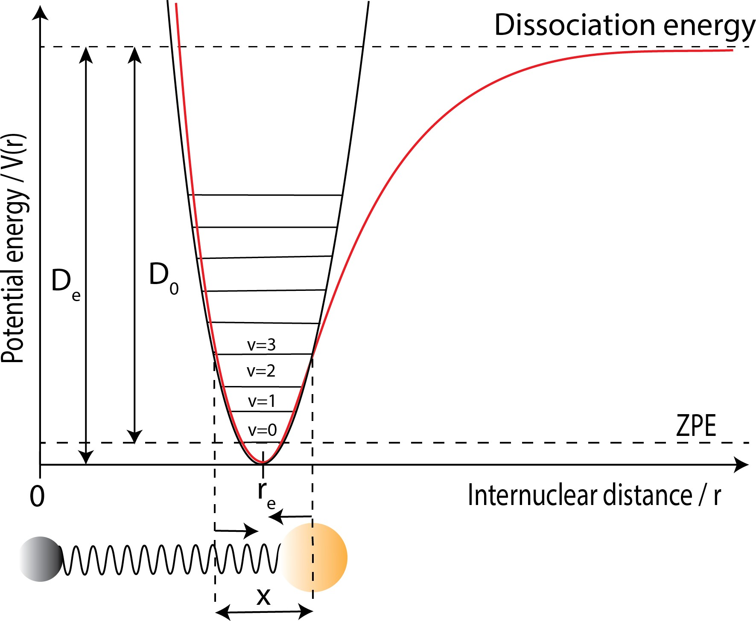

Figure 2.13.: Heteronuclear diatomic molecule (solid circles at the bottom) vibrating at energy level *v* = 3. The black and red curve represent harmonic and anharmonic (Morse) potential energy curves, respectively. *re* is the equilibrium bond length, *D*0 and *De* correspond to dissociation energy with and without ZPE (zero-point energy) correction, respectively.

* + - 1. DIATOMIC MOLECULES

Assuming a simple ball and spring harmonic oscillator model as shown in Figure

2.13 gives us the potential energy (*V* ) from Hooke’s law:

Restoring force = − *dV* (*x*) = −*kx*

*dx*

where *x* = *r* − *re* and *k* is force constant:

*V* (*x*) 1 *kx*2 (2.21)

=

2

Substituting, equation 2.21 in equations 2.18 and 2.20, we get the Schrödinger equation for 1D-oscillator:

**2**

ℏ2 *d*

1 2

− 2*µ dx*2 + 2 *kx*

where *µ* is the reduced mass.

*ψv* (*x*) = *Ev ψv* (*x*) (2.22)

Equation 2.22 can be solved to obtain *Ev* as given below:

*Ev* = *v* + 1 *h*v = *v* + 1 *hcω* (2.23)

2

2

where v is classical vibrational frequency, v = 1 *k* )1/2, *ω* is vibrational

2*π*

*µ*

wavenumber, the vibrational quantum number is *v* = 0, 1, 2, ... .

Equation 2.23 shows that under the harmonic approximation, the vibrational quantum levels are equally spaced by ℏ*ω* and the zero-point energy (ZPE) is *Ev* (*v* = 0) = 1 ℏ*ω*. As shown in Figure 2.13, the ZPE is the minimum energy the molecule may have even at absolute zero temperature.

2

The energy terms are usually referred to in wavenumbers [cm−1], so we can write Eq. 2.23 as:

*Ev ω v hc*

=

+ 1

= *G*(*v*) (2.24)

where *G*(*v*) is the vibrational term value in dimensions of wavenumber, cm−1. As shown in Figure 2.13, depicting the Morse *V* (*r* ) curve, the actual diatomic molecule is not accurately harmonic, especially when *r* ≫ *re* . To account for anharmonicity, the harmonic oscillator term value are modified to a power series

2

in ¡*v* + 1 ¢:

2

*G*(*v*) = *ωe*

*v* + 1

− *ωe xe*

1 2

*v* + 2

+ *ωe ye*

1 3

*v* + 2

+...

where *ωe* is the vibration wavenumber that a classical oscillator would have for an infinitesimal displacement from equilibrium. *ωe xe* , *ωe ye* , ... are the anharmonic constants.

2

To determine, say *ωe* and *ωe xe* , at least two transition wavenumbers must be obtained such as *G*(1) − *G*(0) = *ω*0 and *G*(2) − *G*(1) = *ω*1. The dissociation energy *De* is given approximately (since including only *ωe xe* anharmonic term) by:

*ω*2

*D*  *e*

*e* ≃

4*ωe xe*

* + - 1. POLYATOMIC MOLECULES

**2**

The vibrational modes of an *N* -atomic molecule are give by 3*N* − 5 and 3*N* − 6 normal vibration modes for linear and non-linear configuration, respectively.

Polyatomic vibrational modes are much more complicated to treat theoreti- cally than diatomic. As shown in Figure 2.14, a simple ball-spring model with 3- atoms (H2O), even if one of the nuclei is given a sudden displacement, the whole system undergoes very complicated vibrational motions (bending and stretch- ing); this is known as Lissajous motion. For H2O, we get 3(3)−6 = 3 normal modes of vibrations (*v*1 −*v*3). In general, a normal vibration mode is one in which all the nuclei undergo in-phase harmonic motion with the same frequency but typically with different amplitude.

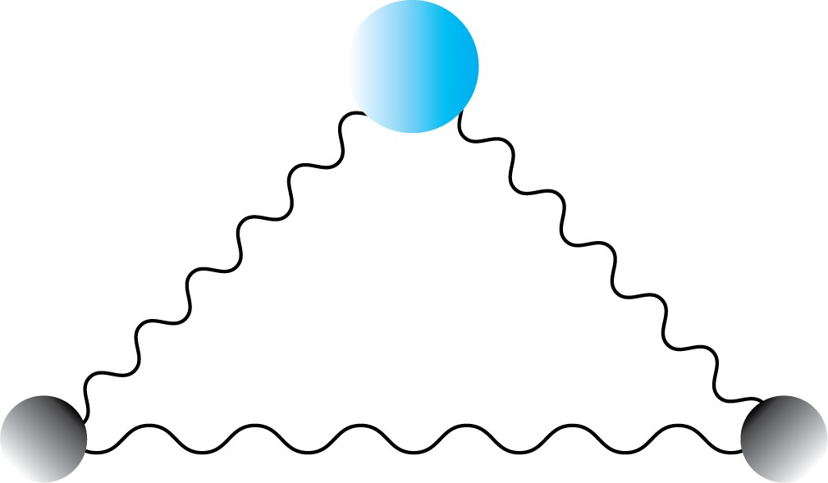

Figure 2.14.: Triatomic molecule (H2O) ball-spring representation. The blue and grey circle represents oxygen and hydrogen, respectively.

In polyatomic molecules, each vibrational mode can be approximated to a normal vibrational mode. With an analogous approximation from diatomic, the vibrational term value *G*(*vi* ) associated with each normal vibration *i* , is given by:

*G*(*vi* ) = *ωi* *vi* + *di*

2

where *di* represents the degree of degeneracy.

* + - 1. SELECTION RULES

When two vibrational states undergo absorption or emission transitions, there is usually an interaction between the molecule and the electric component of

electromagnetic radiation. Therefore, the electric dipole moment (⃗*µ*) determines the selection rule for vibrational transitions in the infrared spectrum.

The vibrational transition intensity is proportional to |*Rv* |2, the square of the

vibrational transition moment *Rv* , defined by:

**2**

*Rv* = *ψ*′⃗*µψ*′′*dτv* (2.25)

where *ψ*′′ and *ψ*′ are initial and final vibrational wavefunctions, respectively. A transition is only allowed if the transition dipole integral is non-zero, i.e.:

*Rv* = 0 forbidden transition

*Rv* ̸= 0 allowed transition

For diatomic molecules, within the harmonic approximation, *Rv* is non-zero only when ∆*v* = ±1. Anharmonicity can lead to ∆*v* = ±2, ±3,..., overtone transitions but they are generally weak.

In general, there are simple requirements for the integral of Eq. 2.25 to be non- zero; they are as follows.

When both *ψ*′′ and *ψ*′ are non-degenerate, the symmetry species of the quantity to be integrated should be totally symmetric; that is:

Γ(*ψ*′ ) ⊗ Γ(⃗*µ*) ⊗ Γ(*ψ*′′ ) = *A*

where *A* denotes the totally symmetric species of any non-degenerate point group, and Γ stands for symmetry representation.

For degenerate states:

Γ(*ψ*′ ) ⊗ Γ(⃗*µ*) ⊗ Γ(*ψ*′′ ) ⊃ *A*

A brief overview of molecular vibration for diatomic and polyatomic molecules has been discussed, along with the selection rule for observing IR active vibrational transition modes using quantum mechanics. The following section deals with the quantum mechanical theory of molecular rotation.

* + 1. MOLECULAR ROTATION

Molecules have electronic and vibrational energy due to the motion of electrons and nuclei, respectively. Furthermore, they have rotational energy due to the overall rotation of the molecule. Like electronic and vibrational, rotational energy is quantized and generally has very small energies compared to the former.

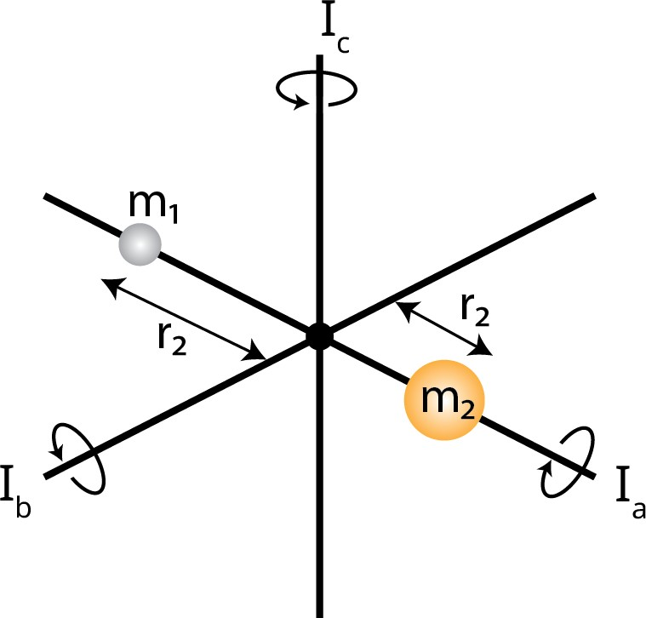

Figure 2.15.: Rotation of linear molecule (heteronuclear diatomic) w.r.t principal rotational axis *a*, *b* and *c*, with corresponding moment of inertia *Ia*, *Ib* and *Ic* , respectively (*Ia*=0, *Ib*=*Ic* for linear and diatomic molecules). *m* and *r* represent the mass of the atom and the distance to the rotating axis, respectively. The centre of mass lies at the origin.

**2**

The molecules are classified according to their principal moments of inertia, *Ia*, *Ib* and *Ic* , i.e., the moment of inertia along the principal rotational axis *a*, *b* and *c*, respectively. The corresponding rotational constants are denoted as *A*, *B* and *C* , respectively. The principal axes are perpendicular to each other and pass through the molecule’s centre of mass (as shown in Figure 2.15). In general, the axes are conventionally defined such that:

*Ia* ≤ *Ib* ≤ *Ic* (2.26)

The moment of inertia, *I* , is defined as

*I* = *mi r* 2

*i*

(2.27)

*i*

where *mi* and *ri* correspond to mass and distance to the rotating principal axis of atom *i* , respectively.

The main classifications are linear and non-linear molecules, while the latter is further divided, as will be briefly discussed in the following sections.

* + - 1. LINEAR MOLECULES

With a rigid rotor approximation, i.e., the bonds are rigid rods and molecule as a rigid rotor, the angular momentum is given by:

1

*PJ* = [*J* (*J* + 1)] 2 ℏ

where the rotational number *J* = 0, 1, 2, 3, ... .

In the presence of an electric or magnetic field,

**2**

(*PJ* )*z* = *MJ* ℏ (2.28)

where, subscript *z* represent z-axis component and *MJ* = *J* , *J* − 1, ..., −*J* . This indicates that in the absence of an electric or magnetic field, each rotational level has 2*J* + 1 degenerate states.

The rotational energy (*Er* ) for a diatomic or linear polyatomic molecule can be solved using Eq. 2.20 and is given by:

*h*2

*Er* = 8*π*2*I*

*b*

*J* (*J* + 1) (2.29)

The rotational energy in frequencies [Hz] can be defined using Eq. 2.29:

*F* (*J* ) = *Er* = *h J* (*J* + 1) = *B J* (*J* + 1) (2.30)

*h* 8*π*2*Ib*

where *F* (*J* ) is the rotational term values and *B* is the rotational constant.

Only *B* rotational constants are involved for linear molecules since as shown in Figure 2.15, *Ia* = 0 and *Ib* = *Ic* .

The rigid rotor approximation does not hold true, especially in higher *J* energy levels, because the chemical bonds expand due to centrifugal forces from molecular rotation. The expansion due to centrifugal force is included in equation 2.30 such that

*F* (*J* ) = *B J* (*J* + 1) − *DJ* 2(*J* + 1)2 +... (2.31)

where *D* is the centrifugal distortion constant. Eq. 2.31 also indicates that further higher-order terms may be included.

* + - 1. NON-LINEAR MOLECULES

The non-linear molecules are further classified based on the principal moment of inertia. Analogous to *B* rotational constant for linear molecule (Eq. 2.30), the rotational constants *A*, *B* and *C* are given by:

*A* = *h* ; *B* = *h* ; *C* = *h*

(2.32)

8*π*2*Ia*

8*π*2*Ib*

8*π*2*Ic*

with units of frequency [Hz].

**Symmetric top:** It has two equal principal moments of inertia which corresponds to two possibilities: (a) *Ia* < *Ib* = *Ic* and (b) *Ia* = *Ib* < *Ic* , these are called prolate and oblate, respectively. In symmetric tops, a second rotational quantum number *K* = 0, 1, 2, ..., *J* . is introduced in addition to *J* ; therefore, Eq.

**2**

2.30 becomes

*F* (*J* , *K* ) = *B J* (*J* + 1) +(*A* − *B* )*K* 2 (prolate) (2.33)

*F* (*J* , *K* ) = *B J* (*J* + 1) +(*C* − *B* )*K* 2 (oblate) (2.34)

The equations 2.33 and 2.34 indicate that for a particular value of *J* , the energy levels diverge and converge for a prolate and oblate symmetric tops, respectively. Since from Eq. 2.26 and 2.32, we have *A* ≥ *B* ≥ *C* .

When the effect of centrifugal distortion is included, Eq. 2.31 becomes (for prolate),

*F* (*J* , *K* ) = *B J* (*J* + 1) +(*A* − *B* )*K* 2 − *DJ J* 2(*J* + 1)2 − *DJK J* (*J* + 1)*K* 2 − *DK K* 4 (2.35)

where there are now three centrifugal constants *DJ* , *DJK* and *DK* .

**Spherical top:** It has all three principal moments of inertia equal, i.e., *Ia* = *Ib* = *Ic* . Therefore, the rotational term value follows the same as the equa- tion for diatomic or linear polyatomic 2.30 and 2.31 (Section 2.4.2.1).

**Asymmetric top:** It has all three principal moments of inertia unequal, i.e., *Ia* ̸= *Ib* ̸= *Ic* . Generally, the vast majority of molecules are asymmetric tops. But unfortunately, there are no analytical formulae for rotational term values for asymmetric tops molecules. *J* is still a good quantum number, but *K* is not, i.e., it does not take integral values. Therefore, only approximate expressions are derived, i.e., to approximate the molecule to either prolate or oblate near- symmetry top, such as:

*F* (*J* , *K* ) ≃ *B* ∗ *J* (*J* + 1) −(*A* − *B* ∗)*K* 2 (near-prolate)

*F* (*J* , *K* ) ≃ *B* ∗ *J* (*J* + 1) −(*C* − *B* ∗)*K* 2 (near-oblate)

where *B* ∗ is equal to 1 (*B* +*C* ) for prolate and 1 (*A* +*C* ) for oblate rotor.

2

2

Since *K* is not strictly a good quantum number and the *F* (*J* , *K* ) is only approximated.

* + - 1. SELECTION RULES

Similar to the vibrational selection rule as discussed in Section 2.4.1.3, the rotational selection rule is determined from the rotational transition moment, *Rr* , defined as:

**2**

*Rr* = *ψ*′ ⃗*µψ*′′

*r*

The rotational selection rule constitutes the condition for which *Rr* is non- zero.

The selection rule:

for linear molecules and spherical top

1. ∆*J* = ±1

for symmetric top

1. ∆*J* = ±1
2. ∆*K* = 0

for the asymmetric top

1. ∆*J* = 0, ±1

In addition to the above rules, all molecules must have a permanent electric dipole moment (⃗*µ* ̸= 0) to observe rotational transition, and in the presence of the electric or magnetic field ∆*M* = 0, ±1 (see Eq. 2.28).

The next section discusses relevant technical details for quantum chemical calculation employed in this thesis work.

* + 1. QUANTUM CHEMICAL CALCULATIONS

The molecular vibration and rotation laboratory spectroscopic studies reported in this work are supported by quantum chemical calculations as described in Section 2.4.1 and 2.4.2. This section briefly discusses the methods and programs used to employ quantum chemical calculations.

Initially, a potential energy surface is computed to characterize the molecular ion of interest, and energetically stable structures are derived and structurally optimised. These investigations are performed at the coupled-cluster singles

and doubles (CCSD) level augmented by a perturbative treatment of triple excitations, CCSD(T) [134], in combination with atomic natural orbital (ANO0, ANO1, and ANO2) basis sets from Almlöf and Taylor [135, 136] as well as the correlation-consistent valence basis set cc-pVDZ [137] in the frozen core (fc) approximation. The equilibrium geometries have been calculated using analytic gradient techniques [138].

**2**

Vibrational modes of molecular ions of interest are further investigated by computing harmonic frequencies using numerical differentiation of gradients [139, 140]. Second-order vibrational perturbation theory (VPT2) [141] has been employed for anharmonic calculations. All CCSD(T) calculations have been carried out using the CFOUR program package [142, 143].

The influence of the rare gas tag on the IRPD spectrum is further investigated by computing interaction energies (using either CFOUR [142] or PSI4 [144] program) as well as harmonic frequencies of the ionic complexes. For the complexes, the Basis Set Superposition Errors (BSSE) [145] are addressed using

i) the counter-poise (CP) method introduced by Boys and Bernardi [146], i.e. by calculating CP-corrected CCSD(T) interaction energies at each geometry, and ii) higher-order symmetry-adapted perturbation theory, SAPT2+3 [147, 148].

Measured pure rotational and vibrational transitions (see Chapter 7) are fitted with an effective Hamiltonian approach using the Pgopher program [129] to derive molecular spectroscopic constants. Further computational details specific to certain ionic species are reported in their respective chapters in detail. The next section focuses on experimental technical details such as determining number density.

* 1. TECHNICAL DETAILS
     1. Determining number density

Our experiments produce the target molecular ion of interest at room temper- ature. It enters the trap, which is collisionally cooled by a continuous inflow (for kinetics and ROSAA measurements) of helium buffer gas. This technique could reach the lowest trap nominal temperature of 4.8(3) K (see Figure 2.3). The helium buffer gas pressure is measured inside the trap using a Spinning Rotor Gauge (MKS SRG3-EL). The SRG measuring head (SRG-SH700-V3) is mounted outside at room temperature and connected to the trap via a 3 mm diameter tube. Therefore, thermal transpiration is considered when calculating the he- lium number density since there is a temperature gradient between the trap and the measuring head.

Reynolds [149] first identified thermal transpiration in 1879. It describes that

when a large temperature difference between the two ends of a pipe connecting two vessels filled with a rarefied (low-pressure) gas, a significant pressure difference will be observed between the two ends. Hence, this phenomenon is known as the *thermo-molecular pressure difference effect*. Knudsen [150] in 1910 derived a low-density approximation for this effect, i.e., if the pressure held in the system is so low that the mean free path of gaseous molecules is several times the diameter of the connecting tube, the ratio of the pressure in the respective vessels is then given as:

**2**

· ;

*Ptrap*

= *PSRG*

*Ttrap*

*TSRG*

(2.36)

where the subscript *trap* and *SRG* correspond to the cryogenic ion trap (low- temperature) and spinning rotor gauge (high-temperature, i.e., room tempera- ture). They are defined in more detail in the next section. Thus, in this section, a detailed relationship between the two systems will be established.

The number density in the trap (at low-density approximation), *ntr ap* , is given by using the ideal gas law:

1 *Ptrap*

*ntr ap* = *kB* · *Ttrap* (2.37)

where *kB* is the Boltzmann constant.

Substituting Eq. 2.36 in Eq. 2.37 we get:

1

*n* = · ✓

*trap*

*kB*

*PSRG*

*Ttrap* · *TSRG*

(2.38)

Substituting *TSRG* = 300 K (room temperature) in Eq. 2.38, the number density in cm−3 is given by:

*ntr ap* [cm−3] = 4.18 · 1017 · *PSRG* [mbar]

* *Ttr ap* [K]

(2.39)

At higher pressure, thermal transpiration (TT) correction using Takaishi- Sensui [151] equation is used:

¡*Ptrap*

¢*T T*

= *PSRG* · 1 +

*Ttrap*

*TSRG*

J − 1

*A* · *X* 2 + *B* · *X* +*C* ·

*X* + 1

I

 (2.40)

*X* [mm Pa K−1] 2 · *d* · *PSRG*

· · =

*Ttrap* + *TSRG*

(2.41)





where *d* is the connecting tube diameter in mm (3 mm) and pressure is expressed in Pascal (1 mBar = 100 Pa). Sanderson *et al.* [152] empirically fitted and derived the A, B and C constants in Eq. 2.40 for helium gas at low temperature (4.35 K)

**2**

*A*[K2 mm−2 Pa−2] = 6.11

*B* [K mm−1 Pa−1] = 4.26

1 1 1

*C* [K 2 mm− 2 Pa− 2 ] = 0.52

The trap number density including thermal transpiration correction,

(*ntr ap* )*T T* , is derived by substituting equation 2.40 in 2.37 and we then get:

(*n* )

*trap T T*

*kB*

*Ttrap*

= 1 · (*Ptrap* )*T T*

(2.42)

1.8

1.6

*ntrap* ratio

1.4

1.2

1.0

10 4 10 3 10 2

*PSRG* [mBar]

Figure 2.16.: Comparing number density, *ntr ap* , with and without thermal transpiration. The figure shows pressure measured using SRG vs *ntr ap* (Thermal transpiration / low-pressure approximation) ratio. The marked box region indicates the pressure range used in this study.

**Uncertainty considerations:** The computed number density ratio, *ntr ap* ratio (*ntrap* )*T T* , is shown in Figure 2.16. In this thesis work, the number density is

*n*

=

*trap*

determined using thermal transpiration corrections. The pressure is measured

using a spinning rotor gauge (SRG), a mean value from 10 iterations per cycle of measurements is taken, and background corrected. When changing the pressure value, a typical wait time of ∼ 5 min is considered for the system to reach equilibrium. The SRG determines the pressure by measuring the relative rate of deceleration of a metal sphere freely rotating in a vacuum ambience. Therefore, a measurement uncertainty of up to 10% 3 must be considered, caused by an increased heating up of the rotor and gas due to the continuous repetition of the sphere drive. In addition, the room temperature, *TSRG* = 300(1) K and tube diameter, *d* = 3.0(1) mm. The number density uncertainty is computed through linear error propagation theory using python *uncertainties package* [153].

**2**

* + 1. CALIBRATION OF THE HOT-CATHODE IONIZATION GAUGE (HIG) TO

SRG

The 22-pole ion trap in the FELion instrument is located at the main chamber where the temperature (*Tchamber* ) and pressure (*Pchamber* ) are different from the trap (*Ttr ap* , *Pchamber* ), because only the trap is mounted onto the cold head as described in Section 2.1.2, and, more importantly, the gas is admitted into the trap and pumped through the entrance and exit electrodes, leading to dif- ferential pumping. A schematic diagram of this setup is shown in Figure 2.17. As discussed in Section 2.5.1 the pressure in the trap is measured using a spin- ning rotor gauge (SRG), i.e., *PSRG* . However, the main chamber is also equipped with a hot-ionisation gauge (Bayard-Alpert gauge, AML AlG17G with NGC2 con- troller), which is often used to measure the gas pressure let into the trap. Now, to determine the number density from the chamber pressure, a relation between *Pchamber* and *PSRG* needs to be established and then the number density of gases can be derived as shown in Section 2.5.1.

**Hot Ionisation Gauge (HIG) background:** In the HIG, electrons are thermionically emitted from a hot cathode filament and are accelerated into an ionization volume (anode) known as the grid (in the main chamber of our instrument). Collisions between free electrons and neutral buffer gas molecules within the volume may result in ionizing the gas molecule (positive ions), which are accelerated into the ion collector (electrode). The generated positive ion collector current (*ic* ) is directly proportional to the number density of gas, i.e., *Pchamber* as follows

*ic* = *K* · *ie* · *Pchamber*

3[https://www.npl.washington.edu/TRIMS/sites/sand.npl.washington.edu.TRIMS/](https://www.npl.washington.edu/TRIMS/sites/sand.npl.washington.edu.TRIMS/files/manuals-documentation/MKS-SRG-3-manual.pdf)

[files/manuals-documentation/MKS-SRG-3-manual.pdf](https://www.npl.washington.edu/TRIMS/sites/sand.npl.washington.edu.TRIMS/files/manuals-documentation/MKS-SRG-3-manual.pdf)

gas in

**2**

gas out (pump)

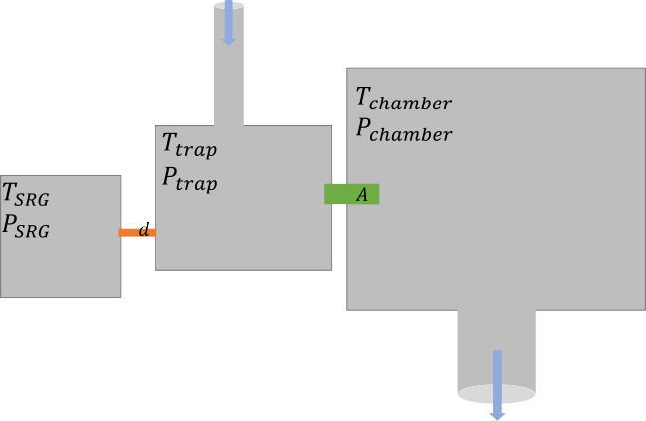

trap

SRG

chamber

FELion

S *[l/s ]*

Figure 2.17.: Schematic diagram on the relation of ion-trap, spinning rotor gauge (SRG) and the main chamber. The orange and green coloured region represents the connecting tube for SRG to trap and trap to the chamber, respectively, with the corresponding aperture of diameter *d* and *A*.

where *ie* and *K* are electron emission current and gauge sensitivity, respec- tively.

**Pumping speed (S) and throughput (Q):** The throughput of the gas molecule

(Q) can be defined in terms of pumping speed, S [liters/s or *l* /*s*] and pressure (*P* ) as follows

*Q* = *P* [mbar]· *S* [*l* /*s*]

As shown in Figure 2.17, the gas is let into the trap (gas in) and flows into the chamber region with an aperture diameter, A, corresponding to the two entrance and exit lenses (6 mm diameter each). The speed at which the gas molecule flows from trap to chamber will depend on the pressure difference between the two regions as well as the geometry of the chamber in-between, i.e., aperture (*A*). The factor which accounts for this difference is known as "conductance" (*C* ′), which is defined as

2.0



1e 3

*PSRG* = *C Pchamber* + *offset* Measured C=179+/-4

offset=0+/-0

1.5

**2**

*PSRG* [mbar]

1.0

0.5

0.0

0.0 0.2 0.4 0.6 0.8 1.0 1.2

*Pchamber* [mbar] 1e 5

Figure 2.18.: Pressure measured with SRG and HIG are plotted at 5 K trap nominal temperature. The derived calibration factor is *C* = 179(4).

such that,

*Ct*′*r ap*

*Qtrap*

= *Ptrap* − *Pchamber*

*Qtrap* = *Ct*′*r ap* · (*Ptrap* − *Pchamber* ) (2.43)

If we define the pumping speed (*SA*) for gas flow from the trap to the chamber via the aperture of diameter A and *S* for the pumping speed at which the gas molecules leave out off the chamber via a vacuum pump (see Figure 2.17), then at equilibrium, we get

*Qtrap* = *Qpump* ⇔ *Ptrap* · *SA* = *Pchamber* · *S* (2.44) Substituting Eq. 2.43 in 2.44, we get

*Ct*′*r ap* · (*Ptrap* − *Pchamber* ) = *Pchamber* · *S*

which becomes,

*Ptrap*

*Pchamber*

*S*

1

= + *C* ′

*trap*

= *C* (2.45)

where *C* is the calibration factor for pressure between the trap and the cham- ber.

Since we are measuring the trap pressure using SRG, i.e., *Ptr ap* = *PSRG* and the SRG temperature is the same as the chamber (both at room temperature, *RT* ), i.e., *TSRG* = *Tchamber* = *RT* , from equation 2.45, we get

**2**

*PSRG* = *C* · *Pchamber* (2.46)

The above equation 2.46 provides us with the required relation between SRG and HIG pressure measurement. Figure 2.18 shows the derived calibration value at 5 K trap nominal temperature, i.e., *C* = 179(4) at 5 K. The *C* value is also found to be temperature independent but depends only on the settings for HIG (the sensitivity is set to N2 gas).

# II

#### Vibrational spectroscopy

69

## 3

### Laboratory gas-phase vibrational spectra of [C3H3]+ isomers and isotopologues by

**IRPD SPECTROSCOPY**

This chapter is adapted from: Marimuthu, A. N.; Sundelin, D.; Thorwirth, S.; Redlich, B.; Geppert, W. D.; Brünken, S. Journal of Molecular Spectroscopy, 374, 111377 (2020)

71

Abstract

Gas phase vibrational spectra of [C3H3]+ isomers and their fully deuterated isotopologues measured in a cryogenic 22-pole ion trap are presented. The widely tunable free electron laser for infrared experiments, FELIX, was employed to cover the frequency range 500-2400 cm−1, complemented with an OPO/OPA system covering 2800-3400 cm−1. Spectral assignments for both the linear and cyclic isomeric form (H2C3H+ and c-C3H3+, respectively) are made based on various high-level computational studies. The effect of ion source conditions and different precursors (allene and propargyl chloride) for the preferential production of a specific isomer is discussed. The perturbation of the vibrational band position due to complexation with Neon in the recorded infrared- predissociation (IRPD) spectra are also reported in this study.

**3**

* 1. INTRODUCTION

Hydrocarbon ions with the chemical composition [C3H3]+ are important in- termediates in combustion processes, where they initiate soot formation [154– 156], and in various astrochemical environments such as the interstellar medium (ISM) [41, 157–159], cometary surfaces [160], and planetary atmospheres [161, 162]. The ion has two stable isomers, the cyclic cyclopropenyl cation, c-C3H3+, and the linear propargyl cation, H2C3H+, see Figure 3.1. The c-C3H3+ isomer is lower in energy by 28 kcal/mol [163], and a significant activation barrier of about 50 kcal/mol separates the two isomers [164]. c-C3H3+ is the smallest aromatic cation stabilised by two delocalised *π* electrons; hence it has been observed as a common stable fragment from the electron impact ionization mass spectra of many larger hydrocarbon molecules [165, 166].

**3**

In the interstellar medium, [C3H3]+ is formed by radiative association addition of H2 to linear C3H+, a molecular ion recently detected in several astronomical sources [167–169] based on accurate laboratory spectroscopic determination of its rotational spectrum [109, 170]. Experimental and theoretical studies support the formation of both isomeric variants of [C3H3]+ in this process [158, 171, 172]. Both c-C3H3+ and H2C3H+ are assumed to be the major precursors (via disso- ciative recombination) of cyclic and linear forms of [C3H2] and [C3H] [41, 157, 158], which are ubiquitous molecules in the interstellar medium [159, 173–178]. The observed large variation in the cyclic-to-linear isomeric ratio of both neu- trals across different astronomical sources is intricately linked to the formation and destruction of isomeric variants of [C3H3]+ [43, 179–181]. Apart from the main isotopologues, also singly and even doubly deuterated variants of [C3H2] were detected [182–184], and are frequently used to investigate deuterium frac- tionation via gas-phase processes in cold dark clouds [185–187]. Although many details about the exact deuteration mechanisms are only partly understood, they all involve deuterated variants of [C3H3]+ [183, 188]. It should also be noted that due to its D3*h* symmetry, the c-C3H3+ isomer has no pure rotational spectrum, thus its direct observation is not possible by radio-astronomy. However, the lin- ear isomer H2C3H+ and also singly or doubly D-substituted variants of c-C3H3+ possess a permanent dipole moment, and are therefore good candidates for radio-astronomical detection.

In a recent study of Titan‘s atmosphere by the Ion and Neutral Mass Spec- trometer (INMS) onboard the CASSINI spacecraft, a strong signal at *m*/*z* = 39 corresponding to the [C3H3]+ cation has been recorded [189]. Although these mass spectrometric detections do not allow to identify the isomeric composi- tion, one can assume the presence of both [C3H3]+ isomers [162]. Reactions of

H2C3H+, which was found in experiments to be much more reactive than the aromatic c-C3H3+ isomer [190–192], with unsaturated hydrocarbons could be the first elongation steps leading to larger ions, including polycyclic hydrocar- bons, in this environment. Upon dissociative and radiative recombination with electrons, heavy neutrals, i.e. tholins, can be formed. Similar processes could happen in other astronomical objects like dark clouds, circumstellar envelopes, star-forming regions, and protoplanetary disks. Model calculations of chemical networks in those environments are dependent on exact data about the reactiv- ity of all isomers of a certain ion. Therefore, it is important to find pathways to produce the isomers selectively to be able to assess their reactive properties in experimental kinetic studies. This has already been done for other ions showing isomers with different reactivity, e.g. for CH2CN+ [193, and references therein]. Although the results are encouraging, the most reliable way to pin down the identities of isomers produced by a certain method is via spectroscopic methods.

**3**

Due to their importance in astrochemistry and other fields, numerous ex- perimental and theoretical spectroscopic studies exist on the [C3H3]+ cations. Breslow and co-workers measured the first infrared spectra of c-C3H3+, but in acid solutions as a stable salt [194]. Both isomers were later studied in a Neon matrix by electronic and vibrational spectroscopy [195]. Very recently the vibra- tional spectrum of H2C3H+ and its fully deuterated form was measured in Argon matrix [196]. The first gas-phase vibrational spectra covering the C-H stretch- ing region of [C3H3]+ were measured using an infrared-predissociation (IRPD) method [197, 198], and interpreted through high-level quantum-chemical cal- culations of the ionic structure including the influence of the various tagging agents [199–201]. The experiments were later extended by Ricks et al., who ob- served several additional fundamental vibrational bands down to the dissocia- tion limit of the Argon tag that they used in the IRPD experiments (approximately 1000 cm−1) [202]. However, some ambiguity in the assignment of several bands of both isomers remained [163, 164]. Linnartz and co-workers reported the first high-resolution gas-phase IR spectra of the fundamental *ν*4 asymmetric C-H stretching band for free (i.e., without ligand tagged) c-C3H3+ using continuous wave cavity ring-down spectroscopy [203], and found excellent agreement of their results to spectroscopic parameters obtained from high-level ab initio cal- culations of quartic force fields [163]. Additional information of vibrational band positions of [C3H3]+ comes from photoelectron studies [204, 205] and electronic spectroscopy [206].

In this study we report the broad range (550-3400 cm−1) vibrational spectra of gas-phase [C3H3]+ and its fully deuterated variants using different tagging agents

(Ne, H2), ion-sources, and precursors. We employed IRPD action spectroscopy in a cryogenic ion trap coupled to the powerful and widely tunable FELIX free- electron IR lasers. The aim of this study is manyfold: (i) to unambiguously assign the vibrational bands of both isomers by comparison to quantum-chemical calculations, which then, in turn, can be used to benchmark these calculations;

(ii) to investigate isomer-selective formation mechanisms as a prerequisite for isomer-specific kinetic studies; (iii) to obtain reliable IR data that can be used to spectroscopically distinguish the isomeric [C3H3]+ products of ion-molecule reactions, and (iv) to provide a basis for follow-up high-resolution rotational studies of those isomers and their isotopologues that possess a permanent dipole moment to aid their astronomical detection.

**3**

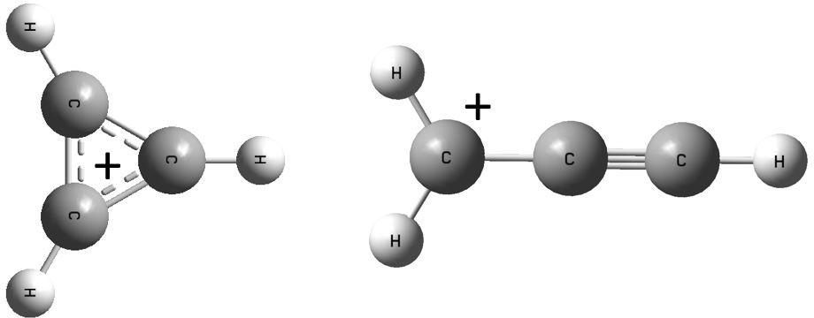

Figure 3.1.: Molecular structures of c-C3H3+ (left) and H2C3H+ (right) isomers.

* 1. METHODS
     1. Experimental details

The vibrational spectra of the [C3H3]+ isomers and isotopologues were recorded using the FELion cryogenic 22-pole ion trap instrument located at the Free Elec- tron Lasers for Infrared eXperiments (FELIX) Laboratory (see Section 2.2.2.1). A detailed account of the FELion instrument is provided in Section 2.1 and the infrared-predissociation (IRPD) of in-situ rare gas tagged cold molecular ions in Section 1.5.1.1. Here we only give a brief account of details specific to the [C3H3]+ system.

30 40 50 60 70 0 20 40 60 80



Allene

105

104

103

102

**3**

Ion Counts

101

105

104

103

Propargyl Chloride

102

101

104



Mass filter => Trap => Tagged with Ne

103

102

101

35 40

45 50 55 60

mass/charge

65 70

Figure 3.2.: Mass spectra of ions produced from electron impact ionization (20 eV) of allene (left, in storage EI source) and propargyl chloride (right, in direct EI source) precursors (upper panel), and of mass filtered [C3H3]+ (m = 39 u) together with tagged Ne-[C3H3]+ (m = 59 u) species produced in the cryogenic ion trap (lower panel).

Isomeric variants of [C3H3]+ (m=39 u) were produced by electron impact ion- ization (electron energy 11 − 70 eV) from neutral allene (C3H4, abcr GmbH, 96 %) and propargyl chloride (HC3H2Cl, Sigma Aldrich, 98 %). Fully deuterated [C3D3]+ was produced from deuterated allene (C3D4, Qmx Laboratories, 98 %). The precursor gases were admitted either pure or diluted with He at a ratio of 1:3 to the ion source chamber at a pressure of ∼ 10−5 mbar. For most experiments, a simple electron-impact (EI) source was used, and additional measurements were done with a Gerlich-type storage ion source (SIS) [207], where primary ions produced by EI are accumulated for the duration of an experimental cycle (of the order of seconds), thereby allowing further reactions with the present neutral gas (see Figure 3.2).

For spectroscopic experiments a few 10 ms long pulse of ions is extracted from the respective source and filtered for the mass of interest, m=39 u in the case of

[C3H3]+ and m=42 u for [C3D3]+, by a quadrupole mass selector before entering the 22-pole ion trap which is held at a fixed temperature in the range 6.1-7 K for experiments using Ne and 11 K for those using H2 as tagging gasses. Around 10-20 ms before the ions enter the trap, an intense 80-150 ms long Ne:He (or H2:He) pulse (1:3 mixing ratio and number density of ∼ 1015 cm−3) is admitted to the trap, leading to efficient collisional cooling of the ions to the ambient temperature. Under these conditions, several 10 % of the primary ions form weakly bound complexes with Ne (or H2), see Figure 3.2. The ions are stored for several seconds in the ion trap and are exposed to several laser pulses be- fore extraction. An IRPD spectrum is recorded by mass-selecting and detecting the [C3H3]+-Ne(H2) complex ions while tuning the laser frequency *ν*. A relative depletion *D* = 1 − *NON* (*ν*) in the number of complex ions *NON* (*ν*) from the base- line value *NOF F* is observed upon resonant vibrational excitation. To account for varying laser pulse energy *P* , pulse number *n*, and for saturation effects, the signal is normalized prior to averaging using *I* = −*ln*(*NON* (*ν*)/*NOFF* ) , giving the in-

**3**

*n*·*P* /(*hν*)

*NOFF*

tensity *I* in units of relative cross-section per photon1. After normalizing each measurement in this way, the final spectrum is then obtained by averaging using statistical binning with a typical bin size of 2.5 cm−1. Line parameters such as band positions, intensities, and line widths (fwhm) are then obtained by fitting a multi-component Gaussian function to the experimental data, also providing statistical errors of the line parameters.

Additionally, we performed saturation depletion experiments (see section 3.3.5) to quantify the isomeric ratio of the ionic mixture as described in de- tail previously [69, 208]. Here we used up to 46 laser pulses, resonant with an isomer-specific vibrational band position, to fully deplete (dissociate) just one isomer complex. The analysis of the depletion signal as a function of laser pulses, corrected for other loss-mechanisms, allows then to derive both the absorption- dissociation cross-section and the isomer abundance.

The vibrational IRPD spectra were recorded using the IR radiation of FEL-2 of the FELIX Laboratory in the frequency region 550-2400 cm−1, also employing the 3rd harmonic mode of the FEL. The laser was operated at 5 or 10 Hz with macro pulse energies in the interaction region between 1.5-60 mJ, and for each data- point *n* =3-66 pulses were admitted depending on the signal strength. The FEL was optimized for narrow bandwidth with a full width at half-maximum (fwhm) of 0.3 − 1 % of the center wavelength. Additional spectra were recorded in the C-H-stretching region between 2800-3400 cm−1using a Laservision OPO/OPA

1This equation only holds for isomer-pure ionic samples. Saturation effects in isomeric mixtures are underestimated in this way, leading to varying intensity ratios in the presented spectra.

system (∼ 3 cm−1 fwhm, 10 Hz, 5 ns pulses) with typical power of ∼ 7-10 mJ.

* + 1. COMPUTATIONAL DETAILS

The [C3H3]+ system has previously been studied quantum-chemically on sev- eral occasions and at various levels of theory [163, 199–201]. In the present investigation of the hydrogenated and perdeuterated variants, quantum chemi- cal calculations have been performed at the coupled-cluster singles and dou- bles (CCSD) level augmented by a perturbative treatment of triple excitations, CCSD(T) [209], together with atomic natural orbital (ANO0, ANO1, and ANO2) basis sets from Almlöf and Taylor [210]. The ANO0, ANO1, and ANO2 basis sets consist of 13s8p6d4f2g to 3s2p1d, 4s3p2d1f, and 5s4p3d2f1fg contractions for C as well as 8s6p4d3f to 2s1p, 4s2p1d, and 4s3p2d1f contractions for H, re- spectively. Equilibrium geometries have been calculated using analytic gradient techniques [211], while harmonic frequencies have been computed using an- alytic second-derivative techniques [212, 213]. For anharmonic calculations, second-order vibrational perturbation theory (VPT2) [214] has been employed and additional numerical differentiation of analytic second derivatives has been applied to obtain the third and fourth derivatives required for the application of VPT2 [213, 215]. The frozen core approximation has been used throughout. All calculations (including those employing VPT2) have been carried out using the CFOUR program package [143, 216].

**3**

The CCSD(T) method in combination with ANO basis sets has been shown previously to provide vibrational wavenumbers of high quality [217, 218]. In the present investigation, harmonic force fields were calculated at the CCSD(T)

/ANO2 level throughout. For the c-C3D3+ and H2C3H+ species, best estimates

of the fundamental vibrational wavenumbers were then calculated by applying anharmonic vibrational corrections calculated at the CCSD(T)/ANO1 level to the CCSD(T)/ANO2 harmonic wavenumbers. Because of numerical problems

in the CCSD(T)/ANO1 VPT2 calculation, for the c-C3H3+ and D2C3D+ species,

anharmonic corrections were taken from corresponding CCSD(T) /ANO0 cal- culations. A comparison of the fundamental vibrational frequencies obtained in this fashion using CCSD(T)/ANO1 and CCSD(T)/ANO0 for the c-C3D3+ and

H2C3H+ species reveals that the differences between the two levels are small,

order of a few cm−1 only. From the anharmonic force field calculations we also find that in the c-C3D3+ species, the *ν*1 mode is in resonance with the overtone of the *ν*5 mode (using thresholds of ∆*ω* = 50 cm−1 and Φ*i j j* = 80 cm−1). The corresponding VPT2 frequencies were unperturbed by removing the term in-

volving the resonance denominators. VPT2 intensities are not unperturbed in the present version of CFOUR and are reported here as provided by the pro- gram. To support the spectroscopic assignment of vibrational features other than the fundamentals, overtone and combination modes were also derived from the CCSD(T)/ANO1 (c-C3D3+ and H2C3H+) and CCSD(T)/ANO0 (c-C3H3+

and D2C3D+) computations. A summary of the computational results is given as part of the electronic supplementary material.

**3**

* 1. RESULTS AND DISCUSSIONS

We measured experimental IRPD spectra of [C3H3]+ isomers under various con- ditions such as using different ligands (Ne and H2), ion sources (storage and direct EI sources, Figure 3.6 ), and different precursors (propargyl chloride and allene) with ionization energy ranging from (14-70) eV. The presence of both iso- mers with varying relative abundance in different conditions was observed and is discussed in detail in Section 3.3.5. The IRPD vibrational band frequencies obtained from an average spectrum (Figure 3.3, including data from the propar- gyl chloride and allene precursors produced in the direct EI source with varying electron impact energies) compared with computed and previous experimental frequencies of both isomers are summarised in Table 3.1. The C-H stretching region was measured with the OPO/OPA system only for the allene precursor produced in the storage source, see Figure 3.4. The vibrational band assign- ments based on various computational studies using coupled cluster methods will be discussed for the cyclic and linear isomer in detail in Sections 3.3.1 and 3.3.2, respectively, and for the deuterated species in Section 3.3.4. The influence of the tagging agent will be discussed in Section 3.2, but was found to be negligi- ble.

600 800 1000 1200 1400 1600 1800 2000 2200

6

Direct EI source

Ne-[C3H3] +

Norm. Intensity ~(*m*2/*photon*)

5

4

**3**

3

2

1

0

0

CCSD(T)

c-*C*3*H* +

3

combination

H2C3H +

combination overtone

:5

20

Intensity (Km/mol)

40

60

80

600 800 1000 1200 1400 1600 1800 2000 2200

Wavenumber (*cm* 1)

Figure 3.3.: The experimental and fitted FELIX IRPD spectrum of Ne-[C3H3]+ (upper panel) compared to computed frequencies (lower panel) at CCSD(T)/ANO2 combined with the anharmonic correction from CCSD(T)/ANO1 (H2C3H+) and CCSD(T)/ANO0 (c-C3H3+). Only

fundamental (solid line), combination (dashed line) and overtone (dotted line) infrared bands with intensity >∼1 km/mol were included. The theoretical spectrum was folded with a Gaussian corresponding to the FEL linewidth. Peaks marked with *:n* indicate that the depicted peak intensity is scaled down by a factor n, for better visualization.

Table 3.1.: Summary of IRPD experimental vibrational band position of Ne- [C3H3]+ compared to computed fundamental, overtone and com- bination band frequencies at the CCSD(T)/ANO2 level of theory combined with anharmonic corrections from CCSD(T)/ANO1 (for H2C3H+ ) and CCSD(T)/ANO0 (for c-C3H3+ ).

**3**

Mode Ne-IRPDa FWHM Calc. [Int.] Ar-IRPD VMI-PEc Ar-Matrixd (this work) cm−1 cm−1[Km/mol] cm−1 cm−1 cm−1

c-C H+

3 3

1

|  |  |  |  |  |  |  |
| --- | --- | --- | --- | --- | --- | --- |
| *ν*1(*a*′ ) | - | - | 3179 [0] | - |  | |
| *ν*2(*a*′ ) | - | - | 1610 [0] | - |
| *ν*3(*a*′ ) | - | - | 1024 [0] | - |
| *ν*4(*e*′ ) | 3133(1)b | 14 | 3127 [189] | 3182 |
| *ν*5(*e*′ ) | 1293(1) | 25 | 1284 [88] | 1293 |
| *ν*6(*e*′ ) | 927(1) | 19 | 925 [60] | nc |
| *ν*7(*a*′′ ) | 757(1) | 20 | 754 [70] | nc |
| *ν*8(*e*′′ ) | - | - | 1000 [0] | - |
| *ν*7+*ν*8(*e*′ ) | - | - | 1739 [1] |  |
| *ν*3+*ν*6(*e*′ ) | - | - | 1921 [2] |  |
| H2C3H+  *ν*1(*a*1) | - | - | 3230 [102] | 3238 |  | 3195.3 |
| *ν*2(*a*1) | 3003(1)b, t | 9 | 2997 [26] | 3004 |  | 3000.6 |
| *ν*3(*a*1) | 2078(1) | 32 | 2078 [346] | 2077 | 2086(15) | 2075.2 |
| *ν*4(*a*1) | 1445(1) | 12 | 1444 [12] | 1445 |  | 1433.2 |
| *ν*5(*a*1) | 1138(4) | 31 | 1109 [2] | 1222 | 1120(15) | 1140 |
| *ν*6(*b*1) | 1138(4) | 31 | 1100 [11] | 1111 |  | 1105.2 |
| *ν*7(*b*1) | 856(1) | 44 | 875 [7] | nc | 858(15) |  |
| *ν*8(*b*1) | nc | nc | 263 [26] | nc |  |  |

1

2

2

a Frequencies (error in parenthesis). nc indicates not-covered and hyphen indicates not observed.

−

b Measured with OPO/OPA system. The remaining bands are measured with the FELIX free electron laser.

c Ref. [204] - Velocity-map imaging photo-electron method.

d Ref. [196] -Direct IR absorption spectra of H2C3H+ in solid Ar matrix.

t Tentative assignment.

* Ref. [202].

**Table 3.1 – continued on next page**

**Table 3.1 – continued from previous page**

Mode Ne-IRPDa FWHM Calc. [Int.] Ar-IRPD VMI-PEc Ar-Matrixd

**3**

|  |  |  |  |  |  |  |
| --- | --- | --- | --- | --- | --- | --- |
| (this work) cm−1 cm−1[Km/mol] cm−1 | | | | | cm−1 | cm−1 |
| *ν*9(*b*2) | 3041(1)b, t | 9 | 3087 [37] | 3093 |  | 3063.4 |
| *ν*10(*b*2) | - | - | 1016 [2] | - |  |  |
| *ν*11(*b*2) | 610(1) | 12 | 618 [56] | nc |  | 606.8 |
| *ν*12(*b*2) | nc | nc | 299 [15] | nc |  |  |
| *ν*3+*ν*5(*a*1) | - | - | 3168 [7] |  |  |  |
| *ν*3+*ν*10(*b*2) | - | - | 3086 [4] |  |  |  |
| *ν*4+*ν*10(*b*2) | - | - | 2444 [2] |  |  |  |
| *ν*7+*ν*8(*a*1) | 1138(4) | 31 | 1154 [50] |  |  |  |
| 2*ν*4(*a*1) | - | - | 2865 [1] |  |  |  |
| 2*ν*5(*a*1) | - | - | 2211 [9] |  | 2247(15) |  |
| 2*ν*7(*a*1) | - | - | 1741 [10] |  | 1744(15) |  |
| 2*ν*10(*a*1) |  | 27 | 2027 [7] |  |  |  |
| 2*ν*11(*a*1) | 1222(1) | 27 | 1224 [7] |  |  |  |

* + 1. CYCLIC ISOMER

The planar c-C3H3+ isomer has *D*3*h* symmetry with an *A*′1 vibronic ground state. All of the only four IR active fundamental bands (*ν*4, *ν*5, *ν*6 and *ν*7, with the for- mer three being doubly-degenerate) of this energetically lowest-lying aromatic isomer are clearly observed (see Figure 3.3 and 3.4, and Table 3.1). The band at 3133 cm−1 is assigned to the *ν*4 asymmetric CH stretching mode, with good agreement to the computed value of 3127 cm−1 and to a previous Ne-IRPD ex- periment by Roth and Dopfer [197], who measured this band at 3130 cm−1 . This vibration has also been reported in Ne-matrix at 3130 cm−1 [195]. Duncan and coworkers had originally reported this band around 3182 cm−1 [202], but later revised their assignment [164], in line with other experiments [197, 203] (see Table 3.1), including this work, and previous calculations [163, 199]. Based on their calculations, Botschwina et al. [199] argued that the 3182 cm−1 band from Duncan’s work could be the *ν*3+*ν*5 combination band of the linear isomeric form and not the *ν*4. The fact that we do not observe a band at 3182 cm−1 under con- ditions preferentially producing the cyclic isomer (see Section 3.3.5), supports this assignment. Somewhat puzzling is the appearance of two weak features at 3003 and 3041 cm−1 which are only present in the Ne-tagged spectrum in Figure

* 1. No combination or overtone bands of the cyclic isomer are predicted at these frequencies. We tentatively assigned them to the *ν*2 and *ν*9 modes of the linear isomer. However, the much stronger *ν*1 band, observed at 3238 cm−1 in the Ne-IRPD spectrum of Botschwina *et al.* [201], is not detected.

The prominent feature *ν*5(*e*′) corresponding to the asymmetric CCC ring stretching is clearly identified at 1293 cm−1 . This band was also reported at 1293 cm−1 with Ar-tagging [202]. Whereas our computed anharmonic frequency at CCSD(T) level is lower by 11 cm−1 , the comparison to CCSD(T) quartic force field calculations in combination with variational calculation (VCI 5MR) from Huang *et al.* [163] shows good agreement (1296.2 cm−1 ). The in-plane CH scis- soring (927 cm−1 , *ν*6(*e*′)) and symmetric CH out-of-plane wagging (757 cm−1

**3**

, *ν*7(*a*2′′)) modes have been measured with an excellent agreement to the com-

puted band positions (see Table 3.1), and gas-phase data of these two bands are reported here for the first time. Previously, they were measured by Craig et al.

[219] in various different polycrystalline salts of c-C3H3+ *X* − (with X=SbF5) at 757

cm−1 (*ν*7) and 925 cm−1 (*ν*6) which agree well with our measurements.

* + 1. LINEAR ISOMER

The linear propargyl isomer with *C*2*v* symmetry and an *A*1 vibronic ground state has 12 fundamental bands, which are all IR active. Previous measurements on the gas-phase H2C3H+ isomer include Ar-IRPD spectra (at frequencies above the Ar binding energy (∼ 1000 cm−1)) [202] and combined vacuum ultraviolet (VUV) laser - velocity-map imaging photoelectron (VMI-PE) spectra obtained only for the *ν*3, *ν*5 and *ν*7 modes [204]. Here we report and discuss the spectral characterization of the H2C3H+ isomer measured in a wide range from 550-3400 cm−1.

The most prominent *ν*3(*a*1) CC triple bond stretching mode at 2078 cm−1 is clearly seen with an excellent agreement to the computed value of the bare ion (2078 cm−1 ) and the experimental value (2077 cm−1 ) obtained with Ar-tagging IRPD [202]. Similarly, the weak band at 1445 cm−1 is assigned to the *ν*4 CH2 scissoring vibration. The broad mode identified at 1222 cm−1 can be assigned to 2*ν*11(*a*1) supported by a computed value of the overtone at 1224 cm−1 with substantial intensity larger than other overtone and combination bands in that region. This band was originally assigned to the *ν*5 band by Ricks et al. [202]. The similarly broad band at 1138 cm−1 with larger uncertainty of 3-4 cm−1 and FWHM of 31 cm−1 is consequently assigned here to a blend of *ν*5, *ν*6, and *ν*7 + *ν*8

(intensity of this combination mode might be over-estimated in the calcula- tion, 50 km/mol, see Figure 3.3), which our anharmonic CCSD(T) calculations predict at 1109, 1100, and 1154 cm−1 , respectively. We should, however, note here that our calculated *ν*5 and *ν*6 band position are not consistent with the earlier coupled cluster calculations from Botschwina and co-workers [199, 201] and Huang et al. [163] (see Table 3.2), who predicted these bands at 1123 cm−1 and 1100 cm−1 , respectively, for Ne-tagged H2C3H+ and around 1130 cm−1 and 1058 cm−1 (depending on the level of theory), respectively, for the bare ion. The discrepancy for the *ν*5 band is likely due to varying theoretical treatment of a Fermi resonance with the *ν*7 + *ν*8 combination band, which might be further influenced by the (small) perturbation of the Ne-tag. Ricks et al. [202] observed a doublet feature centered at 1111 cm−1 with Ar as tagging agent, and assigned it to the partly resolved P- and R-branch of the perpendicular *ν*6 band. The *ν*7 CCH out-of-plane bending and *ν*11 CCH in-plane bending bands clearly appear at 856 and 610 cm−1, respectively. However, the former band is extremely broad, as is the equivalent band in the fully deuterated species, and was difficult to distinguish from baseline fluctuations in the experiments. We assume a fast predissociation of the Ne-ion complex upon excitation of this mode, leading to life-time broadening.

**3**

* + 1. NE-EFFECT

We analyzed the effect of Ne complexation on the bare ions’ vibrational spectra by comparing them to the computed anharmonic frequencies from various cou- pled cluster methods of both ligand tagged and untagged species. Botschwina and co-workers [201] had carried out very detailed computational studies on the weak interactions in the ion-ligand complexes of [C3H3]+ by analyzing the potential energy profile of the complexes while migrating the ligand around the ion-molecule. They have found two *Cs* and one *C*2*v* (highest energy) struc- tures for Ne-c-C3H3+ and three *Cs* minima for Ne-H2C3H+ complex ion. They found negligible shifts of order < 3 cm−1 for the vibrational band positions for both [C3H3]+ isomers and all ligand-ion isomers. A detailed comparison of ligand-induced band shifts in the spectrum of the H2C3H+ isomer is provided in Table 3.2, where we report only values for the lowest energy *Cs* structure from Botschwina *et al.* [201]. The prominent features *ν*3 and *ν*4 appear to have no perturbation within 1 cm−1 uncertainty and this is supported by both our Ne- IRPD experiment and calculations on Ne-H2C3H+. The larger discrepancy in the *ν*7 band could be reasonably explained by other effects as discussed in section

3.3.2 and 3.3.4. The four IR active fundamental band of the cyclic isomer of both

600 800 1000 1200 1400 1600 3000 3200 3400

10

Storage EI source

Ne-[C3H3] +

Storage EI source

H2-[C3H3] +

12

8 10

8

**3**

6

6

4

Norm. Intensity ~(*m*2/*photon*)

4

2 2

0 0

0 0

5 5

10 10

15 15

20 20

25

600 800

1000 1200 1400 1600

Wavenumber (*cm* 1)

25

3000 3200 3400

Figure 3.4.: Comparing Ne-[C3H3]+ (upper panel) and H2-[C3H3]+ (lower panel) IRPD spectra produced from allene precursor in the storage ion source recorded with FELIX laser and OPO.

[C3H3]+ (except *ν*5, see section 3.3.1) and [C3D3]+ (section 3.3.4) also show ex- cellent agreement with the computed fundamental band positions.

We can therefore take the IRPD spectra of the Ne-tagged species as an excellent proxy for those of the bare ion, with predicted vibrational shifts much smaller than those for the corresponding Ar-tagged species. Surprisingly, even the use of H2, which has much higher polarizability than Ne (4.5 a.u. [220] *vs.* 2.66 a.u. [221], respectively) as the tagging agent does not lead to significant shifts, as the comparison in Figure 3.4 shows, taken under conditions favoring the formation

Table 3.2.: Comparing H2C3H+ Ne-IRPD band positions with available computa- tional studies based on coupled cluster methods. All frequencies are in cm−1 units

Mode Ne-IRPD H2C3H+ Ne-H2C3H+ Ar-H2C3H+ H2C3H+

(this work) (this work)*a* Botschwina *et al.* [201]*b* Huang *et al.* [163]*c*

*ν*1(*a*1)

**3**

*ν*2(*a*1) 3003*t*

3230 3237(+1) 3241(+5) 3239.0

2997 2992(+2) 2996(+6) 2998.7

|  |  |  |  |  |  |
| --- | --- | --- | --- | --- | --- |
| *ν*3(*a*1) | 2078 | 2078 | 2080(0) | 2081(+1) | 2082.2 |
| *ν*4(*a*1) | 1445 | 1444 | 1446(0) | 1446(0) | 1434.4 |
| *ν*5(*a*1) | 1138 | 1109 | 1123(0) | 1119(-4) | 1131.8 |
| *ν*6(*b*1) |  | 1100 | 1100(+1) | 1097(-2) | 1058.1 |
| *ν*7(*b*1) | 856 | 875 | 873(+1) | 867(-5) | 861.9 |

*ν*8(*b*1) 263 264(0) 281(+17) 251.7

|  |  |  |  |  |  |
| --- | --- | --- | --- | --- | --- |
| *ν*9(*b*2) | 3041*t* | 3087 | 3082(+2) | 3086(+6) | 3071.0 |
| *ν*10(*b*2) |  | 1016 | 1017(0) | 1017(0) | 1000.6 |
| *ν*11(*b*2) | 610 | 618 | 615(0) | 618(+3) | 607.7 |
| *ν*12(*b*2) |  | 299 | 301(+3) | 302(+4) | 294.8 |

*a* Computed at CCSD(T)/ANO2 combined with anharmonic correction from ANO1

*b Cs* min1 structure computed at CCSD(T)-F12/VTZ-F12. Harmonic shift arising from complex formation is given in parentheses.

*c* Computed at CCSD(T) QFF with VCI 5MR method. Note that the symmetry labelling of b1 of

[163] is b2 in this paper.

*t* Tenative assignment.

of the c-C3H3+ isomer. The predicted small (∼ 1 cm−1 ) splitting of the degenerate e’ modes (*ν*4, *ν*5, and *ν*6) of c-C3H3+ caused by symmetry-breaking due to the ligand could not be resolved with the given laser linewidth in these experiments.

* + 1. DEUTERATED SPECIES

Figure 3.5 shows the IRPD spectra of Ne-tagged [C3D3]+, produced in the di- rect EI source from fully deuterated allene (C3D4) as a precursor. We covered the range 400-2600 cm−1 ; using the FEL in its 3*rd* harmonic mode in the range (1800- 2600 cm−1 ), where the substantially shifted C-D stretching bands are expected. The first comprehensive spectral characterization of c-C3D3+ was reported by Craig *et al.* [219] using poly-crystalline salts. For the linear form D2C3D+, the C≡C stretching *ν*3 band in Ne-matrix [195] and the *ν*1-*ν*6, *ν*9 bands from a recent study of direct absorption of IR bands using isolated solid Ar matrix techniques

[196] were previously reported. However, to the best of our knowledge, there are no reports available on gas-phase data. Hence, here we report the first gas-phase data for [C3D3]+ isomers.

**3**

400 600 800 1000 1200 1400 1600 1800 2000 2200 2400 2600

10

Direct EI source

Ne-[C3D3] +

Norm. Intensity ~(*m*2/*photon*)

8

**3**

6

4

2

0

0

CCSD(T)/ANO2

c-*C*3*D* +

3

combination overtone D2C3D +

combination

overtone

:5

10

20

Intensity (Km/mol)

30

40

50

60

70

400 600 800 1000 1200 1400 1600 1800 2000 2200 2400 2600

Wavenumber (*cm* 1)

Figure 3.5.: The experimental and fitted FELIX IRPD spectrum of Ne-[C3D3]+ (upper panel) compared to computed frequencies (lower panel) at CCSD(T)/ANO2 combined with the anharmonic correction from CCSD(T)/ANO1 (c-C3D3+) and CCSD(T)/ANO0 (D2C3D+). Only

fundamental (solid line) combination (dashed line) and overtone (dotted line) infrared bands with intensity >∼1 km/mol were included. The theoretical spectrum was folded with a Gaussian corresponding to the FEL linewidth. Peaks marked with *:n* indicate that the depicted peak intensity is scaled down by a factor n, for better visualization.

* 1. Results and discussions

89

**3**

Table 3.3.: Summary of IRPD experimental vibrational band position of Ne-[C3D3]+ compared to computed fundamental, overtone and combination band frequencies at the CCSD(T)/ANO2 level of theory combined with anharmonic corrections from CCSD(T)/ANO1 (for c-C3D3+ ) and CCSD(T)/ANO0 (for D2C3D+ ).

|  |  |  |  |  |  |
| --- | --- | --- | --- | --- | --- |
| Mode | Assignment | Ne-IRPD | FWHM | Calc. [Int.] | Prev. Exp. |
|  |  | (this work) a | cm−1 | cm−1[Km/mol] | cm−1 |
|  |  |  |  |  |  |

1

|  |  |  |  |  |  |
| --- | --- | --- | --- | --- | --- |
| c-C3D3+ |  | | | | |
| *ν*1(*a*′ ) | sym. CD str. | - | - | 2474 [0] |  |
| *ν*2(*a*′ ) | sym. CCC str. | - | - | 1478 [0] |  |
| *ν*3(*a*′ ) | in-plane internal torsion | - | - | 838 [0] |  |
| *ν*4(*e*′ ) | asym. CD str | 2343(1) | 30 | 2340 [64] | 2348,c 2344.1(1.0),d2327e |
| *ν*5(*e*′ ) | asym. CCC ring str. | 1249(1) | 25 | 1244 [65] | 1250,c 1239e |
| *ν*6(*e*′ ) | in-plane CD scissoring | 674(1) | 19 | 673 [28] | 670,c 665e |

1

2

2

a Frequencies (error in parenthesis). nc indicates not-covered and hyphen − indicates not observed. ⊕ indicates out-of-plane

b Blended with the *ν*4 band of c-C3D3+ at 2343 cm−1.

c Craig *et al.* [219], Infrared spectra with polycrystalline salts ([C3H3]+ BF4−).

d Wyss *et al.* [195], Infrared spectra in Neon matrix.

e Breslow and Groves [194], Infrared spectra from salts of deuterated cyclopropenyl cation.

f Chin *et al.* [196], Infrared spectra of H2C3H+ in solid Ar matrix

**Table 3.3 – continued on next page**

3. VIBRATIONAL SPECTRA OF [C3 H3 ]+ISOMERS

90

**Table 3.3 – continued from previous page**

**3**

Mode Assignment Ne-IRPD FWHM Calc. [Int.] Prev. Exp.

(this work) a cm−1 cm−1[Km/mol] cm−1

*ν*8(*e*′′ ) asym. CD bending ⊕ - - 817 [0]

*ν*3+*ν*5(*e*′ ) 2067(1) 49 2061[0.02]

2*ν*5(*e*′ ) - - 2466 [1]

D2C3D+

*ν*1(*a*1) CD str. - - 2527 [0.2] 2487.3f

*ν*2(*a*1) CD2 sym str. 2193(1) 55 2200 [1.5] 2201.0f

*ν*3(*a*1) C≡C str. 1951(1) 32 1951[350] 1955.2(1.0),d1942.1f

*ν*4(*a*1) CD2 scissoring - - 1201 [0.09] 1191.7f

a Frequencies (error in parenthesis). nc indicates not-covered and hyphen − indicates not observed. ⊕ indicates out-of-plane

b Blended with the *ν*4 band of c-C3D3+ at 2343 cm−1.

c Craig *et al.* [219], Infrared spectra with polycrystalline salts ([C3H3]+ BF4−).

d Wyss *et al.* [195], Infrared spectra in Neon matrix.

e Breslow and Groves [194], Infrared spectra from salts of deuterated cyclopropenyl cation.

f Chin *et al.* [196], Infrared spectra of H2C3H+ in solid Ar matrix

**Table 3.3 – continued on next page**

* 1. Results and discussions

91

**3**

**Table 3.3 – continued from previous page**

Mode Assignment Ne-IRPD FWHM Calc. [Int.] Prev. Exp.

(this work) a cm−1 cm−1[Km/mol] cm−1

*ν*5(*a*1) C-C str. 956(1) 10 946 [14] 938.7f

*ν*6(*b*1) CD2 wag ⊕ 883(3) 16 882 [1.5] 891.3f

*ν*7(*b*1) CCD bend ⊕ 619(5) 54 700 [0.3]

*ν*8(*b*1) CCC bend ⊕ nc nc 233 [16]

*ν*9(*b*2) CD2 asym str. not resol.b 2324 [14] 2301.9f

*ν*10(*b*2) CD2 wag ⊕ 822(2) 20 822 [4]

*ν*11(*b*2) CCD bend in-plane 472(1) 19 471 [21]

*ν*12(*b*2) CCC bend in-plane nc nc 262 [10]

*ν*1+*ν*7(*b*1) - - 3206 [1]

*ν*4+*ν*5(*a*1) - - 2132 [5]

*ν*7+*ν*8(*a*1) 928(1) 7.7 914 [0.6]

a Frequencies (error in parenthesis). nc indicates not-covered and hyphen − indicates not observed. ⊕ indicates out-of-plane

b Blended with the *ν*4 band of c-C3D3+ at 2343 cm−1.

c Craig *et al.* [219], Infrared spectra with polycrystalline salts ([C3H3]+ BF4−).

d Wyss *et al.* [195], Infrared spectra in Neon matrix.

e Breslow and Groves [194], Infrared spectra from salts of deuterated cyclopropenyl cation.

f Chin *et al.* [196], Infrared spectra of H2C3H+ in solid Ar matrix

**Table 3.3 – continued on next page**

3. VIBRATIONAL SPECTRA OF [C3 H3 ]+ISOMERS

92

**Table 3.3 – continued from previous page**

**3**

Mode Assignment Ne-IRPD FWHM Calc. [Int.] Prev. Exp.

(this work) a cm−1 cm−1[Km/mol] cm−1

|  |  |  |
| --- | --- | --- |
| 2*ν*6(*a*1) | - - | 1741 [7] |
| 2*ν*7(*a*1) | - - | 1372 [5] |

We clearly identify the four IR active fundamental bands of the cyclic isomer (*ν*4, *ν*5, *ν*6 and *ν*7) with excellent agreement to computed fundamental band positions of the untagged species (see Table 3.3). This again demonstrates that the perturbation due to Ne attachment is very small. We also notice an addi- tional feature, with a larger FWHM of 49 cm−1, at 2067 cm−1 . This band can be assigned to the (weak) predicted combination band *ν*3+*ν*5 at 2061 cm−1. For the D2C3D+ isomer, the *ν*2, *ν*3, *ν*5, *ν*6, *ν*7, *ν*10, and *ν*11 vibrational modes are clearly identified. The most prominent feature is the C≡C stretching (*ν*3) band observed at 1951 cm−1. This band was reported at 1955.2 cm−1 in Neon matrix [195]. Most bands are in good agreement with theory (see Table 3.3). The *ν*7 is assigned to the broad feature centered at 619 cm−1 and shows a large deviation to the calculated band position. Interestingly, a similar situation was observed for the corresponding band in the undeuterated species (see Table 3.1). An ad- ditional band observed at 928 cm−1 is assigned to the *ν*7 + *ν*8 combination band predicted at 914 cm−1 .

**3**

* + 1. ISOMER QUANTIFICATION

One of the goals of this study was to find ion production methods that prefer- entially form one of the two [C3H3]+ isomers, in order to perform subsequent ion-molecule reaction kinetic studies starting with an isomer-pure ionic sample. For this purpose, we used two different neutral precursors, allene and propargyl- chloride, two different ion sources, and a range of electron impact energies.

As was described previously [69, 208], it is possible to quantify the percentage of a specific isomer in an isomeric mixture by a saturation depletion method. For this the cluster is resonantly excited at a frequency where only one of the two isomers is active, i.e. absorbs a photon. By increasing the trapping time, thereby increasing the total energy (*E* = *n* · *P* ) deposited, only the active isomer cluster is depleted until it saturates, and the number of clusters is recorded as a function of deposited energy (*NON* (*E* )). To account for additional loss mechanisms from the trap, a second measurement is done with the laser tuned to an off-resonance position, resulting in *NOF F* (*E* ). From this we can quantify the relative depletion of the particular isomer *D*(*E* ) = 1− . Assuming an exponential decay of the

*NOF F* (*E* )

*NON* (*E* )

600 800 1000 1200 1400 1600

4.0

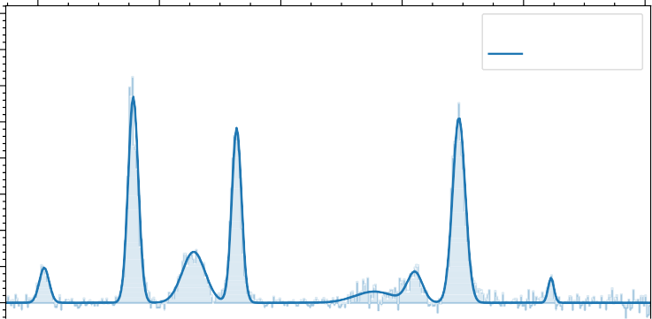

Direct EI source

Ne-[C3H3] +

3.5

3.0

2.5



**3**

2.0

1.5

Norm. Intensity ~(*m*2/*photon*)

1.0

0.5

0.0

0

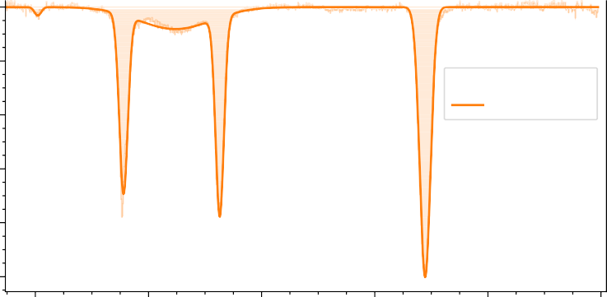

Storage EI source

Ne-[C3H3] +

2

4

6

8

10

600 800 1000 1200 1400 1600

Wavenumber (*cm* 1)

Figure 3.6.: Isomer variation depending on ion production conditions. Upper panel: Experimental IRPD spectrum of Ne-[C3H3]+ produced from propargyl chloride in the EI source. Lower panel: Same as above but using an allene precursor and the storage ion source.

clusters with rate coefficients *KON* and *KOF F* , respectively, we can write:

*NOF F* (*E* ) = *N* · *e*−*KOFF* ·*E*

*NON* (*E* ) = *Na* · *e*−(*KOF F* +*KON* )·*E* + *Nn* · *e*−*KOF F* ·*E*

*NON*

*D*(*E* ) = 1 − = *A* · (1 − *e*−*KON* ·*E* ),

*NOFF*

1750

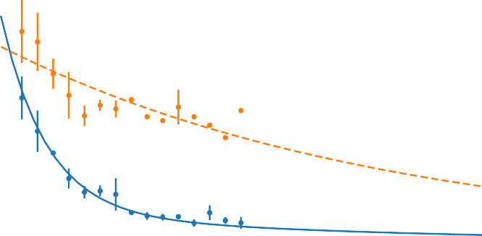

Resonance ON

Resonance OFF

D(E) fitted: A=84.31(0.57) %

Experiment

1500

1250

Ion Counts

1000

**3**

750

500

250

0

0.8

Relative depletion of active isomer

0.6

0.4

0.2

0.0

0.00 0.25 0.50 0.75 1.00 1.25 1.50 1.75 2.00

Total energy deposited (J)

Figure 3.7.: Saturation depletion measurements on the *ν*5 band of c-C3H3+ ,

produced from propargyl chloride in the direct EI ion source with

16.5 eV electrons. Top: On-resonance (blue, at 1293 cm−1 , *ν*5) and off-resonance (orange, at 1150 cm−1 ) depletion measurement. Bottom: Relative depletion *D*(*E* ) as a function of deposited energy *E* , showing saturation at *A* = 84%.

where *N* (= *Na* + *Nn*), *Na* and *Nn* are total cluster, active and non-active isomeric cluster counts respectively, and *A* = *Na* is the relative abundance of the active isomer. By fitting the experimental data to the corresponding exponentials, we can derive the respective rate coefficients, and, more importantly, the relative abundance of the targeted active isomer, *A*. Such an exemplary fit is shown in Figure 3.7. We should note that this method assumes an equal probability for

*Na* +*Nn*

forming Ne complexes for different isomers. This can be safely assumed, since the binding energies for both Ne-[C3H3]+ isomers was calculated to be very sim- ilar [201].

Although for the [C3H3]+ ions the cyclic c-C3H3+ is substantially lower in en- ergy than the linear H2C3H+ form (28 kcal/mol, [163]), both isomers were reg- ularly observed in various experiments [195, 198, 202], including this work. Presumably, due to the high isomerization barrier between the two isomers (50 kcal/mol), both isomers can be formed in the dissociative ionization of the used precursor gases. Theoretical studies have for example shown that the allene and propyne cations, with a linear carbon backbone, can undergo isomerization and ring closure before hydrogen loss, forming dominantly the c-C3H3+ isomer upon dissociation [222, 223]. We indeed observed the cyclic isomer with an abundance of ∼81 % (and the linear form with ∼19 %) upon electron impact ionization of allene in a direct electron impact ionization source, independent of the chosen electron energy in the range (14 − 70) eV, indicating a constant iso- meric branching ratio once the dissociation threshold in the ionization process is reached (allene ionization potential 9.7 eV [224], [C3H3]+ appearance energy

**3**

11.4 eV [225], below 14 eV we could not produce a high enough [C3H3]+ ion number to perform spectroscopic measurements). When using an ion storage source instead, where the primary ions can undergo subsequent reactions with the neutral gas, we predominantly produced the cyclic form (∼90-95 %), indica- tive of the higher reactivity of the linear isomer H2C3H+, as discussed previously [190, 191].

In order to increase the formation yield of the propargyl cation H2C3H+, we also used propargyl chloride (ionization energy 10.68(3) eV, [226]) as a precursor for direct electron impact ionization. The reasoning here was that the chlo- rine is expected to be an efficient leaving group after ionization and that thus the propargyl structure is retained in the [C3H3]+ ionic fragment, as has been proposed in photodissociation studies of the propargyl chloride ion [227]. A comparison between spectra taken under different conditions is given in Figure

3.6. However, the isomeric ratio shifted only marginally towards the linear iso- mer, reaching ∼22 % at 60 eV electron impact energy, and being lower (∼16 %) than for allene ionization at 16.5 eV.

To elucidate the formation of the different isomers upon ionization of propar- gyl chloride, we performed calculations on the potential energy surface of the [ClC3H3]+ system, which are detailed in the Supplementary Information (Figure A.1). Our results agree well with earlier calculations at a lower level of theory

by Won *et al.* [228]. They indicate that the dissociation to c-C3H3+ and Cl via an isomerization to a cyclic form of [ClC3H3]+ is thermodynamically favoured (with a maximum barrier of 53.4 kJ/mol, i.e. 0.55 eV) over the barrier-free dis- sociation channel to H2C3H+ and Cl, which has a relative energy of 81.1 kJ/mol (0.84 eV). Our experimental results indicate that the branching ratio into the two channels stays relatively constant at electron impact ionization energies above

16.5 eV, i.e. 5 eV higher than the H2C3H+ appearance energy. This result seems to be contradicting Duncan and co-workers’ [164, 202] argument that they were predominantly producing the linear isomeric variant using propargyl bromide as a precursor in a discharge coupled to a supersonic expansion. However, for the propargyl bromide cation, the barrier to isomerization to the cyclic variant is slightly higher in energy than the dissociative channel to H2C3H+ and Br [229], which likely alters the branching ratio in favour of H2C3H+ over c-C3H3+ . The fact that they were only able to observe a significant signal of the c-C3H3+ iso- mer when running the discharge "hot", i.e. with higher voltages, supports this scenario. In addition, the high inert gas pressure in the nozzle orifice in these experiments might lead to efficient quenching of the isomerization before dis- sociation. A similar argument might hold for the experiments done by Dopfer and co-workers [198], who used electron impact ionization of allene, propyne, 3-chloro-1-propyne, and benzene in a supersonic expansion and identified both [C3H3]+ isomers with a qualitatively constant ratio of 2:1 (c-C3H3+ :H2C3H+ ) in their spectra. However, earlier reactivity studies pointed towards a higher abundance (approaching 60 %) of the linear isomer when producing [C3H3]+ via low energy electron impact ionization of propyne [191]. We can therefore not exclude that in our experiments the H2C3H+ isomer is chemically quenched in the electron impact ion source, where the ions reside for several *µ*s at neutral gas pressures of 10−5 mbar. A more effective way to dominantly produce the propargyl cation could be ionization of propargyl iodide [230].

**3**

* 1. CONCLUSION

We investigated broadband gas-phase Ne-IRPD spectra of both linear and cyclic forms of [C3H3]+ and reported the first gas-phase IR spectra of the correspond- ing [C3D3]+ isomers. Comparison of this new experimental data with theoretical predictions of the vibrational spectra allowed us to benchmark various high-level coupled-cluster methods. All four IR active fundamental bands of cyclic isomer *ν*4, *ν*5, *ν*6 and *ν*7 for both [C3H3]+ and [C3D3]+ were reported with very good agreement with computed anharmonic frequencies. The *ν*6 and *ν*7 gas-phase IR

spectra were reported for the first time. We, therefore, can confidently resolve the issues regarding *ν*4 assignment for c-C3H3+ in Ricks *et al.* [202]. For the linear isomer, the most prominent vibrational modes *ν*3, *ν*4, *ν*7 and *ν*11 were clearly identified. The *ν*5 and *ν*6 modes were identified as a blended broader feature, but not determined with high accuracy. The effect of Neon complexation on the IRPD spectra seems to have only a small influence on the vibrational band positions, once more indicating that the use of weakly bound rare gas ligands such as Ne or He in IRPD action spectroscopy is well suited to obtain IR spectra resembling those of the bare ion.

**3**

The method of saturation depletion, enabled by the available high FELIX FEL power, was used to investigate the isomeric ratio of [C3H3]+ produced with dif- ferent ion source conditions and precursors. Whereas a rather clean production method could be identified for the formation of c-C3H3+ , but it has proven dif- ficult to form the more reactive H2C3H+ isomer preferentially. Nevertheless, the possibility to quantify the isomer ratio in an isomeric mixture offers great poten- tial for reactivity studies of these ions, which are needed as input for astrochemi- cal models. Furthermore, spectroscopic isomer identification and quantification as described here can be employed to probe the outcome of chemical reactions forming the [C3H3]+ isomers. Examples are the CH3+ +C2H2,4 and C3H+ +H2 reactions proposed to lead to [C3H3]+ in interstellar clouds and planetary atmo- spheres [162, 171].

The accurate spectral characterisation on [C3H3]+ and [C3D3]+ isomers is very important because their fundamental vibrational modes can be used for astro- nomical searches in the IR region for these ions, e.g. with the upcoming JWST telescope. With a robust experimental methodology and theoretical description now at hand, it would be interesting to extend these studies to the singly and doubly deuterated forms of these species. Whereas the c-C3H3+ and c-C3D3+ ions belong to the dihedral *D*3*h* point group, and do not possess a permanent dipole moment, an effective permanent dipole moment is created upon mono/di D- substitution, because the center of mass is displaced from the center of charge [231]. This makes these partly deuterated isomers amenable for direct rotational spectroscopy, e.g. using novel action spectroscopic methods that have been de- veloped recently to obtain rotational spectra of reactive ionic species [65, 101, 109, 114]. Rotational transition frequencies of these species, as well as for the likewise polar H2C3H+ isomer, will enable searches for them in space using sensitive radio telescope, thereby allowing to elucidate their role in interstellar carbon chemistry [181, 183].

## 4

### Infrared predissociation spectroscopy of protonated methyl cyanide, CH3CNH+

This chapter is adapted from : Marimuthu, A. N.; Huis in’t Veld, F.; Thorwirth, S.; Redlich, B.; Brünken, S. Journal of Molecular Spectroscopy, 379, 111477 (2021).

99

Abstract

The gas phase vibrational spectrum of CH3CNH+ is recorded using a messenger infrared predissociation (IRPD) action spectroscopic method. Vibrational bands were recorded in the 300 − 1700 cm−1 and 2000 − 3300 cm−1 regions making use of the widely tunable free electron laser for infrared experiments, FELIX, coupled to a cryogenic ion trap instrument. Band assignments were aided by high-level quantum-chemical calculations, which showed excellent agreement with the experimental data. Effects of the neon atom used as messenger in the IRPD method are investigated in detail. The data presented here will support astronomical searches for the CH3CNH+ ion in space, and provides a basis for high-resolution ro-vibrational and pure rotational studies in vibrationally excited states.

**4**

* 1. INTRODUCTION

Methyl cyanide (CH3CN, also known as acetonitrile) was among the first polyatomic molecules detected during radio-astronomical observations of the interstellar medium (ISM) [232]. It has since been detected in a variety of galactic sources, covering most evolutionary stages from dense cold cores [233, 234], via low- and high-mass star-forming regions [235, 236] and protoplanetary disks [237] to photodissociation regions [238] and circumstellar envelopes [239]. CH3CN has also been detected in the atmosphere of Saturn’s moon Titan [240– 242].

As methyl cyanide has a proton affinity of 788(8) kJ/mol [243], much larger than that of H2, its protonated version (CH3CNH+) might form effectively via exothermic proton transfer from H3+ to CH3CN in the interstellar medium

**4**

[244]. Another effective formation pathway of protonated methyl cyanide is

via radiative association of CH3+

and HCN. The latter pathway, followed by

dissociative recombination, was suggested to be the major gas-phase route for the interstellar synthesis of methyl cyanide (and its isocyanide isomer) [245– 247]. Despite its dominant role in the formation of the ubiquituous methyl cyanide molecule, previous searches for CH3CNH+ in the interstellar medium were unsuccessful [248]. Protonated methyl cyanide, as well as other protonated nitriles, have, however, been detected in Titan’s upper atmosphere by the Ion Neutral Mass Spectrometer (INMS) on board the Cassini spacecraft [249]. It is dominantly formed by protonation of CH3CN via reactions with the highly

abundant ions HCNH+ and C2H5+, whose deprotonated variants have a lower

proton affinity than methyl cyanide [189].

The pure rotational spectrum of protonated methyl cyanide has been studied extensively in the microwave [250] and submillimeter-wave region [251]. Several infrared studies on CH3CNH+ exist, including matrix-isolation FT-IR [252] of its CH and NH stretching bands, infrared-predissociation (IRPD) action spectroscopy of its complex with H2 in the H2 and NH stretching region [253], and high-resolution gas-phase absorption spectroscopy on the *ν*1 NH stretching fundamental band of the bare ion [254, 255]. All these studies focus on the stretching bands located at wavelengths below 3.4 *µ*m, or at wavenumbers above 2900 cm−1, respectively, and to date no spectroscopic data on its low-lying vibrational modes existed.

In this study we recorded the vibrational spectrum of gas-phase CH3CNH+ over a broad frequency range (300 − 1700 and 2000 − 3300 cm−1) covering all fundamental modes except the previously studied NH stretching band. Exper- iments were performed using Ne-tagging infrared-predissociation spectroscopy in a cryogenic ion trap coupled to the powerful and widely tunable FELIX (Free Electron Lasers for Infrared eXperiments, [122]) free-electron IR lasers. These

data can serve as reference data for future laboratory infrared studies at high spectral resolution as well as astronomical searches for this important ion in space, e.g., with the upcoming James Webb Space Telescope (JWST).

* 1. METHODS
     1. Experimental details

105

**4**



Source

104

103

102

101

Ion Counts

20

30 40 50 60 70 80

105



Mass filter => Trap => Tagged with Ne

104

103

102

101

20 30

40 50 60

mass/charge

70 80

Figure 4.1.: Upper panel: Mass spectra of ions produced from electron impact ionization (∼30eV) in a storage ion source. See text for discussion of the main peaks Lower panel: Mass filtered CH3CNH+ (m/z = 42, < 10 % contribution at m/z = 41 and 43) together with tagged CH3CNH+-Ne (m/z = 62, also CH3CNH+-22Ne at m/z = 64) species produced in the cryogenic ion trap. Additional weaker contributions at m/z = 60, 70, and 74 stem from tagging with residual H2O, N2, and O2, respectively.

The vibrational spectrum of CH3CNH+ was recorded using the FELion cryogenic 22-pole ion trap instrument. A detailed account of the FELion instrument is provided in Section 2.1 and the infrared-predissociation (IRPD) of in-situ rare gas tagged cold molecular ions in Section 1.5.1.1. Here we only give a brief account of details specific to the CH3CNH+ ion.

Protonated methyl cyanide (m/z = 42) was produced by electron impact ionization (EI, electron energy 30 eV) from neutral methyl cyanide (Sigma

Aldrich, > 99.9%) in a Gerlich-type storage ion source (SIS) [207], where primary ions produced by EI are accumulated for the duration of an experimental cycle (of the order of seconds). The precursor gas was admitted either pure or diluted with He at a ratio of 1:3 to the ion source chamber at a pressure of ∼ 10−5 mbar. Self-protonation of the primarily formed methyl cyanide radical cations with neutral methyl cyanide [256], led to effective production of CH3CNH+ (see Figure 4.1). Additional prominent mass-peaks in the mass-spectrum are due to the radical methyl cyanide cation (m/z = 41) and the hydrogen loss fragment CH2CN+ with m/z = 40. Interestingly, we observe the appearance of a mass-peak at m/z = 54, which is likely caused by a reaction of CH2CN+ with neutral methyl cyanide in the storage source [257]. Fragment ions, including their protonated forms are apparent in the range m/z = 26 −32, contamination from water and air leads to additional contributions at m/z = 18 (not shown), 28, and 32.

**4**

For spectroscopic IRPD experiments a few 10 ms long pulse of ions is extracted from the respective source and filtered for the mass of interest, m/z = 42 in the case of CH3CNH+ by a quadrupole mass filter before entering the 22-pole ion trap which is held at a fixed temperature in the range 6.1-7 K for experiments using Ne as tagging gas. Around 10-20 ms before the ions enter the trap, an intense 80-150 ms long Ne:He pulse (1:3 mixing ratio and number density of

∼ 1015 cm−3) is admitted to the trap, leading to efficient collisional cooling of the ions to the ambient temperature. Under these conditions, around 20 % of the CH3CNH+ ions form weakly bound complexes with Ne, see Figure 4.1. The ions are stored for several seconds in the ion trap and are exposed to several laser pulses before extraction. An IR-PD spectrum is recorded by mass- selecting and counting the CH3CNH+-Ne complex ions while tuning the laser

frequency *ν*. A relative depletion *D* = 1 − *NON* (*ν*) in the number of complex ions

*NOFF*

*NON* (*ν*) from the baseline value *NOF F* is observed upon resonant vibrational excitation. To account for varying laser pulse energy *P* , pulse number *n*, and for saturation effects, the signal is normalized prior to averaging using *I* = −*ln*(*NON* (*ν*)/*NOFF* ) , giving the intensity *I* in units of relative cross-section per photon. After normalizing each measurement in this way, the final spectrum is then obtained by averaging using statistical binning with a typical bin size of

*n*·*P* /(*hν*)

2.5 cm−1. Line parameters such as band positions, intensities, and line widths (fwhm) are then obtained by fitting a multi-component Gaussian function to the experimental data, also providing statistical errors of the line parameters.

The vibrational IRPD spectra were recorded using the IR radiation of FEL-2 of the FELIX Laboratory in the frequency region 300-1700 cm−1, and in the range 2000-3300 cm−1 employing the 3*rd* harmonic mode of the FEL. The laser was operated at 10 Hz with macro pulse energies in the interaction region between 1.5-60 mJ, and for each datapoint *n* =3-66 pulses were admitted depending on

the signal strength. The FEL was optimized for narrow bandwidth with a full width at half-maximum (fwhm) of 0.3 − 1 % of the center wavelength.

* + 1. COMPUTATIONAL DETAILS

**4**

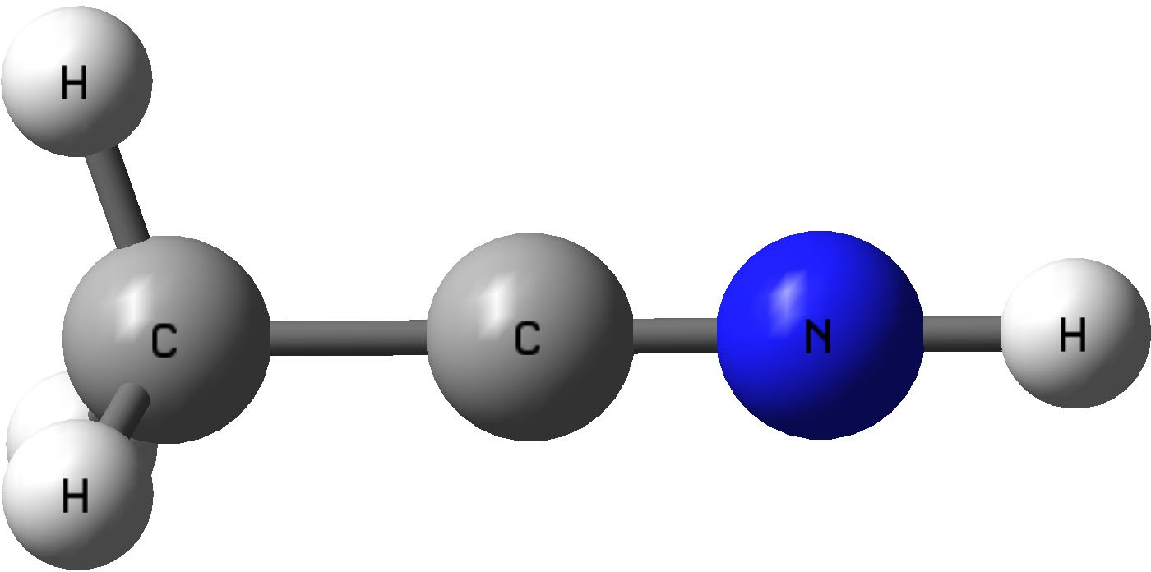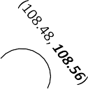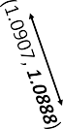

**+**

(1.4486, ***1.4441***) (1.1429, ***1.1400***) (1.0083, ***1.0073*** )

Figure 4.2.: Computed equilibrium geometry (C3*v* symmetry) for CH3CNH+ based on (fc-CCSD(T)/ANO2, ***ae-CCSD(T)/cc-pwCV5Z*** ) level of theory. Bond lengths and angles are in *A*˚ and deg◦ respectively.

The stability and relative energies of the [C2H4N]+ isomeric family have been extensively studied previously at various levels of theory, showing N-protonated acetonitrile (CH3CNH+ , 1 *A*1, C3*v* symmetry) to be the global minimum structure [258, 259]. In the present study we have investigated CH3CNH+ at the coupled- cluster singles and doubles (CCSD) level augmented by a perturbative treatment of triple excitations, CCSD(T) [209], in combination with atomic natural orbital (ANO0, ANO1, and ANO2) basis sets from Almlöf and Taylor [210] as well as the correlation-consistent valence basis set cc-pVDZ [137] in the frozen core (fc) approximation. A best estimate equilibrium structure has been calculated using the cc-pwCV5Z basis set [260] using all electrons in the correlation treatment. Equilibrium geometries of CH3CNH+ have been calculated using analytic gradient techniques [211] and our results for the bare ion (Figure 4.2) match well with an earlier report by Botschwina [261] who employed ab initio methods up to the CCSD(T)/cc-pCVQZ level. Harmonic frequencies were subsequently computed by numerical differentiation of gradients [139, 140]. For anharmonic calculations, second-order vibrational perturbation theory (VPT2)

[214] has been employed. All calculations have been carried out using the CFOUR program package [143, 216]. The CCSD(T) method in combination with ANO basis sets has been shown previously to provide vibrational wavenumbers of high quality [217, 218], and we have recently applied it successfully for a vibrational study of [C3H3]+ isomers and isotopologues [119].

Additionally, we have performed potential energy scans to find the lowest energy structure of CH3CNH+ complexed with Ne, as outlined in Section 4.3.3. These studies were conducted at the CCSD(T)/cc-pVDZ and CCSD(T)/ANO0 level of theory using the PSI4 program package [262]. The potential energy surface as a function of H-Ne distance of the lowest energy conformer was then further investigated to account for Basis Set Superposition Errors [145] using

**4**

i) the counter-poise (CP) method introduced by Boys and Bernardi [146], i.e. by calculating CP-corrected CCSD(T) interaction energies at each geometry, and ii) higher-order symmetry-adapted perturbation theory, SAPT2+3/cc-pVDZ [147, 148]. In all PES calculations the geometry of the bare ion was kept fixed to its equilibrium structure calculated at the same level of theory. No zero- point vibrational energy (ZPE) corrections were applied to the derived binding energies.

* 1. RESULTS AND DISCUSSIONS
     1. VIBRATIONAL SPECTROSCOPY OF CH3 CNH+

The measured IRPD spectra for [C2H4N]+ with Ne as a tagging agent are displayed in Figures 4.3 and 4.4, compared to the calculated spectrum of the energetically lowest lying isomer, CH3CNH+. Based on these results we can infer that only the most stable isomer CH3CNH+ , i.e. N-protonated methyl cyanide, is produced via self-protonation in our storage ion-source. By exposing the complexes to > 100 FEL shots on resonance with the strong band at 898 cm−1 we could verify that > 95% of the complexes dissociate, i.e. that only one isomeric variant absorbing at this specific frequency is present in the ion trap. The CH3CNH+ structure with C3*v* symmetry has 10 IR active fundamental modes of E and A1 symmetry. As can be clearly seen in Figure 4.3 and 4.4, we have covered and assigned all fundamental modes, except the high-lying NH-stretching mode that was out of the range of the FEL. Four remaining weak to moderately strong features could be assigned to combination and overtone modes predicted by the anharmonic force field calculations. The fitted band positions and assignments are summarized in Table 4.1. Several remaining, weak features, e.g., between 600−700 cm−1 are likely due to combination bands of the bare ions fundamental modes and those involving the weakly bound Ne atom. The observed transitions for CH3CNH+-Ne are in very good agreement with the computed values of the

*100

𝜈𝜈10 + 𝜈𝜈9

𝜈𝜈10 + 𝜈𝜈8

**4**

Figure 4.3.: The experimental and fitted FELIX IRPD spectrum of CH3CNH+-Ne (upper panel) compared to the computed anharmonic (VPT2) fre- quency values (lower panel) of CH3CNH+ at the fc-CCSD(T)/ANO2 level of theory showing fundamental (orange, solid line), combina- tion and overtone (orange, dashed line) bands. NOTE: /n and *n in- dicates that the computed intensities are divided or multiplied, re- spectively, by a factor n for better visualisation

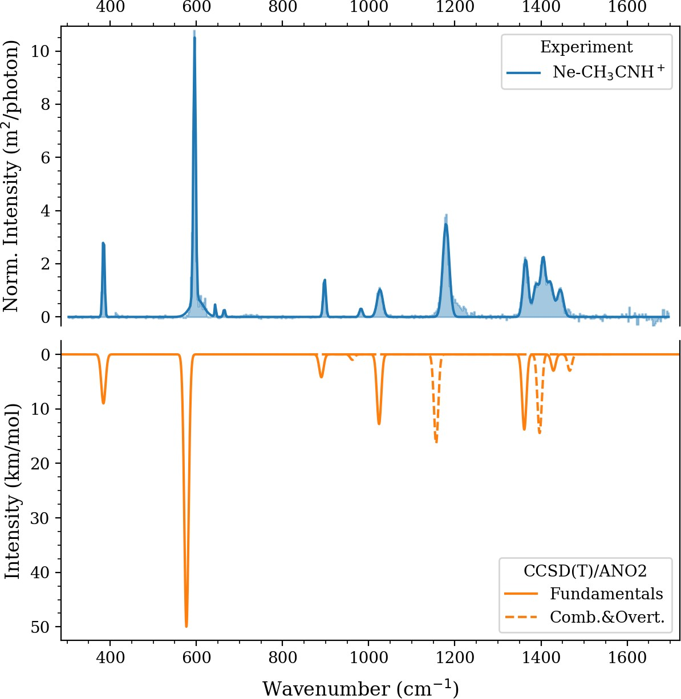

𝜈𝜈9

𝜈𝜈10

2𝜈𝜈9

𝜈𝜈5

𝜈𝜈

4

𝜈𝜈

8

𝜈𝜈

7

𝜈𝜈9 + 𝜈𝜈5

*100

/5

bare ion CH3CNH+ (see Table 4.1). For most bands the deviation is less than 10 cm−1, except for the CNH bending mode, and the overtone and combination modes, as will be discussed below. The influence of the neon-tag on the vibrational band positions is discussed in more detail in section 4.3.3.

**4**

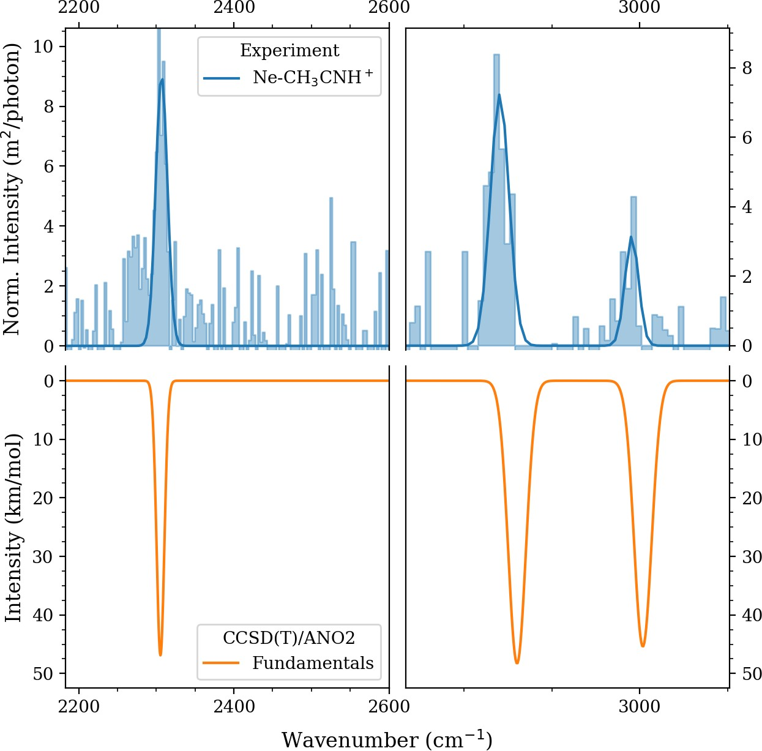

𝜈𝜈3

𝜈𝜈2

𝜈𝜈6

Figure 4.4.: The experimental and fitted FELIX IRPD spectrum of CH3CNH+-Ne (upper panel) but using FELIX in 3*rd* harmonic mode, compared to the computed anharmonic (VPT2) frequency values (lower panel) of CH3CNH+ at the (fc)-CCSD(T)/ANO2 level of theory.

The lowest energy CCN bending mode *ν*10 is clearly observed at 385 cm−1 with excellent agreement to the anharmonic predicted value at 384 cm−1. The most prominent feature, the *ν*9 CNH bending mode, is observed at 596 cm−1, almost 20 cm−1 blue-shifted from the predicted band position of the bare ion. This shift is likely caused by the attached neon atom, that binds to the proton involved in this bending mode (see section 4.3.3). The combination band of these two bending modes (CCN and CNH) was also observed at 982 cm−1 as

a weak feature. Also a very clear feature of the CNH first overtone appears at 1179 cm−1. In general the computed values for the combination and overtone modes are 10 − 20 cm−1 shifted with respect to the experimentally observed bands. The CC stretching frequency *ν*5 is measured at 898 cm−1 with a ∼ 7 cm−1 blue-shift from the predicted value 890 cm−1. The weak combination mode of the CC stretching with the CNH bending mode also appears with sizable intensity at 1445 cm−1. We could also clearly observe the CH3 vibrations, i.e. the *ν*8 wagging and *ν*7 scissoring, at 1026 and 1421 cm−1 respectively (see vibrational displacement vectors given in the Supplementary Information Figure B.2). The former also forms a combination mode with the CCN bending at 1405 cm−1 which matches well with the predicted value at 1397 cm−1 (intensity over 14 km/mol). The *ν*4 CH3 umbrella like bending mode appears at 1364 cm−1 very close to the predicted value at 1361 cm−1. The *ν*3 CN stretching, CH3 *ν*2 symmetric and *ν*6 asymmetric stretching bands were measured with FELIX 3*rd* harmonic mode (see Figure 4.4) resulting in lower resolution and signal-to-noise spectra, reflected in the larger experimental error of these lines. In addition, measurements of the two CH stretching bands suffered from calibration issues of the grating spectrometer used to determine the FEL frequency, reflected in their large systematic errors of 10 cm−1.

**4**

* 1. Results and discussions

109

**4**

Table 4.1.: Summary of IRPD experimental vibrational band position of CH3CNH+-Ne and comparison to computed values. Vibrational frequencies are in cm−1[calc. intensities in km/mol]

|  |  |  |  |
| --- | --- | --- | --- |
| Vibrational symmetry and mode | CCSD(T)/ANO2 | Ne-IRPDb | prev. work |
| (CH3CNH+ , C3*v* , 1A1 ground state) | (VPT2, anh.) Ne correcteda | (this work) |  |

Fundamental bands

|  |  |  |  |  |  |  |
| --- | --- | --- | --- | --- | --- | --- |
| *ν*10 | E | CCN bend | 384 [4.5] | 386 | 385 (1) |  |
| *ν*9 | E | CNH bend | 577 [132.3] | 595 | 596 (1) |  |
| *ν*5 | A1 | CC str. | 890 [4.2] | 891 | 898 (1) |  |
| *ν*8 | E | CH3 wagging | 1024 [6.4] | 1025 | 1026 (1) |  |
| *ν*4 | A1 | CH3 umbrella | 1361 [13.8] | 1362 | 1364 (1) |  |
| *ν*7 | E | CH3 scissoring | 1429 [1.5] | 1429 | 1421 (1) |  |
| *ν*3 | A1 | CN str. | 2305 [46.9] | 2305 | 2307 (2) |  |
| *ν*2 | A1 | CH3 sym. str. | 2930 [48.3] | 2930 | 2924 (10) |  |
| *ν*6 | E | CH3 asym. str. | 3002 [22.7] | 3002 | 2996 (10) | 2946.5 [53]c |

a CH3CNH+ & CH3CNH+-Ne (C3*v* symmetry isomer) harmonic frequencies were computed at the CCSD(T)/ANO0 level of theory and their differences were added as Neon contribution to CH3CNH+ frequencies computed at CCSD(T)/ANO2 (see section 4.3.3).

b Frequencies (error in parentheses). nc indicates not covered.

c Ne-matrix, Ref [252]

d Gas-phase, Ref [255]

**Table 4.1 – continued on next page**

4. VIBRATIONAL SPECTRA OF CH3 CNH+

110

**Table 4.1 – continued from previous page**

**4**

|  |  |  |  |
| --- | --- | --- | --- |
| Vibrational symmetry and mode | CCSD(T)/ANO2 | Ne-IRPDb | prev. work |
| (CH3CNH+ , C3*v* , 1A1 ground state) | (VPT2, anh.) Ne correcteda | (this work) |  |

Fundamental bands

*ν*1 A1 NH str. 3525 [654.7] 3516 nc 3500.6 [677],c 3527.29d

Overtones and Combination bands

*ν*10 + *ν*9 A1 CCN bend + CNH bend 962 [0.01] 982 (2)

2*ν*9 A1 CNH bend (2) 1157 [16.3] 1179 (1)

*ν*10 + *ν*8 A1 CCN bend + CH3 wag 1397 [14.4] 1405 (1)

*ν*9 + *ν*5 E CC str. + CNH bend 1467 [0.03] 1445 (1)

* + 1. PREDICTION OF ROTATIONAL SPECTROSCOPIC PARAMETERS

The above discussion clearly shows that anharmonic calculations at the

CCSD(T)/ANO2 level provide a reliable means to predict vibrational band positions for CH3CNH+. In addition we present in Table 4.2 the calculated equilibrium and ground state rotational constants and compare the latter to experimentally derived values [250, 251] and a previous calculations using the aug-cc-pVQZ basis set [259]. From the relative deviations of the calculated spectroscopic constants to the experimental values, it is obvious that the fc-CCSD(T)/ANO2 calculation of *B*0 (from the equilibrium rotational constant B*e* complemented by the zero point vibrational contribution ∆*B*0, see below) are slightly further off than the CCSD(T)/aug-cc-pVQZ values reported earlier [259], whereas centrifugal distortion constants show a similar accuracy. Best estimate ground state rotational constants have been calculated here using a hybrid approach with the equilibrium structure calculated at the ae-CCSD(T)/cc-pwCV5Z and the zero-point vibrational corrections ∆*B*0 =

**4**

1 L *αB*

2

*i*

(analogous for *A*) from rotation-vibration interaction constants *αi*

calculated at the fc-CCSD(T)/ANO2 level of theory (see Table B.4 in the

Supplementary Information), showing excellent agreement (to within 0.05%) with the experimentally obtained *B*0 value. CH3CNH+ has two energetically low- lying, degenerate bending vibrations, the CCN bending mode at 385 cm−1, and the CNH bending mode at 596 cm−1. These modes should be readily excited in discharge experiments used previously to record the rotational spectrum of the vibrational ground state [250, 251], and in warmer regions of the ISM, i.e. hot cores in star-forming regions. In order to guide future micro-/millimeter- wave studies of the vibrational satellite spectrum, estimates of the rotational constants within these states are provided in the following based on the calculated rotation-vibration interaction constants *αi* (at the CCSD(T)/ANO2 level of theory), applied to the experimentally determined *B*0 value, i.e. *Bi* = *B*0 − *αi* , and the calculated *A*0 values (see Table 4.2). In this way we obtain for the *ν*10

*B*

CCN bending mode (with *αA* = 91.3 MHz, *α*10 = −20.2 MHz) *A*10 = 154929 MHz,

10

*B*10 = 8610.8 MHz and *q*10 = 14.8 MHz for the *l* -type doubling parameter, and for the CNH bending mode (*αA* = 31.1 MHz, *αB* = −8.3 MHz) *A*9 = 154989 MHz,

9

9

*B*9 = 8598.9 MHz and *q*9 = 8.9 MHz, respectively. Direct comparison of the

calculated values with experiment are possible for the *ν*1 NH stretching mode studied by Amano [255]. The calculated value for *B*1 = 8569.1 MHz agrees to within 0.005 % with the experimental one of 8568.6 MHz. The deviation for *A* is larger, Amano gives *A*0 − *A*1 = 49.394 MHz, which is about twice our calculated value of −*α*9 = 23.4 MHz.

Table 4.2.: Comparison of calculated (all using CCSD(T)) and experimental spectroscopic constants for the vibrational ground state of CH3CNH+, with relative deviations to the experimental values [250] given in parentheses (in %). The last two columns give scaled spectroscopic constants for the two lowest vibrational state

**4**

|  |  |  |  |  |  |  |
| --- | --- | --- | --- | --- | --- | --- |
|  | Exp. [250] | Exp. [251] | ANO2  this work | aug-cc-pVQZ [259] | cc-pCVQZ [261] | cc-pwCV5Z best estimate*a* |
| *Ae* (MHz) |  |  | 156213 |  | 156734 | 156897 |
| *Be* (MHz) |  |  | 8569 |  | 8600 | 8614 |
| *A*0 (MHz) | - | - | 154336 | 157166 |  | 155020 |
| *B*0 (MHz) | 8590.557 | 8590.559 | 8541(-0.58) | 8600 (0.11) |  | 8587(-0.045) |
| *DJ* (kHz) | 3.125 | 3.141 | 3.06(-2.1) | 2.93 (-6.5) |  |  |
| *DK* (MHz) | - | - | 2.50 | 2.52 |  |  |
| *DJK* (MHz) | 0.1568 | 0.1633 | 0.161(2.7) | 0.172 (2.0) |  |  |

*a* This work. *A*0 and *B*0 values were obtained by using the corresponding equilibrium values from

ae-CCSD(T)/cc-pwCV5Z and rotation-vibration constants *αi* from fc-CCSD(T)/ANO2 (see Table B.4 in the Supplementary Information for details).

* + 1. INFLUENCE OF THE NEON ATOM ON VIBRATIONAL BAND POSITIONS

Table 4.3.: Computed binding energies *Eint* or *De* , respectively, for the lowest energy CH3CNH+-Ne complex (*C*3*v* structure) using different BSSE corrections methods. All values are in cm−1.

|  |  |  |  |
| --- | --- | --- | --- |
| Method | *De* | CP-corrected: *De* (BSSE) | SAPT2+3: E*int* |
| CCSD(T)/ANO0 | -207 | -105 (-102) | -86 |
| CCSD(T)/cc-pVDZ | -950 | -378 (-572) | -348 |

Usually, the impact of neon-tagging on vibrational spectra is rather small [see, e.g., Ref. 119, 263, 264]. To determine the influence of the neon atom tag on the observed IRPD spectra of CH3CNH+, we first searched for the global minimum structure of the CH3CNH+-Ne complex. In a first step the geometry of the bare

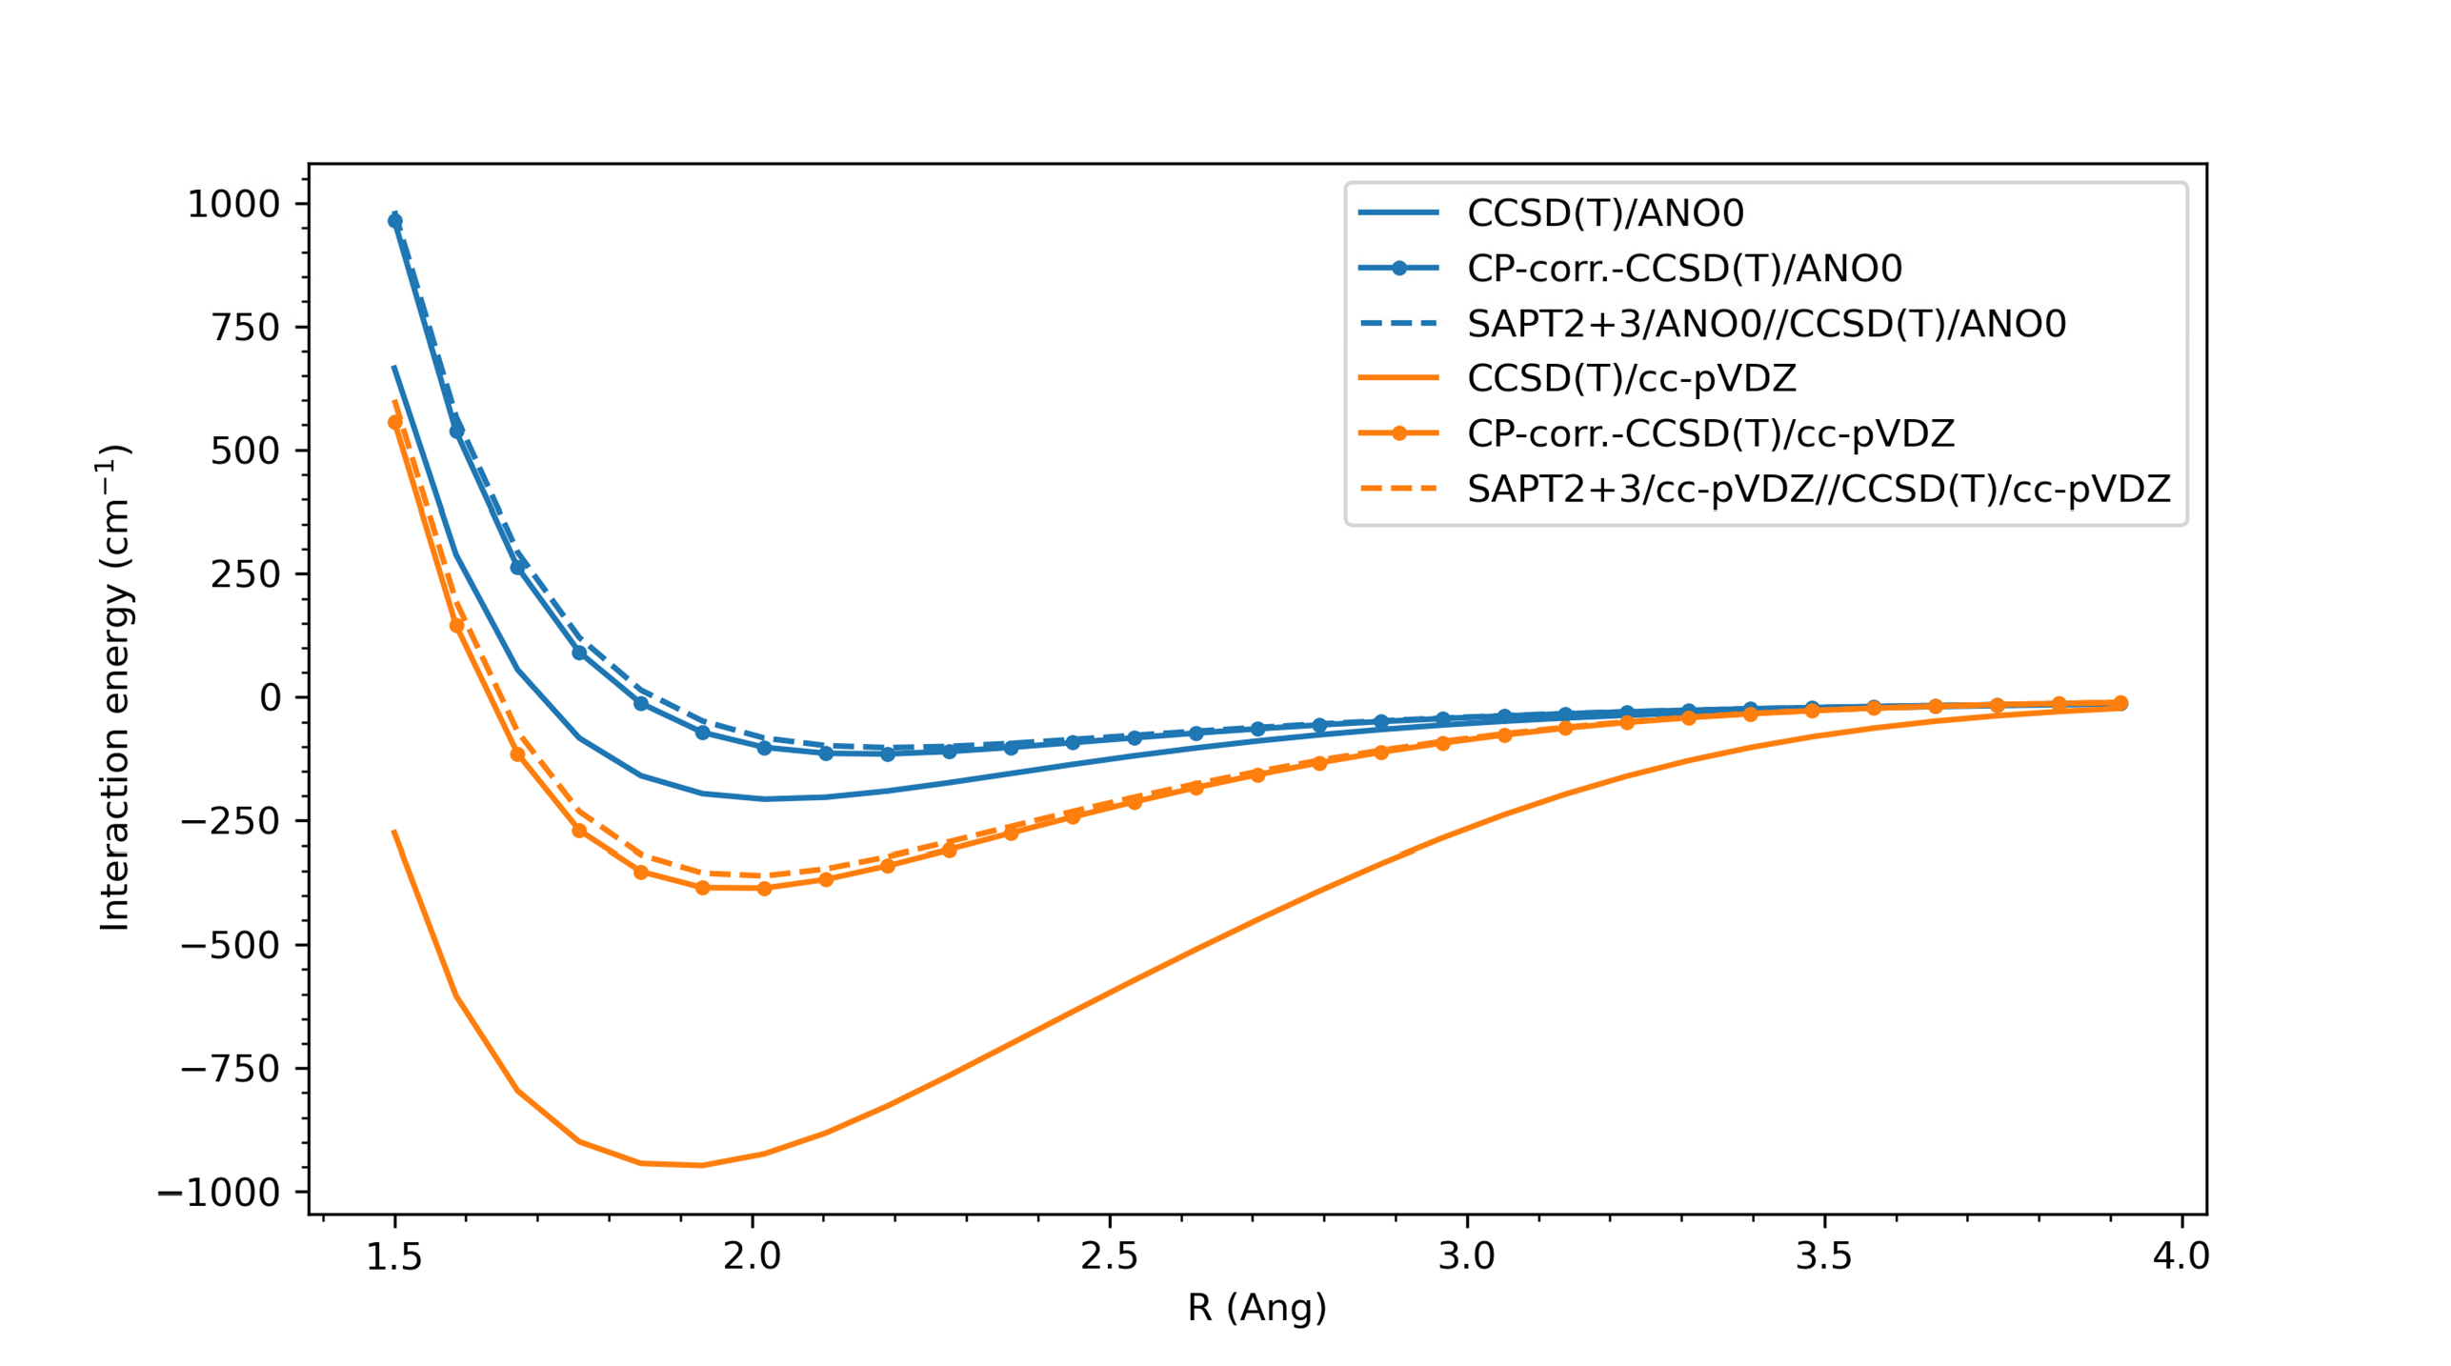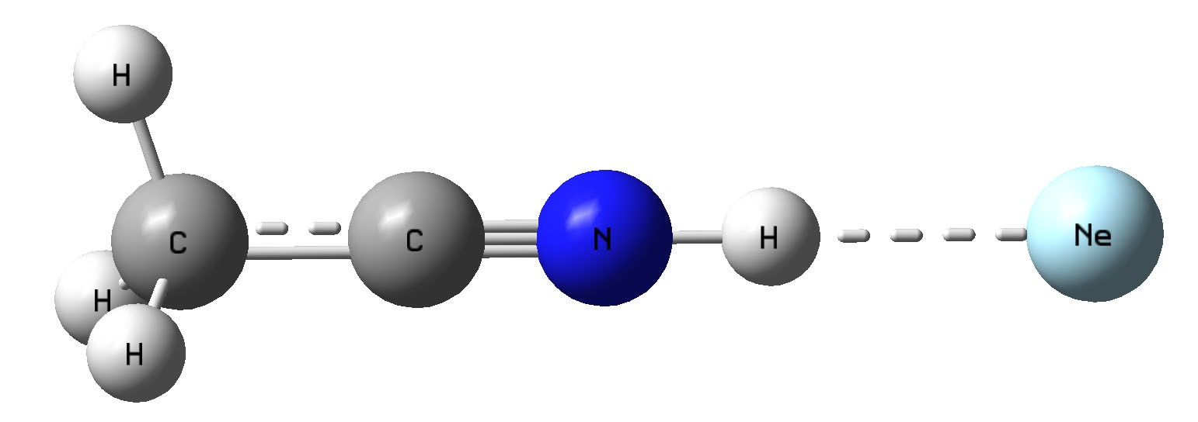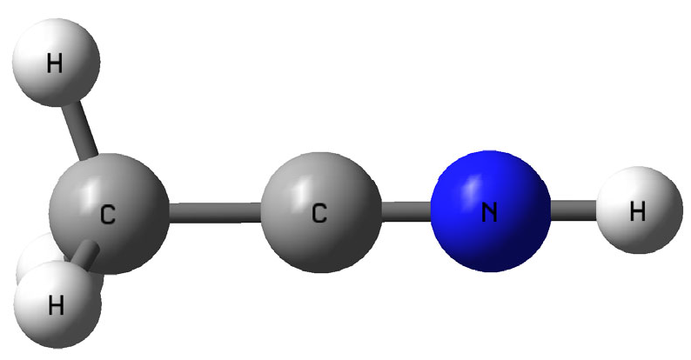

**+**

**R**

Figure 4.5.: Computed potential energy surface as a function of H-Ne distance R for the minimum energy C3*v* structure of the CH3CNH+-Ne complex at various levels of theory.

**4**

ion was optimized at the CCSD(T)/cc-pVDZ level of theory, and then kept rigid at its equilibrium structure in the following calculations. Potential energy scans were performed at the same level of theory as a function of the distance of the neon ligand from the CH3CNH+ ion along three trajectories: i) along the molecular symmetry axis, starting from the protonation site, ii) along the CH coordinate of the methyl group, and iii) starting from the nitrogen atom and moving perpendicular to the molecular symmetry axis. The resulting PESs are shown in the Supplementary Information, Figure B.1, revealing the *C*3*v* structure, with the neon atom bound to the proton, to be the global minimum.

The global minimum structure of the complex was further investigated to account for the Basis Set Superposition Error (BSSE) problem which is a mathematical artefact present in all molecular electronic structure calculations. It is due to the fact that the practical quantum chemical calculations are restricted to the use of finite basis sets [265]. This means that in a complex, the basis sets of the monomers are going to overlap and a situation arises where each atom borrows basis set functions of the other atom, effectively

increasing its basis set and therefore stabilizing its energy, i.e. leading to an artificially too deep potential well, as was first observed for the helium- helium dimer interaction[145, 266]. Since BSSE is strongly geometry dependent, the corresponding PES can substantially differ from the BSSE-free ones [267]. The usual way to correct for BSSE is based on the counterpoise (CP) scheme introduced by Boys and Bernardi [146]. This effect can be clearly noticed in the computed PES as shown in Figure 4.5. The BSSE for comparably sized basis sets, cc-pVDZ and ANO0, are −572 cm−1 and −102 cm−1, respectively (see Table 4.3). Additionally, symmetry-adapted perturbation theory (SAPT) which was developed specifically to describe non-covalent interactions between atoms and/or molecules [147, 148], was also computed on the optimized geometry of CH3CNH+ using the CCSD(T) method with cc-pVDZ and ANO0 basis sets. Since the SAPT computes the interaction energy directly via a pertubative approach, it is inherently BSSE-free as we can also clearly see in Figure 4.5. Interestingly the SAPT interaction energy results are very similar to the CP-corrected CCSD(T) (see Figure 4.5) while being computationally much more efficient as was also noted in previous studies [268]. Therefore, to conclude, the ANO0 basis set removes BSSE relatively more efficiently than the corresponding cc-pVDZ (see Figure 4.5) and also performs better for frequency calculation (see Table B.3 in the Supplementary Information). This is in agreement with previous studies

**4**

[217] where several small poly-atomic molecule’s fundamental frequencies were

computed at CCSD(T) using both cc-pVXZ(X=D,T,Q) and ANOX(X=0,1,2) basis sets, and compared with experimental results. Here the authors stated that the ANO0 outperforms the similarly sized cc-pVDZ basis sets at least for frequency calculations.

Concluding that CCSD(T) in combination with ANO basis sets provides reliable results for structural calculations of the weakly bound CH3CNH+-Ne complex, we calculated its harmonic vibrational frequencies and compared them to those obtained for the bare CH3CNH+ ion at the CCSD(T)/ANO0 level of theory. The calculated differences in band positions were added to the anharmonic fundamental mode positions of the bare ion obtained at the CCSD(T)/ANO2 level of theory, and are summarized in Table 4.1. For most modes the complexation with neon leads to band shifts of below 1 cm−1, within the uncertainty of the experimental data. An exception are the CNH bending and NH stretching modes, with calculated differences of +18 and −9 cm−1, respectively. This is not surprising, since the binding site of the neon atom is at the N*H* -proton, which is involved in those two vibrational modes, causing a blue and red-shift, respectively, of the bending and stretching bands. Similar but more pronounced effects have been seen for other smaller molecular ions tagged with neon, e.g., HCO+ [269] and CH3+ [270]. It is interesting to note that the

corrected frequency for the CNH bending mode now matches the experimental IRPD band position to within its uncertainty. Apart from inducing bandshifts, the IRPD messenger-tagging method can lead to additional bands in the recorded vibrational spectrum caused by combination modes of fundamental modes of the ion core with intramolecular modes involving the neon atom. For the CH3CNH+-Ne complex harmonic calculations predict a degenerate bending mode (E) at 32 cm−1 and a stretching mode (A1) at 68 cm−1 due to vibrations of the neon atom (See Table B.3 in the Supplementary Information). The low-lying bending mode frequency matches well with the frequency difference of weak satellite features observed to the blue of the CCN bending mode (at 414 cm−1

), the CNH bending mode (at 611, 620, 644, 664 cm−1 ), and the CH3 umbrella mode (1388 cm−1 ). These combination modes might also be responsible for the observed shoulder towards higher frequencies of the CCN bending overtone at 1157 cm−1. The long progression of combination bands with multiple excitation of the Ne bending mode seen for the CNH bending mode might be explained by effective dissociation of the CH3CNH+-Ne complex upon excitation along the Ne dissociation coordinate, similar effects have been observed previously for other ion ligand complexes [69, 72, 271].

**4**

* 1. CONCLUSIONS

In this work, we present a comprehensive experimental and quantum-chemical study of the vibrational spectrum of CH3CNH+, a potential interstellar mole- cular ion. Experimental band positions were measured for all fundamental bands, with the exception of the NH stretching band that was studied previously [253, 255]. The assignment of the corresponding vibrational modes was straight- forward based on anharmonic frequency calculations of the bare ion performed at the CCSD(T)/ANO2 level of theory. We could demonstrate that quantum- chemical calculations using the comparatively low-cost ANO0 basis set provide accurate estimates on the influence of the weakly-bound neon atom, used as tag in the IRPD experiments, on the vibrational band positions.

The experimental vibrational frequencies obtained in this work provide reli- able reference data for infrared astronomical observations to search for proto- nated methyl cyanide in warmer regions of the ISM or within (exo-)planetary atmospheres, such as that of Titan, where CH3CNH+ has been mass spectro- scopically detected [249]. The present results also provide a basis for further laboratory studies of CH3CNH+ at higher resolution in the infrared, e.g., via ac- tion spectroscopic schemes like LIICG pioneered in the Schlemmer group [67, 272], and for measurements of rotational transitions in its energetically low-

lying vibrational states, for which spectroscopic constants are predicted based on high-level quantum-chemical calculations.

This work demonstrates once more the versatility of IRPD using weakly bound rare gas atoms as tags, providing vibrational spectra very closely resembling those of the bare ion. However, the proverbial “innocence" of the neon atom needs to be taken with a grain of salt. For the rather small CH3CNH+ molecular ion quite substantial shifts > 10 cm−1 were observed for those vibrational modes that involve the binding site of the neon atom, as also verified by our quantum-chemical calculations. Experiments using helium as tag might be better suited, due to its even lower polarizability and binding energy, as has been demonstrated previously [69, 273–275]. However, for the same reason, i.e. its lower polarizability, He-ion complexes have smaller binding energies, and thus show lower complexation yields, which in turn results in lower signal-to-noise spectra. Using neon as tagging agent in IRPD is thus a reasonable compromise, and allows in combination with the widely tunable FELIX FELs to uncover broad range vibrational spectra of a large class of molecular ions.

**4**

## 5

**A VIBRATIONAL ACTION SPECTROSCOPIC STUDY OF THE**

### Renner-Teller and spin-orbit

##### AFFECTED CYANOACETYLENE RADICAL CATION HC3N+

This chapter is adapted from : Steenbakkers, K., Marimuthu, A.N., Redlich, B., Groenenboom, G.C., Brünken, S.. J. Chem. Phys. 158, 084305 (2023).

This work is an equal contribution of Steenbakkers, K. and Marimuthu, A.N. I would like to thank Steenbakkers, K for her vital contribution to this study, especially the theoretical part.

117

Abstract

The linear radical cation of cyanoacetylene, HC3N+(2Π), is not only of astrophysical interest, being the, so far undetected, cationic counterpart of the abundant cyanoaceteylene, but is also of fundamental spectroscopic interest due to its strong spin-orbit and Renner-Teller interactions. Here, we present the first broadband vibrational action spectroscopic investigation of this ion through the infrared pre-dissociation (IRPD) method using a Ne tag. Experiments have been performed using the FELion cryogenic ion-trap instrument in combination with the FELIX free-electron lasers and a Laservision OPO/OPA system. The vibronic splitting patterns of the three interacting bending modes (*ν*5,*ν*6, *ν*7), ranging from 180 − 1600 cm−1, could be fully resolved revealing several bands that were previously unobserved. The associated Renner-Teller and intermode coupling constants have been determined by fitting an effective Hamiltonian to the experimental data, and the obtained spectroscopic constants are in reasonable agreement with previous photoelectron spectroscopy (PES) studies and *ab initio* calculations on the HC3N+ ion. The influence of the attached Ne atom on the infrared spectrum has been investigated by *ab initio* calculations at the RCCSD(T)-F12a level of theory, which strongly indicates that the discrepancies between the IRPD and PES data are a result of the effects of the Ne attachment.

**5**

* 1. INTRODUCTION

The simplest cyanopolyyne, cyanoacetylene (HC3N), is one of the most wide- spread polyatomic species in the interstellar medium (ISM) and has been observed in a variety of astronomical sources in the Milky Way and in external galaxies[276–278]. It also plays an important role in the complex nitrogen chemistry of Titan, Saturn’s largest moon, being one of the most abundant nitrogen bearing species detected in its atmosphere. [241, 279]. Its highly reactive cationic counterpart, HC3N+, is efficiently produced by ionization of the neutral cyanoacetylene by solar vacuum-ultraviolet (VUV) radiation and may participate in Titan’s thiolin formation [249]. In the ISM, neutral HC3N is readily ionized by cosmic rays or UV photons to form HC3N+[280]. However, this cation has yet to be detected in the ISM, which is likely a result of lack of reference data. Besides being astrochemically relevant, the cyanoacetylene radical cation (2Π) is interesting on a fundamental spectroscopic level due its open-shell linear character. The vibronic coupling effects that occur as a result of this character, such as Renner-Teller (RT) [281] coupling, cause a breakdown of the Born- Oppenheimer (BO) approximation. Subsequent analysis of the complex splitting pattern then requires methods that go beyond the BO approximation, such as effective Hamiltonian analysis (for small couplings)[282] or a full nonadiabatic

**5**

description of the molecule.[283, 284]

Previous work on HC3N+ includes several low- and high-resolution photoelec- tron spectroscopy (PES) studies [285–288]. The high-resolution pulsed-field ion- ization zero kinetic energy (PFI-ZEKE) study by Dai *et al.* [285] presented suffi- cient experimental resolution to reveal an intricate RT and spin-orbit (SO) split- ting pattern in the observed vibronic spectrum, which was analyzed on the basis of diabatic calculations. The observed medium to weak coupling strengths make this ion an excellent candidate for an effective Hamiltonian analysis rendering experimental spectroscopic constants that can be used to benchmark *ab initio* calculations.

Vibrational spectroscopic work on HC3N+ is limited to a Ne-matrix assisted absorption spectroscopy study in the C-H stretching region[289], which does not contain any information on the three RT affected vibrational bending modes. Gaining information on these modes through vibrational spectroscopy would be complementary to the earlier PES work due to the different selection rules at hand and would aid to a full understanding of this complex ion. Furthermore, this data could serve as a reference for future high-resolution studies and for astronomical searches (e.g., with the James Webb Space Telescope operating in the infrared region).

Infrared pre-dissociation spectroscopy (IRPD) is an excellent method to obtain gas-phase vibrational spectra of molecular ions. Here a messenger (usually a

rare-gas atom) is weakly bound to the target ion at cryogenic temperatures and its subsequent on-resonant dissociation is monitored by mass spectrometry. This messenger atom, also called tag, acts as a spectator and in the case of rare- gas atoms like He or Ne its influence on the vibrational structure is generally rather small [119, 120, 263]. This method is especially suited for small reactive cations, since other (tag-free) action spectroscopic methods are not suitable [51](e.g.infrared multi-photon dissociation is limited due to the small size of the ion [290, 291], laser induced reactions [95] require a suitable endothermic reaction, and laser inhibition of complex growth [292, 293] does work only with cw lasers).

The goal of the present study is to obtain the first broad-band gas-phase vibrational spectrum of the HC3N+ cation covering all fundamental vibrational modes including the RT perturbed bending modes, in order to complement and extend the earlier PES studies. The spectrum was recorded by means of infrared pre-dissociation spectroscopy (IRPD) using Ne as a rare-gas (RG) messenger atom carried out in a cryogenic ion trap interfaced with the widely tunable FELIX (Free Electron Laser for Infrared eXperiments) [122] free electron laser [69]. The recorded spectrum is fitted with an effective Hamiltonian and compared to *ab initio* calculation of Dai *et al.* [285], and the results are discussed with an emphasis on the influence of the Ne atom used as a tag in the IRPD scheme.

**5**

* 1. METHODS
     1. Experimental methods

The vibrational spectrum of the cyanoacetylene cation (HC3N+) was recorded using the FELion cryogenic 22-pole ion trap instrument. A detailed account of the FELion instrument is provided in Section 2.1 and the infrared- predissociation (IRPD) of in-situ rare gas tagged cold molecular ions in Section 1.5.1.1, and here we only give a brief account of details specific to the HC3N+ ion. The ion is produced by direct electron impact ionization [28(2) eV] from the neutral precursor acrylonitrile (CH2CHCN, ≥ 99% purity, Sigma-Aldrich). The liquid precursor was evaporated into the ion source and diluted with helium in a 5:1 (He:CH2CHCN) mixing ratio. An about 100 ms long pulse of ions is extracted from the source and the ions of interest, *i.e.*, HC3N+ with m/z 51, are mass selected by a quadrupole mass filter before entering the 22-pole ion trap which is held at a fixed temperature in the range 8−9 K. Around 10−15 ms before the ions enter the trap, an intense ∼80 ms long Ne:He pulse (1:3 mixing ratio and number density of ∼ 1015 cm−3) is admitted to the trap, leading to efficient collisional cooling of the ions close to the trap ambient temperature and the formation of Ne-ion complexes by termolecular collisions. Under these conditions, around

∼ 10% of the primary ions form weakly bound complexes with Ne, see Fig. 5.1.

The ions are stored for several seconds in the ion trap (typically 1 − 3 s) and are exposed to several FELIX IR laser pulses before extraction. An IRPD spectrum is recorded by mass-selecting and detecting the Ne−HC3N+ complex ions as a function of wavenumber. The following wavenumber ranges were covered in this study: (a) 130 − 270 cm−1, (b) 310 − 2500 cm−1 , and (c) 3110 − 3270 cm−1, using the free-electron IR lasers FEL-1 (a) and FEL-2 (b) of the FELIX Laboratory with macropulse repetition rate of 10 Hz, maximum pulse energy in the trap region of < 35 mJ (at 1100 cm−1), and linewidths (fwhm) of around 0.5 % of the center wavenumber. Region (c) was covered using a Laservision OPO/OPA system (∼ 1 cm−1 fwhm, 10 Hz repetition rate) with typical output power of

1

< 20 mJ.

A relative depletion *D* = 1 − *N*ON(*ν*) in the number of complex ions *N*ON(*ν*) from the baseline value *N*OFF is observed upon resonant vibrational excitation. To account for varying laser pulse energy *E* , pulse number *n*, and for saturation effects, the signal is normalized prior to averaging using *I* = −ln[*N*ON(*ν*)/*N*OFF] , giving the intensity *I* in units of cross-section per Joule. After normalizing each individual spectrum in this way, the final spectrum is then obtained by averaging using statistical binning with a typical bin size of 2 cm−1. Line parameters such as band positions, intensities, and line widths (fwhm) are then obtained by fitting

**5**

*N*OFF

*E* (in J)

1<https://www.ru.nl/felix/about-felix/about-felix/felix-laboratory/>

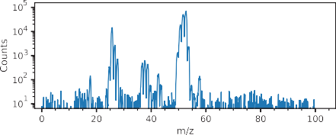

**(a)**

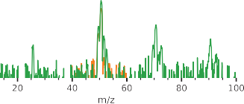

**(b)**

Figure 5.1.: (a) Mass spectrum of ions produced from electron impact ionization (∼ 28 eV) of acrylonitrile (blue). (b) Mass-selected (orange) HC3N+ (m/z 51) together with tagged (green) Ne−HC3N+ (m/z 71) complexes produced in the cryogenic ion trap at temperature 8.5(2) K and He:Ne gas mixture number density of 9(1) 1014 cm−3. The attachment of isotopic 22Ne can also be seen in panel (b). A small contamination from C3N+ (m/z 50) can be seen in the mass-selected spectrum, resulting from insufficient mass-filtering of the primary ions.

·

a multi-component Gaussian function to the experimental data, also providing statistical errors of the line parameters.

* + 1. THEORETICAL APPROACH
       1. AB INITIO

To understand and describe the vibrational IRPD spectra and the influence of the attached Ne atom on the observed band positions we performed *ab initio* quantum chemical calculations on the HC3N+ cation and the Ne−HC3N+ complex. Geometry optimization and subsequent harmonic wavenumber calculations on the bare ion were performed at the partially spin-restricted, explicitly correlated, coupled cluster level of theory, with single, double, and perturbative triple excitations, RCCSD(T)-F12a [294] using cc-pVXZ-F12 (X=D,T,Q) [295] basis sets, and for the Ne−HC3N+ using the cc-pVTZ-F12 basis set. Information on the perpendicular component of the dipole moment of the bare ion was obtained by the use of finite-field perturbation theory, where a finite dipole field (*F* = 0.005 a.u.) is added to the core energy and the one-electron Hamiltonian. The dipole moment *µ* is then obtained as

**5**

*µ E* (+*F* ) − *E* (−*F* ) , (5.1) 2*F*

= −

where *E* (*F* ) is the energy as a function of the field.

To investigate the interaction of HC3N+ with the Ne atom a one-dimensional cut of the potential energy surface was made by attaching the Ne atom to the middle carbon atom for fixed Ne-C-H angles, while optimizing all other geometry parameters. All quantum chemical calculations were performed using the MOLPRO suite, version 2015.1.[296]

* + - 1. EFFECTIVE HAMILTONIAN

The spin-vibronic energy levels of HC3N+ were calculated with an effective Hamiltonian approach similar to the model of He and Clouthier [282] following the nomenclature employed by Dai *et al.* [285]. We ignore the effects of molecular rotation since its effects are too small to be seen with the experimental resolution of approximately 0.5% of the center wavenumber: for Ne−HC3N+ complex *Be* ≈

0.033 cm−1, calculated at the RCCSD(T)-F12a/cc-pVTZ-F12 level of theory. A Hund’s case (a) basis, |***n***〉, was chosen with:

7

fl

|***n***〉 = |Λ〉|Σ〉 |*vk* , *lk* 〉|*K* 〉|*P* 〉. (5.2)

*k*=5

Here, quantum numbers Λ = ±1 and Σ = ±1/2 are the projection of the orbital and spin angular momenta on the molecular axis, respectively, *vk* = 0, 1,... is

the vibrational quantum number of mode *vk* and *lk* is the projection of the vibrational angular momentum (*lk* = −*vk* , −*vk* + 2,..., *vk* ). We only include the three bend normal modes *v*5 − *v*7. Quantum number *K* = Λ + *k lk* is the projection of the total angular momentum excluding electron spin and *P* = *K* +Σ is the projection of the total angular momentum onto the molecular axis. In the case of strong vibronic coupling, such as RT coupling, Λ and *lk* are ill- defined, but *P* is a good quantum number since we neglect overall rotation. Furthermore, we only include diagonal spin-orbit coupling and first order RT, see below, and hence *K* is also a good quantum number. For a basis truncated at *v*tot = *v*5 + *v*6 + *v*7 = 8 we find that energy levels are converged up to *v*tot = 3.

L

We approximate the total effective Hamiltonian by:

*H*ˆ = *H*ˆvib + *H*ˆSO + *H*ˆRT, (5.3)

where *H*ˆvib represents the harmonic vibrational energy,

**5**

7

*H*ˆvib = *ωk* (*νk* + 1) |*νk* 〉〈*νk* |, (5.4)

*k*=5

with *ωk* the harmonic frequencies of the bending modes *ν*5 − *ν*7. The spin-orbit Hamiltonian is given by [297]

*H*ˆSO = *A*SO*L*ˆ*z S*ˆ*z* , (5.5)

where we take the SO constant *A*SO = −44 cm−1 independent of the vibrational mode [285] and *L*ˆ*z* and *S*ˆ*z* are the molecule fixed components of the electronic orbital and spin angular momenta operators, respectively. The effective RT Hamiltonian is [298]

*H*ˆRT =

1 7

2 *k*=5

*k*,+

*gk q*2 + *g*56 *q*5,+*q*6,+ + *g*57 *q*5,+*q*7,+ + *g*67 *q*6,+*q*7,+

|Λ = −1〉〈Λ = 1| +h.c.,

(5.6)

where h.c. stands for Hermitian conjugate and the operator |Λ = −1〉〈Λ = 1| couples the two diabatic electronic states. The constants *gk* are related to the dimensionless RT constants *ϵk* as

*gk* = *ϵk ωk* (5.7)

and the coupling parameters *gkl* are related to the dimensionless intermode RT couplings *ϵkl* by

*gkl* = *ϵkl* I*ωk ωl* . (5.8)

The spherical normal mode operators *qk*,± are related to the Cartesian normal modes *qk*,*x* and *qk*,*y* by

*qk*,± = *qk*,*x* ± *iqk*,*y* . (5.9)

The wave function is expanded in the basis

|Ψ*i* 〉 = ***n*** |***n***〉*u****n***,*i* (5.10)

and the expansion coefficients *u****n***,*i* are determined variationally by solving the matrix eigenvalue problem given below, using the free and open source numerical software SCILAB version 6.1.1. [299].

***Hu****i* = *Ei* ***u****i* , (5.11)

Here *Ei* are the eigenvalues and ***H*** the Hamiltonian matrix of which the matrix elements are given in Ref [282]. All parameters, excluding *A*SO and the *g*57 intermode RT coupling parameter, were obtained from a nonlinear least-squares fit to 14 lines of the experimental spectrum. We use the lsqrsolve Levenberg- Marquardt algorithm implemented in SCILAB, starting from the calculated spectroscopic parameters of Dai *et al.* [285]. For this purpose we write the Hamiltonian matrix ***H*** as

**5**

8

***H*** = ***H***0 + *pj* ***H*** *j* , (5.12)

*j* =1

where the *pj* ’s are the parameters to be fitted {*ω*5, *ω*5, *ω*7, *g*5, *g*6, *g*7, *g*56, *g*67} and ***H***0 contains the spin-orbit Hamiltonian and *ν*5−*ν*7 intermode RT coupling which are kept constant. The fitting algorithm employs the Jacobian matrix ***J*** of the derivatives of the transition energies *Ei* − *E*0 with respect to the parameters

*J* B(*Ei* − *E*0) . (5.13)

*i j* =

B*pj*

We obtain the derivatives of the energies with respect to the parameters as expectation values of the Hamiltonian matrices ***H*** *j* for the normalized eigenvectors ***u****i*

B*Ei T*

B*pj* = ***u****i* ***H*** *j* ***u****i* . (5.14)

where the *T* indicates the transpose of the column vector ***u****i* . The fitting error (*σj* ) in parameter *pj* is approximated by:

*σj* = J***C*** *j*,*j* , (5.15)

where the covariance matrix ***C*** is related to the Jacobian matrix ***J*** and the root- mean-squares (RMS) error in the transition energies (*r* ) by

***C*** = (***J*** *T* ***J*** )−1*r* 2. (5.16)

Finally, the intensities are computed by

*Ik* (*i* ′ ← *i* ) = 〈Ψ*i*′ |*µ*ˆ±|Ψ*i* 〉 2 , (5.17) where the dipole operator *µ*ˆ± is approximated by

7

*µ*ˆ± = *µk*⊥*qk*,±. (5.18)

*k*=5

The perpendicular dipole moments *µk*⊥ are given in Sec. 5.3.2.

**5**

* + - 1. THE HC3N+ ION

The linear HC3N+ ion exhibits a 2Π3/2 electronic ground state known from experimental PES work and calculations [285–287]. As discussed in earlier work [285–288] the *ν*1-*ν*4 modes represent the C H, C N, C C, and C C stretches (of *a*1 symmetry), and the *ν*5-*ν*7 H C C, C C N, and C C C in- (*b*1) and out-of-plane (*b*2) bendings, respectively. Here the plane is defined with respect to the molecular orbitals. For closed-shell species these bending modes are degenerate, but since this ion is open-shell and linear they are RT perturbed.

Already within the Born-Oppenheimer approximation the degeneracy is lifted and the RT coupling causes a complicated splitting pattern in the vibrational structure. *Ab inito* spectroscopic parameters and experimental results from the earlier PFI-ZEKE work of Dai *et al.* [285] show that *ν*5 has the largest RT perturbance (*ϵ*5 ≈ 0.18), while *ν*6 (*ϵ*6 ≈ −0.05) and *ν*7 (*ϵ*7 ≈ −0.06) are only minimally affected. Some differences between the vibrational IRPD spectrum and the PES work may, however, be expected because of the different selection rules at hand; photoelectron spectroscopy is subjected to Franck-Condon overlap and vibrational spectroscopy to the ∆*K* = ±1 and ∆*P* = ±1 selection rules for the RT perturbed bending modes and ∆*P* = 0 for the stretching modes. Furthermore, the HC3N+ is cooled to its vibrational and SO ground state (*P* = 3/2, *A*SO = −44 cm−1), so that one of the two SO components is predominantly observed (*P* = 3/2 for the stretching modes and *P* = 1/2 or *P* = 5/2 for the bending modes ). The population of the other SO level should be limited to approximately ∼ 4.5 %, based on a Boltzmann distribution calculated with 44 cm−1 energy level separation and an estimated ion temperature of 20 K.

* 1. RESULTS AND DISCUSSION

Harmonic vibrational calculations were performed on RCCSD(T)-F12a/cc- pVXZ-F12 (X=D,T,Q) level of theory both for the bare ion as well as the ion-Ne complex (see Sec. 5.3.3). The calculated equilibrium geometries are in good agreement with previous calculations [285, 286, 288] and are shown for the sake of completeness in Table 5.1.

Table 5.1.: Calculated equilibrium bond lengths (in Å) of the bare ion for linear geometry.

H C C C C C C N

|  |  |  |  |  |
| --- | --- | --- | --- | --- |
|  |  |  |  |  |
| RCCSD(T)-F12a/cc-pVQZ-F12 | 1.078 | 1.244 | 1.339 | 1.186 |
| RCCSD(T)-F12a/cc-pVTZ-F12 | 1.078 | 1.244 | 1.339 | 1.186 |
| RCCSD(T)-F12a/cc-pVDZ-F12 | 1.078 | 1.245 | 1.340 | 1.187 |
| RCCSD(T)-F12a/cc-p(c)VTZ-F12 1 | 1.078 | 1.244 | 1.339 | 1.180 |
| CASPT2/AVTZ 2 | 1.067 | 1.237 | 1.328 | 1.188 |
| CCSD(T)/AVTZ 3 | 1.072 | 1.213 | 1.352 | 1.155 |
| PBE0/AVTZ 3 | 1.079 | 1.233 | 1.333 | 1.179 |

**5**

1 From Ref. [285] 2 From Ref. [286] 3 From Ref. [288]

Figure 5.2 shows the recorded IRPD spectrum of HC3N+ using Ne as a messenger atom in the range 130 − 250 cm−1 (FEL-1), 350 − 2500 cm−1 (FEL- 2), and 3110 − 3270 cm−1 (OPO). The obtained line positions are shown in Table

5.2 together with previous experimental [285–289] and computational [285, 287] work. To gain accurate line positions of the weaker bands the relative depletion spectrum (not power corrected) was fitted with a Gaussian profile as described above (Sec. 5.2.1). A full list of the obtained frequencies, relative intensities and their uncertainties is given in Appendix Table C.1. The provided relative intensities were estimated from the power normalized spectrum. For clarity we treat the assignment of the well behaved stretching modes (Sec. 5.3.1) separately from the analysis of the RT and SO splitting patterns of the bending modes (see Sec. 5.3.2).

* + 1. STRETCHING MODES

The bands at 3184, 2170, and 1846 cm−1 can be readily assigned to the *ν*1, *ν*2, and *ν*3 modes representing the C H, C N, and C C stretches, respectively, and they are in good agreement with *ab initio* calculations and earlier experimental work presented in Table 5.2. It is noteworthy that the *ν*1 mode is approximately 60 cm−1 blue-shifted compared to earlier PES works, which is likely a direct consequence of the Ne attachment (see Sec. 5.3.3). This hypothesis

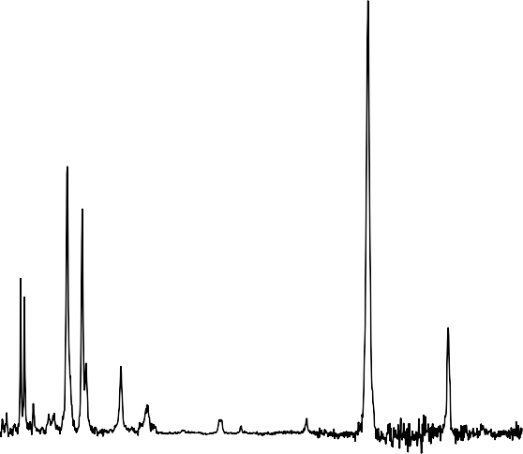

v3

v2

v4

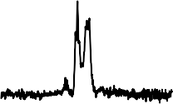

v1

500 1000 1500 2000 2500

Normalized intensity (rel.units)

Wavenumber (cm-1)

3150

3200

3250

Figure 5.2.: Measured IRPD spectrum of the HC3N+ ion in the range 130-270 cm−1 (FEL1) 310-2500 cm−1 (FEL2), and 3110-3270 cm−1 (OPO)

**5**

using Ne as a messenger atom. The *ν*1-*ν*4 labels represent the four stretching modes of HC3N+and *ν*5-*ν*7 the RT-affected bending modes. A full list of the obtained frequencies, relative intensities and their uncertainties is given in Appendix Table C.1.

is strengthened by comparing our experimentally derived wavenumber to the earlier Ne-matrix assisted vibrational spectroscopic measurements by Smith- Gicklhorn *et al.* [289] exhibiting a similar blue-shift.

In the *ν*1 mode a clear substructure is observed with peaks at 3174.0, 3182.9, 3184.7, 3185.7, 3192.9, and 3195.2 cm−1 . The predicted rotational structure (calculated with PGOPHER [129] at 20 K and using *B* = 0.033 cm−1 for the Ne−HC3N+, see Appendix Figure 1) has a FWHM due to unresolved rotational structure of approximately 4 cm−1 and cannot explain all observed peaks. We hypothesize that the 3183, 3184, and 3185 cm−1 peaks are the P, Q, and R branches of the C H stretch, though the observed strong Q-band intensity remains a mystery. The 3192 and 3195 cm−1 bands may be attributed to the P-R branches of a combination band of the C H stretch with one of the low-lying modes involving the Ne atom, which is linearly attached to the hydrogen atom (see Sec. 5.3.3).

5. VIBRATIONAL SPECTRA OF HC3 N+

128

Table 5.2.: Comparison of experimental and calculated harmonic frequencies (in cm−1). If the bands are split due to vibronic interaction the lowest and highest observed components are given.

**5**

|  |  |  |  |  |  |  |  |
| --- | --- | --- | --- | --- | --- | --- | --- |
|  | *ν*1 | *ν*2 | *ν*3 | *ν*4 | *ν*5 | *ν*6 | *ν*7 |
| IRPD (This work) | 3184(1) | 2171(1) | 1845(1) | 957(1) | 626(1)-846(1) | 439(1)-490(1) | 189(1)-238(1) |
| PFI-ZEKE 1 | . . . | 2176(4) | . . . | . . . | . . . | 445(5) | 198(5) |
| TPES 2 | 3123(20) | 2177(20) | 1855(30) | 829(30) | 648(40) | 422(20) | 203(40) |
| IR-matrix 3 | 3196.47 | 2175.79 | 1852.82 | . . . | . . . | . . . | . . . |
| SPES 4 | 3105 | 2185 | 1830 | . . . | . . . | 411 | . . . |
| PFI-ZEKE 5 | 3121 | 2171 | . . . | . . . | 628-873 | 438-488 | 190-236 |
| RCCSD(T)-F12a 6 | 3318 | 2224 | 1870 | 910 | [767,646] | [427,410] | [183,179] |
| RCCSD(T)-F12a 7 | 3317 | 2222 | 1868 | 908 | [771,644] | [462,444] | [196,186] |
| RCCSD(T)-F12a 8 | 3316 | 2217 | 1864 | 907 | [763,638] | [452,436] | [194,186] |
| RCCSD(T)-F12a 9 | 3322 | 2228 | 1872 | 912 | [843,699] | [474,449] | [204,198] |
| CASPT2 10 | 3467 | 2270 | 1881 | 951 | [853,687] | [501,468] | [222,215] |

1 From Ref. [287] 2 Threshold Photoelectron Spectroscopy (TPES) from Ref. [286] 3 From Ref. [289]

4 Slow Photoelectron Spectroscopy (SPES) from Ref. [288] 5 From Ref. [285] 6 Using cc-pVQZ-F12 (this work)

7 Using cc-pVTZ-F12 (this work) 8 Using cc-pVDZ-F12 (this work)

9 Using cc-p(c)VQZ-F12 basis from Ref. [285] 10 Using CASPT2/AVTZ/CAS(9,9) from Ref. [286]

Less trivial is the assignment of the *ν*4 C C stretching mode, which we attribute to the band observed at 950 cm−1. This value agrees with harmonic vibrational wavenumber calculations that predict a band between 908-951 cm−1, depending on the level of theory, but is significantly different from the 829 cm−1 reported in the earlier Threshold PES (TPES) work of Desrier *et al.* [286]. The authors speculated that this red-shift is a result of anharmonic coupling of the polyad involving the *ν*4, *ν*6, and *ν*7 vibrational modes. No other works claim to have detected the *ν*4 stretching mode and in the high-resolution ZEKE work of Dai *et al.* [285] it was not mentioned in their analysis. They, however, do observe two bands at 873 and 920 cm−1, which they attribute to the 51*κ*Σ fundamental and the 5172Π1/2 combination band of the RT and SO affected *ν*5 and *ν*7 vibrational modes. We propose that the bands at 873 and 920 cm−1 observed in the ZEKE study are in fact the two SO components of the *ν*4 stretching mode and the band at 829 cm−1 observed in the TPES work to be one of the vibronic splitting components (also observed by Dai *et al.* [285]). In our work, however, only one of the two SO components is observed for all bands, which is a direct result of the cooling of the ions to their vibrational and SO ground state (*P* = 3 , with a population of 96 % based on the Boltzmann distribution at 20 K). Since only ∆*P* = ±1 transitions are allowed for the bending modes and ∆*P* = 0 for the stretching modes we indeed expect to observe only one of the two SO components. The relative blue-shift of the *ν*4 stretching observed

**5**

2

here may be a result of the Ne attachment similar to the effect on the *ν*1 C H stretching mode (see Sec. 5.3.3).

* + 1. VIBRONIC COUPLING EFFECTS

To test our effective Hamiltonian model we first computed the energy levels of the bending modes based on the *ab initio* spectroscopic parameters of Dai *et al.* [285] (see Appendix Table C.2) and the obtained energies fully agree with the earlier work.

Based on our calculations we assign the energy level at 739.9 cm−1 to 51*κ*Σ and the level at 875.4 cm−1 to 51Π3/2. Note that in Table 3 of Dai *et al.* [285] these assignments were reversed. We also computed the vibrational transition intensities, where we may expect the selection rules ∆*K* = ±1 and ∆*P* = ±1 since the employed Hamiltonian does not include any mixing terms with stretching modes or between the *P* and *K* levels. The dipole moments were approximated

by finite-field calculations in the *xy* -plane (perpendicular to the molecular *z*- axis) at normal mode displacement of each of the three bending modes: *µ*5⊥ =

0.21 a.u., *µ*6⊥ = −0.016 a.u., and *µ*7⊥ = −0.0087 a.u.

Based on the calculated wavenumber positions, intensities, and the proposed selection rules, we could safely assign nine bands corresponding to the *µ*Σ,

∆5/2, and *κ*Σ fundamentals of each mode (see Table 5.3). These fundamentals explain the most intense peaks of the spectrum, but several weaker bands remain unassigned. Based on the *ab initio* calculations these unassigned bands could be attributed to combination bands, overtones or transitions that violate the selection rules of our model. Since the density of states in the higher wavenumber region (>800 cm−1) is rather large and all transitions are of very low or zero predicted intensity their assignment is nontrivial. To gain more clarity regarding the assignment of the weak features we performed a nonlinear least squares fit of the fundamental bands to the effective Hamiltonian and iteratively included newly assigned bands. The final fit included the 14 bands marked with a star in Table 5.3. In order to check the validity of this fitting routine as well as the quality of the *ab initio* parameters, the experimental results of Dai *et al.*

[285] were also fitted using this model. The resulting spectroscopic parameters are compared in Table 5.4.

**5**

We found that the *g*57 intermode RT coupling parameter was ill-defined for both fits, likely because of its large covariance with the *g*67 and *g*56 intermode RT coupling terms. Therefore, we decided to exclude the *g*57 parameter in the fit and kept it fixed at the *ab inito* value, which drastically improved the errors on the estimated parameters. Overall, a reasonable agreement was found between both fits and the *ab initio* values and the RMSs are close to the respective experimental uncertainties (3 cm−1 for PES and 1 cm−1 for IRPD). We note, however, that the *g*67 intermode parameter has a large error for both fits, indicating that it is not well defined within our parameter space, which is likely caused by the interdependence with the g57 term. Furthermore, we notice that the *ω*5, *g*55, and *g*56 parameters are significantly lower for the IRPD work compared to the PES values. A possible explanation of this is the effect of the rare-gas attachment, which is discussed in Sec. 5.3.3.

The fitted spectroscopic parameters were in turn used to predict vibrational band positions and intensities. Figure 5.3 shows the predicted spectrum overlaid with the experimental one and the predicted line positions with their (scaled) intensities are given in Appendix Table C.3. By iteratively including new assignments in the fit, we could assign several more bands with reasonable certainty (e.g. bands at 384, 572, 630, 1097, and 1331 cm−1), though the large density of states >800 cm−1 leads to only tentative assignments of the bands at 1243, 1246, and 1595 cm−1. Table 5.3 summarizes the observed bands together with the *ab initio* values and the predictions based on the final fit including the 14 assigned bands (marked with a star).

All of the newly assigned bands are, however, of zero or very low predicted intensity. We suggest three reasons why this may be happening: First, the employed model excludes coupling between stretching and bending modes,

Table 5.3.: Observed and calculated transition frequencies in wavenumbers together with their normalized calculated intensity.

Obs. [int] *Ab initio* [int] Calc. fit [int] Assignment 189(1)* [0.1] 191 [0.042] 190 [0.040] 71*µ*Σ

200(3)* [0.1] 196 [0.044] 195 [0.017] 71∆5/2

208(2) [0.1] . . . . . . 71∆5/2 + *ν*Ne?

231(1) [0.1] . . . . . . . . .

238(1)* [0.224] 237 [0.132] 240 [0.130] 71*κ*Σ

384(1)* [0.057] 382 [0.000] 381 [0.000] 72Π1/2

439(1)* [0.786] 446 [0.073] 440 [0.073] 61*µ*Σ

454(1)* [0.645] 458 [0.081] 452 [0.079] 61∆5/2

490(1)* [0.164] 497 [0.385] 491 [0.354] 61*κ*Σ

552(2) [0.040] . . . . . . . . .

572(1)* [0.048] 577 [0.005] 574 [0.006] 73∆5/2

**5**

626(1)* [0.861] 630 [0.717] 627 [0.735] 51*µ*Σ

630(1)* [0.367] 627[0.0088] 633 [0.013] 73∆5/2

688(1)* [1] 698 [1] 687 [1] 51∆5/2

704(1) [0.326] . . . . . . 51∆5/2 *ν*Ne?

+

846(1)* [0.322] 875 [0.547] 847 [0.563] 51*κ*Σ

926(1) [0.041] . . . . . . *ν*4 stretch

957(1) [0.147] . . . . . . *ν*4 stretch

981(1) [0.035] . . . . . . *ν*4 stretch

1097(1)* [0.013] 1105 [0.003] 1097 [0.002] 6271∆5/2

1243(1) [0.072] 1257 [0.004] 1256 [0.000] 52Π3/2?

1253(1) [0.067] 1259 [0.001] 1256 [0.000] 52Π3/2?

1331(1)* [0.039] 1339 [0.001] 1331 [0.001] 63Σ

1595(1) [0.072] 1616 [0.001] 1594 [0.000] 52Π3/2?

1 Bands marked with * were included in the fit.

2 Tentatively assigned bands are marked with ?.

but mixing of these terms could potentially result in intensity gain of these low-intensity bending modes. Secondly, mode *ν*5 has a reasonably large RT parameter that may necessitate the inclusion of higher order terms in the effective Hamiltonian, which would in turn result in a mixing of the *K* states and with it relax the selection rule ∆*K* = ±1. Finally, by attaching the Ne atom another RT-affected bending mode is generated (see 5.3.3), which could couple to the bending modes of the HC3N+, affecting their intensity and line positions.

Table 5.4.: *Ab initio* and fitted spectroscopic parameters. The fitted parameters are determined based on the bands marked with a * in Appendix Table C.4

*ab initio* 1 Fit PES 2 Fit IRPD (this work)

*ω*5 (cm−1) 713.25 705(2) 699(1)

*g*55 129.50 132(4) 115(2)

*g*56 −54.13 −63(4) −50(3)

*ω*6 (cm−1) 462.05 460(2) 455(1)

*g*66 −24.77 −26(4) −23(2)

*g*573 −34.72 [−34.72] [−34.72]

*ω*7 (cm−1) 198.18 197(3) 198(2)

*g*77 −12.14 −14(2) −14(2)

*g*67 26.81 29(14) 15(10)

RMS (cm−1) 2.8 1.8

**5**

1 From Dai *et al.* [285] 2 Fitted using experimental line po- sitions from Dai *et al.* [285] 3 *g*57 was kept at the *ab initio* value.

* + 1. INFLUENCE OF THE RARE-GAS TAG

One of the main disadvantages of the IRPD method is that the RG-ion complex is taken as a proxy for the spectrum of the bare ion. For larger, closed-shell molecular ions the attachment or rare-gas atoms like Ne or He typically only results in minimal shifts of the vibrational frequencies [119, 120, 264, 275, 300], but symmetry-breaking effects were observed, e.g., in the case of cyclic C3H3+ [201, 301]. The influence of the tag on the bending modes of RT-affected open- shell species has, however, not yet been investigated. When comparing the observed splitting pattern of the Ne−HC3N+ to that of the earlier ZEKE work

[285] of the bare HC3N+ we note two key differences: First, due to the different selection rules we have on the one hand recorded several features that have not been observed previously, such as the 61∆5/2 fundamental, but on the other, we failed to see several combination bands and overtones, such as the bands at 1414 and 1460 cm−1 (see Appendix Table C.4 for a full comparison between the bands observed with ZEKE [285] and IRPD). Secondly, we only see one of the two SO components since the ions are cooled down to their vibrational and SO ground state (Π3/2) and the selection rule ∆*P* = ±1 for the bending modes must be obeyed. Finally, some of the bands that were observed by both methods are shifted compared to each other. To capture this effect in a reliable way the fitted spectroscopic parameters that were presented before in Table 5.4 were

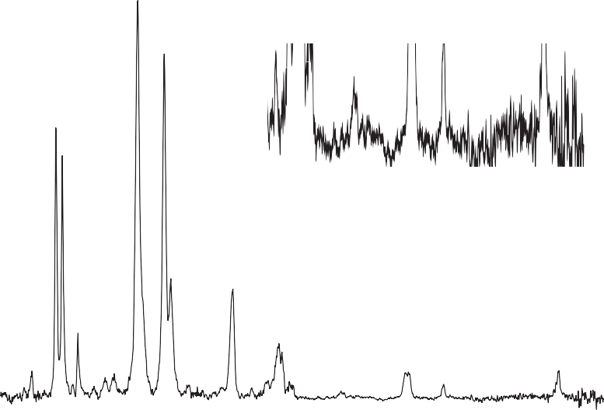

x10

200 400 600 800 1000 1200 1400 1600

**5**

Normalised intensity (rel.units)

Wavelength (cm-1)

Figure 5.3.: Bending region of the IRPD spectrum of Ne−HC3N+ (black) overlaid with the bands predicted from the fitted spectroscopic parameters (orange). For the assignment of weaker features please see Table 5.3. A zoom of the 900 − 1600 cm−1region is presented to show the large density of transitions of weak intensity.

compared. Even though the parameters agree fairly well, the largest deviation is seen in the RT constant of mode *ν*5 (*ϵ*5), which represents the C-C-H bending. We hypothesize that this discrepancy is a result of the Ne attachment.

To investigate the influence of the Ne attachment a scan of the Ne−HC3N+ potential energy surface was made. The Ne atom was attached to the middle C-atom of the HC3N+ and moved around the ion, with all geometry parameters relaxed except for the angle Θ, see inlay in Fig. 5.4. For all Ne−HC3N+geo-metries the bare ion remained linear so that a symmetry plane for the Ne-ion complex could be defined (here xz). The wavefunction can then be either symmetric, A’, or asymmetric, A”, with regard to this plane, where the Π*x* orbital is partially filled for the A’ state and completely filled for the A” state.

Figure 5.4 shows the calculated counter-poise corrected interaction energy as a function of the Ne angle for both A’ and A” symmetry. For both symmetries, the global minimum is located at Θ = 180◦, which represents linear attachment of

the Ne on the H atom, though both states show fairly different potential energy surfaces. Generally, the A’ state is lower in energy than the A” state, which is likely due to the lower electron density in the xz-plane for A’ compared to A”. In order to explain the shape of the curves we can look at the Mulliken charges of the bare HC3N+. The charges on the H, C1, C2, C3, N are +0.37, +0.02, +0.61,

+0.09 and -0.08, respectively. Since the binding strength with the Ne is mainly determined by electrostatic interaction the binding will be stronger for a more positive charge. Furthermore, electrostatic repulsion of the Π*x* orbital must be taken into account. For the A” state this orbital is completely filled so that we only see minima at the H (Θ = 180◦) and C2 Θ = 80◦ positions, where the positive charge is largest. For the A’ the Π*x* orbital is only partially filled, lowering the electrostatic repulsion and allowing the Ne to come closer to the ion thus increasing its interaction energy. For this state a second minimum can then be distinguished at a bent geometry, with Θ = 120◦ and a ∼ 40 cm−1 barrier to linearity.

**5**

Since the Ne atom attaches on the H atom we expect the largest impact to be on the modes that involve this hydrogen, so the C-H stretch (*ν*1) and the C-C-H bend (*ν*5). Harmonic wavenumber calculations (see Table 5.5) indeed show that these modes are most affected. Here modes *ν*1 − *ν*7 correspond to the vibrations of the bare ion, *ν*8 to the Ne-H stretch and *ν*9 to the Ne- H bending. The fact that the bending modes *ν*9 are not fully degenerate indicates that also this mode is Renner-Teller affected and may couple to the bending modes of the bare HC3N+. Whereas in the IRPD experiment the C-H stretching wavenumber is about 60 cm−1 blue-shifted, harmonic wavenumber calculations actually predict a redshift. We hypothesize that this blue shift could be a result of a restriction of the H-stretching amplitude due to the Ne attachment and a subsequent reduction of the anharmonicity of this mode, resulting in a relative blue-shift. Regarding the C-H bending mode, it is beyond the scope of this study to calculate the effect of the Ne attachment on the vibronic splitting patterns: In principle the attachment leads to a six-atom linear open-shell species, introducing an additional degenerate bending mode which likely interacts with the three bending modes of the bare ion discussed above, and is expected to show large-amplitude vibrational characteristics. However, the calculated position of the Ne attachment could explain the relatively large deviation of the RT constant of mode *ν*5 with respect to the earlier PES work.

* 1. CONCLUSIONS

In this work, we have investigated the vibrational structure of the HC3N+ ion with IRPD. The combination of a cryogenic ion trap with the wide wavenumber

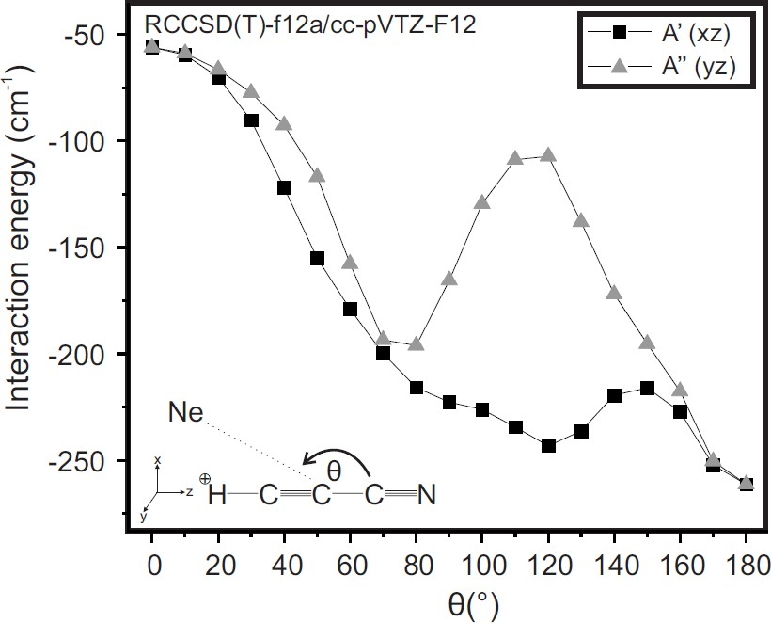

Figure 5.4.: Calculated interaction energy as a function of the Ne angle with respect to the molecular axis. A’ represents the symmetric electronic wavefunction, where the Π*x* orbitals are partially filled. A” represents the antisymmetric electronic wavefunction, where the Π*x* orbitals are completely filled

**5**

Table 5.5.: Harmonic vibrational frequencies of HC3N+and Ne−HC3N+ calcu- lated on RCCSD(T)-F12a/cc-pVTZ-F12 level of theory.

*ν*1 *ν*2 *ν*3 *ν*4 *ν*5 1 *ν*61 *ν*7 1 *ν*8 *ν*9 1

|  |  |  |  |  |  |  |  |  |
| --- | --- | --- | --- | --- | --- | --- | --- | --- |
| HC3N+ | 3317 | 2222 | 1868 | 908 [771,644] | [461,445] | [196,187] | . . . | . . . |
| Ne−HC3N+ | 3306 | 2221 | 1869 | 910 [785,662] | [463,447] | [203,196] | 68 | [28,26] |

1 The *x*- and *y* - components of the bending frequencies are given between brackets

coverage of the FEL-1 and FEL-2 free electron lasers allowed to probe the low- lying RT disturbed bending modes directly, giving complementary information to earlier PES work [285]. The obtained spectrum was fitted with an effective Hamiltonian and the resulting spectroscopic parameters are in reasonable agreement with the *ab initio* and experimental data of Dai *et al.* [285]. The largest

deviations were found in the parameters describing the H C C bending mode *ν*5, which has the largest RT coupling of the three bending modes. We hypothesize that this discrepancy is a direct result of the Ne attachment, which was calculated to bind linearly on the H atom. This hypothesis is strengthened by the large blue shift (60 cm−1) we observe for the C H (*ν*1) stretching mode compared to the other stretches.

This relatively large impact of the Ne on the HC3N+ raises the question of whether the IRPD method may be suitable to investigate these RT-affected ions, but currently, no alternative tag-free methods are available. To overcome the problems of the rare-gas attachment one might look into a way to elucidate the rare-gas effect on these complex open-shell species systematically by using different rare-gas tags (e.g. Ar, or N2) or attaching multiple tags to the same ion. This would not only help to extrapolate to the bare-ion spectrum but also gives insight into weakly-bound system interactions. Furthermore, this data might act as a theory benchmark for future research combining the large-amplitude motion of the tag with the vibronic coupling effects of the ion.

**5**

# III

#### Rotational spectroscopy

137

## 6

### Kinetics of CD+ with He

##### BUFFER GAS

139

* 1. MOTIVATION

This chapter will discuss the kinetics of the CD+ molecular ion with neutral helium atoms. The formation rate coefficient (*ke* ) for He*n*CD+ (*n* indicates the number of He atoms attached to CD+ ion) complexes are derived, and their temperature dependence will be discussed. These kinetics measurements are performed with and without the presence of radiation resonant with the CD+ *J* = 0−1 pure rotational transition via the ROSAA action spectroscopic technique (see Section 2.3.1 for more detail). The main motivation of these studies is to understand the ROSAA process and its signal intensities in detail with the support of numerical simulations. The CD+ ion is best suited for this purpose since at low collisional temperature (< 7 K), one can assume a two-level quantum system (Section 6.8) and state-dependent formation rate coefficient *ke*(*J*) can be derived from a measured *ke* , (Section 6.7.3 and 6.8) which can provide us with an experimental comparison to the developed ROSAA numerical model.

* 1. KINETICS MEASUREMENTS

The experiments were carried out using the 22-pole cryogenic ion trap instrument (FELion). A detailed account of the FELion instrument has been provided in Section 2.1. The CD+ ions were produced by electron impact ionization (EI, electron energy 30−35 eV) from a neutral CD4 precursor (99 atoms

**6**

% D, Sigma-Aldrich). A short pulse, 50 ms, of mass-selected CD+ (typically

∼

4

∼ 10 ions) is injected into the trap and stored for a specified time, typically

∼ 600−900 ms for spectroscopic experiments, and varied between 0 and 6500 ms in 30−40 steps for kinetic measurements, with continuous inflow of He buffer gas for collisional cooling and complex formation. By counting the primary CD+ and He*n*CD+ complexes, and possibly other product ions formed by reactions with neutral contaminats, as a function of trap time, the association and collision- induced dissociation rate constants can be determined, which is discussed in Section 6.3. For measuring rotational transitions of CD+ the ROSAA action spectroscopic technique is employed as described in Section 2.3.1. The pure- rotational spectra are measured in 10 kHz steps and are averaged over ∼ 20 iterations.

At low temperatures and high enough He number densities (typically < 10 K and > 1 · 1014 cm−3, respectively), the He*n*CD+ complexes are readily formed by three-body collision processes but also dissociated by collision-induced dissociation due to their low binding energies. The formation and collisional dissociation processes of CD+ + He are characterized by the formation (*ke* ) and dissociation (*kC ID* ) rate coefficients, discussed in Sections 6.3 and 6.4.

Figure 6.1 shows mass spectra of filtered and trapped CD+ at a nominal

103



103

102

Counts

Counts

102

101 101

10 20 30 40 50

m/z

10 20 30 40 50

m/z

(a) (b)

Figure 6.1.: Measured mass spectrum after storing CD+ ions (m/z 14) for ∼600 ms in the cryogenic ion trap using He buffer gas (a): 1.97(7) · 1014 cm−3; (b): 3.07(12) · 1014 cm−3 number density at T=4.8(3)K, showing the CD+ ion and the subsequent formation of ion-He complexes with up to (a): four; (b): five He atoms attached.

temperature 4.7(3) K. After storing CD+ for about 600 ms, a 14(1) % yield to attach the first He atom is achieved and up to two He atoms (6.1a) are attached at 1.97(7) · 1014 cm−3. Higher order complexes are formed by increasing the He number density as shown in Figure 6.1b, which also increases the HeCD+ yield. In this study, the CD+ + He kinetics measurements were performed for helium number densities in the range of 1−7×1014 cm−3 and in the 5−7 K nominal trap temperature range.

**6**

* 1. THEORY OF ASSOCIATION REACTIONS

The helium complex formation process is an association reaction treated here as an independent “two-step” process. In this section, the equations for the overall effective binary association rate constant as described by Gerlich and Horning [57], and Bates and Herbst [302] are simplified and derived as follows.

Initially as the first step, the ion and neutral come together to form an excited intermediate complex:

A+ +B *kc*

−→

(AB+)∗ (6.1)

where *kc* is a bi-molecular rate constant for complex formation. The term excited intermediate complex indicates that it is a short-lived intermediate molecular ion with total internal energy above its dissociation limit and a lifetime of *τdi s* towards dissociation::

(AB+)∗ *kdis*

−−→

A+ +B (6.2)

where *kdi s* = 1 is a first-order rate for this back-dissociation process. Under most experimental conditions Eq. 6.2 dominates but a fraction of complexes are stabilized either via emitting a photon:

*τdis*

where *kr ad* is a radiative rate,

−−−→

(AB+)∗ *krad*

AB+ + *hv* (6.3)

or via a stabilizing collision with a neutral reactant molecule B

(AB+)∗ +B *kB*

−→

AB+ +B (6.4)

where *kB* is a collisional stabilization rate constant with a neutral third body B and its rate is given by  1 = *kB* [B] .

*τB*

The overall association reaction can be summarised as:

A+ +B *ke*

−→

AB+

where *ke* is an overall second-order effective rate constant for the formation of the AB+ stable complex which can be described as follows (while substituting B

**6**

= He, i.e., helium, which is the neutral reaction partner used in this study)

*kHe* [*He*] + *kr ad e c kdis* + *kHe* [*He*] + *krad*

*k* = *k* ·

where [*He*] indicates helium number density [in cm−3].

(6.5)

Since as discussed in eq. 6.2, *kdi s* dominates over radiative and collisional stabilisation rates i.e., *kdi s* >> *kHe* [*He*] + *kr ad* , Eq. 6.5 can be simplified into the form of:

*k k kHe* [*He*] + *kr ad*

*e* = *c* ·

*kdis*

which can be expressed in terms of ternary association (*k*3) and bi-molecular radiative (*kr* ) rate constants as shown below:

*k k kHe*

3 = *c* ·

*kdis*

*k k krad*

*r* = *c* ·

*kdis*

(6.6)

(6.7)

The final simplified overall effective binary rate constant (*ke* ) and rate (*Re* ) is expressed as:

*ke* = *k*3[*He*] + *kr* (6.8)

*Re* = *ke* [*He*] (6.9)

**Langevin rate coefficient:**

For ion-neutral reactions, the Langevin rate coefficient, *kL*, is a classical theoret- ical reaction rate coefficient given by Langevin [303]. The final equation for *kL*, with an ion of charge *q* [in *C* ], ion-neutral reduced mass *µ* [in amu] and polariz- ability of the neutral *α* [in A˚ 3], summarised by Asvany and Schlemmer [304], is given as:

*kL*[cm3/s] *q πα*

= ;

*ϵ*0*µ*

= 2.342 · ; *α* · 10−9

*µ*

(6.10)

The Langevin rate coefficient, *kL*, for the CD+ + He reaction can be calculated from Eq. 6.10 by substituting helium polarizability, *α* = 0.208 A˚ 3 [305] and HeCD+ pair reduced mass *µ* = 3.11 amu:

**6**

*kL* = 6.06 · 10−10 cm3/s. (6.11)

**HeCD**+ **binding energy:**

Figure 6.2.: HeCD+ optimized geometry computed at the CCSD(T)/aug-cc-pVTZ level of theory.

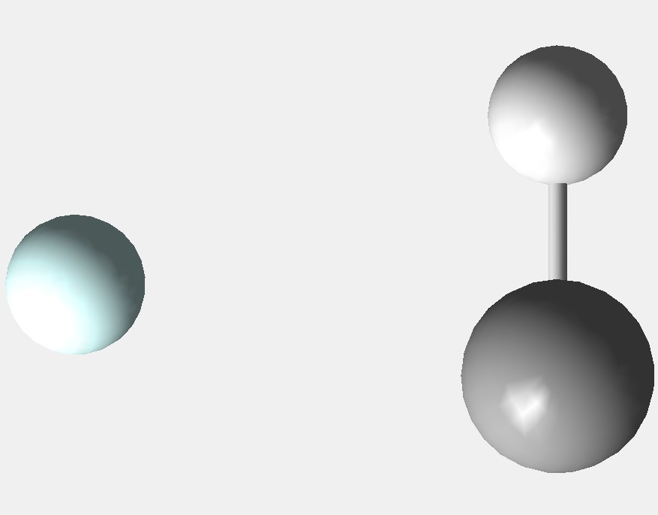

D

He

C

1.11844

The HeCD+ geometry was optmised at the CCSD(T)/aug-cc-pVTZ level of theory. The computed geometry is shown in Figure 6.2. The computed binding energy of HeCD+ is *De* = 491 cm−1 at this level of theory. The binding energy is counterpoise corrected for the basis set superposition error (BSSE) [146]. Stoecklin and Voronin [306] computed BSSE corrected *De* = 513.573 cm−1 for HeCH+ complex using BCCSD(T) /aug-cc-PVQZ method. The binding energy is not zero-point energy corrected.

* 1. RATE EQUATIONS

Following the theory of ternary association processes as discussed in Section 6.3. The pathway for the three-body reaction CD+ + 2He is expressed as shown below:

CD+

ke1

2He ⇌

+

kCID1

HeCD+

+He (6.12)

The first complex, i.e., HeCD+ acts as the source for the formation of higher- order complexes (*n* > 1). The pathway for higher-order complexes is expressed as:

**6**

He*n*−1

ke

⇌

CD+ + 2He n

kCIDn

He*n*

CD+ +He (6.13)

The effective binary complex formation and collision-induced dissociation rates (in s−1) are labelled as *Re* and *RC ID* , respectively. The *Re* is given by eq.

*n*

6.9 and *RC IDn* can be expressed in terms of rate constants *kC IDn* and number density [*He*] as below:

*RC ID* = *kC ID* · [*He*] (6.14)

The corresponding rate equation for Eq. 6.12 and 6.13 are then given as:

*d* CD+

*dt* = −*Re*1

*d* HeCD+

=+ *Re*

* CD+ + *RC ID*
* CD+ − *RC ID*

1 · HeCD+ (6.15)

* HeCD+

*dt* 1 1

− *Re*2 · HeCD+ + *RC ID*2 · He2CD+

A general equation for all (*n* − 1)*th* complex can be expressed as:

*d* He*n*−1CD+ =+ *Re*

*dt*

*n*−1

* He*n*

−2CD+ − *RC ID*

*n*−1

* He*n*

−1CD+

(6.16)

− *Ren* · He*n*−1CD+ + *RC IDn* · He*n*CD+

The complex with the highest observed number *n* of attached He, i.e., He*n*CD+ in this system is treated as a reservoir for all possible higher order complexes, and its rate equation is given as:

*d* He*n*CD+

*dt* = *Ren*

* He*n*

−1CD+ − *RC IDn*

* He*n*CD+ (6.17)
  1. RATE LOSS CHANNELS

The ions are stored up to a maximum of 6 seconds, often this leads to a trap loss of stored ions [307, 308]. To include this loss channel, Eq. 6.15, 6.16 and 6.17 are modified into the following:

*d* CD+ = Eq. 6.15 − *Rloss* · CD+ (6.18)

**6**

*dt*

*d* He*n*−1CD+ = Eq. 6.16 − *Rloss* · He*n*

*dt*

−1CD+ (6.19)

*d* He*n* CD+ = Eq. 6.17 − *Rloss* · He*n*CD+ (6.20) where *Rloss* indicates the trap loss rate [in s−1] . In addition to the *Rloss*

*dt*

channel, we have noticed a growth of m/z=30, which has been seen even at a

very low pressure where no higher order complexes are formed except HeCD+

, as shown in Figure 6.3. Therefore, this channel is accounted for by adding an additional loss channel, as shown below:

*d* CD+ = Eq. 6.18 − *Rloss*30 · CD+ (6.21)

*dt*

The most probable candidate for m/z 30 is DCO+, which could potentially form at low temperatures by the following reaction with CO2 or H2O neutrals (as shown for the main CH+ isotope in the KIDA database [309]):

CD+ +CO2 →− CO +DCO+ (6.22)

CD+ +H2O →− H2 +DCO+ (6.23)

*d* DCO+ = *Rloss*30 · CD+ (6.24)

*dt*

103 103

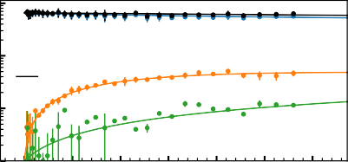

CD +

CD + He

DCO +

SUM

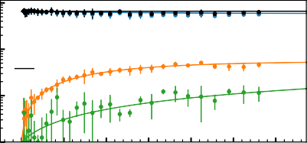

CD +

CD + He

DCO +

SUM

102 102

Counts

Counts

101 101

100

0 1

2 3 4 5 6

Time (s)

100

0

1 2 3 4 5 6

Time (s)

103

(a)

103

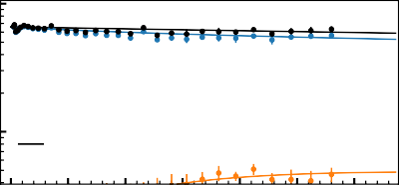

CD +

CD + He

DCO +

SUM

(b)

102 102

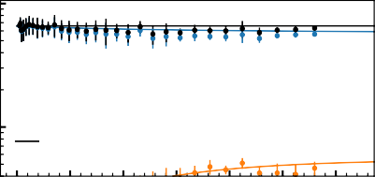

CD +

CD + He

DCO +

SUM

Counts

Counts

0 1 2 3 4 5 6



**6**

Time (s)

(c)

0 1 2 3 4 5 6

Time (s)

(d)

Figure 6.3.: Fitting of the experimental kinetics scans to the rate equation model:

(a) is with both *Rloss* and *Rloss*30 channels included while (b) is only with *Rloss*30. (c) and (d) are zoomed-in regions for (a) and (b), respectively. The measurements were carried out at 6.9(3) K and 1.770(45) · 1014 cm−3 helium number density. No higher order complexes were formed other than mass 30, which most probably is DCO+ as described in Eq. 6.22 and 6.23

Since the m/z 30 also corresponds to the He4CD+ complex, Eq. 6.19 is modified only when *n* − 1 = 4 (or Eq. 6.20 when *n* = 4) by adding the corresponding loss channel *Rloss*30 · CD+ as shown below:

*d* (He4CD+ +DCO+) = (Eq. 6.19 or 6.20) + *Rloss*30 · CD+ (6.25)

*dt*

The coupled ordinary differential equations for the parent ion CD+ (Eq. 6.15, 6.18 or 6.21) and the formed complexes (Eq. 6.16, 6.17 or 6.25) are used to numerically simulate and fit the experimentally observed data to determine the rate constants, which is discussed in more detail in the next section in different aspects. This complex formation process is vital for understanding the ROSAA spectroscopic technique employed in this work.

* 1. DERIVING RATE CONSTANTS

In the experiment, the parent ion CD+ and He*n*CD+ complexes counts are monitored as a function of trap time (in the following, it will be referred to as “kinetics scan”) where all ions are monitored for a duration of up to 6 s, with 4-5 iterations per data point, as shown in Figure 6.4. The coupled ordinary differential (ODE) rate equations, as discussed in section 6.4 and 6.5, are solved using the implicit Runge-Kutta method of the Radau IIA family of order 5 [131], and the solution is numerically fitted to the measured data using the Levenberg- Marquardt algorithm also known as damped least-squares (DLS) method (as shown as solid lines in Figure 6.4) to derive the rates [s−1] *Re* and *RC ID* . These computations are carried out using the SciPy library [132]. The corresponding rate coefficients are derived from the rates as described in equations 6.9 and 6.14.

103



CD + CD + He SUM

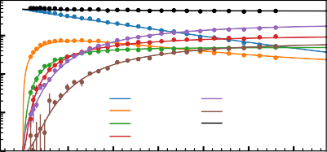

CD +

CD + He CD + He2 CD + He3

CD + He4+DCO +

CD + He5 SUM

102

Counts

Counts

102

**6**

101

10

1

100

0

1 2 3 4 5 6

Time (s)

100

0 1 2 3 4 5 6

Time (s)

(a) (b)

Figure 6.4.: (a) and (b) show the counts of primary and complex ions monitored as a function of trap time at number densities of 1.16(2) · 1014 cm−3 and 6.0(2) · 1014 cm−3, respectively, and at a trap temperature of 4.8(3) K. The circle marker and the solid line represent measured and numerically fitted data, respectively.

Figure 6.5a shows exemplary the derived effective binary rate constant *ke* plotted against the Helium number density [He] to determine the ternary association rate constant (*k*3) and radiative rate (*kr* ) using Eq. 6.8 at 4.8(3) K temperature. The radiative rate, *kr* = 1.2(1.9)· 10−17s−1 could not be determined, and the derived error margin can be viewed as an upper limit to this value. Thus, one can simplify the equation 6.9 such that *k*3[*He*] >> *kr* , then:

*Re* = *ke* [*He*] = *k*3[*He*]2 (6.26)

1.0

1e 15

Fitted values

*k*3 = (1.06±0.10)×10 ³ cm6/s

1

*kr* = (1.12±2.02)×10 ¹ cm3/s

0.8

2.0

3 6

*k*31 [×10 0 cm / s]

*kCID* [×1015 cm3 / s]

0.6

*ke* [cm3/*s*]

1.5

0.4 1.0

1

0.2

0.0

0

2 4 6 8

4

Weighted mean: k31 = (1.11±0.09)×10 ³

3

2

1

0

Weighted mean: k*CID* = (5.21±1.52)×10 ¹

1

*He* [cm 3] 1e14

(a)

0.5

1

0 1 2 3 4 5 6 7 8

Number density [cm 3] 1e14

(b)

Figure 6.5.: The effective binary rate constant (*ke* ), the ternary association (*k*31 ) and collision-induced dissociation (*kC ID*1 ) rate constants are plotted as a function of helium number density. (a) The effective binary rate constant (*ke* ) is plotted as a function of number density to derive *k*31 (ternary association) and *kr* (radiative) rate constants. The solid line indicates the linear fit where the slope and intercept correspond to *k*3 and *kr* , respectively. (b) shows the *k*31 as a function of number density under *k*3[*He*] ≫ *kr* assumption (see text). The weighted mean values are shown in the legend box.

**6**

Table 6.1.: Comparing derived *k*3 rate coefficients [in cm6s−1] in this work to previous results from Brünken *et al.* [65]

*n*

|  |  |  |  |  |  |  |
| --- | --- | --- | --- | --- | --- | --- |
|  | T*tr ap* [*K* ] | T*ion*[*K* ] | *k*31  ×10−30 | *k*32  ×10−30 | *k*33  ×10−30 | *k*34  ×10−30 |
| this work | 4.8(3) | 15(3) | 1.1(1) | 3.6(4) | 13(2) | 10(1) |
| Ref [65] | 5 | 12(1) | 1.2(1) | 3.7(3) | 13(2) | 19(2) |

Table 6.2.: Comparing derived *kC IDn* rate constants [in cm3s−1] in this work to previous results from Brünken *et al.* [65]

|  |  |  |  |  |  |  |
| --- | --- | --- | --- | --- | --- | --- |
|  | T*tr ap* [*K* ] | T*ion*[*K* ] | *kC ID*1  ×10−16 | *kC ID*2  ×10−15 | *kC ID*3  ×10−15 | *kC ID*4  ×10−15 |
| this work | 4.8(3) | 15(3) | 5.2(1.5) | 1.2(2) | 4.3(5) | 2.4(6) |
| Ref [65] | 5 | 12(1) | 9(2) | 1.9(2) | 6.5(9) | 11(3) |

8

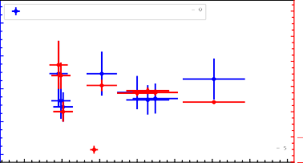

Weighted mean: k31 = (3.62±0.38)×10 ³

8

6

4

2

0

Weighted mean: k*CID* = (1.17±0.19)×10 ¹

1

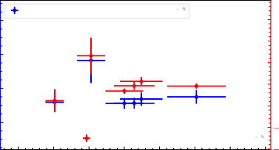

Weighted mean: k31 = (1.27±0.17)×10 ²

60

20

15

40

10

20

5

0

0

5

Weighted mean: k*CID* = (4.31±0.49)×10 ¹

1

6

3 6

*k*32 [×10 0 cm / s]

*kCID* [×1015 cm3 / s]

3 6

*k*33 [×10 0 cm / s]

*kCID* [×1015 cm3 / s]

4

2

3

2

2

0

1 2 3 4 5 6 7 8 4

Number density [cm 3] 1e14

(a)

10

1 2 3 4 5 6 7 8

Number density [cm 3] 1e14

(b)



1 2 3 4 5

3 6

*k*34 [×10 0 cm / s]

Number density [cm 3]

(c)

6 7 8

1e14

5

4

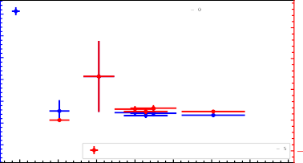

125

Weighted mean: k31 = (9.83±1.57)×10 ³

30

100

75

20

50

10

25

0

0

25

Weighted mean: k*CID* = (2.39±0.58)×10 ¹

10

1

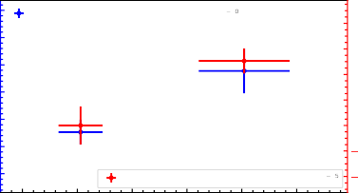

Weighted mean: k31 = (1.06±0.95)×10 ³

8

6

4

2

0

Weighted mean: k*CID* = (3.53±2.32)×10 ¹

1

*kCID* [×1015 cm3 / s]

3 6

*k*35 [×10 0 cm / s]

3

2

1

4

0

1

2 3 4 5 6 7



Number density [cm 3]

(d)

2

5

4

*kCID* [×1015 cm3 / s]

1e14

Figure 6.6.: The numerically derived formation and dissociation rate constants for higher order of complexes (*n* > 1) plotted as a function of number density at 4.8(3) K temperature.



**6**

Figure 6.5b and 6.6 show the derived ternary association rate constants (*k*3) at a nominal trap temperature of 4.8(3) K using equation 6.26. Each data point results from a single kinetics scan (as shown in Figure 6.4) at a given number density. Since the rate constants are defined to be independent (only when *k*3[*He*] >> *kr* ) of number density, one can compute a weighted mean value as reported in Table

6.1 and 6.2. It should be noted that if the trap loss channel is not included (see Section 6.5), then the formation rate (*k*3) does not vary within the given error bar, but the dissociation rate (*kC ID* ) increases by 20 − 25%. This is also evidently seen

in Table 6.1 and 6.2, i.e., the previously reported values [65] for *kC IDn* significantly disagree due to not considering the loss channels. However, the trap loss channel is required to fit the total sum (indicated as a black line in Figure 6.3). Hence

all the derived rate constants include the trap loss and other loss channels as described in Section 6.5.

* 1. INFLUENCE OF RADIATION

Following the main motivation of this chapter (Section 6.1), in this section, the CD+ + He reaction kinetics under the influence of radiation (CD+ , *J* = 0 − 1

transition) will be discussed.

The measurement of the pure rotational *J* = 0 − 1 line of CD+ has been previously studied by employing the ROSAA action spectroscopic method and numerical simulations [65, 123]. In the present study, an improved numerical simulation model has been implemented (see Section 2.3.5) that employs the numerically stable implicit Runge-Kutta ODE solver for stiff equations instead of an explicit Euler approach, CD+ + He collisional rate coefficients [310] instead of derived rate coefficients from the CH+ + He reaction, and that includes spontaneous emission on all involved energy states. As a result, a more adaptable program has been developed for general-purpose numerical kinetics models with an easy-to-use graphical user interface. Additionally, the CD+ *J* = 0 − 1 rotational transition is measured using neon atoms as collision and association partner, allowing the use of a higher temperature range (up to 14 K) which shows us the possibility of using Ne atoms for ROSAA measurement of energetically higher-lying rotational transitions.

* + 1. CD+ ROTATIONAL TRANSITION ( *J* = 0 − 1)

Figure 6.7 shows the measured CD+ rotational spectrum using both He- and Ne-attachment for the ROSAA method fitted with various lineshapes such as Gaussian, Lorentz and Voigt. The experiment is repeated with various temperatures and over large pressure ranges as summarized in Table 6.3 and

**6**

6.4 with fitted parameters such as central transition frequency, signal intensity (HeCD+ depletion %) and full-width half maxima (FWHM). The measured *J* = 0 − 1 transition frequency fitted with a Voigt profile line shape is 453521.852(5) MHz via He-ROSAA and 453521.853(5) MHz via Ne-ROSAA, respectively, and agrees well within the respective error bars with each other and with the previous literature value 453521.8509(7) and 453521.8530(6) MHz via He-ROSAA by Brünken *et al.* [65] and Doménech *et al.* [98], respectively, and with an earlier absorption study in a glow discharge experiment 453521.851(20) MHz by Amano [311].

30 30

CD + (He-ROSAA)

Gaussian Lorentz Voigt

CD + (Ne-ROSAA)

Gaussian Lorentz Voigt

20 20

Depletion [%]

Depletion [%]

10 10

0

453.5212

453.5215 453.5218 453.5221

Frequency [GHz]

453.5224

0

453.5212

453.5215 453.5218 453.5221

Frequency [GHz]

453.5224

(a) (b)

Figure 6.7.: Measured CD+ *J* = 0 − 1 rotational transition using ROSAA technique (see Section 2.3.1). The coloured solid lines indicate the fitted line profile as labelled. The experiment performed at 35(12)*µ*W power -

(a) with He tag, T*tr ap* = 4.7(3) K [He=2.7(4) · 1014 cm−3] and derived T*ion* = 14(5) K and T*coll* = 7(1) K; (b) with Ne tag , T*tr ap* = 8.7(3) K [Ne=1.8(2)· 1014 cm−3] and derived T*ion* = 23(5) K and T*coll* = 19(3) K.

**6**

Table 6.3.: Pure-rotational *J* = 0 −1 transition frequency of CD+ ion using ROSAA action spectroscopy with He tag at 4.5(3) and 5.6(2) K temperature, and 35*µ*W power.

|  |  |  |  |  |
| --- | --- | --- | --- | --- |
| T*trap* | Number density | Frequency | Depletion | FWHM |
| K | ×1014 cm−3 | MHz | % | kHz |
| 4.5(3) | 2.2(3) | 453521.852(05) | 25.56(60) | 420(11) |
| 4.5(3) | 2.7(4) | 453521.856(05) | 24.79(61) | 406(12) |
| 4.5(3) | 5.7(7) | 453521.849(05) | 24.49(66) | 397(12) |
| 5.6(2) | 6.3(9) | 453521.849(13) | 13.19(90) | 384(30) |

Table 6.4.: Pure-rotational *J* = 0 −1 transition frequency of CD+ ion using ROSAA action spectroscopy with Ne tag for temperature range 5-14 K and 35*µ*W power.

**6**

|  |  |  |  |  |
| --- | --- | --- | --- | --- |
| T*trap* | Number density | Frequency | Depletion | FWHM |
| K | ×1014 cm−3 | MHz | % | kHz |
| 16 | 1.9(2) | 453521.908(35) | 11(2) | 455(83) |
| 16 | 1.9(2) | 453521.845(63) | 6(1) | 563(148) |
| 14 | 1.5(2) | 453521.872(26) | 14(1) | 610(60) |
| 8.7 | 1.2(2) | 453521.843(33) | 19(4) | 355(78) |
| 8.7 | 1.8(2) | 453521.848(6) | 22(1) | 446(14) |
| 8.7 | 1.5(2) | 453521.847(9) | 24(1) | 448(22) |
| 9 | 3.8(5) | 453521.828(26) | 14(3) | 253(60) |
| 9 | 2.0(3) | 453521.858(9) | 19(1) | 390(21) |
| 5.5 | 8(1) | 453521.852(26) | 12(3) | 204(61) |
| 6 | 1.0(1) | 453521.845(28) | 19(2) | 414(65) |

* + 1. DETERMINING ION TEMPERATURE

The ion temperature (T*ion*) can be determined from a measured line profile fitted with a Voigt lineshape (see Section 2.3.4 for detail). Figure 6.8 shows a plot comparing measured nominal trap temperature, T*tr ap* and derived T*ion* for CD+ from Table 6.3 and 6.4. The plot is compared with the previously determined values in the FELion instrument by Kluge [123]. This confirms that the ion temperature is higher than the nominal trap temperatures, as observed previously in the 22-pole ion trap [126, 304, 312]. For T*tr ap* < 5 and > 5 K, the corresponding T*ion* are derived from He-ROSAA and Ne-ROSAA measurements, respectively. Each data point in Figure 6.8 is an averaged value of the corresponding T*ion* derived from at least two measurements of FWHM as shown in Table 6.3 and 6.4. The large uncertainty of the T*ion* value in our measurement is because of the large uncertainty in the derived FWHM from the measured line profiles (see Table 6.3 and 6.4). However, the trend of T*ion* with T*tr ap* is consistent with the previous measurements.

60



Literature

This work

50

**6**

40

T*ion* [K]

30

20

10

4 6 8 10 12 14

T*trap* [K]

Figure 6.8.: Comparing nominal trap temperature (T*tr ap* ) and ion temperature (T*ion*) derived from the rotational spectrum. The solid (black) line corresponds to Ref. [123], and the solid (blue) represents data in this work (see text).

Our measured T*ion* data is higher than the previous literature data (see Figure 6.8). However, different experimental conditions could explain this difference. Since, as discussed by Endres *et al.* [126], various factors such as RF heating, buffer gas thermalisation with trap walls, black-body radiation from the surrounding room temperature vacuum chamber, and collision with warm

residual gas that enters the cryogenic trap, in principle, can influence the ion temperature.

The number density variation in the range (2 − 6) · 1014 cm−3 around 5 K temperature for helium (see Table 6.3) did not influence the derived T*ion* within the error limits. The effective collisional temperature, i.e., T*coll* , is derived from T*tr ap* and T*ion* using equation 2.3. The following sections investigate the kinetic measurement in the presence of radiation and ROSAA simulations at a given collisional temperature.

* + 1. KINETICS

The measured formation rate constants (*k*3) in kinetic experiments are weighted average rate coefficients over the thermal population of rotational levels (*J* ) at a given collisional temperature (T*coll* ). The rotational state-specific ternary rate constants (*k*31 ) for the first attachment process can be written as:

*k*31

(*Tcoll*

) *J k*31 (*J* , T*coll* ) · *N*CD+(*J* )

*N*CD+

= L

(6.27)

where *N*CD+(*J* ) indicate the thermal population at a specific rotational *J* level and *N*CD+ is the total population of CD+ ion on all *J* levels.

**6**

5

1e 16

Fitted values

*k*3 = (7.31±1.05)×10 ³¹ cm6/s

1

*kr* = (1.08±2.00)×10 ¹ cm3/s

1.75

6

Weighted mean: k31 = (7.83±0.83)×10 ³¹

5

4

3

2

1

0

Weighted mean: k*CID* = (1.28±0.23)×10 ¹

1

3 6

*k*31 [×10 0 cm / s]

*kCID* [×1015 cm3 / s]

4

1.50

1.25

*ke* [cm3/*s*]

3

1.00

2 0.75

1

1

0

0 1 2 3 4 5 6 7

*He* [cm 3] 1e14

(a)

0.50

0.25

1

1 2 3 4 5 6

Number density [cm 3] 1e14

(b)

Figure 6.9.: Deriving rate coefficients in the presence of radiation resonant with the *J* = 0 − 1 transition of CD+. (a) The effective binary rate constant (*ke* ) is plotted as a function of number density to derive *k*31 (ternary association) and *kr* (radiative) rate constants. The solid line indicates the linear fit where the slope and intercept correspond to *k*3 and *kr* , respectively. (b) shows the ternary association (*k*31 ) and collision- induced dissociation (*kC ID*1 ) rate constants plotted as a function of helium number density under the assumption: *k*3[*He*] ≫ *kr* (see text). The weighted mean values are shown in the legend box.

Figure 6.9 shows the HeCD+ formation rate coefficient as described in equation 6.27. The formation rate coefficients (*k*31 ) for the first complex (HeCD+) measured with and without the presence of radiation resonant with the *J* = 0 − 1 transition of CD+ ion is denoted by *k*31 (*ON* ) and *k*31 (*OFF* ), respectively (see Figure 6.5b and 6.9b).

The derived rate constants at T*coll* = 7 K and P= 3.5 × 10−5 W, is given by:

*k*3 (*OFF* ) = 1.1(1) · 10−30 cm6/s

1

*k*3 (*ON* ) = 7.8(8) · 10−31 cm6/s

1

(6.28)

Following the discussion from Section 2.3.5, the state-dependent formation rate constant is the key factor in understanding the ROSAA process and, subsequently, its signal intensity (referred to as depletion counts [%] in Figure 6.7). The next section discusses this relationship in detail with numerical simulations.

* 1. ROSAA NUMERICAL SIMULATION

In this section, we discuss the results from the numerical simulation of the ROSAA processes described in Section 2.3.5.

**6**

* + 1. COLLISIONAL PROCESS

As the hot CD+ ions from the ion source (T*coll* = 300 K) enter the 22-pole ion trap (T*tr ap* = 4.8(3) K), they are collisionally cooled down by He buffer gas atoms and, at equilibrium, reach the effective collision temperature (T*coll* = 7(1) K). T*coll* is derived using T*ion* and T*tr ap* temperature as described in Eq. 2.3 (see Section 6.7.2). In the absence of radiation and attachment processes, the collisional process reaches an equilibrium of the relative population of rotational quantum states, which is given by the Boltzmann distribution (at T*coll* ), as shown in Figure

6.10 (see Section 2.3.5.1). The collisional rate coefficient values are derived from Werfelli *et al.* [310], for T*coll* = 7 K, the rate constants for *J* = 0 − 5 are given in Appendix Table D.2. The rates are in the order of > 104 s−1 for 2.2 · 1014 cm−3 helium number density. As can be seen in Fig. 6.10, thermalization of the initially hot ions to the Boltzmann distribution at the collisional temperature happens within 0.3 ms under typical experimental conditions.

The spontaneous emission rates (*A*) are also included in this process, as discussed in section 2.3.5.2. However, the collision process dominates it by 8 orders of magnitude (see Table D.2 and D.3). Therefore, in the following sections, spontaneous emission rates will not be mentioned specifically, although they are included in all the cases during simulation.

1.0

0.8

Relative population

0.6

0..4

0.2

1.0

0.8

co + (0)

co + (1)

co + (2)

co + (3)

co + (4)

co + (5)

Boltzmann distribution Coll.

Relative population

0.6

0..4

0.2

0.0 0.0

0.0 0.2 0..4 0.6 0.8 1.0

Time [ms]

0 1 2 3 .4 5

Energy Levels (J)

(a) (b)

**6**

Figure 6.10.: (a) Collisional process for CD+ ions up to *J* = 5 with He buffer gas ([He]= 2.2 · 1014 cm−3). The coloured label indicates the corresponding CD+ (*J* ) state. At *t* = 0, the relative population corresponds to a Boltzmann distribution at T*coll* = 300 K. The relative population evolves through collisions with He with rate constants for T*coll* = 7 K (derived from [310]), subsequently reaching equilibrium after < 0.5 ms. (b) Comparison of the Boltzmann distribution at 7 K with the relative population involving only collisional process (Coll.) at *t* = 1 ms.

* + 1. RADIATIVE PROCESSES

As discussed above, when including only the collisional process, the relative population re-distributed from room temperature (300 K) to a Boltzmann distribution (T*coll* = 7 K) at equilibrium within < 0.5 ms. Furthermore, in the presence of radiation resonant with *J* = 0 − 1 of CD+ , the population can be further re-distributed due to a competing radiative process as shown in Figure

6.11. The simulation of the evolution of the relative population of the CD+ (*J* ) rotational levels is shown in Figure 6.11a for a duration of 1 ms. The derivation of radiative rates is described in detail in section 2.3.5.3. The radiative rates for a radiation power 35 *µ*W are in the same order of magnitude as collisional rates, i.e., > 104 s−1 (see Table D.3).

1.0

0.8

Relative population

0.6

0..4

0.2

- ON -- OFF

co + (0)

co + (1)

co + (2)

co + (3)

co + (4)

co + (5)

1.0

0.8

Boltzmann distribution Coll.

Coll. + Rad.

Relative population

0.6

0..4

0.2

0.0 0.0

0.0 0.2 0..4 0.6 0.8 1.0

Time [ms]

(a)

0 1 2 3 .4 5

Energy Levels (J)

**6**

(b)

Figure 6.11.: (a) Simulated relative rotational level populations for CD+ as labelled in parenthesis. The population evolves from *t* = 0 (T*coll* = 300 K) to reach equilibrium at *t* < 0.5 ms. The solid and dashed lineshapes correspond with (ON) and without (OFF) the presence of radiation on the CD+ *J* = 0 − 1 transition. The radiation power is 35 *µ*W. (b) Comparison of the Boltzmann distribution at 7 K with the relative population involving only the collisional process (Coll.) and, the collision and radiative process (Coll. + Rad.) at *t* = 1 ms.

As depicted in Figure 6.11b, the distribution no longer follows a Boltzmann distribution. Furthermore, if the radiative rates dominate the collisional rates (Coll. ≪ Rad), the resulting population on *J* = 0 and *J* = 1 quantum levels should then reach their statistical weights (*g* (*J* ) = 2*J* + 1) and consequently population ratio (*J* = 1 to *J* = 0) reaches the value 3. The simulated relative population ratio, i.e., the ratio of the population on *J* = 1 to *J* = 0 rotational quantum levels as a function of excitation radiation power at [He]= 2.2·1014 cm−3, is shown in Figure

6.12. The population ratio reaches the value 3 only at a power of > 10−2 W.

The simulated relative population evolution and equilibrium population under the condition Coll. ≪ Rad. is shown in Figure 6.13, for a duration of 1

3.0

2.5

Population ratio (up/down)

2.0

1.5

1.0

0.5

10 7 10 6 10 5 10 4 10 3 10 2 10 1 100

Power [W]

Figure 6.12.: Simulated relative rotational level population ratio (up and down indicates the rotational level of *J* = 1 and *J* = 0, respectively) of CD+ as a function of continuous excitation power on the *J* = 0 − 1 transition after storing for 1 ms in a trap with a constant He number density of [He]= 2.2·1014 cm−3. The simulation only involves collisional and radiative processes.

**6**

1.0

1.0

0.8

0.6

- ON -- OFF

co + (0)

co + (1)

co + (2)

co + (3)

co + (4)

co + (5)

0..4

0.2

0.0

Boltzmann distribution Coll.

Coll. + Rad. Coll. Rad.

0.8

Relative population

Relative population

0.6

0.4

0.2

0.0

0.0 0.2 0..4 0.6 0.8 1.0

Time [ms]

0 1 2 3 4 5

Energy Levels (J)

(a) (b)

Figure 6.13.: (a) Simulated relative rotational level populations for CD+ and corresponding number *J* levels as labelled in parenthesis. The population evolves from *t* = 0 (T*coll* = 300 K) to reach equilibrium at *t* < 0.5 ms. The solid and dashed lineshapes correspond with (ON) and without (OFF) the presence of radiation on the CD+ *J* = 0 − 1 transition. The radiation power is 1 W. (b) Compares the Boltzmann distribution at 7 K with the relative population involving only collisional process (Coll.), collision and radiative process for power 3.5 *µ*W (Coll. + Rad.), and collision and radiative process for power 1 W (Coll. ≪ Rad.), at *t* = 1 ms.

ms. Figure 6.13b also clearly shows the *J* = 0 and *J* = 1 rotational states reaching their statistical weight of 0.25 and 0.75, respectively.

The next section investigates the helium attachment process, vital in understanding the ROSAA signal, i.e., the measured peak intensity [in %].

* + 1. ATTACHMENT PROCESSES

As the CD+ ions collide with the He buffer gas at low temperature and high number density, they form He complexes, i.e., He*n*CD+. The formation and subsequent dissociation rate coefficients of He*n*CD+ are discussed in section

6.6. The numerical simulation method for the attachment process is described in detail in Section 2.3.5.4.

The ROSAA action spectroscopic technique utilises the rotation-specific rate coefficients for the helium attachment process to observe a change in helium- complexes formed at resonant frequency (see Section 2.3). Since, as discussed above, involving radiative processes re-distribute the population of rotational quantum states, this subsequently results in different numbers of complexes form-ed, thus a ROSAA-signal, i.e., depletion counts [%] of HeCD+ as shown in Figure 6.7a.

**6**

A complete simulation involving the radiation, collisional, and attachment processes is vital to investigate the experimentally measured rotational spectrum, i.e., ROSAA-signal intensity. However, a rotational state-specific rate coefficient is required to include the attachment process, which is not straightforward to measure directly. Nevertheless, as discussed in the section 6.2, a weighted rate coefficient was measured for the CD+ + He reaction, with and without the presence of radiation resonant with the *J* = 0−1 transition of the CD+ ion, and this allows to obtain the ratio between the rate-coefficients in the two rotational levels.

Since the relative population of CD+(0) + CD+(1) is ≥ 0.97 at T*coll* = 7 K (see Figure 6.10a), we can assume a 2-level quantum system to determine the rotational state-specific ternary rate constants (*k*31 (*J* )) from the measured, weighted ternary rate coefficients (*k*31 ) using Equation 6.27. The *k*31 ratio (also

referred to as “*a*”) is given by:

*a* = *k*31 (*J* = 1)

*k*31 (*J* = 0)

*X* · CD+(0) −CD+(0)*on* CD+(1)*on* − *X* · CD+(1)

=

(6.29)

where *X* is the ratio of measured weighted rate constant with (ON) and without (OFF) radiation, i.e., *X* = *k*31 (*ON* )/*k*31 (*OFF* ), and CD+ (0) and CD+ (1) represents

CD+ rotational population ratio at *J* = 0 and *J* = 1, respectively. The subscript *on* indicates the relative population in the presence of radiation; otherwise no radiation was admitted.

Using *k*31 (*ON* ) and *k*31 (*OFF* ) value from equation 6.28, we get *X* as:

*X* = 0.7(1) (6.30)

and for the following conditions 1,

*Tcoll* = 7 K

[*He*] = 2.2 · 1014 cm−3

*P* = 3.5 · 10−5 W

the relative population for CD+ (*J* ) is given as (see Figure 6.10a and 6.11a):

**6**

|  |  |
| --- | --- |
| CD+(0) = 0.9 | (6.31) |
| CD+(1) = 0.1 | (6.32) |
| CD+(0)*on* = 0.4 | (6.33) |
| CD+(1)*on* = 0.6 | (6.34) |
| Substituting equations 6.30 through 6.34 in Eq. | 6.29, we can get an |

experimentally derived *k*31 ratio as:

*a* = 0.5(2) (6.35)

The derived *k*31 ratio value, *a* = 0.5(2), agrees within the uncertainties of the previously estimated value *a* = 0.55(5) from Brünken *et al.* [65]. In the previous study, [65], the “*a*” value is estimated by measuring the *J* = 0 − 1 transition of CD+ at different number density and radiation power and fitting the measured ROSAA depletion signal intensity to the numerical model. However, in this study, “*a*” is experimentally derived from kinetic measurements in the presence and absence of radiation resonant with *J* = 0−1 of CD+ molecular ions. This approach also directly validates equation 6.27, and thereby, the rotational state-dependent attachment of rare gas atoms to molecular ions. In addition, this systematically supports our investigation of various processes involved in the ROSAA technique. As described in Section 6.1, the main motivation is to

1*refer Section* *2.3.3* *for power derivation, Section* *2.3.4* *and Figure* *2.3* *for Tcoll derivation*

develop a robust general-purpose ROSAA numerical model that is adaptable to systematically add various processes.

In the following section, the derived “*a*” is used to analyse the full model, including collisional, radiation and attachment processes to the measured pure rotational transition intensity of the CD+ ion.

* + 1. ANALYSING NUMERICAL RESULTS

The full model simulation, i.e., including collisional, radiation and attachment processes for the CD+ molecular ion up to 5 rotational quantum states (*J* = 0−5), is shown in Figure 6.14a for T*coll* = 7 K temperature, 2.2 · 1014 cm−3 helium number density, *k*31 ratio *a* = 0.5 and 3.5 *µ*W power. The CD+ (*J* ) level with *J* > 3 become insignificantly populated within < 0.5 ms, i.e., reaching ≪ 10−10 in relative population ratio while CD+ (2) and CD+ (3) equilibrate to < 10−2 and < 10−6, respectively, in relative population. Therefore, in this simulation the ternary attachment rate coefficients *k*31 (*J* ≥ 2) = 0 due to the insignificant population in these states. Consequently, only the CD+ (*J* = 0) and CD+ (*J* = 1) participate in the cluster formation. However, CD+ (*J* ≥ 2) is included in the simulation to monitor its relative population evolution.

**6**

The attachment and dissociation rate timescale is in the order of 10−1 s−1 (see Table D.1). Thus, the population of the first complex (HeCD+) is very small, i.e., < 10−4 in relative population, during the first 1 ms; however, it tends to increase. Therefore, when the simulation is extended to longer duration, i.e., 600 ms (see Figure 6.14b) and 100 s (see Figure 6.14d), the HeCD+ relative population reaches 0.03 and attains equilibrium at 0.2 after 40 s, respectively. Also, regarding our initial consideration of a 2-level quantum system, the figures support this assumption, i.e., at 7 K temperature and *t* = 0.6 s duration, the relative population pumped into CD+ (0)= 0.86 and CD+ (1)= 0.11 but for CD+ (*J* ≥ 2) it is ≪ 10−4.

As expected, and shown in Figure 6.14b and 6.14d, a significant difference in population is observed in the first HeCD+ complex with (-ON) and without (--

-OFF) radiation resonant with the *J* = 0 − 1 transition of CD+. This difference is indeed the measured ROSAA depletion signal of HeCD+ at resonance. Figure

6.14c presents the expected signal intensity of the measured rotational spectrum (as shown in Figure 6.7) for a trap duration of 600 ms.

At longer time the signal decreases (see Figure 6.14e), this may be because of the formed higher order of complexes does not contribute to the signal intensity and subsequently causes the signal to decrease, eventually reaching a equilib- rium value. Before analysing further, let us look at approaches to validate our model.

0

10 - ON -- OFF

co + (0)

Relative population

10 2 co + (1)

co + (2)

10 4 co + (3)

co + (4)

10 6 co + (5)

Heco +

8 He co +

2

10

10

10

0.0 0.2 0.4 0.6 0.8 1.0 1.2

Time [ms]

(a)

0

10

27.0

al: 27 %

Sign

Relative population

1

Hee□ + □epletion [%]

10 26.5

26.0

2

10

25.5

3 25.0

10

24.5

4

10

0 200 400 600

T me [ms]

24.0

0 100 200 300 400 500 600

Time [ms]

(b)

**6**

0

10

(c)

26

Signal: 18 %

Relative population

HeCD + Depletion [%]

24

1

10

22

20

2

10

0 20000 40000 60000 80000 100000 120000

T me [ms]

18

0 20000 40000 60000 80000 100000

Time [ms]

(d) (e)

Figure 6.14.: (a) Simulated relative rotational level populations for CD+ and corresponding number of He*n*CD+ clusters (n=1, 2) where CD+ (*J* ) indicates CD+ in the *J* rotational state. The simulation conditions are as follows: *k*31 ratio *a* = 0.5, collisional rates for T*coll* = 7 K (at *t* = 0, T*coll* = 300 K), Helium number density 2.2 · 1014 cm−3and radiation power 3.5 · 10−5 W. The solid and dashed lines correspond to with (-ON) and without (–OFF) radiation on the CD+ *J* = 0 − 1 transition frequency. The simulation duration is for (a) 1 ms, (b) 600 ms and (d) 100 s. Figures (c) and (e) correspond to signal intensity, i.e., HeCD+ depletion % as a function of time for (b) and (d), respectively.

There are three direct ways to verify the validity of the numerical model.

* + - 1. One is to compare it with the Boltzmann distribution when only collisional processes are considered. Then at equilibrium, the relative population of CD+ (*J* ) reaches T*coll* , which should be equivalent to the Boltzmann distribution at T*coll* . This has been discussed in Section 6.8.1 and can be verified in Figure 6.10b.
      2. Another way is when collisional and radiative processes are involved, competing with each other. Under conditions when the radiative process (for the *J* = 0−1 transition of CD+) dominates the collisional process (Coll.

≪ Rad.), the equilibrium relative population of CD+ (*J* = 0) and CD+ (*J* = 1) should reach their statistical weights (*g* (*J* ) = 2*J* + 1), i.e., 0.25 and 0.75, respectively. This has been discussed in section 6.8.2 and can be verified in Figure 6.13b.

* + - 1. Another direct approach is to verify the signal intensity is ∼ 0 when the *k*31 ratio *a* = 1. This indicates that the rate constants are not state-dependent but rather the same, thus leading to the absence of ROSAA signal intensity.

**6**

In addition to validating the third point (3) for the numerical model, similar to the signal intensity plot as shown in Figure 6.14c and 6.14e, a complete overview of signal intensity simulations as a function of power ranging from 10−7 − 10−2

W, number density from 1012 − 1016 cm−3and *k*3 ratio *a* ranging from 0.3 − 1, is

1

shown in Figure 6.15. The third point can be verified in Figure 6.15e, where the signal intensity is 0 as expected when *a* = 1.

The experimental ROSAA signal strength under the condition of 2.2· 1014 cm−3 helium number density and 35 *µ*W power at 600 ms trap time is 26(1)% (see Table 6.3). With the same condition, Figure 6.14c predicts a signal intensity of 27% at *t* = 600 ms. Therefore, there is close agreement with our numerical model simulation results. Figure 6.15c depicts an overview of the achievable signal intensity as a function of number density and power for *a* = 0.5 and 600 ms duration. They are directly proportional to radiation power and are inversely proportional to number density. We have utilised our THz radiation source to full power without attenuation (see Section 2.2.2), with the number density adjusted for 700 − 1000 counts of HeCD+ complexes formed for spectroscopy measurement (see Figure 6.1). As shown in Table 6.3, we have measured at different number densities, and 2.2 · 1014 cm−3 at T*tr ap* =4.8(3) K (T*coll* =7(1) K) appears to be an optimal condition to achieve a signal of 27(1)% which is not far from the maximum achievable signal, i.e., ≈ 33% as shown in Figure 6.15c.

70



0

2

10 3

10 4

1012

1013



0

70

60

50

40

30

20

10

0

2

10 3

10 4

1012

1013

0

70

60

50

40

30

20

10

0

2

10 3

10 4

1012

1013

|  |  |  |  |  |  |  |  |  |  |  |  |  |  |  |
| --- | --- | --- | --- | --- | --- | --- | --- | --- | --- | --- | --- | --- | --- | --- |
|  |  |  |  |  |  |  |  |  |  |  |  |  |  | |
|  |  |  |  |  |  |  |  |  |  |  |  |
|  |  |  |  |  |  |  |  |  |  |  |  |
|  |  |  |  |  |  |  |  |  |  |  |  |
|  |  |  |  |  |  |  |  |  |  |  |  |
|  |  |  |  |  |  |  |  |  |  |  |  |
|  |  |  |  |  |  |  |  |  |  |  |  |
|  |  |  |  |  |  |  |  |  |  |  |  |
|  |  |  |  |  |  |  |  |  |  |  |  |
|  |  |  |  |  |  |  |  |  |  |  |  |
| 10 5 |  | 1014 |  |  | 10 5 |  | 1014 |  |  | 10 5 |  | 1014 |
| 10 6 | 1015 |  |  |  | 10 6 | 1015 |  |  |  | 10 6 | 1015 |  |  |  |
|  |  |  |  |  |  |  |  |  |  |  |  |  |  |  |

60

50

40

30

20

10

1 0 1 1

10 7 1016

10 7 1016

10 7 1016

|  |  |  |  |  |  |  |  |  |
| --- | --- | --- | --- | --- | --- | --- | --- | --- |
|  |  |  |  |  |  |  |  |  |
|  |  |  |  |  |  |  |  |  |
|  |  |  |  |  |  |  |  |  |
|  |  |  |  |  |  |  |  |  |
|  |  |  |  |  |  |  |  |  |
|  |  |  |  |  |  |  |  |  |
|  |  |  |  |  |  |  |  |  |
|  |  |  |  |  |  |  |  |  |
|  |  |  |  |  |  |  |  |  |
|  |  |  |  |  |  |  |  |  |
| 4  10 5 | 13  1014 |  | 4  10 5 | 13  1014 |  |  | 1015  14 | 10 3  10 4  10 5 |

* + - * 1. *k*31 ratio = 0.6

**6**

(a) *k*31 ratio = 0.3

10 2

10 3

10

70

60

50

40

30

20

10

0

1012

10

10 6

10 7 1016

1015

(b) *k*31 ratio = 0.4

10 2

10 3

10

70

60

50

40

30

20

10

0

1012

10

10 6

10 7 1016

1015

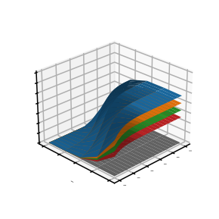

(c) *k*31 ratio = 0.5

70

60

50

40

30

20

10

0

1016

10 2

10

1013

10 6

1012 10 7

* + - * 1. *k*31 ratio = 1
        2. combined

Figure 6.15.: Numerical simulation of ROSAA process with computed signal intensities as a function of radiation power, 10−7 − 10−2 W, He

number density, 1012−1016 cm−3, and *k*3 ratio, 0.3−1, at 600 ms trap

1

duration and T*coll* = 7(1) K temperature. The captions of subplots (a)-(e) indicate the respective *k*31 ratio value. (f) as captioned, shows the combined plots of (a)-(e).

The Ne-ROSAA measurement is shown in Figure 6.7b and Table 6.4. Since a pure Ne kinetics measurement of the attachment process was very challenging at low temperatures due to freeze-out , it will be explored in detail in future studies, and here we assume the same attachment and dissociation rate coefficients as for helium. We run simulations under the following conditions:

[*Ne*] = 1.5 · 1014 cm−3

*P* = 35 *µ*W

*t* = 600 ms T*tr ap* = 8.7 K T*coll* = 18.2 K

The experimentally measured Ne-ROSAA signal of 24(1)% fits with the sim- ulation result (24%) but only with a reduced *a* = 0.25 rather than *a* = 0.5, at T*coll* = 18.2 K. As also discussed in Brünken *et al.* [65], *k*31 (*J* = 1) likely shows a steeper decreasing temperature dependence than *k*31 ( *j* = 0).

Our initial goal was to develop an adaptable and robust numerical simulation model (with an easy-to-use graphical user interface). In addition to investigating the He-CD+ and Ne-CD+ ROSAA model, it can be easily extended to investigate the CO+ molecular ion (Chapter 7), which is an open-shell species hence the rotational quantum states split into fine structure levels due to non-zero net electron spin. Therefore, we have shown that extending this model to different systems is possible and will be used to predict the ROSAA signal intensity for rotational transition measurements when energy level information (from the calculation) and rate coefficients from kinetic measurements are available.

**6**

The next section briefly discusses an interesting observation on the temperature dependence of ternary attachment rate coefficients.

* 1. TEMPERATURE DEPENDENCE OF RATE COEFFICIENTS

This section briefly discusses the temperature dependence of the ternary association and collision-induced dissociation of the CD+ ion with He buffer gas. As discussed in Section 6.6, Figure 6.16 shows the experimentally measured formation (*k*31 ) and collision induced dissociation (*kC ID*1 ) rate coefficient plotted as a function of temperature (T*tr ap* ). The subscript 1 corresponds to the first complex, i.e., HeCD+. As depicted in the figure, both *k*31 and *kC ID*1 increase as the temperature increases.

The dissociation rates are collision-induced. The reaction cross-section gives the probability of ion and neutral collision. Thus, the rate coefficients are derived by multiplying the cross-section with a relative velocity of reactants followed by averaging over a Maxwell-Boltzmann distribution. So, as the temperature in- creases, the collisional velocity and energy increase, which increases *kC ID* rate

2.25

2.00

30 6

*k*31 [x10 cm / s]

T*ion* [K]

12 14 16 18 20 22 24 26 28

2.0

15 3

*kCID*1 [x10 cm / s]

1.75

1.5

1.50

1.25

1.00

1.0

0.5

0.75

4 5

6 7

T*trap* [K]

0.0

8 9

Figure 6.16.: HeCD+ formation (*k*31 ) and dissociation (*kC ID*1 ) rate constants (weighted) are plotted as a function of nominal trap temperature (T*tr ap* ) and ion temperature (T*ion*). The x-axis error bar corresponds to T*tr ap* .

**6**

coefficients.

The dependence of *kC ID* on temperature has been discussed by Savic´ *et al.*

[313] with a simple Arrhenium like expression as given below:

*kC ID* = *kL* · exp(−*D*0/*kB Tcoll* ) (6.36) where *D*0 is the binding energy and *kL* is Langevin rate coefficient.

The binding energy for the dissociation of CD+ is 491 cm−1 and *kL* = 6.06·10−10 cm3s−1(see section 6.3). Therefore, by substituting the values in Eq. 6.36, we get *kC ID* = 8.9 · 10−54 cm3s−1at T*coll* = 7 K. However, from Table 6.2, we have *kC ID* = 5.2(1.5) · 10−16 cm3s−1at T*coll* = 7 K which is significantly larger than the obtained value. The very small computed value for the dissociation rate coef- ficient is perhaps due to the fact that the equation 6.36 assumes the thermal equilibrium of reactants, thereby incorporates only the fraction of ions with an energy >= *D*0, which is determined by the Boltzmann distribution. However, in our experiment, we have a continuous inflow of helium neutral atoms which leads to non-equilibrium thermal effects and deviation from the Boltzmann dis- tribution. As a consequence, the dissociation rate coefficient is much larger than

the computed value.

However, the formation rates, especially for the ternary association reactions between ions and neutrals, possess an inverse temperature dependence because of a decrease in the effective probability of forming a stable complex with a single collision [42] (see Section 6.3 for two-step process). This contrasts our observation as shown in Figure 6.16. Ternary rate coefficients exhibiting inverse temperature dependence, i.e., *k*3(T) ∝ T−*n* (*n* > 1) was discussed back in the 1970s by Herbst [314] for ion-neutral three-body association reactions for *T* ≥ 100 K. Similar inverse temperature dependence was also shown in recent studies based on the classical trajectory approach for low temperatures [315, 316].

Bohringer *et al.* [317] experimentally investigated the temperature depen- dence (30 − 300 K) of He2+ formation via ternary association using a cryogenic selected ion drift tube, i.e., a similar ion-neutral reaction, but the He+ ion is in-

vestigated instead of molecular CD+

He+ + 2He → He2+ +He (6.37)

They observed an inverse temperature dependence and derived a relation for Eq. 6.37:

**6**

*k*3(T) = 1.4 × 10−31(300 K/T)0.6 cm6s−1 (6.38)

Gerlich [318] and Plašil, et al. [319] performed the same He2+ experiment but using a ring electrode trap and 22-pole cryogenic ion trap, respectively. They showed an inverse temperature dependence for *k*3 at T*tr ap* > 10 K that agrees with equation 6.38.

In order to investigate if the discrepancy stems from the fact that we use a molecular ion, or if the observed increase might stem from a reaction-specific resonance in the attachment process, we repeated the measurement but now with N+, i.e.,

N+ + 2He → NHe+ +He

The N+ ion has the same *m*/*z* 14 as CD+. The experimental procedure is similar to the one described in Section 6.2. The derived formation and dissociative rate coefficients are shown in Figure D.1 (in appendix) for a temperature T*tr ap* = 5 − 10 K and a pressure range from (1 − 9) · 1014cm−3. The temperature dependence plot for *k*3 and *kC ID* for the N++2He reaction is shown in Figure 6.17.

T*ion* [K]

14 16 18 20 22 24 26 28 30 32

5

2.0 4

30 6

*k*31 [×10 cm / s]

16 3

*kCID*1 [×10 cm / s]

1.5 3

1.0 2

0.5 1

4 6 8 10 12

T*trap* [K]

Figure 6.17.: HeN+ formation (*k*31 ) and dissociation (*kC ID*1 ) rate constants (weighted) are plotted as a function of the nominal trap tempera- ture. The T*ion* indicated here is measured for the CD+ ion which has the same m/z 14.

**6**

Table 6.5.: Formation (*k*31 ) and dissociation (*kC ID*1 ) rate constants for N+ and CD+ reactions with helium at different nominal trap temperature

|  |  |  |  |  |
| --- | --- | --- | --- | --- |
| T*tr ap* [K] | *k*3 [cm6s−1] *kC ID* [cm3s−1]  1 1  ×10−30 ×10−16  N+ CD+ N+ CD+ | | | |
| 4.7(3) | 0.79(8) | 1.1(1) | 1.7(3) | 5.2(1.5) |
| 6.5(5) | 1.1(2) | 1.4(2) | 2.2(6) | 15.6(2.0) |
| 8.4(5) | 1.3(2) | 1.7(2) | 3.4(5) | 15.1(2.8) |
| 10.0(5) | 1.7(2) | - | 2.6(2) | - |
|  |  | | | |

.

Surprisingly, similar to CD+ ion, the N+ molecular ion also shows the same increasing trend for the *k*31 . The measured ternary association and collision- induced dissociation rate coefficients are summarised in Table 6.5.

However, most experiments previously performed, including the study on He+ discussed above are performed at temperatures > 10 K. Interestingly, Gerlich [81] again investigated the He2+ formation (see Eq. 6.37) using a 22-pole cryogenic ion trap but at T*tr ap* = 4 K temperature. Unlike the experiments at > 10 K, these results disagree (i.e., *k*3 deviates from inverse proportionality to temperature) with the relation as shown in equation 6.38.

Xie *et al.* [320] performed a quantum dynamical study for the same He2+ formation reaction via three-body association (Eq. 6.37). They reported that the ternary association rate coefficient dramatically increases with temperature, i.e., *k*3(T) ∝ T, but only at temperatures below < 30 K, then it drops after reaching a maximum value. They argued that this behaviour is because, up to a certain low temperature, the population of quantum states of ions contributing to a resonance state promoting complex formation increases with temperature, thus increasing in *k*3. This also indicates that the particular ion-neutral reaction proceeds via a two-step mechanism as discussed in Section 6.3.

In order to verify if the complex formation for HeCD+ and HeN+ also proceeds via a resonance state, theoretical calculations need to be performed. First quasi-classical scattering calculations cannot reproduce the observed temperature dependence (J. Perez-Rios, private communication), thus full quantum scattering calculations are likely needed. The fact that both temperature curves (for N+ and CD+) show the same behaviour, might also indicate an experimental artefact, e.g., periodic freezing out of He to the trap walls due to the 1s duty cycle of the cryostat. In the future, we thus would like to repeat the He2+ reaction at low temperatures in our apparatus and compare the results to literature values [81, 317, 319].

**6**

* 1. CONCLUSION

We have reported a detailed systematic analysis of the ternary attachment reaction of CD+ with He atoms. A kinetic measurement in the presence of resonant radiation to derive a rotational-state-specific *k*3 is illustrated. Altogether this helps us to investigate the ROSAA signal intensity of pure rotational spectra via a numerical simulation model. A complete simulation overview of the model, i.e., function of time, number density, power and *k*3 ratio is reported and analyzed for the *J* = 0 − 1 rotational transition of the CD+ molecular ion. Furthermore, the reaction of the N+ ion with helium atoms is investigated. The temperature dependence of *k*3 and *kC ID* are discussed for CD+, and N+ reactions with He at low temperatures, i.e., T*tr ap* < 10 K.

## 7

### The Zeeman effect in CO+ observed with rotational action spectroscopy

This chapter is adapted from : Marimuthu, A. N.; Steenbakkers, K.; Redlich, B.; Brünken, S. Molecular Physics, 120, 15 – 16, e2067089 (2022).

171

Abstract

We discuss newly measured rotational transitions of CO+ (*X* 2Σ+) in its vibrational ground state *v* = 0, in particular the fine-structure components of the *N* = 0 − 1 and *N* = 1 − 2 transitions. We employed a rotational action spectroscopic technique in a cryogenic ion trap for the measurements. The recorded low-temperature and high-resolution spectra of CO+ show resolved Zeeman splittings caused by the Earth’s magnetic field. The highly accurate experimental transition frequencies and derived molecular constants agree with previous measurements and improve the spectroscopic parameters for this known interstellar molecular ion.

**7**

* 1. INTRODUCTION

Carbon monoxide, CO, is the second most abundant molecule in the interstellar medium (after H2). In its ionic form, CO+, it was first detected in interstellar photo-dissociation regions (PDRs) and planetary nebulae (PNs) by Latter *et al.* [321]. Later studies confirmed the presence of CO+ in several other dense PDRs, PNs and reflection nebulae [322–326], and also in an external galaxy [327]. A search for CO+ in the diffuse interstellar medium has been unsuccessful so far, but the obtained upper limits on its abundance provide crucial information on the origin of CO in these regions [328].

The rotational spectrum of the CO+ (X2Σ+, *v*=0) molecular ion has been rather extensively studied previously. The pure rotational spectrum of its two lowest fine-structure components *N* = 0 − 1 was first measured by Dixon and Woods

[329] by a direct absorption experiment through a CO discharge. The spectral coverage was later extended to higher frequencies by Sastry *et al.* [330] covering the *N* = 1 − 2 through *N* = 3 − 4 transitions, and Heuvel and Dymanus [331] mea- sured the first far-infrared (supra THz) *N* = 8−9 transition of CO+. A recent study from Spezzano *et al.* [332] extended the range up to 1.3 THz (up to *N* = 10 − 11) and also provides the to date most accurate spectroscopic parameters for CO+ and its isotopologues based on an isotopically invariant fit.

Interestingly, so far the astronomically observed CO+ emission lines indicate that the rotational excitation temperatures are typically around 10 K [321], which is much lower than the surrounding PDR. This anomaly is yet to be understood; Stäuber and Bruderer [333] suggested this may be due to CO+ being excited upon formation. On the other hand, this suggests the need of accurate laboratory mea- surements at low temperatures for astronomical detections of molecular ions.

**7**

The previous laboratory measurements of the CO+ molecular ion as discussed above were based on direct absorption experiments through liquid-nitrogen cooled DC glow discharges. This approach poses some challenging limitations for achieving very high spectral resolution, mainly due to the high kinetic and excitation temperatures in the discharge, leading to large Doppler linewidths and partition functions, and due to difficulties in producing the reactive ions with sufficient number density, leading to low signal-to-noise spectra. Another complication arises from background contamination from other species that are formed in the discharge. These limitations can be avoided by employing ac- tion spectroscopic methods based on sensitive mass-spectrometric techniques, which measure the change in chemical composition of ions when they interact with resonant radiation light. This can offer several advantages such as mass

selection and storage in a cold ion-trap, which leads to uncontaminated spectra and narrow linewidths. The first realization of pure rotational action spectro- scopy in a cryogenic trap was shown by Schlemmer and coworkers [103] using a direct rotational laser induced reaction (LIR) method. Further action spec- troscopic techniques were later developed to generalise the scheme for a wide range of molecular ions, such as rotation-vibration double resonance - via LIR [104, 105], predissociation [107], or laser induced inhibition of complex growth (LIICG) [101]. Another direct method for high-resolution rotational action spec- troscopy is rotational state-dependent attachment of rare gas atoms (ROSAA) [65, 109], which is used in the present study. A detailed review of these tech- niques was recently provided by Asvany and Schlemmer [52].

In this study, we used the ROSAA action spectroscopic method [65] to record several low *N* rotational transitions of CO+ in a 4K-cryogenic ion trap instrument. The open shell CO+ molecular ion in its ground electronic and vibrational state has 2Σ+ symmetry. Each rotational quantum state *N* splits into two fine-structure components (*NJ* = *N* ± 1/2) due to the presence of the uncoupled electron spin *S* = 1/2. The allowed transitions are ∆*N* = 1 and

∆*J* = 0, ±1. In the presence of a magnetic field each *NJ* levels splits further into 2*J* + 1 Zeeman components, thereby lifting the angular momentum degeneracy. In fact, the CO+ ground state *N* = 0 − 1 rotational transition was already targeted by us using this technique in an earlier study [65]. Interestingly, only the ∆*J* = 1, *NJ* = 01/2 − 13/2 transition was observed at the time (without any observable sub-structure due to Zeeman splitting), with a signal strength ten times higher than the 3*σ* noise level at the position of the ∆*J* = 0, *NJ* = 01/2 − 11/2 transition. At the time it was speculated whether this non-detection is related to intrinsic quantum-mechanical state-dependent effects during the formation of the He- CO+ complex. This puzzling finding partly motivated the current study. In this work we present and discuss the measured high-resolution pure rotational transitions of CO+ (*X* 2Σ+, *v* = 0), namely the *NJ* =01/2 −11/2, 01/2 −13/2, 13/2 −23/2 and 11/2 − 23/2 transitions. We observe clearly resolved Zeeman splittings for the 01/2 − 11/2 transition caused by the Earth’s magnetic field.

**7**

* 1. EXPERIMENT

The rotational spectra of CO+ were recorded with a novel action spectroscopic scheme ROSAA using the FELion cryogenic 22-pole ion trap instrument. A de- tailed account of the FELion instrument is provided in Section 2.1 and of the ROSAA technique in Section 2.3. Here we only give a brief account of details specific to the CO+ ion.

104



CO+

He-CO+

He2-CO+

He3-CO+

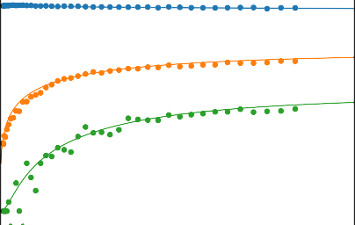

CO +

CO + He

CO + He2

103

103

102

Counts

Counts

102

HCO+

101

101

0

10 20

30 40 50 60 70

m/z

100

1000 2000 3000 4000 5000 6000

Time (ms)

(a) (b)

Figure 7.1.: (a): Measured mass spectrum after storing CO+ ions (m/z 28) for ∼600 ms in the cryogenic ion trap using He buffer gas (∼ 4 · 1014 cm−3 number density, T=4.7(3) K), showing the CO+ ion and the subsequent formation of ion-He complexes with up to three He atoms attached. A small contamination from HCO+ can be seen, resulting from insufficient mass-filtering of the primary ions. (b): The counts of primary and complex ions are monitored as a function of trap time (∼ 1.5 · 1014 cm−3, T=4.7(3) K). The formation (*k*3 ) and dissociation rate (*kC ID*1 ) constants as described in Eq. 7.1 are derived by numerical fitting.

**7**

1

The ions were produced by electron impact ionization (EI, electron energy 25 eV) from neutral CO precursor. A short pulse (∼50 ms) of mass-selected (using the quadrupole mass filter) CO+ is injected into the trap and stored for a specified time, typically ∼600 ms for spectroscopic experiments, with continuous inflow of He buffer gas for collisional cooling and complex formation. At low temperature (around ∼ 4.7(3) K ambient temperature in the present experiments) and high number density ∼ 1014 cm−3 of gas inflow, helium gas will readily attach to CO+ by ternary association and can dissociate by collision induced dissociation (CID):

*k*3*n*

He*n*−1-CO+ + 2He −→ He*n*-CO+ + He ; where *n* ≥ 1 (7.1)

*kC*←*I D*−*n*

The efficient formation of complexes can be clearly seen in the mass spectrum shown in Figure 7.1a. The formed complex is mass filtered with a second quadru- ple mass-filter and detected with a single ion counting Daly detector[127].

By measuring the primary CO+ and He-CO+ complex ion counts as a func- tion of trap time, we measured the ternary association and collision induced

dissociation rate coefficients as shown in Figure 7.1b. At a nominal trap tem- perature of ∼ 4.7(3) K, translating to a collisional temperature of ∼ 6 K caused by the higher kinetic energy (∼ 15 K) of the ions in the radio-frequency trap, we

30 6 −1 −15 3 −1

obtained *k*31 = 1.74(1) · 10− cm s , and *kC ID* = 2.01(4) · 10 cm s .

1

0.40

--OFF, -ON

*CO* + (00.5)

*CO* + (10.5)

*CO* + (11.5)

*CO* + (21.5)

*CO* + (22.5)

0.35

0.30

Population

0.25

0.20

0.15

0.10

0.05

0.0 0.1 0.2 0.3 0.4 0.5

Time (ms)

Figure 7.2.: CO+ (*X* 2Σ+, *v* = 0): Numerical simulation of rotational population distribution of *NJ* states with (-ON) and without (–OFF) radiation for the *NJ* = 01/2 − 11/2 transition. At t=0, the initial population is given by a Boltzmann distribution (at collisional temperature T=6(1) K) and the collisional rates (with He number density [He]=4 · 1014 cm−3) are derived from He-CO+ collisional rate constants values [334]. The radiation rates (Einstein B coefficients for stimulated emission and absorption) are derived from Einstein A coefficients for spontaneous emission (PGOPHER simulation [129]).

**7**

For measuring rotational transitions of CO+ we employed the ROSAA tech- nique, which utilises the change in the helium attachment rate to molecular ions depending on their internal excitation, i.e, ions with certain quantum number *NJ* have different attachment rate coefficients for forming He-CO+ clusters with Helium. The measured *k*3 rate coefficient given above is actually a weighted averaged rate coefficient over the thermal population of rotational levels, i.e., the Boltzmann distribution close to the nominal trap temperature, reached by He collisions with a rate of ∼ 104 s−1 at the typical number densities used in these experiments. Upon resonant excitation the thermal equilibrium distribution is disturbed by competing radiative processes (typically with comparable rates of ∼ 105 s−1 for the CO+ ground state transitions), leading to a change in the attachment rate and thus number of formed complexes. Hence, the measured signal intensity (*S*) is given as the observed change (in %) of the number of He-

1.0

He number density

2 1014cm 3

4 1014cm 3

6 1014cm 3

0.9

0.8

0.7

10.5 / 00.5

0.6

0.5

0.4

10 8 10 7 10 6 10 5 10 4 10 3 10 2 10 1

Power (W)

Figure 7.3.: Simulated population ratio (*NJ* : up/down) of the CO+ *NJ* = 01/2 −11/2 transition as a function of excitation power, at different He number densities, after storing for 600 ms in the trap. Lower He number densities lead to saturation of the transition at lower excitation power.

**7**

CO+ complexes formed between the set frequency (*ION* ) and a fixed reference frequency (*IOF F* , offset about 3 GHz from scanning range), and scaled by *IOF F* , i.e, *S* = (*IOF F* − *ION* )/*IOF F* , after storing for a fixed time of 600 ms in the trap at each data point. The spectra are measured in 10 kHz steps and are averaged over 70 iterations.

The temporal changes in rotational level population, neglecting Zeeman split- ting, without and with radiation (switched on at *t* = 0) are shown exemplary for excitation of the *N* "*J*" − *NJ*′ ′ =01/2 − 11/2 transition and typical experimental

conditions (radiation power ∼ 25 *µ*W, He number density 4 · 1014 cm−3) in Figure

7.2. We used collisional rate coefficients for the He-CO+ system that were re- cently calculated [334] and Einstein coefficients determined using the PGopher program suite [129]. The dependence of the ratio of the upper-to-lower level population *NJ*′ ′ /*N* "*J*" = 11/2/01/2 on the radiation power in the trap at different He number densities is shown in Figure 7.3. The actual power of 25 *µ*W used in the experiments to minimize power broadening is only slightly below the satu- ration power for the used He number density of 4 · 1014 cm−3. Without radiation the ratio is 0.4, with a total population of *Ptot* = (16 + 40)% = 56 % in both states,

given by the Boltzmann distribution. The maximum achievable population change upon radiation leads to a ratio corresponding to the statistical weight ratio of (2*J* ′ + 1)/(2*J* " + 1) = 1, with the same total population of 56 % in both states, i.e., the percentage of molecular ions addressed directly by the applied radiation. An upper limit on the observable depletion signal can be estimated by, albeit unrealistically, assuming that all states except the excited one form com- plexes with the same rate, and the excited one does not form complexes at all: *Smax* ≈ 14 %. In reality the depletion signal will be lower depending on the actual change in the attachment rate coefficient for different rotational levels, and by the Zeeman splitting of the lower state levels, leading to an equal partitioning of the overall population over the two Zeeman states. Numerical simulations for other rotational transitions are shown in the Supplementary Information.

As radiation source we used a continuous wave Signal Generator Extension (SGX) Module (VDI - Virginia Diode, Inc. WR9.0-SGX) to cover the *NJ* =01/2 −11/2, 01/2 − 13/2 transitions at frequencies around 117 and 118 GHz, respectively. For the *NJ* =11/2 − 23/2 and 13/2 − 23/2 transitions we used an additional frequency doubler (WR9.0SGX + WR4.3X2) to reach approximately 235 GHz. The SGX is driven by a muwave signal generator (R&S ® SMB100A) disciplined by an atomic clock (Stanford Research Systems - FS740). Intrinsic radiation linewidths are better than 1 kHz and the relative frequency accuracy is specified to be better than 1 · 10−13. The radiation is directed into the trap through a 0.6 mm thick CVD diamond window (Diamond Materials GmbH) with a conical horn antenna. The maximum output power of this radiation source setup is ∼20 mW (∼3 mW when using the doubler), which can be regulated. Considering the geometrical aspect and distance of the trap from the source, around ∼ 5 % of the output is reaching the trap center. We did not attempt to compensate for the Earth magnetic field, as was done in earlier absorption measurements [335].

**7**

* 1. RESULTS AND DISCUSSIONS

We targeted four fine-structure lines of CO+, of which three were detected as shown in Figure 7.5. The signal-to-noise ratio of the 13/2 − 23/2 transition is very low, thus no transition frequencies were extracted in this case. As shown in Figure 7.4, each *NJ* levels splits further into 2*J* + 1 Zeeman components in the presence of a magnetic field. The splitting energy, i.e, magnetic interaction energy (∆*EJ* ) of each *NJ* state at low magnetic-field strengths is defined as:

∆*EJ* = *g J* · *MJ* · *µB* · *B* (7.2)

N J M



3/2

0

5/2

3/2

1/2

‐1/2

‐3/2

‐5/2

3/2

1/2

‐1/2

‐3/2

Spin‐rotation Anomalous

coupling Zeeman effect

3/2

3/2 1/2

1

1/2

‐1/2

‐3/2 1/2

‐1/2

0

1/2

1/2

∆𝐸௃

‐1/2

5/2

2

Energy

Not to scale

Figure 7.4.: Rotational energy level diagram for CO+ (*X* 2Σ+, *v* = 0) showing fine- structure and Zeeman splittings (not to scale). The dashed arrow lines show the expected Zeeman components of the *NJ* = 01/2 − 11/2 transition. ∆*EJ* , the magnetic interaction energy is given by Equation 7.2.

**7**

where

*g g S*(*S* + 1) + *J* (*J* + 1) − *N* (*N* + 1)

*J* = *S* ·

2*J* (*J* + 1)

(7.3)

is the effective Landé g-factor [336] for the Zeeman effect due to a weak mag- netic field in the presence of net non-zero electron spin, *gS* = 2.002318 is the electron spin g-factor, *MJ* is the magnetic quantum number, and *µB* and *h* are Bohr magneton and Planck’s constants, respectively. *B* corresponds to the mag- netic field strength, which can be derived from a fit to an effective Hamiltonian using PGOPHER [129]. The allowed transitions follow ∆*N* = 1 = ±1, ∆*J* = (0, ±1) and ∆*M* = (0, ±1). From our measurements we determined the total magnetic field as *B* =∼ 60(1) *µ*T, which closely corresponds to the total Earth magnetic field (EMF) of ∼ 49 *µ*T at the location Nijmegen (The Netherlands). The small difference of the measured *B* field from EMF is likely due to the nearby magnetic bearings of a high vacuum pump. Further, as shown in Figure 7.5a a), we see both *σ* (∆*M* = ±1) and *π* (∆*M* = 0) transitions of comparable strength, which

(a) (b)

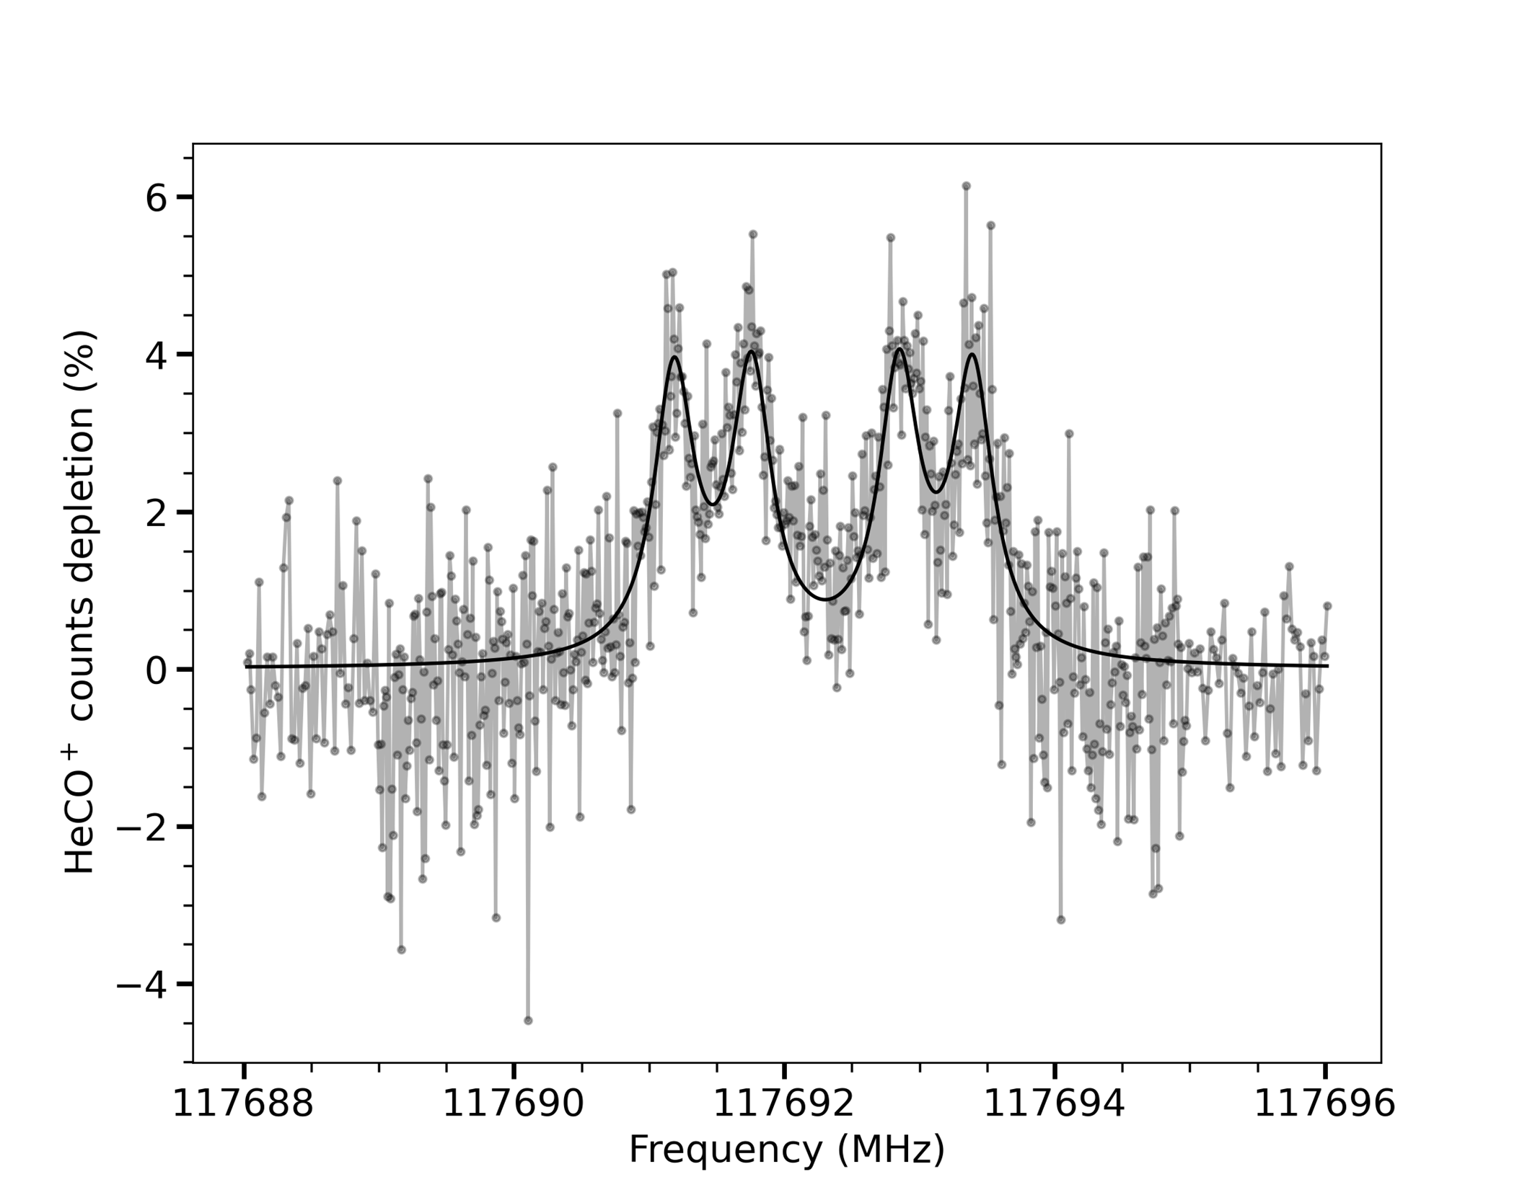

CO+: 01/2 → 11/2

π σ σ π

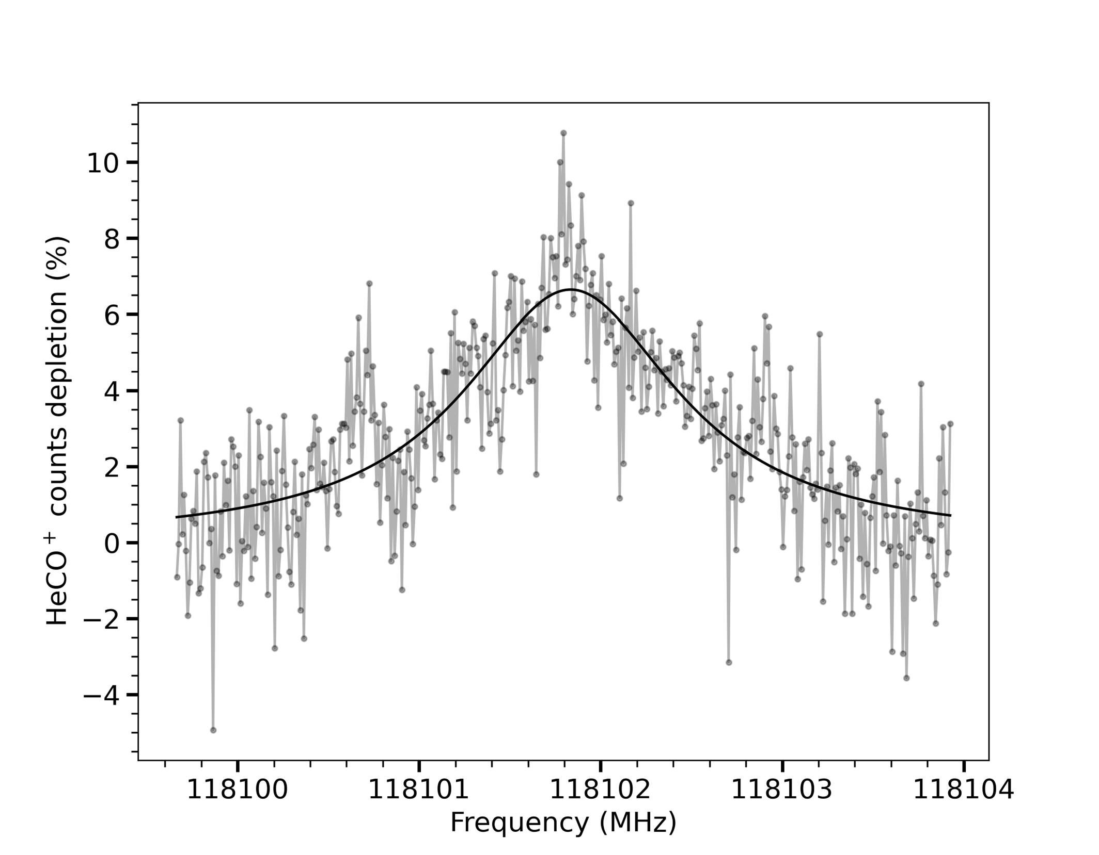

CO+: 01/2 → 13/2

σ σ

σ π

π σ

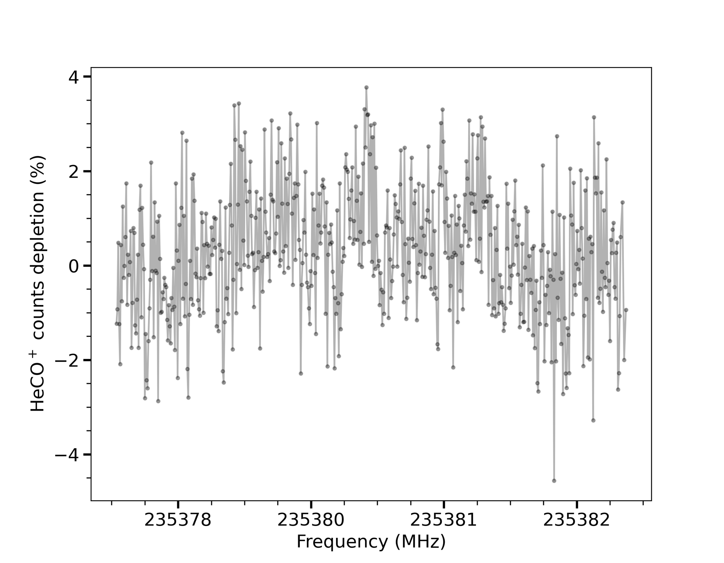

CO+: 13/2 → 23/2

π σ σ π σ σ π σ σ π

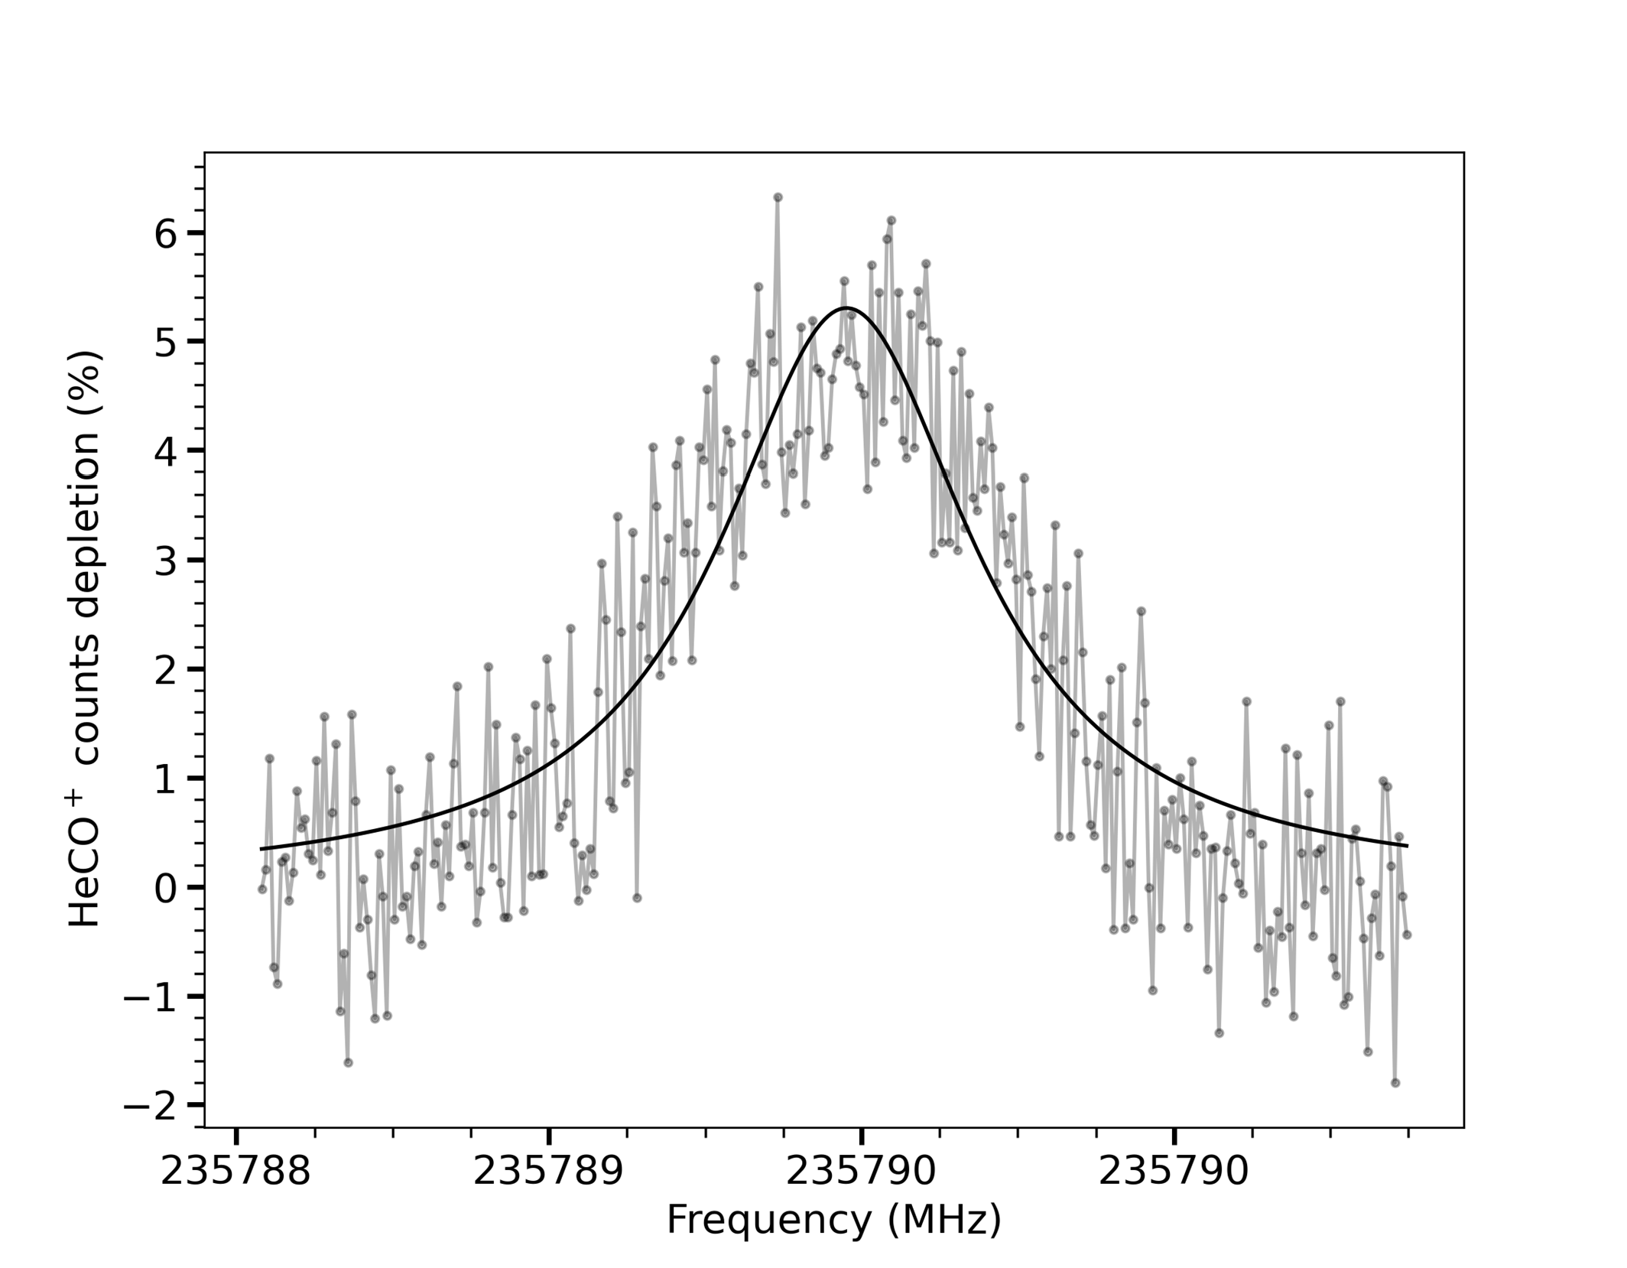

CO+: 11/2 → 23/2

σ σ π π σ σ

Depletion signal S[%]

Depletion signal S[%]

Depletion signal S[%]

Depletion signal S[%]

(c) (d)

Figure 7.5.: Measured rotational transitions of the CO+ molecular ion in the presence of Earth magnetic field causing anomalous Zeeman splitting. The *σ* and *π* correspond to perpendicular (∆*M* = ±1) and parallel (∆*M* = 0) magnetic field, respectively, w.r.t electric field.

**7**

indicates that the magnetic field is oriented under nearly 45◦ relative to our ver- tically polarised radiation. However, due to the action spectroscopic method used, we would expect the same depletion signal for each of the Zeeman com- ponents once we saturate the transition.

Figure 7.5a shows the *NJ* =01/2 − 11/2 transition with clearly resolved Zeeman splitting (see Table 7.1 for line positions). The Zeeman effect on the other two transitions *NJ* = 01/2 − 13/2 and 11/2 − 23/2 could not be clearly resolved (Figure 7.5). Since we are measuring at low kinetic ion temperature *Tion* ≈ 15 K, we min- imise the Doppler broadening (Doppler FWHM, *fD* =∼ 60 kHz for *NJ* = 01/2−11/2 and ∼ 110 kHz for *NJ* = 11/2 − 23/2, compared to values of ∼ 270 and ∼ 550 kHz at room temperature, for the above transitions respectively). The Doppler width

Table 7.1.: Resolved Zeeman splitting for *NJ* = 01/2 − 11/2 transition

*M* ′′ →− *M* ′ Frequencies (MHz)

+1/2 →−

-1/2 →−

+1/2 →−

+1/2 117691.183 (14)

+1/2 117691.759 (14)

-1/2 117692.849 (14)

-1/2 →− -1/2 117693.395 (14)

increases proportionally with I*T* and frequency. We could also minimise the Lorentz contribution ( *fL*) caused by power broadening by reducing the radiation power ( *fL* = 350 kHz for the *NJ* = 01/2 −13/2 transition corresponds to < 0.5 W/m2 or 25 *µ*W total power inside the trap). Since the power broadening effect is dom- inating over Doppler, the transition frequencies are derived from the measured line profile by analytically fitting the spectra with a Lorentzian line shape (given in Table 7.2). The FWHM obtained for the resolved *JN* = 01/2 − 11/2 Zeeman components is 360(20) kHz. For this fine-structure component the actual (un- split) transition frequency was obtained from a weighted average of the four Zeeman components. For the unresolved transitions, with combined FWHM of

**7**

∼ 1.4 MHz and ∼ 0.8 MHz for the *JN* = 01/2−13/2 and *JN* = 11/2−23/2, respectively, a single Lorentzian line shape was used for fitting. Therefore, as a result, we can obtain accurate measurements of line frequencies with small experimental un- certainties. Compensating for the Earth magnetic field might yield even better accuracies, but was not attempted here.

The measured frequencies were fitted with an open-shell effective Hamilto- nian approach using the PGOPHER program [129]. The *B*0 and *γ*0 constants as determined from a partial fit, i.e., just including data from this work (using *D*0 fixed to that obtained from previous measurements) agree well with previous measurements (Table 7.3) [329–332]. The measured transitions from this work combined with all available previous measurements (global fit), see Table 7.2, yield spectroscopic constants *B*0 = 58983.029(1) MHz , *γ*0 = 273.008(5) MHz and *D*0 = 189.150(12) kHz with reduced uncertainties compared to those obtained from previous work alone, as shown in Table 7.3. Therefore, our high-resolution narrow-linewidth measurements allow us to provide more accurate spectro- scopic parameters for the CO+ molecular ion. The sextic centrifugal distortion parameter *H*0 could not be determined (*H*0 = −2.1(3.6) · 10−7 MHz) and did not

Table 7.2.: Rotational transition frequencies of CO+ (*X* 2Σ+)

*N* "*J*" →− *NJ*′ ′ Frequencies (MHz) *O* −*C* (kHz) Prev. work

01/2 →−

01/2 →−

13/2 →−

11/2 →−

13/2 →−

23/2 →−

25/2 →−

35/2 →−

37/2 →−

47/2 →−

49/2 →−

59/2 →−

511/2 →−

611/2 →−

613/2 →−

713/2 →−

**7**

715/2 →−

815/2 →−

917/2 →−

919/2 →−

1019/2 →−

1021/2 →−

11/2 ⋆⋆ 117692.296 (007) ⋆ 2.5 117692.360(030) *d*

13/2 118101.835 (023) ⋆ 29.3 118101.812(050) *d*

23/2 235380.046 (150) *a* 2.6

23/2 235789.555 (011) ⋆ -4.6 235789.641(030) *b*

25/2 236062.553 (020) *a* -14.7

35/2 353741.223 (030) *b* -19.4

37/2 354014.257 (020) *b* 6.5

47/2 471679.213 (120) *b* -96.4

49/2 471952.343 (100) *b* 25.5

59/2 589599.236 (100) *b* 28

511/2 589872.224 (100) *b* -0.1

611/2 707496.506 (100) *b* 90.4

613/2 707769.401 (100) *b* -27.7

713/2 825366.363 (200) *b* -29.6

715/2 825639.665 (200) *b* 262.3

815/2 943204.603 (250) *b* 17.5

817/2 943477.836 (200) *b* 249.4

917/2 1061005.900 (1.0) *c* -558.5

1019/2 1178767.451 (200) *b* -28.2

1021/2 1179040.392 (100) *b* -96.3

1121/2 1296756.174 (100) *b* 60

1123/2 1296483.005 (200) *b* -101.9

⋆ this work. ⋆⋆ Derived from Table 7.1.

*a* Sastry et. al., [330]. *b* Spezzano et. al., [332]. *c* Heuvel and Dymanus [331].

*d* Bogey et. al., [335]

change the rotational and quartic centrifugal distortion constant within their respective error limits; it was thus not included in the fit.

In contrast to our earlier work [65], where the *NJ* = 01/2 − 11/2 ∆*J* = 0 transition was not observed down to a depletion signal *S* < 1 %, we clearly observe it here with *S* ≈ 5 % for each Zeeman component, comparable to that of individual (only

Table 7.3.: Derived molecular constants

Constants (MHz) Partial fit*a* Global Fit*b* Previous work*c*

|  |  |  |  |
| --- | --- | --- | --- |
| *B*0 | 58983.030 (5) | 58983.029 (1) | 58983.032 (2) |
| *γ*0 | 273.009 (14) | 273.008 (5) | 272.971 (15) |
| *D*0 × 103 | [189.162] *c* | 189.150 (12) | 189.162 (15) |

*a* The fit includes data from this work exclusively, but uses *D*0 from a fit to previous work (*c*).

*b* The final global fit including all available data (*a*+*c*)

*c* Constants derived from previous measurements alone [329–332]

partly resolved) Zeeman transitions of the *NJ* = 01/2 − 13/2 transition. The non- resolved FWHM of 1.4 MHz of the latter transition observed here is larger than the 420 kHz measured earlier, which points to a smaller Zeeman splitting in the earlier investigation (since the used radiation power and thus power broadening is comparable), and thus the depletion signal should have been even larger and detectable. In the present study, we used a lower radiation power of 25 *µ*W com- pared to 80 *µ*W used earlier, and a higher He number density of ∼ 4 · 1014 cm−3 compared to ∼ 2·1014 cm−3, respectively, for both *N* = 0−1 fine-structure compo- nents. Judging from Figures 7.3, demonstrating that radiative pumping is more efficient at lower He number densities (collisions acting to maintain the thermal Boltzmann population), the earlier study should have achieved a comparable population change and thus observable depletion signal for the *NJ* = 01/2 − 11/2 fine-structure component. Our numerical simulations can thus not explain the earlier results. As a consequence, the earlier non-detection seems not to be re- lated to the different change in *J* quantum number of the two transitions, ∆*J* = 0 vs. ∆*J* = 1 for the *NJ* = 01/2 −11/2 and *NJ* = 01/2 −13/2 transitions, respectively. In- stead it is likely an energetic effect, i.e., molecular ions in higher-lying rotational states (the *NJ* = 11/2 and 13/2 rotational states have a comparable rotational en- ergy) are less likely to form stable He-ion complexes.

**7**

The around two-fold weaker signal observed for the *NJ* = 13/2 − 23/2 over the *NJ* = 11/2 − 23/2 transition can however easily be explained by a) the presence of ten over six magnetic Zeeman levels, respectively, leading to a dilution of the signal strength and b) the lower absorption cross-section for the ∆*J* = 0 over the

∆*J* = 1 transition, leading to only partial population change in the former case

when using the same radiation power of 25 *µ*W, see Figures E.2 and E.3 (Supple- mentary Information) for the respective simulations).

* 1. CONCLUSIONS

In summary, we measured several fine-structure components of the two lowest rotational transitions of CO+ at low temperature in a cryogenic ion trap with (partly) resolved Zeeman splittings. The rotational action spectroscopic method used in this study can provide accurate transition frequencies of pure rotational transitions of this open-shell molecular ion, as was shown for closed-shell species in earlier studies [109, 111, 114, 116]. Interestingly, earlier attempts to use this method for open-shell systems had failed [77, 337]. Including the new rotational data to a global dataset and fitting to an effective Hamiltonian including spin-rotation provides accurate spectroscopic parameters for CO+ in its vibrational ground state, important data for its astronomical observation.

The work presented here is also vital for our understanding of the state depen- dent action spectroscopic method (ROSAA) applied to systems with uncoupled electron spin and non-degenerate Zeeman transitions. Our results show that the change in ternary rate attachment for different rotational fine-structure states in CO+ is mainly due to energetic effects. A qualitative discussion on the ob- served signal intensities was provided on the example of the *NJ* = 01/2 − 11/2 and *NJ* = 13/2 − 23/2 transitions, paving the way for a more elaborate study to extract rotational and fine-structure state-dependent ternary attachments rate coefficients of rare gas atoms to CO+. The overall attachment rate with and without resonant excitation is a weighted averaged value over all quantum states involved. Since several rotational and fine-structure states are populated initially even at the low temperatures used in the experiments, and rotational excitation resonant on one transition influences the population of neighbouring levels, see Figure 7.2, this would involve measurements of additional higher-lying ro- tational transitions. This might be possible by heating the ion trap to higher temperatures, and using other more strongly bound rare gas atoms, e.g., neon or argon, for complex formation.

**7**

###### APPENDICES

185

# A

### Chapter 3

187

* 1. INTERNAL COORDINATES OF C-C3H3+

**A**

* + 1. FC-CCSD( T)/ANO0

X

X 1 rd

C 2 r1 1 a90

C 2 r1 1 a90 3 d120

C 2 r1 1 a90 4 d120

H 2 r2 1 a90 3 d0

H 2 r2 1 a90 4 d0

H 2 r2 1 a90 5 d0

|  |  |
| --- | --- |
| rd = | 1.000000613972272 |
| r1 = | 0.795954871089489 |
| a90 = | 90.000000000000000 |
| d120 = | 120.000000000000043 |
| r2 = | 1.882733950537102 |
| d0 = | 0.000000000000000 |

* + 1. FC-CCSD( T)/ANO1

X

X 1 rd

C 2 r1 1 a90

C 2 r1 1 a90 3 d120

C 2 r1 1 a90 4 d120

H 2 r2 1 a90 3 d0

H 2 r2 1 a90 4 d0

H 2 r2 1 a90 5 d0

|  |  |
| --- | --- |
| rd = | 1.000000409314806 |
| r1 = | 0.789085470855492 |
| a90 = | 90.000000000000000 |
| d120 = | 120.000000000000014 |
| r2 = | 1.869030138645467 |
| d0 = | 0.000000000000000 |

* + 1. FC-CCSD( T)/ANO2

X

X 1 rd

C 2 r1 1 a90

**A**

C 2 r1 1 a90 3 d120

C 2 r1 1 a90 4 d120

H 2 r2 1 a90 3 d0

H 2 r2 1 a90 4 d0

H 2 r2 1 a90 5 d0

|  |  |
| --- | --- |
| rd = | 1.000000613972272 |
| r1 = | 0.787249651644386 |
| a90 = | 90.000000000000000 |
| d120 = | 119.999999999999986 |
| r2 = | 1.866721530420376 |
| d0 = | 0.000000000000000 |

* 1. INTERNAL COORDINATES OF H2C3H+
     1. FC-CCSD( T)/ANO0

H

C 1 r1

X 2 rd 1 a90

C 2 r2 3 a90 1 d180

X 4 rd 2 a90 3 d0

C 4 r3 5 a90 2 d180

H 6 r4 4 a1 5 d0

H 6 r4 4 a1 5 d180

|  |  |  |
| --- | --- | --- |
| r1 | = | 1.081884877618416 |
| rd | = | 1.000000409314806 |
| a90 | = | 90.000000000000000 |
| r2 | = | 1.246343011416748 |
| d180 | = | 180.000000000000000 |
| d0 | = | 0.000000000000000 |
| r3 | = | 1.361798271600899 |
| r4 | = | 1.094590581296569 |
| a1 | = | 120.284642603942274 |

* + 1. FC-CCSD( T)/ANO1

H

C 1 r1

X 2 rd 1 a90

C 2 r2 3 a90 1 d180

**A**

X 4 rd 2 a90 3 d0

C 4 r3 5 a90 2 d180

H 6 r4 4 a1* 5 d0

H 6 r4 4 a1* 5 d180

|  |  |  |
| --- | --- | --- |
| r1 | = | 1.074705266639338 |
| rd | = | 1.000000204657382 |
| a90 | = | 90.000000000000000 |
| r2 | = | 1.234261558515133 |
| d180 | = | 180.000000000000000 |
| d0 | = | 0.000000000000000 |
| r3 | = | 1.351397370372584 |
| r4 | = | 1.088292080166718 |
| a1 | = | 120.373581553220575 |

* + 1. FC-CCSD( T)/ANO2

H

C 1 r1

X 2 rd 1 a90

C 2 r2 3 a90 1 d180

X 4 rd 2 a90 3 d0

C 4 r3 5 a90 2 d180

H 6 r4 4 a1* 5 d0

H 6 r4 4 a1* 5 d180

|  |  |  |
| --- | --- | --- |
| r1 | = | 1.074153711426225 |
| rd | = | 1.000000409314806 |
| a90 | = | 90.000000000000000 |
| r2 | = | 1.231322876212024 |
| d180 | = | 180.000000000000000 |
| d0 | = | 0.000000000000000 |
| r3 | = | 1.349557181907095 |
| r4 | = | 1.087405908293182 |
| a1 | = | 120.356533501538024 |

Table A.1.: Vibrational wavenumbers and IR intensities of c-C3H3+ (cm−1 and km/mol, respectively).

**A**

|  |  |  |  |  |  |
| --- | --- | --- | --- | --- | --- |
| Mode | Harm.*a* | Anharm.*a* | Harm.*b* | Anharm.*c* | Int.*a* |
| *ν*1(*a*′ ) | 3325 | 3194 | 3310 | 3179 | 0 |
| *ν*2(*a*′ ) | 1629 | 1596 | 1642 | 1610 | 0 |
| *ν*3(*a*′ ) | 1028 | 1004 | 1048 | 1024 | 0 |
| *ν*4(*e*′ ) | 3276 | 3142 | 3260 | 3127 | 189 |
| *ν*5(*e*′ ) | 1301 | 1266 | 1318 | 1284 | 88 |
| *ν*6(*e*′ ) | 940 | 920 | 944 | 925 | 60 |
| *ν*7(*a*′′ ) | 763 | 754 | 764 | 754 | 69 |
| *ν*8(*e*′′ ) | 1007 | 989 | 1017 | 1000 | 0 |

1

1

2

2

*a* fc-CCSD(T)/ANO0. IR intensity obtained via VPT2.

*b* fc-CCSD(T)/ANO2

*c* From fc-CCSD(T)/ANO2 harmonic wavenumbers and fc-CCSD(T)/ANO0 anharmonic corrections.

Table A.2.: Vibrational wavenumbers and IR intensities of c-C3D3+ (cm−1 and km/mol, respectively); CCSD(T)/ANO1 anharmonic force field.

|  |  |  |  |  |  |
| --- | --- | --- | --- | --- | --- |
| Mode | Harm.*a* | Anharm.*a* | Harm.*b* | Anharm.*c* | Int.*a* |
| *ν*1(*a*′ ) | 2552 | 2475 | 2552 | 2474 | 0 |
| *ν*2(*a*′ ) | 1501 | 1472 | 1507 | 1478 | 0 |
| *ν*3(*a*′ ) | 845 | 831 | 852 | 838 | 0 |
| *ν*4(*e*′ ) | 2420 | 2341 | 2419 | 2340 | 64 |
| *ν*5(*e*′ ) | 1266 | 1236 | 1273 | 1244 | 66 |
| *ν*6(*e*′ ) | 684 | 673 | 684 | 673 | 28 |
| *ν*7(*a*′′ ) | 561 | 556 | 561 | 556 | 29 |
| *ν*8(*e*′′ ) | 823 | 813 | 827 | 817 | 0 |

1

1

2

2

*a* fc-CCSD(T)/ANO1. IR intensity obtained via VPT2.

*b* fc-CCSD(T)/ANO2

*c* From fc-CCSD(T)/ANO2 harmonic wavenumbers and fc-CCSD(T)/ANO1 anharmonic corrections.

Table A.3.: Vibrational wavenumbers and IR intensities of c-C3D3+ (cm−1 and km/mol, respectively); CCSD(T)/ANO0 anharmonic force field.

**A**

|  |  |  |  |  |  |
| --- | --- | --- | --- | --- | --- |
| Mode | Harm.*a* | Anharm.*a* | Harm.*b* | Anharm.*c* | Int.*a* |
| *ν*1(*a*′ ) | 2560 | 2481 | 2552 | 2473 | 0 |
| *ν*2(*a*′ ) | 1497 | 1466 | 1507 | 1477 | 0 |
| *ν*3(*a*′ ) | 835 | 818 | 852 | 835 | 0 |
| *ν*4(*e*′ ) | 2430 | 2346 | 2419 | 2336 | 52 |
| *ν*5(*e*′ ) | 1256 | 1225 | 1273 | 1243 | 62 |
| *ν*6(*e*′ ) | 681 | 670 | 684 | 672 | 26 |
| *ν*7(*a*′′ ) | 560 | 554 | 561 | 555 | 27 |
| *ν*8(*e*′′ ) | 818 | 806 | 827 | 815 | 0 |

1

1

2

2

*a* fc-CCSD(T)/ANO0. IR intensity obtained via VPT2.

*b* fc-CCSD(T)/ANO2

*c* From fc-CCSD(T)/ANO2 harmonic wavenumbers and fc-CCSD(T)/ANO0 anharmonic corrections.

Table A.4.: Vibrational wavenumbers and IR intensities of H2C3H+ (cm−1 and km/mol, respectively); CCSD(T)/ANO1 anharmonic force field.

|  |  |  |  |  |  |
| --- | --- | --- | --- | --- | --- |
| Mode | Harm.*a* | Anharm.*a* | Harm.*b* | Anharm.*c* | Int.*a* |
| *ν*1(*a*1) | 3365 | 3233 | 3362 | 3230 | 103 |
| *ν*2(*a*1) | 3119 | 2998 | 3118 | 2997 | 26 |
| *ν*3(*a*1) | 2123 | 2077 | 2123 | 2078 | 348 |
| *ν*4(*a*1) | 1477 | 1442 | 1480 | 1444 | 13 |
| *ν*5(*a*1) | 1131 | 1106 | 1133 | 1109 | 2 |
| *ν*6(*b*1) | 1125 | 1104 | 1120 | 1100 | 13 |
| *ν*7(*b*1) | 877 | 873 | 878 | 875 | 8 |
| *ν*8(*b*1) | 259 | 266 | 256 | 263 | 27 |
| *ν*9(*b*2) | 3227 | 3086 | 3228 | 3087 | 37 |
| *ν*10(*b*2) | 1037 | 1015 | 1037 | 1016 | 2 |
| *ν*11(*b*2) | 619 | 612 | 624 | 618 | 59 |
| *ν*12(*b*2) | 286 | 296 | 289 | 299 | 15 |

*a* fc-CCSD(T)/ANO1. IR intensity obtained via VPT2.

*b* fc-CCSD(T)/ANO2

*c* From fc-CCSD(T)/ANO2 harmonic wavenumbers and fc-CCSD(T)/ANO1 anharmonic corrections.

**A**

Table A.5.: Vibrational wavenumbers and IR intensities of H2C3H+ (cm−1 and km/mol, respectively); CCSD(T)/ANO0 anharmonic force field.

|  |  |  |  |  |  |
| --- | --- | --- | --- | --- | --- |
| Mode | Harm.*a* | Anharm.*a* | Harm.*b* | Anharm.*c* | Int.*a* |
| *ν*1(*a*1) | 3372 | 3239 | 3362 | 3229 | 104 |
| *ν*2(*a*1) | 3131 | 3005 | 3118 | 2992 | 24 |
| *ν*3(*a*1) | 2118 | 2070 | 2123 | 2076 | 325 |
| *ν*4(*a*1) | 1473 | 1437 | 1480 | 1443 | 12 |
| *ν*5(*a*1) | 1124 | 1121 | 1133 | 1130 | 7 |
| *ν*6(*b*1) | 1112 | 1091 | 1120 | 1100 | 11 |
| *ν*7(*b*1) | 865 | 858 | 878 | 872 | 7 |
| *ν*8(*b*1) | 249 | 257 | 256 | 264 | 26 |
| *ν*9(*b*2) | 3250 | 3103 | 3228 | 3082 | 37 |
| *ν*10(*b*2) | 1034 | 1012 | 1037 | 1015 | 2 |
| *ν*11(*b*2) | 598 | 587 | 624 | 612 | 57 |
| *ν*12(*b*2) | 267 | 276 | 289 | 298 | 13 |

*a* fc-CCSD(T)/ANO0. IR intensity obtained via VPT2.

*b* fc-CCSD(T)/ANO2

*c* From fc-CCSD(T)/ANO2 harmonic wavenumbers and fc-CCSD(T)/ANO0 anharmonic corrections.

**A**

Table A.6.: Vibrational wavenumbers and IR intensities of D2C3D+ (cm−1 and km/mol, respectively).

|  |  |  |  |  |  |
| --- | --- | --- | --- | --- | --- |
| Mode | Harm.*a* | Anharm.*a* | Harm.*b* | Anharm.*c* | Int.*a* |
| *ν*1(*a*1) | 2609 | 2531 | 2605 | 2527 | 0 |
| *ν*2(*a*1) | 2288 | 2210 | 2278 | 2200 | 2 |
| *ν*3(*a*1) | 1987 | 1949 | 1990 | 1951 | 329 |
| *ν*4(*a*1) | 1209 | 1192 | 1218 | 1201 | 0.02 |
| *ν*5(*a*1) | 949 | 942 | 953 | 946 | 12 |
| *ν*6(*b*1) | 887 | 874 | 895 | 882 | 1 |
| *ν*7(*b*1) | 693 | 688 | 706 | 700 | 0.3 |
| *ν*8(*b*1) | 225 | 228 | 230 | 233 | 16 |
| *ν*9(*b*2) | 2424 | 2341 | 2408 | 2324 | 13 |
| *ν*10(*b*2) | 830 | 817 | 835 | 822 | 4 |
| *ν*11(*b*2) | 457 | 447 | 481 | 471 | 22 |
| *ν*12(*b*2) | 241 | 245 | 257 | 262 | 9 |

*a* fc-CCSD(T)/ANO0. IR intensity obtained via VPT2.

*b* fc-CCSD(T)/ANO2

*c* From fc-CCSD(T)/ANO2 harmonic wavenumbers and fc-CCSD(T)/ANO0 anharmonic corrections.

**A**

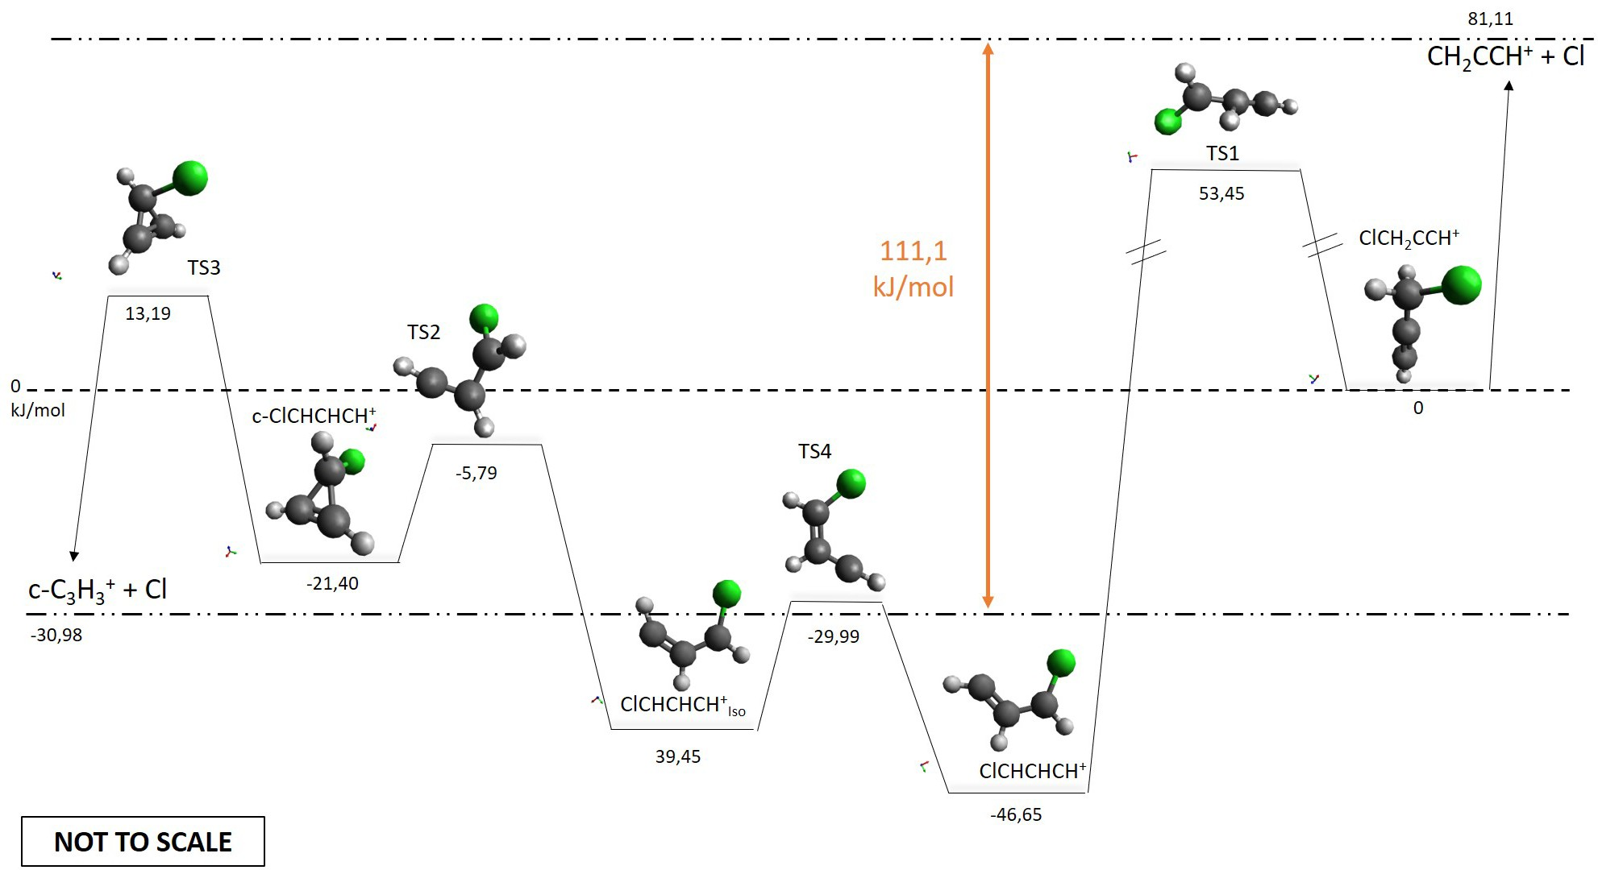

Figure A.1.: Potential energy pathway for c-C3H3+ and H2C3H+ formation from ionization of propargyl chloride (ClCH2CCH). The calculations are done at the CCSD(T)/cc-pVTZ level with zero-point energy corrections from MP2/cc-pVTZ level. The ClCH2CCH+ ion (propargyl chloride cation, relative energy arbitrarily set to 0 kJ/mol) can undergo hydrogen migration to the linear ClCHCHCH+ ion (Erel = −46.56 kJ/mol) via transition state TS1 (Erel = 53.45 kJ/mol). This isomer can then convert to ClCHCHCH+ (iso) (Erel=- 30.98 kJ/mol) via TS4 (Erel=-39.45 kJ/mol). The latter species can subsequently cyclisise via a submerged transition state TS2 (Erel=- 5.79 kJ/mol) to the cyclic c-ClCHCHCH+ (Erel=-21.40 kJ/mol). This means that the highest barrier for the isomerisation of ClCH2CCH+ to c-ClCHCHCH+ is 53.45 kJ/mol, i.e. only 0.55 eV. Also the dissociation energy barrier to c-C3H3+ and Cl (Erel= -29.99 kJ/mol) is only at 13.19 kJ/mol (TS3).

# B

### Chapter 4

197

* 1. INTERNAL COORDINATES OF CH3CNH+
     1. FC-CCSD( T)/ANO0

**B**

|  |  |  |  |  |
| --- | --- | --- | --- | --- |
| H C | 1 | r1 |  | |
| C | 2 | r2 | 1 | a1 |
| X | 3 | rd | 2 | a90 1 d0 |
| N | 3 | r3 | 4 | a90 2 d180 |
| X | 5 | rd | 3 | a90 4 d0 |
| H | 5 | r4 | 6 | a90 3 d180 |
| H | 2 | r1 | 3 | a1 1 d120 |
| H | 2 | r1 | 3 | a1 8 d120 |
| r1 | | = | 1.097234034575213 | |
| r2 | | = | 1.461586511773973 | |
| a1 | | = | 108.354029317585457 | |
| rd | | = | 1.000000409314806 | |
| a90 | | = | 89.999999999999972 | |
| d0 | | = | 0.000000000000000 | |
| r3 | | = | 1.153699023716097 | |
| d180 | | = | 180.000000000000000 | |
| r4 | | = | 1.013272030286403 | |
| d120 | | = | 120.000000000000114 | |

* + 1. FC-CCSD( T)/ANO1

H

C 1 r1

C 2 r2 1 a1

X 3 rd 2 a90 1 d0

N 3 r3 4 a90 2 d180

X 5 rd 3 a90 4 d0

H 5 r4 6 a90 3 d180

H 2 r1 3 a1 1 d120

H 2 r1 3 a1 8 d120

|  |  |  |
| --- | --- | --- |
| r1 | = | 1.091588568955683 |
| r2 | = | 1.450334012198720 |

|  |  |  |
| --- | --- | --- |
| a1 | = | 108.507798899076860 |
| rd | = | 1.000000613972271 |
| a90 | = | 89.999999999999986 |
| d0 | = | 0.000000000000000 |
| r3 | = | 1.145583771122200 |
| d180 | = | 180.000000000000000 |
| r4 | = | 1.008294043229717 |
| d120 | = | 119.999999999999972 |

* + 1. FC-CCSD( T)/ANO2

**B**

|  |  |  |  |  |
| --- | --- | --- | --- | --- |
| H C | 1 | r1 |  | |
| C | 2 | r2 | 1 | a1 |
| X | 3 | rd | 2 | a90 1 d0 |
| N | 3 | r3 | 4 | a90 2 d180 |
| X | 5 | rd | 3 | a90 4 d0 |
| H | 5 | r4 | 6 | a90 3 d180 |
| H | 2 | r1 | 3 | a1 1 d120 |
| H | 2 | r1 | 3 | a1 8 d120 |
| r1 | | = | 1.090663342780039 | |
| r2 | | = | 1.448609574844010 | |
| a1 | | = | 108.480759568085148 | |
| rd | | = | 1.000001227944922 | |
| a90 | | = | 90.000000000000028 | |
| d0 | | = | 0.000000000000000 | |
| r3 | | = | 1.142864353443497 | |
| d180 | | = | 180.000000000000000 | |
| r4 | | = | 1.008334309784723 | |
| d120 | | = | 120.000000000000327 | |

* + 1. FC-CCSD( T)/CC-PVDZ

H

C 1 r1

C 2 r2 1 a1

**B**

|  |  |  |  |  |
| --- | --- | --- | --- | --- |
| X | 3 | rd | 2 | a90 1 d0 |
| N | 3 | r3 | 4 | a90 2 d180 |
| X | 5 | rd | 3 | a90 4 d0 |
| H | 5 | r4 | 6 | a90 3 d180 |
| H | 2 | r1 | 3 | a1 1 d120 |
| H | 2 | r1 | 3 | a1 8 d120 |
| r1 | | = | 1.104421287381395 | |
| r2 | | = | 1.467855029147642 | |
| a1 | | = | 108.258731223153745 | |
| rd | | = | 1.000000409314806 | |
| a90 | | = | 89.999999999999957 | |
| d0 | | = | 0.000000000000000 | |
| r3 | | = | 1.160263599078930 | |
| d180 | | = | 180.000000000000000 | |
| r4 | | = | 1.020376191984162 | |
| d120 | | = | 120.000000000000171 | |

* + 1. FC-CCSD( T)/CC-PVTZ

|  |  |  |  |  |
| --- | --- | --- | --- | --- |
| H C | 1 | r1 |  | |
| C | 2 | r2 | 1 | a1 |
| X | 3 | rd | 2 | a90 1 d0 |
| N | 3 | r3 | 4 | a90 2 d180 |
| X | 5 | rd | 3 | a90 4 d0 |
| H | 5 | r4 | 6 | a90 3 d180 |
| H | 2 | r1 | 3 | a1 1 d120 |
| H | 2 | r1 | 3 | a1 8 d120 |
| r1 | | = | 1.091362895166567 | |
| r2 | | = | 1.453075807535473 | |
| a1 | | = | 108.438787022956490 | |
| rd | | = | 1.000000204657382 | |
| a90 | | = | 89.999999999999986 | |
| d0 | | = | 0.000000000000000 | |
| r3 | | = | 1.146078556823367 | |
| d180 | | = | 180.000000000000000 | |
| r4 | | = | 1.009021121407080 | |

d120 = 120.000000000000099

* + 1. AE-CCSD( T)/CC-PWCV5Z

**B**

H

N 1 r1*

X 2 rd 1 a90

C 2 r2* 3 a90 1 d180

X 4 rd 2 a90 3 d0

C 4 r3* 5 a90 2 d180

H 6 r4* 4 a1* 5 d0

H 6 r4* 4 a1* 7 d120

H 6 r4* 4 a1* 8 d120

|  |  |  |
| --- | --- | --- |
| r1 | = | 1.0073314907 |
| rd | = | 1.0 |
| a90 | = | 90.0 |
| r2 | = | 1.1399556988 |
| d180 | = | 180.000000000000000 |
| d0 | = | 0.000000000000000 |
| r3 | = | 1.4440897526 |
| r4 | = | 1.0887809197 |
| a1 | = | 108.5586585536 |
| d120 | = | 120.0 |

* 1. INTERNAL COORDINATES OF CH3CNH+ -NE
     1. FC-CCSD( T)/ANO0

H

C 1 r1

C 2 r2 1 a1

X 3 rd 2 a90 1 d0

N 3 r3 4 a90 2 d180

X 5 rd 3 a90 4 d0

H 5 r4 6 a90 3 d180

H 2 r1 3 a1 1 d120

H 2 r1 3 a1 8 d120

X 7 rd 5 a90 6 d0

NE 7 r5 10 a90 5 d180

|  |  |  |  |
| --- | --- | --- | --- |
| r1 | | = | 1.097234259132258 |
| **B** | r2 | = | 1.461586810898442 |
|  | a1 | = | 108.354029317585457 |
|  | rd | = | 1.000000613972271 |
|  | a90 | = | 89.999999999999972 |
|  | d0 | = | 0.000000000000000 |
|  | r3 | = | 1.153699259829119 |
|  | d180 | = | 180.000000000000000 |
|  | r4 | = | 1.013272237660004 |
|  | d120 | = | 119.999999999999758 |
|  | r5 | = | 2.117272059249112 |

* + 1. FC-CCSD( T)/CC-PVDZ

H

C 1 r1

C 2 r2 1 a1

X 3 rd 2 a90 1 d0

N 3 r3 4 a90 2 d180

X 5 rd 3 a90 4 d0

H 5 r4 6 a90 3 d180

H 2 r1 3 a1 1 d120

H 2 r1 3 a1 8 d120

X 7 rd 5 a90 6 d0

NE 7 r5 10 a90 5 d180

|  |  |  |
| --- | --- | --- |
| r1 | = | 1.097234483689349 |
| r2 | = | 1.461587110022973 |
| a1 | = | 108.354029317585457 |
| rd | = | 1.000000818629779 |
| a90 | = | 89.999999999999972 |
| d0 | = | 0.000000000000000 |
| r3 | = | 1.153699495942189 |
| d180 | = | 180.000000000000000 |
| r4 | = | 1.013272445033648 |
| d120 | = | 119.999999999999758 |

r5 = 1.990534530346215

**B**

204

B. Chapter 4

Table B.1.: Computed fc-CCSD(T) vibrational frequencies (in cm−1) using ANO basis sets for CH3CNH+ .

**B**

mode sym exp.*a* harmonic*b* anharmonic (VPT2)*b*

|  |  |  |  |  |  |  |  |  |
| --- | --- | --- | --- | --- | --- | --- | --- | --- |
|  | C3*v* |  | ANO0 | ANO1 | ANO2 | ANO0 | ANO1 | ANO2 |
| *ν*10 | E | 385 | 374 (-11) | 381 (-4) | 382 (-3) | 376 (-9) | 384 (-1) | 384 (-1) |
| *ν*9 | E | 596 | 581 (-15) | 580 (-16) | 585 (-11) | 570 (-26) | 579 (-17) | 577 (-19) |
| *ν*5 | A1 | 898 | 889 (-9) | 897 (-1) | 900 (2) | 878 (-20) | 887 (-11) | 890 (-8) |
| *ν*8 | E | 1026 | 1051 (25) | 1048 (22) | 1050 (24) | 1025 (-1) | 1023(-3) | 1024 (-2) |
| *ν*4 | A1 | 1364 | 1395 (31) | 1393 (29) | 1398 (34) | 1358 (-6) | 1358(-6) | 1361 (-3) |
| *ν*7 | E | 1421 | 1444 (23) | 1442 (21) | 1447 (26) | 1422 (1) | 1428(7) | 1429 (8) |
| *ν*3 | A1 | 2307 | 2336 (29) | 2345 (38) | 2350 (43) | 2290 (-17) | 2300(-7) | 2305 (-2) |
| *ν*2 | A1 | 2924 | 3060 (136) | 3049 (125) | 3051 (127) | 2934 (10) | 2927(3) | 2930 (6) |
| *ν*6 | E | 2996 | 3174 (178) | 3149 (153) | 3152 (156) | 3019 (23) | 2999(3) | 3002 (6) |
| *ν*1 | A1 | nc | 3688 (-) | 3699 (-) | 3687 (-) | 3528 (-) | 3534(-) | 3525 (-) |

*a* This work, Ne-IRPD experiment.

*b* Shift from Ne-IRPD experiment is given in parenthesis.

Table B.2.: Computed harmonic CCSD(T) vibrational frequencies (in cm−1) using Dunning’s basis sets for CH3CNH+ .

**B**

|  |  |  |  |  |
| --- | --- | --- | --- | --- |
| mode | sym. | exp.*a* | cc-pVDZ*b* | cc-pVTZ*b* |
| *ν*10 | E | 385 | 362 (-23) | 380 (-5) |
| *ν*9 | E | 596 | 564 (-32) | 586 (-10) |
| *ν*5 | A1 | 898 | 893 (-5) | 895 (-3) |
| *ν*8 | E | 1026 | 1042 (15) | 1052 (25) |
| *ν*4 | A1 | 1364 | 1381 (16) | 1398 (34) |
| *ν*7 | E | 1421 | 1433 (12) | 1450 (29) |
| *ν*3 | A1 | 2307 | 2331 (24) | 2343 (36) |
| *ν*2 | A1 | 2924 | 3066 (142) | 3052 (128) |
| *ν*6 | E | 2996 | 3181 (185) | 3151 (154) |
| *ν*1 | A1 | nc | 3663 (-) | 3684 (-) |

*a* This work, Ne-IRPD experiment.

*b* Shift from Ne-IRPD experiment is given in parenthesis.

Table B.3.: Computed harmonic CCSD(T) vibrational frequencies (in cm−1) comparing both CH3CNH+ (bare ion) and CH3CNH+-Ne (complex) using ANO0 and cc-pVDZ basis sets.

**B**

mode sym. exp.*a* ANO0*b* cc-pVDZ*b*

|  |  |  |  |  |  |  |
| --- | --- | --- | --- | --- | --- | --- |
| C3*v* | |  | CH3CNH+ | CH3CNH+-Ne | CH3CNH+ | CH3CNH+-Ne |
| *ν*Ne-bend E | |  |  | 32 |  | 26 |
| *ν*Ne-str. A1 | |  |  | 68 |  | 102 |
| *ν*10 | E | 385 | 374 (-11) | 375 (-10) | 362 (-23) | 322 (-63) |
| *ν*9 | E | 596 | 581 (-15) | 599 (3) | 564 (-32) | 551 (-45) |
| *ν*5 | A1 | 898 | 889 (-9) | 890 (-8) | 893 (-5) | 913 (15) |
| *ν*8 | E | 1026 | 1051 (25) | 1052 (26) | 1042 (15) | 1024 (-2) |
| *ν*4 | A1 | 1364 | 1395 (31) | 1395 (31) | 1381 (16) | 1370 (6) |
| *ν*7 | E | 1421 | 1444 (23) | 1445 (24) | 1433 (12) | 1425 (4) |
| *ν*3 | A1 | 2307 | 2336 (29) | 2336 (29) | 2331 (24) | 2380 (73) |
| *ν*2 | A1 | 2924 | 3060 (136) | 3060 (136) | 3066 (142) | 3129 (205) |
| *ν*6 | E | 2996 | 3174 (178) | 3173 (177) | 3181 (185) | 3247 (251) |
| *ν*1 | A1 | nc | 3688 (-) | 3679 (-) | 3663 (-) | 3730 (-) |

*a* This work, Ne-IRPD experiment.

*b* Shift from Ne-IRPD experiment is given in parenthesis.

**B**

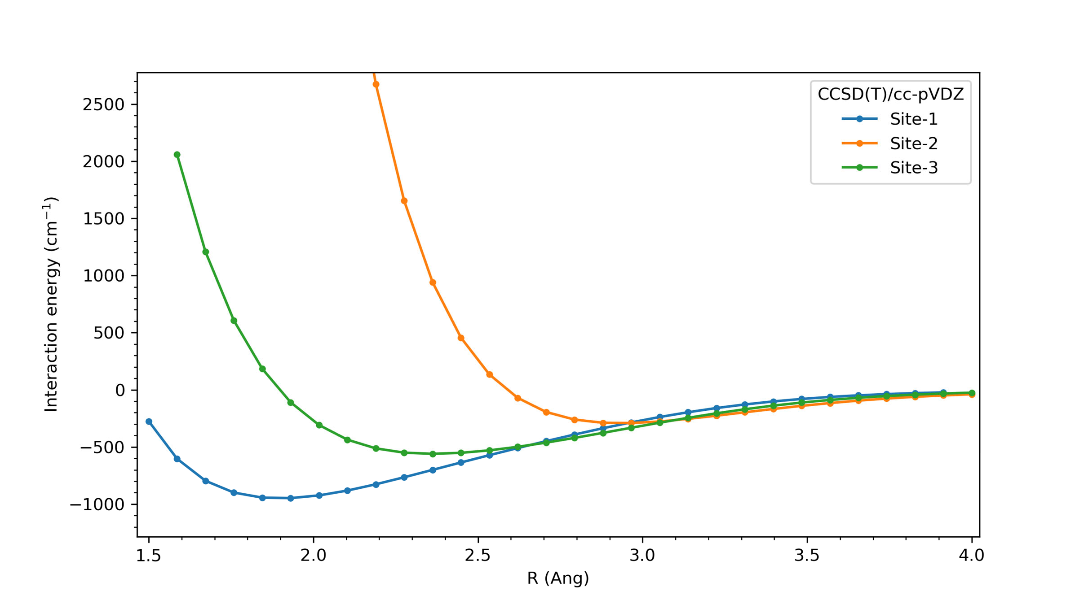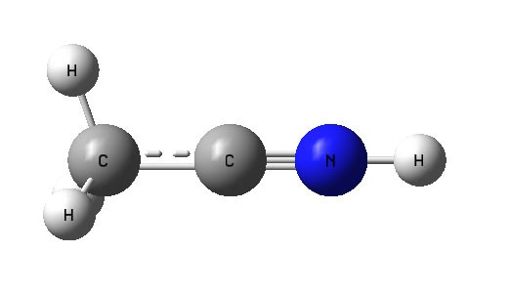

site3

site2

**+**

site1

Figure B.1.: Computed potential energy surface as a function of Ne distance R for CH3CNH+-Ne from various sites neon atom placed.

**B**

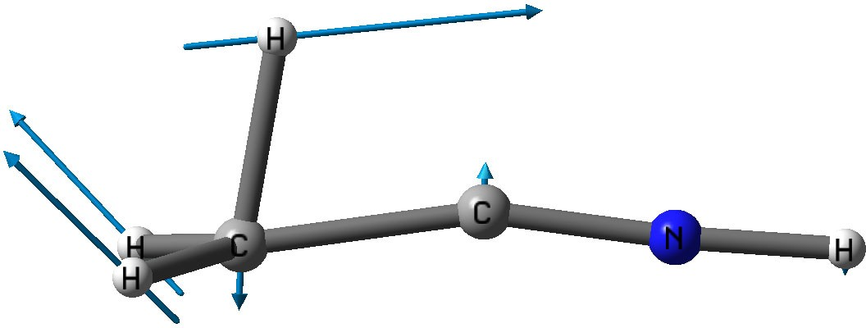CH3 wagging

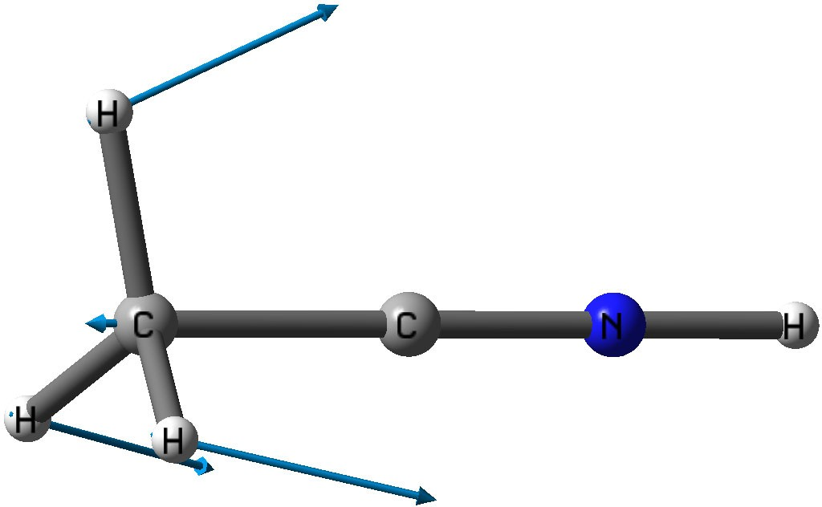CH3 umbrella

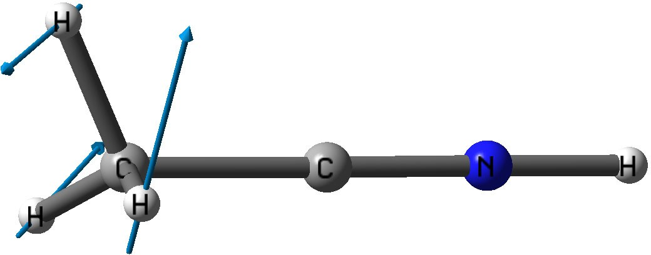CH3 scissoring

Figure B.2.: Vibrational displacement vectors for CH3 modes.

Table B.4.: Calculated spectroscopic parameters of CH3CNH+ at the CCSD(T)/ANO2 level of theory. Rotational constants *Be* , *B*0,

**B**

*i*

*i*

∆*B*0 = 1/2Σ*αB*

*i*

(∆*A*0 analogous), and *αA*

and *αB* . All values are

in MHz.

|  |  |  |  |  |  |
| --- | --- | --- | --- | --- | --- |
| *Ae* | *A*0 | ∆*A*0 | *Be* | *B*0 | ∆*B*0 |
| 156213.5 | 154336.7 | 1876.8 | 8659.2 | 8541.5 | 27.8 |

*i* *i*

|  |  |  |  |  |
| --- | --- | --- | --- | --- |
|  | mode | *αA* | *αB* | *qi* |
| *ν*10 | CCN bend | 91.3 | -20.2 | 14.8 |
| *ν*9 | CNH bend | 31.1 | -8.3 | 8.9 |
| *ν*5 | CC stretch | 251 | 50.6 |  |
| *ν*8 | CH3 wagging | -883 | -0.09 | 3.6 |
| *ν*4 | CH3 umbrella | -912 | 68.0 |  |
| *ν*7 | CH3 scissoring | 902 | -37.7 | 60.2 |
| *ν*3 | CN stretch | 103 | 44.0 |  |
| *ν*2 | CH3 sym. stretch | 1645 | 2.2 |  |
| *ν*6 | CH3 asym. stretch | 1204 | 0.99 | 0.634 |
| *ν*1 | NH stretch | -23.4 | 21.5 |  |

# C

### Chapter 5

211

Table C.1.: Observed band centers and intensities in the IRPD spectrum of HC3N+tagged with Ne obtained from fitting Gaussian functions to the experimental data in both relative depletion and power normalized intensity units (see main text). The frequency error is dominated by the calibration method using either a grating spectrometer (FEL) or a wavemeter (OPO).

**C**

|  |  |  |  |
| --- | --- | --- | --- |
| **Freq. (cm**−1**)** a | **Freq. err. (cm**−1**)** | **Norm. Int. (rel.u)**b | **Norm. Int. err. (rel.u)**b |
| 189 | 2 | 1.6 c | - |
| 200 | 3 | 1.6 c | - |
| 208 | 3 | 1.6 c | - |
| 231 | 2 | 1.4 c | - |
| 238 | 1 | 3.4 | 0.5 |
| 384 | 1 | 0.9 | 0.3 |
| 439 | 1 | 12.1 | 0.3 |
| 454 | 1 | 9.9 | 0.3 |
| 489 | 1 | 2.5 | 0.3 |
| 552 | 2 | 0.6 | 0.2 |
| 572 | 2 | 0.7 | 0.2 |
| 626 | 1 | 13.2 | 0.5 |
| 631 | 1 | 5.7 | 0.4 |
| 688 | 1 | 15.4 | 0.2 |
| 704 | 1 | 5.0 | 0.2 |
| 846 | 1 | 4.9 | 0.2 |
| 926 | 1 | 0.6 | 0.2 |
| 957 | 1 | 2.2 | 0.2 |
| 981 | 2 | 0.5 | 0.2 |
| 1097 | 1 | 0.2 | 0.2 |
| 1243 | 1 | 1.1 | 0.3 |
| 1253 | 1 | 1.0 | 0.5 |
| 1331 | 1 | 0.6 | 0.3 |
| 1595 | 1 | 1.1 | 0.2 |

a Taken from Gaussian fit of relative depletion spectrum (not power normalized).

b Taken from Gaussian fit of power normalized spectrum.

c Estimated from power normalized spectrum: fitting was problematic in the power normalized spectrum in this region due to the high noise level as a result of the relatively low power.

**Table C.1 – continued on next page**

**Table C.1 – continued from previous page**

**C**

|  |  |  |  |
| --- | --- | --- | --- |
| **Freq. (cm**−1**)** a | **Freq. err. (cm**−1**)** | **Norm. Int. (rel.u)**b | **Norm. Int. err. (rel.u)**b |
| 1845 | 1 | 35.9 | 0.2 |
| 2171 | 1 | 8.8 | 0.2 |
| 3174.0 | 1 | 5.4 | 0.4 |
| 3182.9 | 0.5 | 16 | 2 |
| 3184.7 | 0.5 | 19 | 2 |
| 3185.7 | 0.5 | 22 | 1 |
| 3191.9 | 0.5 | 20 | 4 |
| 3195.2 | 0.5 | 28 | 3 |

a Taken from Gaussian fit of relative depletion spectrum (not power normalized).

b Taken from Gaussian fit of power normalized spectrum.

c Estimated from power normalized spectrum: fitting was problematic in the power normalized spectrum in this region due to the high noise level as a result of the relatively low power.

0.014

0.012

0.010

**C**

0.008

Normalized Intensity

0.006

0.004

0.002

0.000

3120 3130 3140 3150 3160 3170 3180 3190 3200 3210 3220 3230 3240 3250 3260 3270

Wavenumber/cm-1

Figure C.1.: IRPD spectrum of the HC3N+ ion tagged with Ne in the range 3120- 3260 cm−1 recorded with an OPO (red) overlayed with a prediction of the *ν*1 ro-vibrational structure using the PGOPHER program package

[129] (black, *T* =20 K and *B* = 0.033 cm−1, calculated at RCCSD(T)/cc- pVTZ level of theory).

Table C.2.: Calculated frequencies and intensities based on *ab initio* parameters of Dai *et al.* [285] together with the assigned *P* and *K* quantum numbers and the population in the *ν*5, *ν*6 and *ν*7 bending modes.

|  |  |  |  |  |  |  |  |  |
| --- | --- | --- | --- | --- | --- | --- | --- | --- |
| **Freq** | **Rel.** | **Int** | ***K*** | ***P*** | **pop** | **pop** | **pop** | **pop** |
| **(cm**−1**)** | **(a.u.)** |  |  |  | *ν*5 | *ν*6 | *ν*7 | **tot** |
| 190.77 | 0.0423 |  | 0 | 0.5 | 0.02 | 0.01 | 0.99 | 1.02 |
| 195.46 | 0.0443 |  | 2 | 2.5 | 0.01 | 0.01 | 1.01 | 1.03 |
| 237.33 | 0.132 |  | 0 | 0.5 | 0.02 | 0.02 | 0.98 | 1.02 |
| 238.17 | 0 |  | 2 | 1.5 | 0.02 | 0.01 | 1.01 | 1.04 |
| 382.26 | 0 |  | 1 | 0.5 | 0.02 | 0.02 | 1.98 | 2.02 |
| 383.77 | 0 |  | 1 | 1.5 | 0.02 | 0.01 | 2 | 2.03 |
| 431.86 | 0 |  | 1 | 1.5 | 0.03 | 0.04 | 1.96 | 2.03 |

continued on next page

**Table C.2 – continued from previous page**

**C**

|  |  |  |  |  |  |  |  |  |
| --- | --- | --- | --- | --- | --- | --- | --- | --- |
| **Freq** | **Rel.** | **Int** | **K** | **P** | **pop** | **pop** | **pop** | **pop** |
| **(cm**−1**)** | **(a.u.)** |  |  |  | *ν*5 | *ν*6 | *ν*7 | **tot** |
| 434.43 | 0 |  | 1 | 0.5 | 0.03 | 0.02 | 1.98 | 2.03 |
| 446.02 | 0.0727 |  | 0 | 0.5 | 0.04 | 0.97 | 0.02 | 1.03 |
| 457.8 | 0.081 |  | 2 | 2.5 | 0.01 | 1.01 | 0.01 | 1.03 |
| 496.53 | 0.3849 |  | 0 | 0.5 | 0.17 | 0.83 | 0.02 | 1.02 |
| 500.45 | 0.0084 |  | 2 | 1.5 | 0.02 | 1.01 | 0.01 | 1.04 |
| 573.56 | 0.0051 |  | 0 | 0.5 | 0.02 | 0.02 | 2.99 | 3.03 |
| 574.26 | 0.0004 |  | 2 | 1.5 | 0.02 | 0.02 | 2.97 | 3.01 |
| 576.7 | 0.0046 |  | 2 | 2.5 | 0.02 | 0.02 | 3 | 3.04 |
| 626.58 | 0.0088 |  | 2 | 2.5 | 0.04 | 0.05 | 2.94 | 3.03 |
| 629.6 | 0.7167 |  | 0 | 0.5 | 0.84 | 0.17 | 0.02 | 1.03 |
| 630.58 | 0.0514 |  | 0 | 0.5 | 0.04 | 0.04 | 2.94 | 3.02 |
| 631.05 | 0 |  | 2 | 1.5 | 0.03 | 0.03 | 2.98 | 3.04 |
| 639.03 | 0 |  | 1 | 0.5 | 0.04 | 0.97 | 1.01 | 2.02 |
| 640.54 | 0 |  | 1 | 1.5 | 0.03 | 0.99 | 1.01 | 2.03 |
| 649.84 | 0 |  | 1 | 1.5 | 0.03 | 0.99 | 1 | 2.02 |
| 688.74 | 0 |  | 1 | 0.5 | 0.05 | 1 | 0.98 | 2.03 |
| 694.18 | 0 |  | 1 | 1.5 | 0.16 | 0.85 | 1.01 | 2.02 |
| 696.79 | 0 |  | 1 | 0.5 | 0.14 | 0.87 | 1.02 | 2.03 |
| 697.87 | 1 |  | 2 | 2.5 | 1.03 | 0.01 | 0.01 | 1.05 |
| 739.89 | 0 |  | 2 | 1.5 | 1.04 | 0.01 | 0.01 | 1.06 |
| 823.55 | 0 |  | 1 | 1.5 | 0.85 | 0.18 | 0.99 | 2.02 |
| 824.04 | 0 |  | 1 | 0.5 | 0.85 | 0.17 | 1 | 2.02 |
| 830.01 | 0.0027 |  | 0 | 0.5 | 0.03 | 1 | 2 | 3.03 |
| 832.29 | 0.0006 |  | 2 | 1.5 | 0.04 | 0.98 | 2 | 3.02 |
| 833.64 | 0.003 |  | 2 | 2.5 | 0.03 | 1 | 2.01 | 3.04 |
| 840.86 | 0.0132 |  | 0 | 0.5 | 0.04 | 1 | 1.99 | 3.03 |
| 847.01 | 0.0105 |  | 2 | 2.5 | 0.04 | 0.98 | 2.02 | 3.04 |
| 875.36 | 0.5467 |  | 0 | 0.5 | 0.93 | 0.09 | 0.14 | 1.16 |
| 880.22 | 0.1438 |  | 0 | 0.5 | 0.11 | 0.98 | 1.81 | 2.9 |
| 883.97 | 0 |  | 2 | 1.5 | 0.05 | 1.01 | 1.99 | 3.05 |
| 887.72 | 0 |  | 1 | 1.5 | 0.94 | 0.22 | 0.89 | 2.05 |
| 891.73 | 0 |  | 2 | 2.5 | 0.15 | 0.87 | 2 | 3.02 |
| 895.48 | 0.0012 |  | 0 | 0.5 | 0.15 | 0.87 | 2.01 | 3.03 |
| 895.59 | 0 |  | 1 | 0.5 | 0.06 | 1.93 | 0.03 | 2.02 |
| 895.62 | 0 |  | 2 | 1.5 | 0.14 | 0.86 | 2.03 | 3.03 |
| 897.55 | 0 |  | 1 | 1.5 | 0.13 | 1.78 | 0.12 | 2.03 |

continued on next page

**Table C.2 – continued from previous page**

**C**

|  |  |  |  |  |  |  |  |  |
| --- | --- | --- | --- | --- | --- | --- | --- | --- |
| **Freq** | **Rel.** | **Int** | **K** | **P** | **pop** | **pop** | **pop** | **pop** |
| **(cm**−1**)** | **(a.u.)** |  |  |  | *ν*5 | *ν*6 | *ν*7 | **tot** |
| 927.01 | 0 |  | 1 | 0.5 | 1 | 0.14 | 0.9 | 2.04 |
| 952.36 | 0 |  | 1 | 1.5 | 0.26 | 1.72 | 0.05 | 2.03 |
| 959.59 | 0 |  | 1 | 0.5 | 0.26 | 1.67 | 0.11 | 2.04 |
| 1016.86 | 0.0031 |  | 0 | 0.5 | 0.86 | 0.17 | 1.99 | 3.02 |
| 1017.8 | 0.0044 |  | 2 | 2.5 | 0.87 | 0.18 | 1.99 | 3.04 |
| 1018.63 | 0 |  | 2 | 1.5 | 0.86 | 0.17 | 2 | 3.03 |
| 1065.54 | 0 |  | 1 | 1.5 | 0.94 | 0.17 | 1.06 | 2.17 |
| 1069.42 | 0 |  | 1 | 0.5 | 0.96 | 0.09 | 1.05 | 2.1 |
| 1077.95 | 0.003 |  | 0 | 0.5 | 0.85 | 0.43 | 1.76 | 3.04 |
| 1083.01 | 0.0032 |  | 2 | 2.5 | 0.98 | 0.14 | 1.94 | 3.06 |
| 1088.09 | 0.0052 |  | 0 | 0.5 | 0.23 | 1.6 | 1.2 | 3.03 |
| 1089.7 | 0 |  | 2 | 1.5 | 0.06 | 1.94 | 1.02 | 3.02 |
| 1090.94 | 0.0013 |  | 2 | 2.5 | 0.09 | 1.87 | 1.07 | 3.03 |
| 1094.39 | 0 |  | 1 | 0.5 | 0.77 | 1.17 | 0.23 | 2.17 |
| 1097.24 | 0 |  | 1 | 1.5 | 0.79 | 1.22 | 0.02 | 2.03 |
| 1097.4 | 0.0045 |  | 0 | 0.5 | 0.08 | 1.89 | 1.06 | 3.03 |
| 1104.7 | 0.0025 |  | 2 | 2.5 | 0.04 | 2 | 1 | 3.04 |
| 1116.79 | 0.0025 |  | 0 | 0.5 | 1 | 0.18 | 1.86 | 3.04 |
| 1121.83 | 0 |  | 2 | 1.5 | 1.02 | 0.12 | 1.93 | 3.07 |
| 1142.98 | 0 |  | 2 | 1.5 | 0.05 | 2.03 | 0.97 | 3.05 |
| 1144.64 | 0 |  | 1 | 1.5 | 1.14 | 0.79 | 0.11 | 2.04 |
| 1150.29 | 0.0057 |  | 0 | 0.5 | 0.25 | 1.7 | 1.08 | 3.03 |
| 1151.33 | 0.0037 |  | 2 | 2.5 | 0.25 | 1.74 | 1.04 | 3.03 |
| 1157.74 | 0 |  | 2 | 1.5 | 0.23 | 1.73 | 1.09 | 3.05 |
| 1158.66 | 0.0013 |  | 0 | 0.5 | 0.25 | 1.71 | 1.08 | 3.04 |
| 1171.57 | 0 |  | 1 | 0.5 | 1.26 | 0.73 | 0.06 | 2.05 |
| 1256.75 | 0.0037 |  | 2 | 2.5 | 0.96 | 0.21 | 1.99 | 3.16 |
| 1259.34 | 0.0012 |  | 0 | 0.5 | 0.98 | 0.18 | 1.93 | 3.09 |
| 1263.41 | 0 |  | 2 | 1.5 | 0.98 | 0.11 | 2 | 3.09 |
| 1270.56 | 0 |  | 1 | 1.5 | 1.72 | 0.29 | 0.05 | 2.06 |
| 1285.89 | 0.0004 |  | 0 | 0.5 | 0.83 | 1.2 | 1 | 3.03 |
| 1287.75 | 0 |  | 1 | 0.5 | 1.62 | 0.39 | 0.04 | 2.05 |
| 1287.92 | 0 |  | 2 | 1.5 | 0.82 | 1.19 | 1.05 | 3.06 |
| 1289.36 | 0.0027 |  | 2 | 2.5 | 0.81 | 1.23 | 0.99 | 3.03 |
| 1291.39 | 0.0008 |  | 0 | 0.5 | 0.82 | 1.21 | 1.02 | 3.05 |
| 1337.46 | 0.0064 |  | 0 | 0.5 | 0.83 | 1.39 | 0.81 | 3.03 |

continued on next page

**Table C.2 – continued from previous page**

**C**

|  |  |  |  |  |  |  |  |  |
| --- | --- | --- | --- | --- | --- | --- | --- | --- |
| **Freq** | **Rel.** | **Int** | **K** | **P** | **pop** | **pop** | **pop** | **pop** |
| **(cm**−1**)** | **(a.u.)** |  |  |  | *ν*5 | *ν*6 | *ν*7 | **tot** |
| 1339.32 | 0.0013 |  | 2 | 2.5 | 0.9 | 1.3 | 0.85 | 3.05 |
| 1344.8 | 0.005 |  | 0 | 0.5 | 0.38 | 2.31 | 0.34 | 3.03 |
| 1346.92 | 0 |  | 2 | 1.5 | 0.07 | 2.91 | 0.05 | 3.03 |
| 1346.99 | 0.0033 |  | 2 | 2.5 | 1.02 | 0.97 | 1.06 | 3.05 |
| 1349.2 | 0.0001 |  | 2 | 2.5 | 0.28 | 2.48 | 0.27 | 3.03 |
| 1350.4 | 0 |  | 1 | 0.5 | 1.11 | 0.91 | 0.03 | 2.05 |
| 1353.66 | 0 |  | 1 | 1.5 | 1.09 | 0.93 | 0.09 | 2.11 |
| 1366.31 | 0.0014 |  | 0 | 0.5 | 1.18 | 0.84 | 1.02 | 3.04 |
| 1370.89 | 0 |  | 2 | 1.5 | 1.23 | 0.74 | 1.09 | 3.06 |
| 1377.57 | 0 |  | 2 | 1.5 | 1.02 | 1.15 | 0.89 | 3.06 |
| 1409.08 | 0.0012 |  | 2 | 2.5 | 0.32 | 2.64 | 0.07 | 3.03 |
| 1415.93 | 0.0003 |  | 0 | 0.5 | 0.36 | 2.59 | 0.09 | 3.04 |
| 1420.3 | 0 |  | 2 | 1.5 | 0.3 | 2.61 | 0.14 | 3.05 |
| 1464.62 | 0.001 |  | 0 | 0.5 | 1.58 | 0.38 | 1.35 | 3.31 |
| 1467.83 | 0.0003 |  | 2 | 2.5 | 1.41 | 0.53 | 1.56 | 3.5 |
| 1483.97 | 0 |  | 2 | 1.5 | 1.42 | 0.6 | 1.34 | 3.36 |
| 1485.88 | 0.0017 |  | 0 | 0.5 | 1.61 | 0.44 | 1.03 | 3.08 |
| 1529.41 | 0.0009 |  | 0 | 0.5 | 1.13 | 1.2 | 0.76 | 3.09 |
| 1539.79 | 0.0013 |  | 0 | 0.5 | 1.11 | 1.1 | 0.89 | 3.1 |
| 1539.97 | 0.0015 |  | 2 | 2.5 | 1.1 | 1.09 | 0.97 | 3.16 |
| 1542.3 | 0 |  | 2 | 1.5 | 1.11 | 0.98 | 0.99 | 3.08 |
| 1558.24 | 0 |  | 2 | 1.5 | 0.76 | 2.16 | 0.24 | 3.16 |
| 1562.27 | 0.0015 |  | 2 | 2.5 | 0.8 | 2.16 | 0.07 | 3.03 |
| 1562.55 | 0.0019 |  | 0 | 0.5 | 0.8 | 2.01 | 0.26 | 3.07 |
| 1578.58 | 0.0026 |  | 2 | 2.5 | 2 | 0.13 | 0.94 | 3.07 |
| 1596.91 | 0 |  | 0 | 0.5 | 1.17 | 1.62 | 0.26 | 3.05 |
| 1606.17 | 0.0019 |  | 2 | 2.5 | 1.18 | 1.69 | 0.19 | 3.06 |
| 1612.81 | 0 |  | 2 | 1.5 | 1.89 | 0.45 | 0.74 | 3.08 |
| 1615.51 | 0.0014 |  | 0 | 0.5 | 1.33 | 1.59 | 0.13 | 3.05 |

Table C.3.: Same as Table C.2, but calculated based on fitted spectroscopic parameters of the IRPD spectrum, all given in cm−1: *ω*5 = 699, *g*55 = 115, *g*56 = −50, *ω*6 = 455, *g*66 = −23, *g*57 = −34.72, *ω*7 = 198, *g*77 = −14,

*g*67 = 15, *ASO* = −44.

**Freq**

**Rel. Int**

***K P* pop**

**pop**

**pop**

**pop**

**C**

|  |  |  |  |  |  |  |  |
| --- | --- | --- | --- | --- | --- | --- | --- |
| **(cm**−1**)** | **(a.u.)** |  |  | *ν*5 | *ν*6 | *ν*7 | **tot** |
| 190.26 | 0.0399 | 0 | 0.5 | 0.01 | 0.01 | 1 | 1.02 |
| 195.14 | 0.0138 | 2 | 2.5 | 0.01 | 0 | 1.01 | 1.02 |
| 238.09 | 0.0399 | 2 | 1.5 | 0.01 | 0 | 1.01 | 1.02 |
| 240.07 | 0.1296 | 0 | 0.5 | 0.02 | 0.01 | 0.99 | 1.02 |
| 381.43 | 0 | 1 | 0.5 | 0.02 | 0.01 | 1.99 | 2.02 |
| 382.02 | 0 | 1 | 1.5 | 0.01 | 0.01 | 2 | 2.02 |
| 436.77 | 0 | 1 | 1.5 | 0.03 | 0.02 | 1.97 | 2.02 |
| 437.94 | 0 | 1 | 0.5 | 0.03 | 0.01 | 1.99 | 2.03 |
| 439.59 | 0.0727 | 0 | 0.5 | 0.03 | 0.98 | 0.01 | 1.02 |
| 452.45 | 0.0789 | 2 | 2.5 | 0.01 | 1.01 | 0 | 1.02 |
| 490.94 | 0.3548 | 0 | 0.5 | 0.14 | 0.86 | 0.01 | 1.01 |
| 495.41 | 0.0099 | 2 | 1.5 | 0.01 | 1.01 | 0.01 | 1.03 |
| 570.88 | 0.0068 | 0 | 0.5 | 0.02 | 0.01 | 3 | 3.03 |
| 573.24 | 0 | 2 | 1.5 | 0.02 | 0.01 | 2.99 | 3.02 |
| 573.91 | 0.0061 | 2 | 2.5 | 0.02 | 0.01 | 3 | 3.03 |
| 626.7 | 0.7345 | 0 | 0.5 | 0.87 | 0.14 | 0.01 | 1.02 |
| 631.6 | 0 | 1 | 0.5 | 0.03 | 0.98 | 1 | 2.01 |
| 632.92 | 0 | 1 | 1.5 | 0.03 | 0.99 | 1.01 | 2.03 |
| 633.33 | 0.0127 | 2 | 2.5 | 0.04 | 0.02 | 2.96 | 3.02 |
| 635.16 | 0 | 2 | 1.5 | 0.03 | 0.01 | 2.99 | 3.03 |
| 636.84 | 0.0192 | 0 | 0.5 | 0.04 | 0.02 | 2.97 | 3.03 |
| 645.02 | 0 | 1 | 1.5 | 0.03 | 0.99 | 1 | 2.02 |
| 684.3 | 0 | 1 | 0.5 | 0.08 | 0.93 | 1.01 | 2.02 |
| 686.69 | 1 | 2 | 2.5 | 1.03 | 0.01 | 0.01 | 1.05 |
| 689.14 | 0 | 1 | 1.5 | 0.13 | 0.88 | 1 | 2.01 |
| 692.86 | 0 | 1 | 0.5 | 0.08 | 0.95 | 0.99 | 2.02 |
| 729.03 | 0 | 2 | 1.5 | 1.03 | 0.01 | 0.01 | 1.05 |
| 821.32 | 0 | 1 | 1.5 | 0.88 | 0.14 | 1.01 | 2.03 |
| 821.47 | 0 | 1 | 0.5 | 0.87 | 0.14 | 1.01 | 2.02 |
| 821.75 | 0.0037 | 0 | 0.5 | 0.03 | 0.99 | 2 | 3.02 |
| 824.05 | 0.0008 | 2 | 1.5 | 0.04 | 0.98 | 2 | 3.02 |
| 825.56 | 0.0012 | 2 | 2.5 | 0.03 | 0.99 | 2.01 | 3.03 |

continued on next page

**Table C.3 – continued from previous page**

**C**

|  |  |  |  |  |  |  |  |  |
| --- | --- | --- | --- | --- | --- | --- | --- | --- |
| **Freq** | **Rel.** | **Int** | ***K*** | ***P*** | **pop** | **pop** | **pop** | **pop** |
| **(cm**−1**)** | **(a.u.)** |  |  |  | *ν*5 | *ν*6 | *ν*7 | **tot** |
| 836.16 | 0.0387 |  | 0 | 0.5 | 0.04 | 0.99 | 1.98 | 3.01 |
| 840.33 | 0.0083 |  | 2 | 2.5 | 0.03 | 0.98 | 2.01 | 3.02 |
| 846.54 | 0.5631 |  | 0 | 0.5 | 0.98 | 0.03 | 0.02 | 1.03 |
| 878.37 | 0 |  | 1 | 1.5 | 0.98 | 0.12 | 0.94 | 2.04 |
| 879.26 | 0 |  | 2 | 1.5 | 0.08 | 0.94 | 2.02 | 3.04 |
| 880.88 | 0.0163 |  | 0 | 0.5 | 0.06 | 0.99 | 1.97 | 3.02 |
| 882.64 | 0 |  | 1 | 0.5 | 0.05 | 1.95 | 0.01 | 2.01 |
| 885.21 | 0 |  | 1 | 1.5 | 0.08 | 1.88 | 0.06 | 2.02 |
| 886.98 | 0.0014 |  | 2 | 2.5 | 0.13 | 0.9 | 1.99 | 3.02 |
| 890.93 | 0 |  | 2 | 1.5 | 0.08 | 0.95 | 2 | 3.03 |
| 891.72 | 0.0052 |  | 0 | 0.5 | 0.11 | 0.92 | 1.99 | 3.02 |
| 918.98 | 0 |  | 1 | 0.5 | 1.03 | 0.06 | 0.96 | 2.05 |
| 940.47 | 0 |  | 1 | 1.5 | 0.22 | 1.78 | 0.02 | 2.02 |
| 946.85 | 0 |  | 1 | 0.5 | 0.2 | 1.78 | 0.05 | 2.03 |
| 1014.15 | 0.0036 |  | 0 | 0.5 | 0.88 | 0.14 | 2.01 | 3.03 |
| 1016.01 | 0.0042 |  | 2 | 2.5 | 0.88 | 0.14 | 2.01 | 3.03 |
| 1016.35 | 0 |  | 2 | 1.5 | 0.88 | 0.13 | 2.01 | 3.02 |
| 1040.55 | 0 |  | 1 | 1.5 | 1 | 0.05 | 0.98 | 2.03 |
| 1042.23 | 0 |  | 1 | 0.5 | 0.98 | 0.04 | 1.02 | 2.04 |
| 1069.81 | 0.0049 |  | 0 | 0.5 | 0.78 | 0.53 | 1.72 | 3.03 |
| 1073.23 | 0.0022 |  | 2 | 2.5 | 1 | 0.07 | 1.97 | 3.04 |
| 1074.13 | 0.0037 |  | 0 | 0.5 | 0.29 | 1.48 | 1.25 | 3.02 |
| 1075.53 | 0 |  | 2 | 1.5 | 0.05 | 1.96 | 1.01 | 3.02 |
| 1077.85 | 0.0007 |  | 2 | 2.5 | 0.06 | 1.92 | 1.04 | 3.02 |
| 1083.16 | 0 |  | 1 | 0.5 | 0.83 | 1.17 | 0.04 | 2.04 |
| 1083.64 | 0.0033 |  | 0 | 0.5 | 0.06 | 1.93 | 1.03 | 3.02 |
| 1085.87 | 0 |  | 1 | 1.5 | 0.82 | 1.19 | 0.02 | 2.03 |
| 1096.72 | 0.0019 |  | 2 | 2.5 | 0.03 | 2 | 1 | 3.03 |
| 1110.16 | 0.0025 |  | 0 | 0.5 | 1.03 | 0.08 | 1.93 | 3.04 |
| 1113.19 | 0 |  | 2 | 1.5 | 1.03 | 0.05 | 1.98 | 3.06 |
| 1126.29 | 0 |  | 1 | 1.5 | 1.11 | 0.87 | 0.05 | 2.03 |
| 1135.28 | 0.0037 |  | 0 | 0.5 | 0.21 | 1.78 | 1.04 | 3.03 |
| 1136.8 | 0 |  | 2 | 1.5 | 0.07 | 1.95 | 1.01 | 3.03 |
| 1139.19 | 0.0018 |  | 2 | 2.5 | 0.21 | 1.79 | 1.02 | 3.02 |
| 1145.99 | 0 |  | 2 | 1.5 | 0.15 | 1.87 | 1.02 | 3.04 |
| 1146.25 | 0.0013 |  | 0 | 0.5 | 0.2 | 1.79 | 1.03 | 3.02 |

continued on next page

**Table C.3 – continued from previous page**

**C**

|  |  |  |  |  |  |  |  |  |
| --- | --- | --- | --- | --- | --- | --- | --- | --- |
| **Freq** | **Rel.** | **Int** | ***K*** | ***P*** | **pop** | **pop** | **pop** | **pop** |
| **(cm**−1**)** | **(a.u.)** |  |  |  | *ν*5 | *ν*6 | *ν*7 | **tot** |
| 1157.14 | 0 |  | 1 | 0.5 | 1.22 | 0.79 | 0.03 | 2.04 |
| 1234.44 | 0.0038 |  | 2 | 2.5 | 1.01 | 0.08 | 1.95 | 3.04 |
| 1236.07 | 0.0006 |  | 0 | 0.5 | 1 | 0.08 | 1.95 | 3.03 |
| 1237.54 | 0 |  | 2 | 1.5 | 0.98 | 0.06 | 2.02 | 3.06 |
| 1256.04 | 0 |  | 1 | 1.5 | 1.65 | 0.36 | 0.02 | 2.03 |
| 1271.64 | 0 |  | 1 | 0.5 | 1.54 | 0.46 | 0.02 | 2.02 |
| 1275.18 | 0.0008 |  | 0 | 0.5 | 0.83 | 1.17 | 1.07 | 3.07 |
| 1277.29 | 0 |  | 2 | 1.5 | 0.8 | 1.15 | 1.18 | 3.13 |
| 1279.09 | 0.0011 |  | 2 | 2.5 | 0.84 | 1.18 | 1.02 | 3.04 |
| 1281.57 | 0.0002 |  | 0 | 0.5 | 0.85 | 1.16 | 1.01 | 3.02 |
| 1319.08 | 0 |  | 1 | 0.5 | 1.22 | 0.8 | 0.07 | 2.09 |
| 1319.78 | 0.0043 |  | 0 | 0.5 | 0.92 | 1.23 | 0.87 | 3.02 |
| 1322.17 | 0 |  | 1 | 1.5 | 1.23 | 0.79 | 0.02 | 2.04 |
| 1322.77 | 0.0015 |  | 2 | 2.5 | 1.05 | 0.98 | 1.02 | 3.05 |
| 1325.64 | 0.0032 |  | 0 | 0.5 | 0.23 | 2.6 | 0.2 | 3.03 |
| 1327.4 | 0 |  | 2 | 1.5 | 0.07 | 2.93 | 0.02 | 3.02 |
| 1328.4 | 0.0025 |  | 2 | 2.5 | 0.86 | 1.36 | 0.82 | 3.04 |
| 1331.24 | 0.0014 |  | 2 | 2.5 | 0.27 | 2.51 | 0.24 | 3.02 |
| 1351.38 | 0.0005 |  | 0 | 0.5 | 1.19 | 0.84 | 1.01 | 3.04 |
| 1353.43 | 0 |  | 2 | 1.5 | 1.2 | 0.8 | 1.05 | 3.05 |
| 1367.33 | 0 |  | 2 | 1.5 | 1.03 | 1.08 | 0.94 | 3.05 |
| 1390.86 | 0.0009 |  | 2 | 2.5 | 0.28 | 2.71 | 0.04 | 3.03 |
| 1397.54 | 0.0005 |  | 0 | 0.5 | 0.32 | 2.57 | 0.23 | 3.12 |
| 1401.23 | 0 |  | 2 | 1.5 | 0.24 | 2.72 | 0.08 | 3.04 |
| 1449.53 | 0.0014 |  | 0 | 0.5 | 1.66 | 0.35 | 1.05 | 3.06 |
| 1453.17 | 0.0008 |  | 2 | 2.5 | 1.62 | 0.38 | 1.06 | 3.06 |
| 1468.25 | 0 |  | 2 | 1.5 | 1.56 | 0.45 | 1.02 | 3.03 |
| 1471.2 | 0.0014 |  | 0 | 0.5 | 1.43 | 0.6 | 1.11 | 3.14 |
| 1508.58 | 0.0002 |  | 0 | 0.5 | 1.28 | 0.85 | 0.94 | 3.07 |
| 1512.92 | 0 |  | 2 | 1.5 | 1.21 | 0.83 | 1.06 | 3.1 |
| 1514.27 | 0.0011 |  | 2 | 2.5 | 1.24 | 0.83 | 0.98 | 3.05 |
| 1514.62 | 0.002 |  | 0 | 0.5 | 1.23 | 0.84 | 1 | 3.07 |
| 1538.77 | 0.0016 |  | 0 | 0.5 | 0.81 | 2.15 | 0.07 | 3.03 |
| 1538.92 | 0 |  | 2 | 1.5 | 0.82 | 2.18 | 0.04 | 3.04 |
| 1542.34 | 0.0011 |  | 2 | 2.5 | 0.82 | 2.18 | 0.07 | 3.07 |
| 1558.55 | 0.002 |  | 2 | 2.5 | 2.03 | 0.06 | 0.97 | 3.06 |

continued on next page

**Table C.3 – continued from previous page**

**C**

|  |  |  |  |  |  |  |  |  |
| --- | --- | --- | --- | --- | --- | --- | --- | --- |
| **Freq** | **Rel.** | **Int** | ***K*** | ***P*** | **pop** | **pop** | **pop** | **pop** |
| **(cm**−1**)** | **(a.u.)** |  |  |  | *ν*5 | *ν*6 | *ν*7 | **tot** |
| 1569.7 | 0 |  | 0 | 0.5 | 1.14 | 1.78 | 0.12 | 3.04 |
| 1581.14 | 0.0014 |  | 2 | 2.5 | 1.12 | 1.84 | 0.08 | 3.04 |
| 1589.09 | 0 |  | 1 | 0.5 | 1.48 | 0.81 | 0.37 | 2.66 |
| 1592.68 | 0 |  | 1 | 0.5 | 0.74 | 1.93 | 0.84 | 3.51 |
| 1593.52 | 0 |  | 1 | 1.5 | 1.9 | 0.16 | 0.08 | 2.14 |
| 1596.32 | 0 |  | 2 | 1.5 | 1.93 | 0.26 | 0.94 | 3.13 |
| 1611.11 | 0 |  | 2 | 1.5 | 1.33 | 1.55 | 0.17 | 3.05 |

Table C.4.: Comparison between the derived band center frequencies of the PFI- ZEKE work [285] and those obtained in our work.

**C**

|  |  |  |
| --- | --- | --- |
| Obs IRPD | Obs ZEKE | Assignment |
| 189* | 190* | 71*µ*Σ |
| 200* | 190* | 71∆5/2 |
| ... | 236* | 71∆3/2 |
| 238* | 236* | 71*κ*Σ |
| 384* | 380* | 72Π1/2 |
| ... | 380* | 72Π1/2 |
| 439* | 438* | 61*µ*Σ |
| 454* | ... | 73∆5/2 |
| 490* | 488* | 61*κ*Σ |
| 572 | ... | 73*µ*Σ |
| 626* | 628* | 51*µ*Σ |
| 630* | ... | 73∆5/2 |
| 688* | 683* | 51∆5/2 |
| ... | 727* | 51∆3/2 |
| ... | 817* | 5171Π3/2 |
| ... | 817* | 5171Π1/2 |
| ... | 833 | 6172Σ |
| 846* | 873* | 51*κ*Σ |
| 957 | 920 | *ν*4 stretch |
| 1097* | ... | 6271∆5/2 |
| 1243 | 1262* | 52Π3/2? |
| 1253 | 1262 | 52Π3/2? |
| ... | 1322 | 516171Σ? |
| 1331* | ... | 63*µ*Σ |
| ... | 1414 | 63∆5/2? |
| ... | 1460 | 516171Σ? |
| ... | 1586 | 5162Σ? |
| 1595 | ... | 52Π3/2 |

1 Tentatively assigned bands are marked with ?.

2 Bands that were included in the re- spective fits are marked with a *.

# D

### Chapter 6

223

* 1. CD+ + HE RATE COEFFICIENTS

Table D.1.: Derived attachment and dissociation rate coefficients (*k*3 & *kC ID* ) and rates(*R*3 & *RC ID* ), for CD+ molecular ion collision with helium buffer gas at 2.2·1014 cm−3 number density. The rates are given for up to two complexes, i.e., HeCD+ and He2CD+.

*k*3

[cm3/s]

*R*3

[s−1]

*kC ID*

[cm6/s]

*RC ID*

[s−1]

**D**

HeCD+ He2CD+

3.6 · 10−30

1.1 · 10−30

0.174 1.2 · 10−15

0.053 5.9 · 10−16

0.130

0.264

Table D.2.: Derived collisional rates at *T* = 7 K (derived from [310]), CD+ collision with He [2.2 · 1014 cm−3 number density] for an initial |*i* 〉 state transitions into final | *j* 〉 state via *ki j* rate coefficients [in cm3/s] and *Ri j* rate [in s−1].

i j *ki j Ri j*

0 → 1 9.9 · 10−11 2.2 · 104

0 → 2 6.3 · 10−11 1.4 · 104

1 → 2 1.6 · 10−10 3.4 · 104

0 → 3 4.3 · 10−11 9.4 · 103

1 → 3 6.1 · 10−11 1.3 · 104

2 → 3 1.5 · 10−10 3.2 · 104

0 → 4 5.5 · 10−12 1.2 · 103

1 → 4 5.8 · 10−11 1.3 · 104

2 → 4 8.7 · 10−11 1.9 · 104

3 → 4 1.3 · 10−10 2.9 · 104

0 → 5 1.4 · 10−11 3.1 · 103

1 → 5 2.0 · 10−11 4.4 · 103

2 → 5 5.7 · 10−11 1.3 · 104

3 → 5 1.0 · 10−10 2.3 · 104

4 → 5 1.2 · 10−10 2.7 · 104

1 → 0 1.3 · 10−11 2.9 · 103

2 → 0 2.8 · 10−14 6.2 · 100

* 1. CD+ + He rate coefficients

225

2 → 1 5.2 · 10−13 1.1 · 102

3 → 0 2.4 · 10−18 5.2 · 10−4

3 → 1 2.5 · 10−17 5.6 · 10−3

3 → 2 1.8 · 10−14 4.1 · 100

4 → 0 1.6 · 10−24 3.5 · 10−10

4 → 1 1.3 · 10−22 2.8 · 10−8

4 → 2 5.7 · 10−20 1.3 · 10−5

4 → 3 6.8 · 10−16 1.5 · 10−1

5 → 0 9.4 · 10−31 2.1 · 10−16

5 → 1 9.9 · 10−30 2.2 · 10−15

5 → 2 8.4 · 10−27 1.8 · 10−12

**D**

5 → 3 1.2 · 10−22 2.7 · 10−8

5 → 4 2.8 · 10−17 6.1 · 10−3

Table D.3.: Derived radiative rates at P=3.5 · 10−5 W, for an initial |*i* 〉 state tran- sitions into final | *j* 〉 state with *Ai j* spontaneous emission, *Bi j* stim- ulated absorption and *Bji* stimulated emission. The spontaneous emission rates are derived from the effective Hamiltonian fitting of CD+ ion using the Pgopher program [129]. Subsequently, the stimu- lated emissions are computed from spontaneous emission rates (see Section 2.3.5.3). All *Ai j* , *Bi j* and *Bji* are in units of s−1.

i j *Ai j Bi j Bji*

1 0 3.6 · 10−4 2.5 · 104 7.4 · 104

2 1 3.5 · 10−3 3.0 · 104 4.9 · 104

3 2 1.3 · 10−2 3.2 · 104 4.4 · 104

4 3 3.1 · 10−2 3.3 · 104 4.2 · 104

5 4 6.1 · 10−2 3.4 · 104 4.1 · 104

6 4

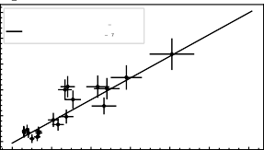

1e 16

Fitted values

*k* = (4.20±0.43)×10 ³¹ cm6/s

31

*kr* = (9.43±0.87)×10 ¹ cm3/s

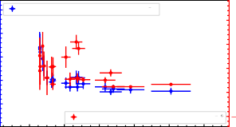

Weighted mean: k31 = (7.86±0.75)×10 ³¹

1.5

1.0

0.5

0.0

Weighted mean: k*CID* = (1.72±0.30)×10 ¹ 0.5

1

5 3

*k* [×10 0 cm / s]

*kCID* [×1015 cm3 / s]

4

*ke* [cm3/*s*]

3 6

2

3

1

31

1

2

1

0.0

0.2 0.4 0.6 0.8 1.0 1.2

*He* [cm 3] 1e15

(a)

0

0.0 0.2 0.4 0.6 0.8 1.0



Number density [cm 3] 1e15

(b)

4.5

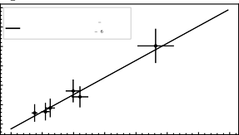

1e 16

Fitted values

*k*3 = (4.41±1.17)×10 ³¹ cm6/s

1

*kr* = (1.38±0.21)×10 ¹ cm3/s

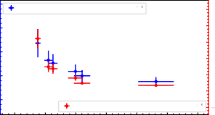

4

Weighted mean: k3 = (1.10±0.18)×10 ³

1

2.5

3

2.0

1.5

2

1.0

1

0.5

0.0

0

Weighted mean: k*CID* = (2.25±0.64)×10 ¹

1

0.5

4.0

*kCID* [×1015 cm3 / s]

3.5

*ke* [cm3/*s*]

3 6

*k* [×10 0 cm / s]

3.0

2.5

31

1

2.0



**D**

1.5

0 1 2 3 4 5 6 7

*He* [cm 3] 1e14

(c)

0 1 2 3 4 5 6

Number density [cm 3] 1e14

(d)

5

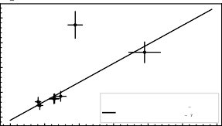

1e 16

Fitted values

*k*3 = (7.65±1.45)×10 ³¹ cm6/s

1

*kr* = (8.71±2.00)×10 ¹ cm3/s

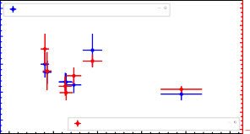

4

Weighted mean: k3 = (1.33±0.16)×10 ³

1.2

1

1.0

3

0.8

2

0.6

0.4

1

0.2

0.0

0

Weighted mean: k*CID* = (3.37±0.55)×10 ¹

1

0.2

4

*ke* [cm3/*s*]

3 6

*k* [×10 0 cm / s]

*kCID* [×1015 cm3 / s]

3

2

31

1

1

0 1 2 3 4 5 6

*He* [cm 3] 1e14

(e)

0 1 2 3 4 5



Number density [cm 3] 1e14

(f)

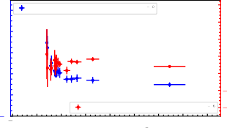8 Weighted mean: k31 = (1.70±0.18)×10 ³

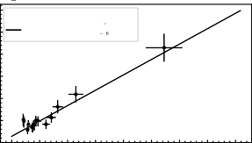

1e 16

Fitted values

*k*3 = (6.97±1.06)×10 ³¹ cm6/s

1

*kr* = (1.28±0.12)×10 ¹ cm3/s

7

6

*k* [×10 0 cm / s]

6

5

*ke* [cm3/*s*]

3 6

4

4

2

3

31

2 0

Weighted mean: k*CID* = (2.59±0.24)×10 ¹

1

2.0

1.5

[×10 5 cm / s]

1.0

1 3

0.5

0.0

*kCID*

1

0.5

1.0

1

0 1 2 3 4 5 6 7 8

*He* [cm 3] 1e14

(g)

2 1 0 1 2 3 4 5 6 7

Number density [cm 3] 1e14

(h)

Figure D.1.: N+ + He reaction rate constants at (*a*)&(*b*) ⇒ 4.8(3) K, (*c*)&(*d* ) ⇒ 6.5(3) K, (*e*)&( *f* ) ⇒ 8.4(3) K and (*g* )&(*h*) ⇒ 10.0(4) K: The ternary association (*k*31 ) and collision-induced dissociation (*kC ID*1 ) rate constants are plotted as a function of helium number density. (a, c, e, g) - represents: Effective binary rate constants are plotted as a function of number density to derive *k*31 (ternary association) and *kr* (radiative) rate coefficients. The solid line indicates the linear fit where the slope and intercept correspond to *k*3 and *kr* , respectively. (b, d, f, h) corresponds to formation rate without *kr* , the weighted average values are shown in the legend box (see Section 6.6).

# E

### Chapter 7

227

0.5

CO + : 00.5 10.5

CO + : 00.5 11.5

0.4

0.4

0.3

Population

Population

0.3

0.2

0.2

0.1

0.1

0.000 0.025 0.050 0.075 0.100 0.125 0.150 0.175 0.200

Time (ms)

(a)

0.000 0.025 0.050 0.075 0.100 0.125 0.150 0.175 0.200

Time (ms)

(b)

0.4 0.4

CO + : 10.5 21.5

CO + : 11.5 21.5

0.3 0.3

Population

Population

0.2 0.2

**E**

0.1 0.1

0.000 0.025 0.050 0.075 0.100 0.125 0.150 0.175 0.200

Time (ms)

(c)

0.000 0.025 0.050 0.075 0.100 0.125 0.150 0.175 0.200

Time (ms)

(d)

Figure E.1.: Numerical simulations of the rotational state population distribution of *NJ* states with (solid line) and without (dashed line) radiation upon excitation of the transitions indicated in the title of each figure. The color code represents *NJ* states as follows: CO+ (00.5), CO+ (10.5), CO+ (11.5), CO+ (21.5) and CO+ (22.5). At t=0, the initial population is given by the Boltzmann distribution at T=300 K which undergoes collisional cooling to reach collisional temperature T=6(1) K. The collisional rates are computed from collisional rate constants and He number density [He]∼ 4 · 1014 cm−3. The radiative rates (Einstein B coefficients for stimulated emission and absorption) are derived from Einstein A coefficients for spontaneous emission (PGOPHER simulation) with radiation power for (a) & (b) 25 *µW* and (c) & (d) 20 *µW* .

229

1.0

0.9

0.8

*NJ*(10.5) / *NJ*(00.5)

0.7

0.6

0.5

0.4

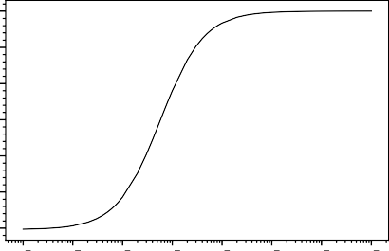10 8 10 7 10 6 10 5 10 4 10 3 10 2 10 1

Power (W)

2.0

1.8

1.6

*NJ*(11.5) / *NJ*(00.5)

1.4

1.2

1.0

0.8

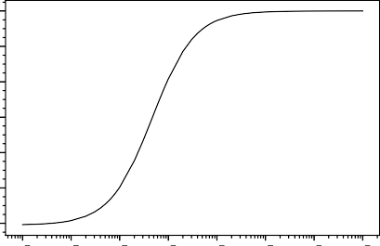10 8 10 7 10 6 10 5 10 4 10 3 10 2 10 1



**E**

Power (W)

2.00

1.75

1.50

*NJ*(21.5) / *NJ*(10.5)

1.25

1.00

0.75

0.50

0.25

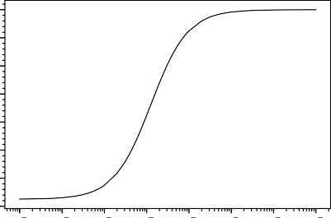10 8 10 7 10 6 10 5 10 4 10 3 10 2 10 1

Power (W)

1.0

0.8

*NJ*(21.5) / *NJ*(11.5)

0.6

0.4

0.2

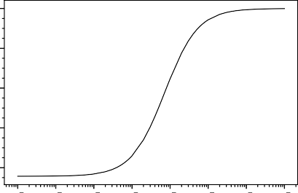10 8 10 7 10 6 10 5 10 4 10 3 10 2 10 1

Power (W)

Figure E.2.: Simulated population ratio (*NJ* : up/down) of CO+ fine-structure transitions as a function of continuous excitation power on the respective transition after storing for 600ms in the trap with a constant He number density of [He]∼ 4·1014 cm−3.

1.0

0.8

Normalised *NJ* ratio : up/down

0.6

**E**

Rotational transitions

00.5 - 10.5

00.5 - 11.5

10.5 - 21.5

11.5 - 21.5

0.4

0.2

0.0

10 8 10 7 10 6 10 5 10 4 10 3 10 2 10 1

Power (W)

Figure E.3.: Comparison of the normalized simulated population ratio (*NJ* : up/down) of the respective CO+ fine-structure transitions as a function of continuous excitation power on the respective transition after storing for 600ms in a trap with a constant He number density of [He]∼ 4·1014 cm−3. Transitions with higher transition strength reach saturation at lower excitation power.

##### BIBLIOGRAPHY

1. F. W. Bessel, Monthly Notices of the Royal Astronomical Society **4**, 152–161 (1838). doi:[10.1093/mnras/4.17.152](https://doi.org/10.1093/mnras/4.17.152)
2. T. Henderson, Memoirs of the Royal Astronomical Society **11**, 61 (1840).
3. F. G. W. Struve, *Stellarum duplicium et multiplicium mensurae micromet- ricae per magnum fraunhoferi tubum annis a 1824 ad 1837 in specula dor- patensi institutae...* (1, 1837).
4. M. J. Reid and K. M. Menten, Astronomische Nachrichten **341**, 860–869 (2020). doi:[10.1002/asna.202013833](https://doi.org/10.1002/asna.202013833)
5. J. v. Fraunhofer, Denkschriften der Münch. Akademie der Wissenschaften

**5**, 193 (1817).

1. I. Newton, American Journal of Physics **61**, 108–112 (1993). doi:[10.1119/](https://doi.org/10.1119/1.17323)

[1.17323](https://doi.org/10.1119/1.17323)

1. J. Tennyson, *Astronomical spectroscopy: an introduction to the atomic and molecular physics of astronomical spectra*, v. 2 (London : Hackensack, N.J, 2005), 192 pp.
2. G. Kirchhoff and R. Bunsen, Annalen der Physik und der Chemie **110**, 161–189 (1860).
3. J. Harju, M. Juvela, S. Schlemmer, L. K. Haikala, K. Lehtinen, and K. Mattila, Astronomy & Astrophysics **482**, 535–539 (2008). doi:10 . 1051 /

0004-6361:20079259

1. B. J. McCall, Proceedings of the International Astronomical Union **1**, 165– 174 (2005). doi:[10.1017/S1743921306007162](https://doi.org/10.1017/S1743921306007162)
2. A. S. Eddington, Proceedings of the Royal Society of London. Series A, Containing Papers of a Mathematical and Physical Character **111**, 424– 456 (1926). doi:[10.1098/rspa.1926.0076](https://doi.org/10.1098/rspa.1926.0076)
3. J. Hartmann, The Astrophysical Journal **19**, 268–286 (1904). doi:[10.1086/](https://doi.org/10.1086/141112)

[141112](https://doi.org/10.1086/141112)

1. M. L. Heger, Lick Observatory Bulletin **326**, 59–63 (1919). doi:[10 . 5479 /](https://doi.org/10.5479/ADS/bib/1919LicOB.10.59H) [ADS/bib/1919LicOB.10.59H](https://doi.org/10.5479/ADS/bib/1919LicOB.10.59H)

231

1. J. S. Plaskett, Monthly Notices of the Royal Astronomical Society **84**, 80–93 (1923). doi:[10.1093/mnras/84.2.80](https://doi.org/10.1093/mnras/84.2.80)
2. P. W. Merrill, Publications of the Astronomical Society of the Pacific **46**, 206 (1934). doi:[10.1086/124460](https://doi.org/10.1086/124460)
3. H. N. Russell, Monthly Notices of the Royal Astronomical Society **95**, 610– 636 (1935). doi:[10.1093/mnras/95.8.610](https://doi.org/10.1093/mnras/95.8.610)
4. P. W. Merrill, The Astrophysical Journal **83**, 126 (1936). doi:[10.1086/143707](https://doi.org/10.1086/143707)
5. E. K. Campbell, M. Holz, D. Gerlich, and J. P. Maier, Nature **523**, 322–323 (2015). doi:[10.1038/nature14566](https://doi.org/10.1038/nature14566)
6. T. Dunham Jr, Publications of the Astronomical Society of the Pacific **49**, 26 (1937). doi:[10.1086/124759](https://doi.org/10.1086/124759)
7. W. S. Adams, *Quoted in "dunham, t., publ. astron. soc. pac. 49, 26–8 (1937)" unpublished* (1937).

**E**

1. A. McKellar, Publications of the Astronomical Society of the Pacific **52**, 187–192 (1940).
2. A. McKellar, Publications of the Astronomical Society of the Pacific **52**, 312 (1940). doi:[10.1086/125205](https://doi.org/10.1086/125205)
3. F. A. Jenkins and D. E. Wooldridge, Physical Review **53**, 137–140 (1938). doi:[10.1103/PhysRev.53.137](https://doi.org/10.1103/PhysRev.53.137)
4. A. E. Douglas and G. Herzberg, The Astrophysical Journal **94**, 381 (1941). doi:[10.1086/144342](https://doi.org/10.1086/144342)
5. A. E. Douglas and G. Herzberg, Canadian Journal of Research **20a**, 71–82 (1942). doi:[10.1139/cjr42a-008](https://doi.org/10.1139/cjr42a-008)
6. D. R. Bates and L. Spitzer Jr., The Astrophysical Journal **113**, 441 (1951). doi:[10.1086/145415](https://doi.org/10.1086/145415)
7. P. M. Solomon and W. Klemperer, The Astrophysical Journal **178**, 389–422 (1972). doi:[10.1086/151799](https://doi.org/10.1086/151799)
8. E. Herbst and W. Klemperer, The Astrophysical Journal **185**, 505–534 (1973). doi:[10.1086/152436](https://doi.org/10.1086/152436)
9. S. Weinreb, A. H. Barrett, M. L. Meeks, and J. C. Henry, Nature **200**, 829– 831 (1963). doi:[10.1038/200829a0](https://doi.org/10.1038/200829a0)
10. A. C. Cheung, D. M. Rank, C. H. Townes, D. D. Thornton, and W. J. Welch, Physical Review Letters **21**, 1701–1705 (1968). doi:[10.1103/PhysRevLett.](https://doi.org/10.1103/PhysRevLett.21.1701)

[21.1701](https://doi.org/10.1103/PhysRevLett.21.1701)

1. A. C. Cheung, D. M. Rank, C. H. Townes, D. D. Thornton, and W. J. Welch,

Nature **221**, 626–628 (1969). doi:[10.1038/221626a0](https://doi.org/10.1038/221626a0)

1. L. E. Snyder, D. Buhl, B. Zuckerman, and P. Palmer, Physical Review Letters **22**, 679–681 (1969). doi:[10.1103/PhysRevLett.22.679](https://doi.org/10.1103/PhysRevLett.22.679)
2. B. A. McGuire, The Astrophysical Journal Supplement Series **259**, 30 (2021). doi:[10.3847/1538-4365/ac2a48](https://doi.org/10.3847/1538-4365/ac2a48)
3. F. C. Gillett, W. J. Forrest, and K. M. Merrill, The Astrophysical Journal **183**, 87 (1973). doi:[10.1086/152211](https://doi.org/10.1086/152211)
4. A. Li, Nature Astronomy **4**, 339–351 (2020). doi:[10.1038/s41550-020-1051-](https://doi.org/10.1038/s41550-020-1051-1)

[1](https://doi.org/10.1038/s41550-020-1051-1)

1. K. M. Merrill, B. T. Soifer, and R. W. Russell, The Astrophysical Journal **200**,

L37 (1975). doi:[10.1086/181891](https://doi.org/10.1086/181891)

1. R. W. Russell, B. T. Soifer, and S. P. Willner, The Astrophysical Journal **217**,

**E**

L149 (1977). doi:[10.1086/182559](https://doi.org/10.1086/182559)

1. S. P. Willner, B. T. Soifer, R. W. Russell, R. R. Joyce, and F. C. Gillett, The Astrophysical Journal **217**, L121–L124 (1977). doi:[10.1086/182553](https://doi.org/10.1086/182553)
2. A. Leger and J. L. Puget, Astronomy and Astrophysics **137**, L5–L8 (1984).
3. L. J. Allamandola, A. G. G. M. Tielens, and J. R. Barker, The Astrophysical Journal **290**, L25–L28 (1985). doi:[10.1086/184435](https://doi.org/10.1086/184435)
4. D. Smith, Chemical Reviews **92**, 1473–1485 (1992). doi:[10 . 1021 /](https://doi.org/10.1021/cr00015a001) [cr00015a001](https://doi.org/10.1021/cr00015a001)
5. E. Herbst, 239–262 (1988). doi:[10.1007/978-94-009-3007-0_15](https://doi.org/10.1007/978-94-009-3007-0_15)
6. S. Cuadrado, J. R. Goicoechea, P. Pilleri, J. Cernicharo, A. Fuente, and C. Joblin, ASTRONOMY & ASTROPHYSICS **575**, doi:[10 . 1051 / 0004 - 6361 /](https://doi.org/10.1051/0004-6361/201424568)

[201424568](https://doi.org/10.1051/0004-6361/201424568) (2015).

1. B. A. McGuire and Mcguiregroup, doi:[10.5281/ZENODO.5541828](https://doi.org/10.5281/ZENODO.5541828) (2021).
2. T. Oka, Science **347**, 1313–1314 (2015). doi:[10.1126/science.aaa6935](https://doi.org/10.1126/science.aaa6935)
3. O. Asvany, P. K. P, B. Redlich, I. Hegemann, S. Schlemmer, and D. Marx,

Science **309**, 1219–1222 (2005). doi:[10.1126/science.1113729](https://doi.org/10.1126/science.1113729)

1. S. Earnshaw, Transactions of the Cambridge Philosophical Society **7**, 97 (1848).
2. W. Paul, O. Osberghaus, and E. Fischer, Forschungsberichte des Verkehrs- und Wirtschaftsministeriums Nordrhein-Westfalen **415**, 1–42 (1955).
3. W. Paul and M. Raether, Zeitschrift für Physik **140**, 262–273 (1955). doi:[10.](https://doi.org/10.1007/BF01328923) [1007/BF01328923](https://doi.org/10.1007/BF01328923)
4. H. Schwarz and K. R. Asmis, Chem.: Eur. J. **25**, 2112–2126 (2019). doi:[10.](https://doi.org/10.1002/chem.201805836) [1002/chem.201805836](https://doi.org/10.1002/chem.201805836)
5. A. Pereversev and J. Roithová, J. Mass Spectrom. **57**, e4826 (2022). doi:[10.](https://doi.org/10.1002/jms.4826) [1002/jms.4826](https://doi.org/10.1002/jms.4826)
6. O. Asvany and S. Schlemmer, Physical Chemistry Chemical Physics **23**, 26602–26622 (2021). doi:[10.1039/d1cp03975j](https://doi.org/10.1039/d1cp03975j)
7. H. G. Dehmelt, *Advances in atomic and molecular physics*, Vol. 3, edited by

D. R. Bates and I. Estermann (Academic Press, 1, 1968), pp. 53–72, doi:[10.](https://doi.org/10.1016/S0065-2199(08)60170-0) [1016/S0065-2199(08)60170-0](https://doi.org/10.1016/S0065-2199(08)60170-0)

1. R. Wester, Journal of Physics B: Atomic, Molecular and Optical Physics **42**, 154001 (2009). doi:[10.1088/0953-4075/42/15/154001](https://doi.org/10.1088/0953-4075/42/15/154001)
2. D. Gerlich, Physica Scripta **T59**, 256–263 (1995). doi:[10.1088/0031-8949/](https://doi.org/10.1088/0031-8949/1995/T59/035) [1995/T59/035](https://doi.org/10.1088/0031-8949/1995/T59/035)

**E**

1. O. Asvany, F. Bielau, D. Moratschke, J. Krause, and S. Schlemmer, Review of Scientific Instruments **81**, 076102 (2010). doi:[10.1063/1.3460265](https://doi.org/10.1063/1.3460265)
2. D. Gerlich and S. Horning, Chemical Reviews **92**, 1509–1539 (1992). doi:[10.1021/cr00015a003](https://doi.org/10.1021/cr00015a003)
3. D. Gerlich, *Advances in chemical physics* (John Wiley & Sons, Ltd, 1992),

pp. 1–176.

1. F. C. Fehsenfeld, A. L. Schmeltekopf, and E. E. Ferguson, The Journal of Chemical Physics **46**, 2802–2808 (1967). doi:[10.1063/1.1841117](https://doi.org/10.1063/1.1841117)
2. J. K. Kim, L. P. Theard, and W. T. Huntress, The Journal of Chemical Physics

**62**, 45–52 (1975). doi:[10.1063/1.430236](https://doi.org/10.1063/1.430236)

1. D. Smith, N. G. Adams, and T. M. Miller, The Journal of Chemical Physics

**69**, 308–318 (1978). doi:[10.1063/1.436354](https://doi.org/10.1063/1.436354)

1. W. Paul, B. Lücke, S. Schlemmer, and D. Gerlich, International Journal of Mass Spectrometry and Ion Processes **149-150**, 373–387 (1995). doi:[10 .](https://doi.org/10.1016/0168-1176(95)04269-Q) [1016/0168-1176(95)04269-Q](https://doi.org/10.1016/0168-1176(95)04269-Q)
2. W. Paul, S. Schlemmer, B. Lücke, and D. Gerlich, Chemical Physics **209**, 265–274 (1996). doi:[10.1016/0301-0104(96)00160-7](https://doi.org/10.1016/0301-0104(96)00160-7)
3. S. Chakrabarty, M. Holz, E. K. Campbell, A. Banerjee, D. Gerlich, and J. P. Maier, The Journal of Physical Chemistry Letters **4**, 4051–4054 (2013). doi:[10.1021/jz402264n](https://doi.org/10.1021/jz402264n)
4. S. Brünken, L. Kluge, A. Stoffels, J. Pérez-Ríos, and S. Schlemmer, Journal of Molecular Spectroscopy **332**, 67–78 (2017). doi:[10.1016/j.jms.2016.10.](https://doi.org/10.1016/j.jms.2016.10.018)

[018](https://doi.org/10.1016/j.jms.2016.10.018)

1. J. G. Redwine, Z. A. Davis, N. L. Burke, R. A. Oglesbee, S. A. McLuckey, and

T. S. Zwier, International Journal of Mass Spectrometry **348**, 9–14 (2013). doi:[10.1016/j.ijms.2013.04.002](https://doi.org/10.1016/j.ijms.2013.04.002)

1. O. Asvany, S. Brünken, L. Kluge, and S. Schlemmer, English, Applied Physics B **114**, 203–211 (2014). doi:[10.1007/s00340-013-5684-y](https://doi.org/10.1007/s00340-013-5684-y)
2. A. Günther, P. Nieto, D. Müller, A. Sheldrick, D. Gerlich, and O. Dopfer, Journal of Molecular Spectroscopy **332**, 8–15 (2017). doi:[10.1016/j.jms.](https://doi.org/10.1016/j.jms.2016.08.017) [2016.08.017](https://doi.org/10.1016/j.jms.2016.08.017)
3. P. Jusko, S. Brünken, B. Brünken, O. Asvany, S. Thorwirth, A. Stoffels,

L. Van Der Meer, G. Berden, B. Redlich, J. Oomens, and S. Schlemmer,

Faraday Discuss. **217**, 172 (2019). doi:[10.1039/c8fd00225h](https://doi.org/10.1039/c8fd00225h)

1. D. B. Rap, J. G. M. Schrauwen, A. N. Marimuthu, B. Redlich, and S. Brünken, Nature Astronomy **6**, 1059–1067 (2022). doi:[10.1038 /s41550-](https://doi.org/10.1038/s41550-022-01713-z) [022-01713-z](https://doi.org/10.1038/s41550-022-01713-z)

**E**

1. R. C. Dunbar, Journal of the American Chemical Society **95**, 472–476 (1973). doi:[10.1021/ja00783a028](https://doi.org/10.1021/ja00783a028)
2. M. Okumura, L. I. Yeh, and Y. T. Lee, The Journal of Chemical Physics **83**, 3705–3706 (1985). doi:[10.1063/1.449127](https://doi.org/10.1063/1.449127)
3. E. J. Bieske and J. P. Maier, Chemical Reviews **93**, 2603–2621 (1993). doi:[10.](https://doi.org/10.1021/cr00024a002) [1021/cr00024a002](https://doi.org/10.1021/cr00024a002)
4. M. A. Duncan, International Reviews in Physical Chemistry **22**, 407–435 (2003). doi:[10.1080/0144235031000095201](https://doi.org/10.1080/0144235031000095201)
5. J. M. Lisy, The Journal of Chemical Physics **125**, 132302 (2006). doi:[10 .](https://doi.org/10.1063/1.2338317) [1063/1.2338317](https://doi.org/10.1063/1.2338317)
6. K. R. Asmis, M. Brümmer, C. Kaposta, G. Santambrogio, G. v. Helden, G. Meijer, K. Rademann, and L. Wöste, Physical Chemistry Chemical Physics **4**, 1101–1104 (2002). doi:[10.1039/B111056J](https://doi.org/10.1039/B111056J)
7. H. Kohguchi, P. Jusko, K. M. T. Yamada, S. Schlemmer, and O. Asvany, The Journal of Chemical Physics **148**, 144303 (2018). doi:[10.1063/1.5023633](https://doi.org/10.1063/1.5023633)
8. M. Töpfer, A. Jensen, K. Nagamori, H. Kohguchi, T. Szidarovszky, A.

G. Császár, S. Schlemmer, and O. Asvany, Physical Chemistry Chemical Physics **22**, 22885–22888 (2020). doi:[10.1039/D0CP04649C](https://doi.org/10.1039/D0CP04649C)

1. F. Dahlmann, P. Jusko, M. Lara-Moreno, P. Halvick, A. N. Marimuthu, T. Michaelsen, R. Wild, K. Geistlinger, S. Schlemmer, T. Stoecklin, R. Wester, and S. Brünken, Molecular Physics **120**, e2085204 (2022). doi:[10 . 1080 /](https://doi.org/10.1080/00268976.2022.2085204) [00268976.2022.2085204](https://doi.org/10.1080/00268976.2022.2085204)
2. J. Roithová, A. Gray, E. Andris, J. Jašík, and D. Gerlich, Accounts of Chemical Research **49**, 223–230 (2016). doi:[10 . 1021 / acs . accounts .](https://doi.org/10.1021/acs.accounts.5b00489) [5b00489](https://doi.org/10.1021/acs.accounts.5b00489)
3. D. Gerlich, Journal of the Chinese Chemical Society **65**, 637–653 (2018). doi:[10.1002/jccs.201800122](https://doi.org/10.1002/jccs.201800122)
4. N. R. Isenor, V. Merchant, R. S. Hallsworth, and M. C. Richardson,

Canadian Journal of Physics **51**, 1281–1287 (1973). doi:[10.1139/p73-169](https://doi.org/10.1139/p73-169)

1. C. A. Wight and J. L. Beauchamp, Journal of the American Chemical Society **103**, 6499–6501 (1981). doi:[10.1021/ja00411a042](https://doi.org/10.1021/ja00411a042)
2. T. Gäumann, J. M. Riveros, and Z. Zhu, Helvetica Chimica Acta **73**, 1215– 1218 (1990). doi:[10.1002/hlca.19900730510](https://doi.org/10.1002/hlca.19900730510)
3. D. M. Peiris, M. A. Cheeseman, R. Ramanathan, and J. R. Eyler, The Journal of Physical Chemistry **97**, 7839–7843 (1993). doi:[10.1021/j100132a009](https://doi.org/10.1021/j100132a009)

**E**

1. J. Oomens, A. J. A. v. Roij, G. Meijer, and G. v. Helden, The Astrophysical Journal **542**, 404–410 (2000). doi:[10.1086/309545](https://doi.org/10.1086/309545)
2. J. Lemaire, P. Boissel, M. Heninger, G. Mauclaire, G. Bellec, H. Mestdagh,

A. Simon, S. L. Caer, J. M. Ortega, F. Glotin, and P. Maitre, Physical Review Letters **89**, 273002 (2002). doi:[10.1103/PhysRevLett.89.273002](https://doi.org/10.1103/PhysRevLett.89.273002)

1. N. C. Polfer, Chemical Society Reviews **40**, 2211–2221 (2011). doi:[10.1039/](https://doi.org/10.1039/C0CS00171F) [C0CS00171F](https://doi.org/10.1039/C0CS00171F)
2. J. G. Black, E. Yablonovitch, N. Bloembergen, and S. Mukamel, Physical Review Letters **38**, 1131–1134 (1977). doi:[10.1103/PhysRevLett.38.1131](https://doi.org/10.1103/PhysRevLett.38.1131)
3. A. A. Makarov, I. Y. Petrova, E. A. Ryabov, and V. S. Letokhov, The Journal of Physical Chemistry A **102**, 1438–1449 (1998). doi:[10.1021/jp972487c](https://doi.org/10.1021/jp972487c)
4. J. Oomens, B. G. Sartakov, G. Meijer, and G. von Helden, International Journal of Mass Spectrometry **254**, 1–19 (2006). doi:[10.1016/j.ijms.2006.](https://doi.org/10.1016/j.ijms.2006.05.009)

[05.009](https://doi.org/10.1016/j.ijms.2006.05.009)

1. P. Parneix, M. Basire, and F. Calvo, The Journal of Physical Chemistry A

**117**, 3954–3959 (2013). doi:[10.1021/jp402459f](https://doi.org/10.1021/jp402459f)

1. J. I. Steinfeld, *Molecules and radiation: an introduction to modern molecular spectroscopy*, 2nd ed (MIT Press, Cambridge, Mass, 1985).
2. S. Schlemmer, T. Kuhn, E. Lescop, and D. Gerlich, International Journal of Mass Spectrometry **185-187**, 589–602 (1999). doi:[10.1016/S1387-3806(98)](https://doi.org/10.1016/S1387-3806(98)14141-6)

[14141-6](https://doi.org/10.1016/S1387-3806(98)14141-6)

1. S. Schlemmer, E. Lescop, J. von Richthofen, D. Gerlich, and M. A. Smith, The Journal of Chemical Physics **117**, 2068–2075 (2002). doi:[10.1063/1.](https://doi.org/10.1063/1.1487373)

[1487373](https://doi.org/10.1063/1.1487373)

1. O. Asvany, T. Giesen, B. Redlich, and S. Schlemmer, Physical Review Letters **94**, 073001 (2005). doi:[10.1103/PhysRevLett.94.073001](https://doi.org/10.1103/PhysRevLett.94.073001)
2. S. Schlemmer, O. Asvany, and T. Giesen, Physical Chemistry Chemical Physics **7**, 1592–1600 (2005). doi:[10.1039/B418495P](https://doi.org/10.1039/B418495P)
3. J. L. Doménech, P. Jusko, S. Schlemmer, and O. Asvany, The Astrophysical Journal **857**, 61 (2018). doi:[10.3847/1538-4357/aab36a](https://doi.org/10.3847/1538-4357/aab36a)
4. P. Jusko, C. Konietzko, S. Schlemmer, and O. Asvany, Journal of Molecular Spectroscopy **319**, 55–58 (2016). doi:[10.1016/j.jms.2015.12.002](https://doi.org/10.1016/j.jms.2015.12.002)
5. P. Jusko, A. Stoffels, S. Thorwirth, S. Brünken, S. Schlemmer, and O. Asvany, Journal of Molecular Spectroscopy **332**, 59–66 (2017). doi:[10 .](https://doi.org/10.1016/j.jms.2016.10.017) [1016/j.jms.2016.10.017](https://doi.org/10.1016/j.jms.2016.10.017)

**E**

1. C. R. Markus, S. Thorwirth, O. Asvany, and S. Schlemmer, Physical Chemistry Chemical Physics **21**, 26406–26412 (2019). doi:[10 . 1039 /](https://doi.org/10.1039/c9cp05487a) [c9cp05487a](https://doi.org/10.1039/c9cp05487a)
2. J. L. Doménech, O. Asvany, C. R. Markus, S. Schlemmer, and S. Thorwirth, Journal of Molecular Spectroscopy **374**, 111375 (2020). doi:[10.1016/j.jms.](https://doi.org/10.1016/j.jms.2020.111375)

[2020.111375](https://doi.org/10.1016/j.jms.2020.111375)

1. O. Asvany, O. Ricken, H. S. Müller, M. C. Wiedner, T. F. Giesen, and S. Schlemmer, Physical Review Letters **100**, 13–16 (2008). doi:[10 . 1103 /](https://doi.org/10.1103/PhysRevLett.100.233004) [PhysRevLett.100.233004](https://doi.org/10.1103/PhysRevLett.100.233004)
2. S. Gärtner, J. Krieg, A. Klemann, O. Asvany, S. Brünken, and S. Schlemmer, Journal of Physical Chemistry A **117**, 9975–9984 (2013). doi:[10 . 1021 /](https://doi.org/10.1021/jp400258e) [jp400258e](https://doi.org/10.1021/jp400258e)
3. P. Jusko, O. Asvany, A. C. Wallerstein, S. Brünken, and S. Schlemmer, Physical Review Letters **112**, 253005, 2–5 (2014). doi:[10.1103/PhysRevLett.](https://doi.org/10.1103/PhysRevLett.112.253005)

[112.253005](https://doi.org/10.1103/PhysRevLett.112.253005)

1. R. V. Olkhov, S. A. Nizkorodov, and O. Dopfer, The Journal of Chemical Physics **110**, 9527–9535 (1999). doi:[10.1063/1.478917](https://doi.org/10.1063/1.478917)
2. M. Töpfer, T. Salomon, H. Kohguchi, O. Dopfer, K. M. Yamada, S. Schlemmer, and O. Asvany, Physical Review Letters **121**, 143001 (2018). doi:[10.1103/PhysRevLett.121.143001](https://doi.org/10.1103/PhysRevLett.121.143001)
3. S. Lee, D. Hauser, O. Lakhmanskaya, S. Spieler, E. S. Endres, K. Geistlinger,

S. S. Kumar, and R. Wester, Physical Review A **93**, 032513 (2016). doi:[10.](https://doi.org/10.1103/PhysRevA.93.032513) [1103/PhysRevA.93.032513](https://doi.org/10.1103/PhysRevA.93.032513)

1. S. Brünken, L. Kluge, A. Stoffels, O. Asvany, and S. Schlemmer, The Astrophysical Journal **783**, L4, L4 (2014). doi:[10.1088/2041- 8205/783/](https://doi.org/10.1088/2041-8205/783/1/L4) [1/L4](https://doi.org/10.1088/2041-8205/783/1/L4)
2. A. Stoffels, L. Kluge, S. Schlemmer, and S. Brünken, Astronomy & Astrophysics **593**, A56 (2016). doi:[10.1051/0004-6361/201629101](https://doi.org/10.1051/0004-6361/201629101)
3. J. L. Doménech, S. Schlemmer, and O. Asvany, The Astrophysical Journal

**849**, 60 (2017). doi:[10.3847/1538-4357/aa8fca](https://doi.org/10.3847/1538-4357/aa8fca)

1. T. Salomon, M. Töpfer, P. Schreier, S. Schlemmer, H. Kohguchi, L. Surin, and O. Asvany, Physical Chemistry Chemical Physics **21**, 3440–3445 (2019). doi:[10.1039/C8CP04532A](https://doi.org/10.1039/C8CP04532A)
2. J. L. Doménech, S. Schlemmer, and O. Asvany, The Astrophysical Journal

**866**, 158 (2018). doi:[10.3847/1538-4357/aadf83](https://doi.org/10.3847/1538-4357/aadf83)

1. S. Thorwirth, P. Schreier, T. Salomon, S. Schlemmer, and O. Asvany,

**E**

Astrophys. J. Lett. **882**, L6 (2019). doi:[10.3847/2041-8213/ab3927](https://doi.org/10.3847/2041-8213/ab3927)

1. P. C. Schmid, S. Thorwirth, C. P. Endres, M. Töpfer, Á. Sánchez-Monge,

A. Schwörer, P. Schilke, S. Schlemmer, and O. Asvany, Frontiers in Astronomy and Space Sciences **8**, doi:[10.3389/fspas.2021.805162](https://doi.org/10.3389/fspas.2021.805162) (2022).

1. O. Asvany, C. R. Markus, A. Roucou, S. Schlemmer, S. Thorwirth, and C. Lauzin, Journal of Molecular Spectroscopy **378**, 111447 (2021). doi:[10 .](https://doi.org/10.1016/j.jms.2021.111447) [1016/j.jms.2021.111447](https://doi.org/10.1016/j.jms.2021.111447)
2. O. Asvany, C. R. Markus, K. Nagamori, H. Kohguchi, J. Furuta, K. Kobayashi, S. Schlemmer, and S. Thorwirth, The Astrophysical Journal **910**, 15 (2021). doi:[10.3847/1538-4357/abe536](https://doi.org/10.3847/1538-4357/abe536)
3. A. N. Marimuthu, K. Steenbakkers, B. Redlich, and S. Brünken, Molecular Physics, e2067089 (2022). doi:[10.1080/00268976.2022.2067089](https://doi.org/10.1080/00268976.2022.2067089)
4. A. N. Marimuthu, D. Sundelin, S. Thorwirth, B. Redlich, W. D. Geppert, and S. Brünken, J. Mol. Spectrosc. **374**, 111377 (2020). doi:[10.1016/j.jms.](https://doi.org/10.1016/j.jms.2020.111377) [2020.111377](https://doi.org/10.1016/j.jms.2020.111377)
5. A. N. Marimuthu, F. Huis in’t Veld, S. Thorwirth, B. Redlich, and S. Brünken, J. Mol. Spectrosc. **379**, 111477 (2021). doi:[10.1016/J.JMS.2021.](https://doi.org/10.1016/J.JMS.2021.111477)

[111477](https://doi.org/10.1016/J.JMS.2021.111477)

1. K. Steenbakkers, A. N. Marimuthu, B. Redlich, G. C. Groenenboom, and

S. Brünken, The Journal of Chemical Physics **158**, 084305 (2023). doi:[10.](https://doi.org/10.1063/5.0135000) [1063/5.0135000](https://doi.org/10.1063/5.0135000)

1. D. Oepts, A. F. van der Meer, and P. W. van Amersfoort, Infrared Phys. Technol. **36**, 297–308 (1995). doi:[10.1016/1350-4495(94)00074-U](https://doi.org/10.1016/1350-4495(94)00074-U)
2. L. A. Kluge, “State-selective attachment of helium to molecular ions in a new cryogenic ion trap”, PhD thesis (Universität zu Köln, Köln, 2016), 171 pp.
3. A. J. Dempster, Physical Review **11**, 316–325 (1918). doi:[10.1103/PhysRev.](https://doi.org/10.1103/PhysRev.11.316)

[11.316](https://doi.org/10.1103/PhysRev.11.316)

1. W. Bleakney, Physical Review **34**, 157–160 (1929). doi:[10.1103/PhysRev.](https://doi.org/10.1103/PhysRev.34.157)

[34.157](https://doi.org/10.1103/PhysRev.34.157)

1. E. S. Endres, G. Egger, S. Lee, O. Lakhmanskaya, M. Simpson, and R. Wester, Journal of Molecular Spectroscopy **332**, 134–138 (2017). doi:[10 .](https://doi.org/10.1016/j.jms.2016.12.006) [1016/j.jms.2016.12.006](https://doi.org/10.1016/j.jms.2016.12.006)
2. N. R. Daly, Review of Scientific Instruments **31**, 264–267 (1960). doi:[10.](https://doi.org/10.1063/1.1716953) [1063/1.1716953](https://doi.org/10.1063/1.1716953)
3. J. J. Olivero and R. L. Longbothum, Journal of Quantitative Spectroscopy and Radiative Transfer **17**, 233–236 (1977). doi:[10.1016/0022- 4073(77)](https://doi.org/10.1016/0022-4073(77)90161-3)

**E**

[90161-3](https://doi.org/10.1016/0022-4073(77)90161-3)

1. C. M. Western, J. Quant. Spectrosc. Radiat. Transf. **186**, 221–242 (2017). doi:[10.1016/j.jqsrt.2016.04.010](https://doi.org/10.1016/j.jqsrt.2016.04.010)
2. E. Hairer and G. Wanner, *Solving ordinary differential equations II*, Vol. 14 (Springer Berlin Heidelberg, Berlin, Heidelberg, 1991), doi:[10.1007/978-](https://doi.org/10.1007/978-3-662-09947-6) [3-662-09947-6](https://doi.org/10.1007/978-3-662-09947-6)
3. E. Hairer and G. Wanner, *Solving ordinary differential equations II: stiff and differential-algebraic problems*, edited by E. Hairer and G. Wanner (Springer, Berlin, Heidelberg, 1996), pp. 118–130, doi:[10.1007/978-3-642-](https://doi.org/10.1007/978-3-642-05221-7_8) [05221-7_8](https://doi.org/10.1007/978-3-642-05221-7_8)
4. P. Virtanen, R. Gommers, T. E. Oliphant, M. Haberland, T. Reddy, D. Cournapeau, E. Burovski, P. Peterson, W. Weckesser, J. Bright, S. J. van der Walt, M. Brett, J. Wilson, K. J. Millman, N. Mayorov, A. R. Nelson,

E. Jones, R. Kern, E. Larson, C. J. Carey, ˙I. Polat, Y. Feng, E. W. Moore,

J. VanderPlas, D. Laxalde, J. Perktold, R. Cimrman, I. Henriksen, E. A. Quintero, C. R. Harris, A. M. Archibald, A. H. Ribeiro, F. Pedregosa, P. van Mulbregt, A. Vijaykumar, A. P. Bardelli, A. Rothberg, A. Hilboll, A. Kloeckner, A. Scopatz, A. Lee, A. Rokem, C. N. Woods, C. Fulton, C. Masson, C. Häggström, C. Fitzgerald, D. A. Nicholson, D. R. Hagen, D. V. Pasechnik, E. Olivetti, E. Martin, E. Wieser, F. Silva, F. Lenders, F. Wilhelm,

G. Young, G. A. Price, G. L. Ingold, G. E. Allen, G. R. Lee, H. Audren,

I. Probst, J. P. Dietrich, J. Silterra, J. T. Webber, J. Slavicˇ, J. Nothman, J. Buchner, J. Kulick, J. L. Schönberger, J. V. de Miranda Cardoso, J. Reimer, J.

Harrington, J. L. C. Rodríguez, J. Nunez-Iglesias, J. Kuczynski, K. Tritz, M. Thoma, M. Newville, M. Kümmerer, M. Bolingbroke, M. Tartre, M. Pak,

N. J. Smith, N. Nowaczyk, N. Shebanov, O. Pavlyk, P. A. Brodtkorb, P. Lee,

R. T. McGibbon, R. Feldbauer, S. Lewis, S. Tygier, S. Sievert, S. Vigna, S. Peterson, S. More, T. Pudlik, *et al.*, Nature Methods 2020 17:3 **17**, 261–272

(2020). doi:[10.1038/s41592-019-0686-2](https://doi.org/10.1038/s41592-019-0686-2)

1. M. Born and R. Oppenheimer, Annalen der Physik **389**, 457–484 (1927). doi:[10.1002/andp.19273892002](https://doi.org/10.1002/andp.19273892002)
2. K. Raghavachari, G. W. Trucks, J. A. Pople, and M. Head-Gordon, Chemical Physics Letters **157**, 479–483 (1989). doi:[10.1016/S0009-2614(89)87395-6](https://doi.org/10.1016/S0009-2614(89)87395-6)
3. J. Almlöf and P. R. Taylor, The Journal of Chemical Physics **86**, 4070–4077 (1987). doi:[10.1063/1.451917](https://doi.org/10.1063/1.451917)
4. J. Almlöf and P. R. Taylor, *Advances in quantum chemistry*, Vol. 22, edited by P.-O. Löwdin, J. R. Sabin, and M. C. Zerner (Academic Press, 1, 1991),

**E**

pp. 301–373, doi:[10.1016/S0065-3276(08)60366-4](https://doi.org/10.1016/S0065-3276(08)60366-4)

1. T. H. Dunning, The Journal of Chemical Physics **90**, 1007–1023 (1989). doi:[10.1063/1.456153](https://doi.org/10.1063/1.456153)
2. J. D. Watts, J. Gauss, and R. J. Bartlett, Chemical Physics Letters **200**, 1–7 (1992). doi:[10.1016/0009-2614(92)87036-O](https://doi.org/10.1016/0009-2614(92)87036-O)
3. T. J. Lee and A. P. Rendell, The Journal of Chemical Physics **94**, 6229–6236 (1991). doi:[10.1063/1.460411](https://doi.org/10.1063/1.460411)
4. J. D. Watts, J. Gauss, and R. J. Bartlett, The Journal of Chemical Physics **98**, 8718–8733 (1993). doi:[10.1063/1.464480](https://doi.org/10.1063/1.464480)
5. I. M. Mills, *Molecular spectroscopy*, edited by K. N. Rao and C. W. Mathews (Academic Press, 1, 1972), pp. 115–140, doi:[10.1016/B978-0-12-580640-](https://doi.org/10.1016/B978-0-12-580640-4.50013-3)

[4.50013-3](https://doi.org/10.1016/B978-0-12-580640-4.50013-3)

1. D. A. Matthews, L. Cheng, M. E. Harding, F. Lipparini, S. Stopkowicz, T.-C. Jagau, P. G. Szalay, J. Gauss, and J. F. Stanton, The Journal of Chemical Physics **152**, 214108 (2020). doi:[10.1063/5.0004837](https://doi.org/10.1063/5.0004837)
2. M. E. Harding, T. Metzroth, J. Gauss, and A. A. Auer, Journal of Chemical Theory and Computation **4**, 64–74 (2008). doi:[10.1021/ct700152c](https://doi.org/10.1021/ct700152c)
3. D. G. A. Smith, L. A. Burns, A. C. Simmonett, R. M. Parrish, M. C. Schieber,

R. Galvelis, P. Kraus, H. Kruse, R. Di Remigio, A. Alenaizan, A. M. James,

S. Lehtola, J. P. Misiewicz, M. Scheurer, R. A. Shaw, J. B. Schriber, Y. Xie,

Z. L. Glick, D. A. Sirianni, J. S. O’Brien, J. M. Waldrop, A. Kumar, E. G. Hohenstein, B. P. Pritchard, B. R. Brooks, H. F. Schaefer, A. Y. Sokolov, K. Patkowski, A. E. DePrince, U. Bozkaya, R. A. King, F. A. Evangelista, J. M. Turney, T. D. Crawford, and C. D. Sherrill, The Journal of Chemical Physics **152**, 184108 (2020). doi:[10.1063/5.0006002](https://doi.org/10.1063/5.0006002)

1. A. D. M. B. Liu, J. Chem. Phys. **59**, 4557 (1973). doi:[10.1063/1.1680654](https://doi.org/10.1063/1.1680654)
2. S. Boys and F. Bernardi, Molecular Physics **19**, 553–566 (1970). doi:[10 .](https://doi.org/10.1080/00268977000101561) [1080/00268977000101561](https://doi.org/10.1080/00268977000101561)
3. B. Jeziorski, R. Moszynski, and K. Szalewicz, Chemical Reviews **94**, 1887– 1930 (1994). doi:[10.1021/cr00031a008](https://doi.org/10.1021/cr00031a008)

**E**

1. E. G. Hohenstein and C. D. Sherrill, The Journal of Chemical Physics **133**, 014101 (2010). doi:[10.1063/1.3451077](https://doi.org/10.1063/1.3451077)
2. O. Reynolds, Philosophical Transactions of the Royal Society of London

**170**, 727–845 (1879). doi:[10.1098/rstl.1879.0078](https://doi.org/10.1098/rstl.1879.0078)

1. M. Knudsen, Annalen der Physik **336**, 633–640 (1910). doi:[10.1002/ANDP.](https://doi.org/10.1002/ANDP.19103360310)

[19103360310](https://doi.org/10.1002/ANDP.19103360310)

1. T. Takaishi and Y. Sensui, Transactions of the Faraday Society **59**, 2503 (1963). doi:[10.1039/tf9635902503](https://doi.org/10.1039/tf9635902503)
2. J. Sanderson, H. Tanuma, N. Kobayashi, and Y. Kaneko, The Journal of Chemical Physics **103**, 7098–7103 (1995). doi:[10.1063/1.470338](https://doi.org/10.1063/1.470338)
3. E. O. LEBIGOT, *Uncertainties: a python package for calculations with uncertainties*.
4. J. M. Goodings, D. K. Bohme, and C.-w. Ng, COMBUSTION AND FLAME

**43**, 27–43 (1979).

1. S. E. Wheeler, K. A. Robertson, W. D. Allen, H. F. S. Iii, Y. J. Bomble, and J. F.

Stanton, J. Phys. Chem. A **111**, 3819–3830 (2007). doi:[10.1021/jp0684630](https://doi.org/10.1021/jp0684630)

1. J. A. Miller and M. J. Pilling, Proceedings of the Combustion Institute **30**, 43–88 (2005). doi:[10.1016/j.proci.2004.08.281](https://doi.org/10.1016/j.proci.2004.08.281)
2. E. Herbst, N. G. Adams, and D. Smith, The Astrophysical Journal **269**, 329 (1983). doi:[10.1086/161046](https://doi.org/10.1086/161046)
3. N. G. Adams and D. Smith, Journal of Chemical Information and Modeling **317**, L25–L27 (1987). doi:[10.1086/184906](https://doi.org/10.1086/184906)
4. J. Cernicharo, C. Gottlieb, M. Guelin, T. Killian, G. Paubert, P. Thaddeus, and J. Vrtilek, Astrophys. J. **368**, L39–L41 (1991). doi:[10.1086/185943](https://doi.org/10.1086/185943)
5. A. Korth, M. L. Marconi, D. A. Mendis, F. R. Krueger, A. K. Richter, R. P. Lin,

D. L. Mitchell, K. A. Anderson, C. W. Carlson, H. Rème, J. A. Sauvaud, and

C. d’Uston, Nature **337**, 53–55 (1989). doi:[10.1038/337053a0](https://doi.org/10.1038/337053a0)

1. V. G. Anicich, D. B. Milligan, D. A. Fairley, and M. J. McEwan, Icarus **146**, 118–124 (2000). doi:[10.1006/icar.2000.6353](https://doi.org/10.1006/icar.2000.6353)
2. A. Ali, E. C. Sittler, D. Chornay, B. R. Rowe, and C. Puzzarini, Planetary and Space Science **87**, 96–105 (2013). doi:[10.1016/j.pss.2013.07.007](https://doi.org/10.1016/j.pss.2013.07.007)
3. X. Huang, P. R. Taylor, and T. J. Lee, J. Phys. Chem. A **115**, 5005–5016 (2011). doi:[10.1021/jp2019704](https://doi.org/10.1021/jp2019704)
4. M. A. Duncan, J. Phys. Chem. A **116**, 11477–11491 (2012). doi:[10.1021/](https://doi.org/10.1021/jp309037d)

[jp309037d](https://doi.org/10.1021/jp309037d)

**E**

1. T. Baer, C.-Y. Ng, and I. Powis, *The structure, energetics, and dynamics of organic ions* (Wiley, 1996).
2. J. L. Holmes, C. Aubry, and P. M. Mayer, *Assigning structures to ions in mass spectrometry* (CRC Press, 2007).
3. J. Pety, P. Gratier, V. Guzmán, E. Roueff, M. Gerin, J. R. Goicoechea, S. Bardeau, A. Sievers, F. Le Petit, J. Le Bourlot, A. Belloche, and D. Talbi, Astron. Astrophys. **548**, A68, A68 (2012). doi:[10 . 1051 / 0004 - 6361 /](https://doi.org/10.1051/0004-6361/201220062)

[201220062](https://doi.org/10.1051/0004-6361/201220062)

1. B. A. McGuire, P. B. Carroll, R. A. Loomis, G. A. Blake, J. M. Hollis, F. J. Lovas,

P. R. Jewell, and A. J. Remijan, Astrophys. J. **774**, 56, 56 (2013). doi:[10.1088/](https://doi.org/10.1088/0004-637X/774/1/56) [0004-637X/774/1/56](https://doi.org/10.1088/0004-637X/774/1/56)

1. B. A. McGuire, P. B. Carroll, J. L. Sanders III, S. L. W. Weaver, G. A. Blake, and A. J. Remijan, Mon. Not. R. Astron. Soc. **442**, 2901–2908 (2014). doi:[10.](https://doi.org/10.1093/mnras/stu1047) [1093/mnras/stu1047](https://doi.org/10.1093/mnras/stu1047)
2. M. C. McCarthy, K. N. Crabtree, M.-A. Martin-Drumel, O. Martinez Jr.,

B. A. McGuire, and C. A. Gottlieb, Astrophys. J. Suppl. S. **217**, doi:[10.1088/](https://doi.org/10.1088/0067-0049/217/1/10) [0067-0049/217/1/10](https://doi.org/10.1088/0067-0049/217/1/10) (2015).

1. D. Smith and N. Adams, Int. J. Mass. Spectrom. **76**, 307–317 (1987). doi:[10.](https://doi.org/10.1016/0168-1176(87)83035-5) [1016/0168-1176(87)83035-5](https://doi.org/10.1016/0168-1176(87)83035-5)
2. S. Maluendes, A. Mclean, K. Yamashita, and E. Herbst, J. Chem. Phys. **99**, 2812–2820 (1993). doi:[10.1063/1.465190](https://doi.org/10.1063/1.465190)
3. P. Thaddeus, J. M. VRTILEK, and C. A. GOTTLIEB, The Astrophysical Journal **299**, L63–L66 (1985).
4. H. Matthews and W. Irvine, Astrophys. J. **298**, L61–L65 (1985). doi:[10 .](https://doi.org/10.1086/184567) [1086/184567](https://doi.org/10.1086/184567)
5. K. Kawaguchi, N. Kaifu, M. Ohishi, S.-I. Ishikawa, Y. Hirahara, S. Yamamoto, S. Saito, S. Takano, A. Murakami, J. M. Vrtilek, C. A. Gottlieb,

P. Thaddeus, and W. M. Irvine, PASJ **43**, 607–619 (1991).

1. J. Cernicharo, P. Cox, D. Fosse, and R. Güsten, Astron. Astrophys. **351**, 341– 346 (1999).
2. S. Yamamoto, S. Saito, M. Ohishi, H. Suzuki, S. Ishikawa, N. Kaifu, and A.

Murakami, Astrophys. J. **322**, L55–L58 (1987). doi:[10.1086/185036](https://doi.org/10.1086/185036)

1. P. Thaddeus, C. Gottlieb, A. Hjalmarson, L. Johansson, W. Irvine, P. Friberg, and R. Linke, Astrophys. J. **294**, L49–L53 (1985). doi:[10.1086/184507](https://doi.org/10.1086/184507)
2. S. Maluendes, A. McLean, and E. Herbst, Astrophys. J. **417**, 181–186 (1993). doi:[10.1086/173301](https://doi.org/10.1086/173301)

**E**

1. O. Sipilä, S. Spezzano, and P. Caselli, Astron. Astrophys. **591**, doi:[10.1051/](https://doi.org/10.1051/0004-6361/201628689) [0004-6361/201628689](https://doi.org/10.1051/0004-6361/201628689) (2016).
2. J.-C. Loison, M. Agundez, V. Wakelam, E. Roueff, P. Gratier, N. Marcelino,

D. N. Reyes, J. Cernicharo, and M. Gerin, Mon. Not. R. Astron. Soc. **470**, 4075–4088 (2017). doi:[10.1093/mnras/stx1265](https://doi.org/10.1093/mnras/stx1265)

1. M. B. Bell, P. A. Feldman, H. E. Matthews, and L. W. Avery, ApJ **311**, L89 (1986). doi:[10.1086/184804](https://doi.org/10.1086/184804)
2. S. Spezzano, S. Brünken, P. Schilke, P. Caselli, K. M. Menten, M. C. McCarthy, L. Bizzocchi, S. P. Trevinõ-Morales, Y. Aikawa, and S.

Schlemmer, ApJ **769**, L19, L19 (2013). doi:[10.1088/2041-8205/769/2/L19](https://doi.org/10.1088/2041-8205/769/2/L19)

1. S. Spezzano, H. Gupta, S. Brünken, C. A. Gottlieb, P. Caselli, K. M. Menten, H. S. P. Mueller, L. Bizzocchi, P. Schilke, M. C. McCarthy, and S. Schlemmer, Astron. Astrophys. **586**, doi:[10.1051/0004-6361/201527460](https://doi.org/10.1051/0004-6361/201527460)

(2016).

1. M. Gerin, H. A. Wootten, F. Combes, F. Boulanger, I. Peters W. L., T. B. H. Kuiper, P. J. Encrenaz, and M. Bogey, A&A **173**, L1–L4 (1987).
2. M. B. Bell, L. W. Avery, H. E. Matthews, P. A. Feldman, J. K. G. Watson, S. C.

Madden, and W. M. Irvine, ApJ **326**, 924 (1988). doi:[10.1086/166150](https://doi.org/10.1086/166150)

1. L. Majumdar, P. Gratier, I. Andron, V. Wakelam, and E. Caux, MNRAS **467**, 3525–3532 (2017). doi:[10.1093/mnras/stx259](https://doi.org/10.1093/mnras/stx259)
2. I. Savic´, S. Schlemmer, and D. Gerlich, Astrophys. J. **621**, 1163–1170 (2005). doi:[10.1086/427648](https://doi.org/10.1086/427648)
3. V. Vuitton, R. V. Yelle, and M. J. McEwan, Icarus **191**, 722–742 (2007). doi:[10.1016/j.icarus.2007.06.023](https://doi.org/10.1016/j.icarus.2007.06.023)
4. K. SMYTH, S. LIAS, and P. AUSLOOS, COMBUSTION SCIENCE AND TECHNOLOGY **28**, 147–154 (1982). doi:[10.1080/00102208208952550](https://doi.org/10.1080/00102208208952550)
5. M. McEwan, C. McConnell, C. Freeman, and V. Anicich, J. Phys. Chem. **98**, 5068–5073 (1994). doi:[10.1021/j100070a021](https://doi.org/10.1021/j100070a021)
6. V. G. Anicich, Journal of Physical and Chemical Reference Data **22**, 1469– 1569 (1993). doi:[10.1063/1.555940](https://doi.org/10.1063/1.555940)
7. P. Fathi, W. D. Geppert, A. Kaiser, and D. Ascenzi, MOLECULAR ASTROPHYSICS **2**, 1–11 (2016). doi:[10.1016/j.molap.2015.09.002](https://doi.org/10.1016/j.molap.2015.09.002)
8. R. Breslow and J. T. Groves, Journal of the American Chemical Society **92**, 984–987 (1970). doi:[10.1021/ja00707a040](https://doi.org/10.1021/ja00707a040)
9. M. Wyss, E. Riaplov, and J. P. Maier, Journal of Chemical Physics **114**, 10355 (2001). doi:[10.1063/1.1367394](https://doi.org/10.1063/1.1367394)

**E**

1. C.-H. Chin, M.-Y. Lin, T.-P. Huang, P.-Z. Wu, and Y.-J. Wu, Sci. Rep. **8**, 14392 (2018). doi:[10.1038/s41598-018-32644-3](https://doi.org/10.1038/s41598-018-32644-3)
2. D. Roth and O. Dopfer, Physical Chemistry Chemical Physics **4**, 4855–4865 (2002). doi:[10.1039/b206170h](https://doi.org/10.1039/b206170h)
3. O. Dopfer, D. Roth, and J. Maier, INTERNATIONAL JOURNAL OF MASS SPECTROMETRY **218**, 281–297 (2002). doi:[10 . 1016 / S1387 - 3806(02 )](https://doi.org/10.1016/S1387-3806(02)00737-6)

[00737-6](https://doi.org/10.1016/S1387-3806(02)00737-6)

1. P. Botschwina, R. Oswald, and G. Rauhut, PHYSICAL CHEMISTRY CHEMICAL PHYSICS **13**, 7921–7929 (2011). doi:[10.1039/c1cp20206e](https://doi.org/10.1039/c1cp20206e)
2. P. Botschwina and R. Oswald, JOURNAL OF CHEMICAL PHYSICS **134**, doi:[10.1063/1.3525466](https://doi.org/10.1063/1.3525466) (2011).
3. P. Botschwina, R. Oswald, and O. Dopfer, Physical Chemistry Chemical Physics **13**, 14163–14175 (2011). doi:[10.1039/c1cp20815b](https://doi.org/10.1039/c1cp20815b)
4. A. M. Ricks, G. E. Douberly, P. v. R. Schleyer, and M. A. Duncan, JOURNAL OF CHEMICAL PHYSICS **132**, doi:[10.1063/1.3298881](https://doi.org/10.1063/1.3298881) (2010).
5. D. Zhao, K. D. Doney, and H. Linnartz, Astrophys. J. Lett. **791**, doi:[10.1088/](https://doi.org/10.1088/2041-8205/791/2/L28) [2041-8205/791/2/L28](https://doi.org/10.1088/2041-8205/791/2/L28) (2014).
6. H. Gao, Z. Lu, L. Yang, J. Zhou, and C. Y. Ng, JOURNAL OF CHEMICAL PHYSICS **137**, doi:[10.1063/1.4764306](https://doi.org/10.1063/1.4764306) (2012).
7. G. A. Garcia, B. Gans, J. Kruger, F. Holzmeier, A. Roder, A. Lopes, C. Fittschen, C. Alcaraz, and J.-C. Loison, Phys. Chem. Chem. Phys. **20**, 8707– 8718 (2018). doi:[10.1039/c8cp00510a](https://doi.org/10.1039/c8cp00510a)
8. K. J. Catani, J. A. Sanelli, V. Dryza, N. Gilka, P. R. Taylor, and E. J. Bieske, JOURNAL OF CHEMICAL PHYSICS **143**, doi:[10.1063/1.4935169](https://doi.org/10.1063/1.4935169) (2015).
9. D. Gerlich, *Adv. chem. phys.: state-selected and state-to-state ion-molecule reaction dynamics*, Vol. LXXXII, edited by C.-Y. Ng and M. Baer (Wiley,

New York, 1992), pp. 1–176, doi:[10.1002/9780470141397.ch1](https://doi.org/10.1002/9780470141397.ch1)

1. P. Jusko, A. Simon, S. Banhatti, S. Brünken, and C. Joblin, ChemPhysChem

**23**, 3182–3185 (2018). doi:[10.1002/cphc.201800744](https://doi.org/10.1002/cphc.201800744)

1. K. Raghavachari, G. W. Trucks, J. A. Pople, and M. Head-Gordon, Chem. Phys. Lett. **157**, 479–483 (1989).
2. J. Almlöf and P. R. Taylor, J. Chem. Phys. **86**, 4070–4077 (1987).
3. J. D. Watts, J. Gauss, and R. J. Bartlett, Chem. Phys. Lett. **200**, 1–7 (1992).
4. J. Gauss and J. F. Stanton, Chem. Phys. Lett. **276**, 70–77 (1997).

**E**

1. J. F. Stanton and J. Gauss, Int. Rev. Phys. Chem. **19**, 61–95 (2000).
2. I. M. Mills, “Vibration-Rotation Structure in Asymmetric- and Symmetric- Top Molecules”, *Molecular Spectroscopy: Modern Research*, edited by K. N. Rao and C. W. Mathews (Academic Press, New York, 1972), pp. 115–140.
3. J. F. Stanton, C. L. Lopreore, and J. Gauss, J. Chem. Phys. **108**, 7190–7196 (1998).
4. D. A. Matthews, L. Cheng, M. E. Harding, F. Lipparini, S. Stopkowicz, T.-C. Jagau, P. G. Szalay, J. Gauss, and J. F. Stanton, J. Chem. Phys. **152**, 214108 (2020).
5. L. McCaslin and J. F. Stanton, Molecular Physics **111**, 1492–1496 (2013).
6. S. Thorwirth, M. E. Harding, D. Muders, and J. Gauss, J. Mol. Spectrosc.

**251**, 220–223 (2008).

1. N. C. Craig, J. Pranata, S. J. Reinganum, J. R. Sprague, and P. S. Stevens, Journal of the American Chemical Society **108**, 4378–4386 (1986). doi:[10.](https://doi.org/10.1021/ja00275a025) [1021/ja00275a025](https://doi.org/10.1021/ja00275a025)
2. E. Miliordos and K. L. C. Hunt, The Journal of Chemical Physics **149**, 234103 (2018). doi:[10.1063/1.5066308](https://doi.org/10.1063/1.5066308)
3. P. Schwerdtfeger and J. K. Nagle, Molecular Physics **117**, 1200–1225 (2019). doi:[10.1080/00268976.2018.1535143](https://doi.org/10.1080/00268976.2018.1535143)
4. G. Frenking and H. Schwarz, International Journal of Mass Spectrometry and Ion Physics **52**, 131–138 (1983). doi:https://doi.org/10.1016/0020- 7381(83)85034-7
5. A. M. Mebel and A. D. Bandrauk, The Journal of Chemical Physics **129**, 224311 (2008). doi:[10.1063/1.3037204](https://doi.org/10.1063/1.3037204)
6. Z. Yang, L. Wang, Y. Lee, D. Shirley, S. Huang, and W. Lester, Chemical Physics Letters **171**, 9–13 (1990). doi:https : / / doi . org / 10 . 1016 / 0009 - 2614(90)80041-B
7. L. FP, English, CANAD. J. CHEM.; CANADA; DA. 1972; VOL. 50; NO 24; PP. 3973-3981; ABS. FR.; BIBL. 50 REF. (1972).
8. B. P. Tsai, A. S. Werner, and T. Baer, The Journal of Chemical Physics **63**, 4384–4392 (1975). doi:[10.1063/1.431155](https://doi.org/10.1063/1.431155)
9. R. Krailler and D. Russell, INTERNATIONAL JOURNAL OF MASS SPECTROMETRY AND ION PROCESSES **66**, 339–351 (1985). doi:[10.1016/](https://doi.org/10.1016/0168-1176(85)80007-0)

[0168-1176(85)80007-0](https://doi.org/10.1016/0168-1176(85)80007-0)

1. D. Won, J. Choe, and M. Kim, English, Rapid Commun. Mass. Spectrom.

**E**

**14**, 1110–1115 (2000).

1. D. Y. Kim, J. C. Choe, and M. S. Kim, The Journal of Physical Chemistry A

**103**, 4602–4608 (1999). doi:[10.1021/jp990526+](https://doi.org/10.1021/jp990526%2B)

1. J. L. Holmes and F. P. Lossing, Canadian Journal of Chemistry **57**, 249–252 (1979). doi:[10.1139/v79-041](https://doi.org/10.1139/v79-041)
2. X. Huang and T. J. Lee, The Astrophysical Journal **33**, 736–745 (2011). doi:[10.1088/0004-637X/736/1/33](https://doi.org/10.1088/0004-637X/736/1/33)
3. P. M. Solomon, K. B. Jefferts, A. A. Penzias, and R. W. Wilson, Astrophys. J.

**168**, L107 (1971). doi:[10.1086/180794](https://doi.org/10.1086/180794)

1. P. Gratier, L. Majumdar, M. Ohishi, E. Roueff, J. C. Loison, K. M. Hickson, and V. Wakelam, Astrophys. J. Supp. Ser. **225**, 25 (2016). doi:[10.3847/0067-](https://doi.org/10.3847/0067-0049/225/2/25) [0049/225/2/25](https://doi.org/10.3847/0067-0049/225/2/25)
2. Vastel, C., Loison, J. C., Wakelam, V., and Lefloch, B., Astron. Astrophys.

**625**, A91 (2019). doi:[10.1051/0004-6361/201935010](https://doi.org/10.1051/0004-6361/201935010)

1. I. Andron, P. Gratier, L. Majumdar, T. H. G. Vidal, A. Coutens, J.-C. Loison, and V. Wakelam, Mon. Not. R. Astron. Soc. **481**, 5651–5659 (2018). doi:[10.](https://doi.org/10.1093/mnras/sty2680) [1093/mnras/sty2680](https://doi.org/10.1093/mnras/sty2680)
2. Fayolle, Edith C., Öberg, Karin I., Garrod, Robin T., van Dishoeck, Ewine F., and Bisschop, Suzanne E., Astron. Astrophys. **576**, A45 (2015). doi:[10.](https://doi.org/10.1051/0004-6361/201323114) [1051/0004-6361/201323114](https://doi.org/10.1051/0004-6361/201323114)
3. K. I. Öberg, V. V. Guzmán, K. Furuya, C. Qi, Y. Aikawa, S. M. Andrews,

R. Loomis, and D. J. Wilner, Nature **520**, 198–201 (2015). doi:[10 . 1038 /](https://doi.org/10.1038/nature14276) [nature14276](https://doi.org/10.1038/nature14276)

1. V. V. Guzman, J. Pety, P. Gratier, J. R. Goicoechea, M. Gerin, E. Roueff, F. Le Petit, and J. Le Bourlot, FARADAY DISCUSSIONS **168**, 103–127 (2014).

doi:[10.1039/c3fd00114h](https://doi.org/10.1039/c3fd00114h)

1. M. Agundez, J. Cernicharo, G. Quintana-Lacaci, L. Velilla Prieto, A. Castro- Carrizo, N. Marcelino, and M. Guelin, Astrophys. J. **814**, doi:[10 . 1088 /](https://doi.org/10.1088/0004-637X/814/2/143) [0004-637X/814/2/143](https://doi.org/10.1088/0004-637X/814/2/143) (2015).
2. A. Marten, T. Hidayat, Y. Biraud, and R. Moreno, Icarus **158**, 532–544 (2002). doi:[10.1006/icar.2002.6897](https://doi.org/10.1006/icar.2002.6897)
3. A. E. Thelen, C. Nixon, N. Chanover, M. Cordiner, E. Molter, N. Teanby, P. Irwin, J. Serigano, and S. Charnley, Icarus **319**, 417–432 (2019). doi:https:

//doi.org/10.1016/j.icarus.2018.09.023

1. T. Iino, H. Sagawa, and T. Tsukagoshi, Astrophys. J. **890**, 95 (2020). doi:[10.](https://doi.org/10.3847/1538-4357/ab66b0) [3847/1538-4357/ab66b0](https://doi.org/10.3847/1538-4357/ab66b0)

**E**

1. J. S. Knight, C. G. Freeman, and M. J. McEwan, J. Am. Chem. Soc. **108**, 1404–1408 (1986). doi:[10.1021/ja00267a007](https://doi.org/10.1021/ja00267a007)
2. A. J. Illies, S. Liu, and M. T. Bowers, J. Am. Chem. Soc. **103**, 5674–5676 (1981). doi:[10.1021/ja00409a007](https://doi.org/10.1021/ja00409a007)
3. J. Huntress W. T. and G. F. Mitchell, Astrophys. J. **231**, 456–467 (1979). doi:[10.1086/157207](https://doi.org/10.1086/157207)
4. D. J. Defrees, A. D. McLean, and E. Herbst, Astrophys. J. **293**, 236 (1985). doi:[10.1086/163229](https://doi.org/10.1086/163229)
5. E. Vigren, M. Kamin´ska, M. Hamberg, V. Zhaunerchyk, R. D. Thomas, M. Danielsson, J. Semaniak, P. U. Andersson, M. Larsson, and W. D. Geppert,

Phys. Chem. Chem. Phys. **10**, 4014–4019 (2008). doi:[10.1039/B801566J](https://doi.org/10.1039/B801566J)

1. B. E. Turner, T. Amano, and P. A. Feldman, Astrophys. J. **349**, 376 (1990). doi:[10.1086/168321](https://doi.org/10.1086/168321)
2. V. Vuitton, R. V. Yelle, and V. G. Anicich, Astrophys. J. **647**, L175–L178 (2006). doi:[10.1086/507467](https://doi.org/10.1086/507467)
3. C. A. Gottlieb, A. J. Apponi, M. C. McCarthy, P. Thaddeus, and H. Linnartz,

J. Chem. Phys. **113**, 1910–1915 (2000). doi:[10.1063/1.481994](https://doi.org/10.1063/1.481994)

1. T. Amano, K. Hashimoto, and T. Hirao, J. Mol. Struct. **795**, 190–193 (2006). doi:[10.1016/j.molstruc.2006.02.035](https://doi.org/10.1016/j.molstruc.2006.02.035)
2. M. Frankowski, Z. Sun, and A. Smith-Gicklhorn, PHYSICAL CHEMISTRY CHEMICAL PHYSICS **7**, 797–805 (2005). doi:[10.1039/b415412f](https://doi.org/10.1039/b415412f)
3. O. Dopfer, D. Roth, R. V. Olkhov, and J. P. Maier, J. Chem. Phys. **110**, 11911– 11917 (1999). doi:[10.1063/1.479176](https://doi.org/10.1063/1.479176)
4. T. Amano, Astrophys. J. **330**, L137 (1988). doi:[10.1086/185222](https://doi.org/10.1086/185222)
5. T. Amano, J. Mol. Spectrosc. **153**, 654–665 (1992). doi:[10 . 1016 / 0022 -](https://doi.org/10.1016/0022-2852(92)90500-N) [2852(92)90500-N](https://doi.org/10.1016/0022-2852(92)90500-N)
6. H. Tachikawa, T. Fukuzumi, K. Inaoka, and I. Koyano, Phys. Chem. Chem.

Phys **12**, 15399 (2010). doi:[10.1039/c004202a](https://doi.org/10.1039/c004202a)

1. D. Ascenzi, P. Tosi, P. Franceschi, D. Catone, S. Turchini, and K. C. Prince, Chemical Physics **398**, 269–277 (2012). doi:[10.1016/j.chemphys.2011.06.](https://doi.org/10.1016/j.chemphys.2011.06.009)

[009](https://doi.org/10.1016/j.chemphys.2011.06.009)

1. E. U. Wuerthwein, The Journal of Organic Chemistry **49**, 2971–2978 (1984). doi:[10.1021/jo00190a023](https://doi.org/10.1021/jo00190a023)
2. H. B. Cerqueira, J. C. Santos, F. Fantuzzi, F. D. A. Ribeiro, M. L. M. Rocco,

R. R. Oliveira, and A. B. Rocha, Journal of Physical Chemistry A **124**, 6845– 6855 (2020). doi:[10.1021/acs.jpca.0c03529](https://doi.org/10.1021/acs.jpca.0c03529)

**E**

1. K. A. Peterson and T. H. Dunning, J. Chem. Phys. **117**, 10548–10560 (2002).
2. P. Botschwina, Journal of molecular spectroscopy **203**, 203–204 (2000). doi:[10.1006/jmsp.2000.8172](https://doi.org/10.1006/jmsp.2000.8172)
3. R. M. Parrish, L. A. Burns, D. G. A. Smith, A. C. Simmonett, A. E. DePrince,

E. G. Hohenstein, U. Bozkaya, A. Y. Sokolov, R. Di Remigio, R. M. Richard,

J. F. Gonthier, A. M. James, H. R. McAlexander, A. Kumar, M. Saitow, X. Wang, B. P. Pritchard, P. Verma, H. F. Schaefer, K. Patkowski, R. A. King, E. F. Valeev, F. A. Evangelista, J. M. Turney, T. D. Crawford, and C. D. Sherrill,

J. Chem. Theory Comput. **13**, 3185–3197 (2017). doi:[10 . 1021 / acs. jctc .](https://doi.org/10.1021/acs.jctc.7b00174) [7b00174](https://doi.org/10.1021/acs.jctc.7b00174)

1. D. B. Rap, A. N. Marimuthu, B. Redlich, and S. Brünken, J. Mol. Spectrosc.

**373**, 111357 (2020). doi:[10.1016/j.jms.2020.111357](https://doi.org/10.1016/j.jms.2020.111357)

1. S. Thorwirth, M. E. Harding, O. Asvany, S. Bruenken, P. Jusko, K. L. K. Lee,

T. Salomon, M. C. McCarthy, and S. Schlemmer, Mol. Phys. **118**, 19–20 (2020). doi:[10.1080/00268976.2020.1776409](https://doi.org/10.1080/00268976.2020.1776409)

1. J. R. A.-I. Annia Galano, J. Comput. Chem. **27**, 1204 (2006). doi:[10.1002/](https://doi.org/10.1002/jcc.20438) [jcc.20438](https://doi.org/10.1002/jcc.20438)
2. N. R. Kestner, J. Chem. Phys **48**, 252 (1968). doi:[10.1063/1.1667911](https://doi.org/10.1063/1.1667911)
3. P. Salvador, B. Paizs, M. Duran, and S. Suhai, J. Comput. Chem. **22**, 765– 786 (2001). doi:[10.1002/jcc.1042](https://doi.org/10.1002/jcc.1042)
4. K. Szalewicz, JWIREs Comput Mol Sci **2**, 254–272 (2012). doi:[10 . 1002 /](https://doi.org/10.1002/wcms.86) [wcms.86](https://doi.org/10.1002/wcms.86)
5. S. A. Nizkorodov, O. Dopfer, M. Meuwly, J. P. Maier, and E. J. Bieske, J.

Chem. Phys. **105**, 1770–1777 (1996). doi:[10.1063/1.472052](https://doi.org/10.1063/1.472052)

1. O. Dopfer, R. V. Olkhov, and J. P. Maier, J. Chem. Phys. **112**, 2176–2186 (2000). doi:[10.1063/1.480783](https://doi.org/10.1063/1.480783)
2. N. L. Pivonka, C. Kaposta, M. Brümmer, G. von Helden, G. Meijer, L. Wöste, D. M. Neumark, and K. R. Asmis, J. Chem. Phys. **118**, 5275–5278 (2003). doi:[10.1063/1.1559478](https://doi.org/10.1063/1.1559478)
3. O. Asvany, K. M. T. Yamada, S. Brünken, A. Potapov, and S. Schlemmer,

Science **347**, 1346–1349 (2015). doi:[10.1126/science.aaa3304](https://doi.org/10.1126/science.aaa3304)

1. M. Brümmer, C. Kaposta, G. Santambrogio, and K. R. Asmis, J. Chem.

Phys. **119**, 12700–12703 (2003). doi:[10.1063/1.1634254](https://doi.org/10.1063/1.1634254)

1. O. Dopfer, Int. Rev. Phys. Chem. **22**, 437–495 (2003). doi:[10/bv6cfj](https://doi.org/10/bv6cfj)
2. J. Jašík, J. Žabka, J. Roithová, and D. Gerlich, Int. J. Mass Spectrom. **354– 355**, 204–210 (2013). doi:[10.1016/j.ijms.2013.06.007](https://doi.org/10.1016/j.ijms.2013.06.007)

**E**

1. B. Turner, Astrophys. J. **163**, L35 (1971). doi:[10.1086/180662](https://doi.org/10.1086/180662)
2. M. Morris, B. E. Turner, P. Palmer, and B. Zuckerman, Astrophys. J. **205**, 82–93 (1976). doi:[10.1086/154252](https://doi.org/10.1086/154252)
3. R. Mauersberger, C. Henkel, and L. J. Sage, Astron. Astrophys. **236**, 63–68 (1990). doi:10.1051/0004-6361:20030386
4. M. A. Cordiner, C. A. Nixon, N. A. Teanby, P. G. J. Irwin, J. Serigano, S. B. Charnley, S. N. Milam, M. J. Mumma, D. C. Lis, G. Villanueva, L. Paganini, Y.-J. Kuan, and A. J. Remijan, Astrophys. J. Lett. **795**, 30 (2014). doi:[10 .](https://doi.org/10.1088/2041-8205/795/2/L30) [1088/2041-8205/795/2/L30](https://doi.org/10.1088/2041-8205/795/2/L30)
5. V. Wakelam, E. Herbst, J.-C. Loison, I. W. M. Smith, V. Chandrasekaran, B. Pavone, N. G. Adams, M.-C. Bacchus-Montabonel, A. Bergeat, K. Béroff,

V. M. Bierbaum, M. Chabot, A. Dalgarno, E. F. Van Dishoeck, A. Faure,

W. D. Geppert, D. Gerlich, D. Galli, E. Hébrard, F. Hersant, K. M. Hickson,

P. Honvault, S. J. Klippenstein, S. Le Picard, G. Nyman, P. Pernot, S. Schlemmer, F. Selsis, I. R. Sims, D. Talbi, J. Tennyson, J. Troe, R. Wester, and L. Wiesenfeld, Astrophys. J. Suppl. Ser. **199**, 21 (2012). doi:[10.1088/](https://doi.org/10.1088/0067-0049/199/1/21) [0067-0049/199/1/21](https://doi.org/10.1088/0067-0049/199/1/21)

1. R. Renner, Z. Phys. **92**, 172–193 (1934). doi:[10.1007/bf01350054](https://doi.org/10.1007/bf01350054)
2. S.-G. He and D. J. Clouthier, J. Chem. Phys. **123**, 519 (2005). doi:[10.1063/](https://doi.org/10.1063/1.1938947) [1.1938947](https://doi.org/10.1063/1.1938947)
3. M. Peric´, Mol. Phys. **105**, 59–69 (2007). doi:[10.1080/00268970601129076](https://doi.org/10.1080/00268970601129076)
4. H. Köppel, W. Domcke, L. S. Cederbaum, and H. Koppel, J. Chem. Phys.

**74**, 7367 (1981). doi:[10.1063/1.441417](https://doi.org/10.1063/1.441417)

1. Z. Dai, W. Sun, J. Wang, and Y. Mo, J. Chem. Phys. **143**, 054301 (2015). doi:[10.1063/1.4927005](https://doi.org/10.1063/1.4927005)
2. A. Desrier, C. Romanzin, N. Lamarre, C. Alcaraz, B. Gans, D. Gauyacq, J. Liévin, and S. Boyé-Péronne, J. Chem. Phys. **145**, 234310 (2016). doi:[10.](https://doi.org/10.1063/1.4972019) [1063/1.4972019](https://doi.org/10.1063/1.4972019)
3. B. Gans, N. Lamarre, and M. Broquier, J. Chem. Phys. **145**, 234309 (2016). doi:[10.1063/1.4972018](https://doi.org/10.1063/1.4972018)
4. S. Leach, G. A. Garcia, A. Mahjoub, Y. Bénilan, N. Fray, M. C. Gazeau, F. Gaie-Levrel, N. Champion, and M. Schwell, J. Chem. Phys. **140**, 174305 (2014). doi:[10.1063/1.4871298](https://doi.org/10.1063/1.4871298)
5. A. M. Smith-Gicklhorn, M. Lorenz, and R. Kołos, J. Chem. Phys. **115**, 7534 (2001). doi:[10.1063/1.1405019](https://doi.org/10.1063/1.1405019)

**E**

1. L. Jašíková and J. Roithová, Chem. Eur. J **24**, 3374–3390 (2018). doi:[10 .](https://doi.org/10.1002/chem.201705692) [1002/chem.201705692](https://doi.org/10.1002/chem.201705692)
2. J. S. Brodbelt and J. Wilson, Mass Spectrom. Rev. **28**, 390–424 (2009). doi:[10.1002/MAS.20216](https://doi.org/10.1002/MAS.20216)
3. S. Chakrabarty, M. Holz, E. K. Campbell, A. Banerjee, D. Gerlich, and J. P. Maier, J. Phys. Chem. Lett. **4**, 4051–4054 (2013). doi:[10.1021/JZ402264N/](https://doi.org/10.1021/JZ402264N/ASSET/IMAGES/LARGE/JZ-2013-02264N_0005.JPEG) [ASSET/IMAGES/LARGE/JZ-2013-02264N_0005.JPEG](https://doi.org/10.1021/JZ402264N/ASSET/IMAGES/LARGE/JZ-2013-02264N_0005.JPEG)
4. O. Avany, K. Yamada, S. Brünken, A. Potapov, and S. Schlemmer, Science **347**, 1346–1348 (2015). doi:[10.1126/SCIENCE.AAA3304/SUPPL_FILE/](https://doi.org/10.1126/SCIENCE.AAA3304/SUPPL_FILE/ASVANY.SM.PDF) [ASVANY.SM.PDF](https://doi.org/10.1126/SCIENCE.AAA3304/SUPPL_FILE/ASVANY.SM.PDF)
5. L. Kong, F. A. Bischoff, and E. F. Valeev, Chem. Rev. **112**, 75–107 (2012). doi:[10.1021/cr200204r](https://doi.org/10.1021/cr200204r)
6. K. A. Peterson, T. B. Adler, and H.-J. Werner, J. Chem. Phys. **128**, 84102 (2008). doi:[10.1063/1.2831537](https://doi.org/10.1063/1.2831537)
7. H.-J. Werner, P. J. Knowles, and F. R. Manby, J. Chem. Phys. **152**, 144107 (2020). doi:[10.1063/5.0005081](https://doi.org/10.1063/5.0005081)
8. J. A. Pople, Mol. Phys. **3**, 16–22 (1960). doi:[10.1080/00268976000100021](https://doi.org/10.1080/00268976000100021)
9. J. M. Brown, J. Mol. Spectrosc. **68**, 412–422 (1977). doi:[10 . 1016 / 0022 -](https://doi.org/10.1016/0022-2852(77)90245-4)

[2852(77)90245-4](https://doi.org/10.1016/0022-2852(77)90245-4)

1. SCILAB *version 6.1.1.* [www.scilab.org](http://www.scilab.org/)
2. G. E. Douberly, A. Ricks, P. V. R. Schleyer, and M. A. Duncan, J. Phys. Chem.

A. Lett., doi:[10.1021/jp802020n](https://doi.org/10.1021/jp802020n) (2008).

1. O. Dopfer, D. Roth, and J. P. Maier, J. Am. Chem. Soc., doi:[10 . 1021 /](https://doi.org/10.1021/ja012004p) [ja012004p](https://doi.org/10.1021/ja012004p) (2002).
2. D. R. Bates and E. Herbst, *Radiative association. in: millar, t.j., williams,*

*d.a. (eds) rate coefficients in astrochemistry. astrophysics and space science library*, Vol. 146 (Springer, Dordrecht, 1988), pp. 17–40, doi:[10.1007/978-](https://doi.org/10.1007/978-94-009-3007-0_2) [94-009-3007-0_2](https://doi.org/10.1007/978-94-009-3007-0_2)

1. P. Langevin, Ann. Chim. Phys. **5**, 245 (1905).
2. O. Asvany and S. Schlemmer, International Journal of Mass Spectrometry

**279**, 147–155 (2009). doi:[10.1016/J.IJMS.2008.10.022](https://doi.org/10.1016/J.IJMS.2008.10.022)

1. T. N. Olney, N. M. Cann, G. Cooper, and C. E. Brion, Chemical Physics

**223**, 59–98 (1997). doi:[10.1016/S0301-0104(97)00145-6](https://doi.org/10.1016/S0301-0104(97)00145-6)

**E**

1. T. Stoecklin and A. Voronin, The European Physical Journal D **46**, 259–265 (2008). doi:[10.1140/epjd/e2007-00293-3](https://doi.org/10.1140/epjd/e2007-00293-3)
2. J. Mikosch, U. Frühling, S. Trippel, D. Schwalm, M. Weidemüller, and

R. Wester, Physical Review Letters **98**, 223001 (2007). doi:[10 . 1103 /](https://doi.org/10.1103/PhysRevLett.98.223001) [PhysRevLett.98.223001](https://doi.org/10.1103/PhysRevLett.98.223001)

1. J. Mikosch, U. Frühling, S. Trippel, R. Otto, P. Hlavenka, D. Schwalm, M. Weidemüller, and R. Wester, Physical Review A **78**, 023402 (2008). doi:[10.](https://doi.org/10.1103/PhysRevA.78.023402) [1103/PhysRevA.78.023402](https://doi.org/10.1103/PhysRevA.78.023402)
2. V. Wakelam, J.-C. Loison, E. Herbst, B. Pavone, A. Bergeat, K. Béroff, M. Chabot, A. Faure, D. Galli, W. D. Geppert, D. Gerlich, P. Gratier, N. Harada,

K. M. Hickson, P. Honvault, S. J. Klippenstein, S. D. L. Picard, G. Nyman,

M. Ruaud, S. Schlemmer, I. R. Sims, D. Talbi, J. Tennyson, and R. Wester, The Astrophysical Journal Supplement Series **217**, 20 (2015). doi:[10.1088/](https://doi.org/10.1088/0067-0049/217/2/20) [0067-0049/217/2/20](https://doi.org/10.1088/0067-0049/217/2/20)

1. G. Werfelli, C. Balança, T. Stoecklin, B. Kerkeni, and N. Feautrier, Monthly Notices of the Royal Astronomical Society **468**, 2582–2589 (2017). doi:[10.](https://doi.org/10.1093/mnras/stx675) [1093/mnras/stx675](https://doi.org/10.1093/mnras/stx675)
2. T. Amano, The Astrophysical Journal Letters **716**, L1 (2010). doi:[10.1088/](https://doi.org/10.1088/2041-8205/716/1/L1) [2041-8205/716/1/L1](https://doi.org/10.1088/2041-8205/716/1/L1)
3. R. Otto, A. Von Zastrow, T. Best, and R. Wester, Physical Chemistry Chemical Physics **15**, 612–618 (2013). doi:[10.1039/c2cp43186f](https://doi.org/10.1039/c2cp43186f)
4. I. Savic´, D. Gerlich, O. Asvany, P. Jusko, and S. Schlemmer, Mol. Phys. **113**, 2320–2332 (2015). doi:[10.1080/00268976.2015.1037802](https://doi.org/10.1080/00268976.2015.1037802)
5. E. Herbst, J. Chem. Phys. **70**, 2201 (1979).
6. J. Pérez-Ríos and C. H. Greene, The Journal of Chemical Physics **143**, 041105 (2015). doi:[10.1063/1.4927702](https://doi.org/10.1063/1.4927702)
7. C. H. Greene, P. Giannakeas, and J. Pérez-Ríos, Reviews of Modern Physics

**89**, 035006 (2017). doi:[10.1103/RevModPhys.89.035006](https://doi.org/10.1103/RevModPhys.89.035006)

1. H. Bohringer, W. Glebe, and F. Arnold, Journal of Physics B: Atomic and Molecular Physics **16**, 2619 (1983). doi:[10.1088/0022-3700/16/14/022](https://doi.org/10.1088/0022-3700/16/14/022)
2. D. Gerlich, Journal of the Chemical Society, Faraday Transactions **89**, 2199–2208 (1993). doi:[10.1039/FT9938902199](https://doi.org/10.1039/FT9938902199)
3. R. Plašil, I. Zymak, P. Jusko, D. Mulin, D. Gerlich, and J. Glosík, Philosophical Transactions of the Royal Society A: Mathematical, Physical and Engineering Sciences **370**, 5066–5073 (2012). doi:[10.1098/rsta.2012.](https://doi.org/10.1098/rsta.2012.0098)

[0098](https://doi.org/10.1098/rsta.2012.0098)

**E**

1. J. Xie, B. Poirier, and G. I. Gellene, The Journal of Chemical Physics **119**, 10678–10686 (2003). doi:[10.1063/1.1621384](https://doi.org/10.1063/1.1621384)
2. W. B. Latter, C. K. Walker, and P. R. Maloney, The Astrophysical Journal

**419**, L97 (1993). doi:[10.1086/187146](https://doi.org/10.1086/187146)

1. H. Stoerzer, J. Stutzki, and A. Sternberg, Astronomy and Astrophysics **296**, L9–12 (1995).
2. A. Fuente and J. Martín-Pintado, Astrophys. J. **477**, L107–L109 (1997). doi:[10.1086/310532](https://doi.org/10.1086/310532)
3. A. Fuente, A. Rodríguez-Franco, S. García-Burillo, J. Martin-Pintado, and

J. H. Black, Astronomy and Astrophysics **406**, 899–913 (2003). doi:10 . 1051/0004-6361:20030712

1. S. P. Treviño-Morales, A. Fuente, Á. Sánchez-Monge, P. Pilleri, J. R. Goicoechea, V. Ossenkopf-Okada, E. Roueff, J. R. Rizzo, M. Gerin, O. Berné, J. Cernicharo, M. Gónzalez-García, C. Kramer, S. García-Burillo, and J. Pety, Astron. Astrophys. **593**, L12, L12 (2016). doi:[10.1051/0004-](https://doi.org/10.1051/0004-6361/201628899) [6361/201628899](https://doi.org/10.1051/0004-6361/201628899)
2. J. R. Goicoechea, S. Cuadrado, J. Pety, E. Bron, J. H. Black, J. Cernicharo, E. Chapillon, A. Fuente, and M. Gerin, Astron. Astrophys. **601**, L9, L9 (2017). doi:[10.1051/0004-6361/201730716](https://doi.org/10.1051/0004-6361/201730716)
3. A. Fuente, S. García-Burillo, M. Gerin, J. R. Rizzo, A. Usero, D. Teyssier,

E. Roueff, and J. Le Bourlot, The Astrophysical Journal **641**, L105–L108 (2006). doi:[10.1086/503605](https://doi.org/10.1086/503605)

1. M. Gerin and H. Liszt, Astron. Astrophys. **648**, A38, A38 (2021). doi:[10 .](https://doi.org/10.1051/0004-6361/202039915) [1051/0004-6361/202039915](https://doi.org/10.1051/0004-6361/202039915)
2. T. A. Dixon and R. C. Woods, Physical Review Letters **34**, 61–63 (1975). doi:[10.1103/PhysRevLett.34.61](https://doi.org/10.1103/PhysRevLett.34.61)
3. K. V. L. N. Sastry, P. Helminger, E. Herbst, and F. C. de Lucia, The Astrophysical Journal **250**, L91 (1981). doi:[10.1086/183680](https://doi.org/10.1086/183680)
4. F. van den Heuvel and A. Dymanus, Chem. Phys. Lett. **92**, 219–222 (1982). doi:[10.1016/0009-2614(82)80263-7](https://doi.org/10.1016/0009-2614(82)80263-7)
5. S. Spezzano, S. Brünken, H. S. Müller, G. Klapper, F. Lewen, K. M. Menten, and S. Schlemmer, Journal of Physical Chemistry A **117**, 9814– 9818 (2013). doi:[10.1021/jp312616u](https://doi.org/10.1021/jp312616u)
6. P. Stäuber and S. Bruderer, Astronomy and Astrophysics **505**, 195–203 (2009). doi:[10.1051/0004-6361/200912381](https://doi.org/10.1051/0004-6361/200912381)

**E**

1. B. Anusuri, Comput. Theor. Chem. **1188**, 112937 (2020). doi:[10.1016/j.](https://doi.org/10.1016/j.comptc.2020.112937) [comptc.2020.112937](https://doi.org/10.1016/j.comptc.2020.112937)
2. M. Bogey, C. Demuynck, and J. L. Destombes, Mol. Phys. **46**, 679–681 (1982). doi:[10.1080/00268978200101521](https://doi.org/10.1080/00268978200101521)
3. A. Landé, Zeitschrift für Physik **5**, 231–241 (1921). doi:[10 . 1007 /](https://doi.org/10.1007/BF01335014) [BF01335014](https://doi.org/10.1007/BF01335014)
4. O. Asvany, C. R. Markus, T. Salomon, P. C. Schmid, S. Banhatti, S. Brünken,

F. Lipparini, J. Gauss, and S. Schlemmer, J. Mol. Struct. **1214**, 128023 (2020). doi:[10.1016/j.molstruc.2020.128023](https://doi.org/10.1016/j.molstruc.2020.128023)

1. F. Dahlmann, C. Lochmann, A. N. Marimuthu, M. Lara-Moreno, T. Stoecklin, P. Halvick, M. Raoult, O. Dulieu, R. Wild, S. Schlemmer, S. Brünken, and R. Wester, The Journal of Chemical Physics **155**, 241101 (2021). doi:[10.1063/5.0073749](https://doi.org/10.1063/5.0073749)

##### SUMMARY AND OUTLOOK

Interstellar molecules were once thought to be very unlikely to exist in space due to the extreme conditions of the interstellar medium (ISM). The extremely low densities and temperatures, as well as the intense radiation and high-energy particles present in space, were believed to prevent the formation and survival of molecules.

However, this understanding began to change in the early 20*th* century with the discovery of the molecular species CH, CN and CH+ in the ISM based on four sharp absorption lines seen in the optical spectra of several distant stars using the Mount Wilson Observatory. The later discovery of other molecules, such as the hydroxyl radical, water, ammonia and formaldehyde in the ISM by radio astronomy in the 1960s provided evidence for the existence of a wide variety of molecular species in space.

This revelation was significant because it challenged the prevailing view of the ISM and led to the development of new theoretical models about the chemical processes that occur in space. One such revelation is that ion-neutral reactions are a crucial part of the chemistry in the interstellar medium, driving the formation of complex molecules and influencing the chemistry of the ISM. This also provides new insights into the origin of life in the universe, as the discovery of complex organic molecules in space suggests that these building blocks of life may be prevalent throughout the cosmos.

Spectroscopic methods are crucial in studying interstellar molecules and

(exo-) planetary atmospheres as well. These methods have been and will continue to be, crucial in discovering new interstellar molecules and in understanding the chemistry of space and (exo-) planetary atmospheres. The introduction chapter 1 gives a detailed introduction to molecular ions in space, astrochemistry and the development of spectroscopic methods for studying molecular ions in a cryogenic ion trap.

Cryogenic ion traps are important tools in the field of spectroscopy, particularly in the study of molecular ions. They allow us to perform gas-phase action spectroscopy on cold molecular ions at < 10 K ambient temperature, i.e., simulating ISM conditions. The combination of action spectroscopic methods with cryogenic ion traps provides several advantages over traditional spectroscopy methods, such as mass selection and storage in a cold ion trap,

255

uncontaminated spectra and narrow line widths. Chapter 2 gives a detailed account of the instrumental setup and various measurement techniques used in this study for the rotational and vibrational transition characterisation of cold molecular ions.

The following chapters 3, 4 and 5 provide a characterisation of the vibrational transitions of potential candidates of interstellar molecular ions. They are experimentally (using IRPD) and theoretically investigated, and the results are is briefly summarised below:

The C3H3+

hydrocarbon molecular ion is an important intermediate in

various astrochemical environments such as the interstellar medium, cometary

comae, and planetary atmospheres. Therefore, in chapter 3 we characterize [C3H3]+ and [C3D3]+ isomers. Since these ions have two stable isomers, the cyclic cyclopropenyl cation, c-C3H3+, and the linear propargyl cation, H2C3H+, isomer quantification with different ion-source conditions and precursors is investigated using kinetic scans, i.e., monitoring target ion-complex depletion as a function of time in the presence of resonant radiation on a chosen vibrational transition specific to one isomeric species.

Methyl cyanide (CH3CN) was among the first polyatomic molecules detected during radio-astronomical observations of the ISM. As methyl cyanide has a high proton affinity, much larger than that of H2, its protonated version (CH3CNH+) can form effectively via exothermic proton transfer from H3+ to CH3CN in the interstellar medium. Chapter 4 focuses on CH3CNH+ providing a comprehensive experimental and quantum-chemical study of the vibrational spectrum of Ne-CH3CNH+. The influence of the weakly-bound neon atom on the IRPD experiments is investigated in detail using various computational methods.

Cyanopolyynes are a class of molecules consisting of a chain of carbon and nitrogen atoms. The simplest cyanopolyyne is cyanoacetylene (HC3N), one of the ISM’s most widespread polyatomic species. It has been observed in various astronomical environments, including the interstellar medium, comets, and the atmosphere of Titan, one of Saturn’s moons. However, its highly reactive cationic counterpart (HC3N+), which is postulated to form from the ionisation of HC3N by cosmic rays or UV photons, has yet to be detected in space. Therefore, in chapter 5 we investigate HC3N+ through vibrational studies. Interestingly, the HC3N+ molecular ion is an open-shell linear species which results in pronounced Renner-Teller (RT) effects, i.e., vibronic coupling. Therefore, the breakdown of the Born-Oppenheimer approximation due to the RT effect is analysed using an effective Hamiltonian approach. The influence of the tag in IRPD, especially on the RT-affected bending modes, is discussed in detail.

The last two chapters, i.e., 6 and 7, focus on the investigation of high-resolution

257

pure-rotational action spectroscopy. Rotational transitions provide similar or even more distinct molecular fingerprints than vibrational transitions. Due to their low excitation temperature, most interstellar species are identified through their rotational transitions. The high-resolution rotational action spectroscopy technique employed in this thesis is called ROtational State-dependent Attach- ment of rare gas Atoms (ROSAA), which utilises a change in rare-gas atom attach- ment rates for measuring pure rotational transitions of bare ions. The main mo- tivation of the last two chapters is to understand the ROSAA process and its signal intensities in detail with the support of numerical simulation results. Therefore, implementation and investigation of this novel rotational action spectroscopic technique are illustrated for a closed-shell (CD+ in chapter 6) and, for the first time, an open-shell molecular ion (CO+ in chapter 7). Chapter 6 experimentally investigates the kinetics of the ion-neutral three-body collisional process, subse- quently systematically developing a ROSAA kinetics model, while chapter 7 gives a detailed account of utilising this model for the open-shell species CO+ which was rotationally characterized with resolved Zeeman splitting due to the Earth’s magnetic field.

In the following paragraphs, a brief outlook is provided for continuation further in future studies.

As discussed above, measuring the rotational transitions of molecular ions can increase the possibility of their astronomical detection significantly. Therefore, the molecular ions which were vibrationally characterized in this thesis shall be investigated further using the ROSAA method. The vibrational spectra and quantum-chemical calculations provided in this work form, together with the developed numerical model, a solid basis for these future studies. For example, the propargyl cation *l* −C3H3 + (i.e., CH2CCH+) is an important candidate to study since its neutral form had been recently (2021) detected in the TMC-1 region and was shown to be one of the most abundant radicals to ever found. Likewise, it would be interesting to study rotational transitions of the singly and doubly deuterated forms of *c*−C3H3 + (the undeuterated cyclic variant *c*−C3H3 + does not possess a permanent dipole moment).

In another scenario, we have tried to measure the rotational transitions of the linear isomer of the [CH2CN]+ ion, i.e., the H2CCN+ (cyanomethyl) molecular ion, which has recently been studied in our group using IRPD spectroscopy. So far they have not been detected by ROSAA which should be further investigated using the developed ROSAA model. The search for the rotational transitions was based on high-level quantum-mechanical calculations, which should limit the search range to within 1 GHz, for which the previously recorded IRPD data provided good benchmarking. In future studies, the model reported in this

thesis can be readily utilised to first understand the expected signal intensity at a given temperature, number density and power, and to evaluate the possibility of applying the ROSAA technique.

The main advantages of the ROSAA technique are (1) that the possibility of helium attachment to nearly any cation at low temperature (< 15 K) makes it a very general technique that allows the studying of otherwise very challenging highly reactive molecular ions, and (2) that the technique is very sensitive compared to traditional absorption methods, i.e., it only requires a few hundred ions to record the spectroscopic signal. However, one typically requires to spend a long integration time to obtain a high signal-to-noise ratio. For instance, it takes around ∼ 28 hrs to scan 50 MHz in 10 kHz steps for 10 iteration cycles, resulting in a typical signal-to-noise level of 3%, which allows to detect ROSAA signals at around three times this value. This is a vital step because the ROSAA spectroscopic signal intensity is directly related to the change in the number of ion-complexes formed as a result of a change in the internal rotational level population distribution at the resonant frequency. Weak signals are also expected when there are only a few ions residing in a target rotational level at a given temperature, hence a very small change in population can be induced at resonance. However, it is indeed possible to detect such small changes by longer integration time as discussed before, even for ions which are very difficult to produce and challenging to study.

Therefore, one can utilise the ROSAA technique in the future and provide

accurate rotational constants of, for example, carbocations and nitrogen- bearing carbon-chain radical ions. This information can be used for the astronomical identifications of the aforementioned radical ions which are important intermediates for many organic molecules that are observed abundantly in ISM.

##### SAMENVATTING EN VOORUITZICHTEN

Het bestaan van interstellaire moleculen in de ruimte werd ooit als zeer onwaarschijnlijk beschouwd vanwege de extreme omstandigheden van het interstellaire medium (ISM). De extreem lage dichtheden en temperaturen, evenals de intense straling en hoogenergetische deeltjes die aanwezig zijn in de ruimte zouden de vorming en overleving van moleculen voorkomen.

Dit begon echter te veranderen aan het begin van de 20*e* eeuw met de ontdekking van de moleculen CH, CN en CH+ in het ISM op basis van vier scherpe absorptielijnen die werden gezien in de optische spectra van verschillende verre sterren met behulp van het Mount Wilson Observatorium. De latere ontdekking van andere moleculen in het ISM door middel van radioastronomie in de jaren 60, zoals het hydroxylradicaal, water, ammoniak en formaldehyde, leverde bewijs voor het bestaan van een breed scala aan moleculaire verbindingen in de ruimte.

Deze ontdekking was belangrijk omdat het de heersende opvatting over het ISM betwistte en leidde tot de ontwikkeling van nieuwe theoretische modellen over de chemische processen in de ruimte. Een voorbeeld van een ontdekking is dat reacties tussen ionen en neutrale moleculen een cruciaal onderdeel zijn van de chemie in het ISM, en dat deze reacties de vorming van complexe moleculen in gang zetten en daardoor de chemie van het ISM beïnvloeden. Dit leverde ook nieuwe inzichten over de oorsprong van het leven in het universum, omdat de vondst van deze complexe organische moleculen in de ruimte suggereert dat deze bouwstenen van het leven in grote getalen kunnen voorkomen in de kosmos.

Spectroscopische methoden zijn cruciaal bij het bestuderen van interstellaire moleculen en (exo-) planetaire atmosferen. Deze methoden zijn en blijven belangrijk voor het ontdekken van nieuwe interstellaire moleculen en voor het begrijpen van de chemie in de ruimte en in (exo-) planetaire atmosferen. Het introductie hoofdstuk 1 geeft een gedetailleerde inleiding over moleculaire ionen in de ruimte, astrochemie en de ontwikkeling van spectroscopische methoden voor het bestuderen van moleculaire ionen in een cryogene ionenval.

Cryogene ionenvallen zijn belangrijke hulpmiddelen in het vakgebied van

259

de spectroscopie, met name voor het bestuderen van moleculaire ionen. Ze stellen ons in staat om actiespectroscopie in de gasfase uit te voeren op koude moleculaire ionen bij een temperatuur van < 10 K, d.w.z. een simulatie van de omstandigheden in het ISM. De combinatie van actiespectroscopische methoden en cryogene ionenvallen biedt verschillende voordelen ten opzichte van traditionele spectroscopiemethoden, waaronder massaselectie en opslag in een koude ionenval, niet-verontreinigde spectra en smalle lijnbreedtes. Hoofdstuk 2 geeft een gedetailleerde beschrijving van de instrumentele opstelling en verschillende meettechnieken die in deze studie worden gebruikt voor de karakterisering van de rotationele en vibrationele overgangen van koude moleculaire ionen.

De volgende hoofdstukken 3, 4 en 5 geven een karakterisering van de vibrationele overgangen van potentiële interstellaire moleculaire ionen. Ze worden experimenteel (met behulp van IRPD) en theoretisch onderzocht en de resultaten zijn als volgt:

Het koolwaterstofion C3H3+ is een belangrijk reactie intermediair in verschil-

lende astronomische omgevingen, zoals het interstellaire medium, de coma van kometen en planetaire atmosferen. Daarom karakteriseren we de isomeren van [C3H3]+ en [C3D3]+ in hoofdstuk 3. Aangezien deze ionen twee stabiele iso-

meren hebben, namelijk het cyclische cyclopropenyl-kation, c-C3H3+, en het li-

neaire propargyl-kation, H2C3H+, worden de isomeren gekwantificeerd bij ver- schillende ion-broncondities en met verschillende beginstoffen met behulp van kinetische scans. Hierbij wordt het verdwijnen van het ioncomplex gemonitord als functie van de tijd en in aanwezigheid van resonante straling voor een speci- fieke vibrationele overgang voor dat isomeer.

Methylcyanide (CH3CN) was één van de eerste moleculen die tijdens radio-astronomische waarnemingen van het ISM werd gedetecteerd. Omdat methylcyanide een hoge protonaffiniteit heeft, veel groter dan die van H2, kan de geïoniseerde versie (CH3CNH+) effectief in het interstellaire medium gevormd worden via exotherme protonoverdracht van H+ naar CH3CN. Hoofdstuk 4 richt zich op CH3CNH+ en geeft een uitgebreide experimentele en kwantumchemische studie van het vibrationele spectrum van Ne-CH3CNH+. De invloed van het zwak gebonden neonatoom op de IRPD-experimenten wordt gedetailleerd onderzocht met behulp van verschillende computationele methoden.

Cyanopolyynes zijn een klasse van moleculen bestaande uit een keten van koolstof- en stikstofatomen. Het eenvoudigste cyanopolyyne molecuul is cyanoacetyleen (HC3N), een van de meest voorkomende polyatomische soorten in het ISM. Het is in verschillende astronomische omgevingen waargenomen, waaronder het interstellaire medium, kometen en de atmosfeer van Titan, een

van de manen van Saturnus. Het sterk reactieve kation (HC3N+), die kan ontstaan uit de ionisatie van HC3N door kosmische straling of UV-fotonen is echter nog niet in de ruimte gedetecteerd. Daarom onderzoeken we in hoofdstuk 5 HC3N+ met vibrationele studies. Interessant is dat het HC3N+ moleculaire ion een lineair molecuul is met een gedeeltelijk-gevulde elektronenschil. Dit leidt tot de aanwezigheid van Renner-Teller (RT)-effecten, d.w.z. vibronische koppelingen. Hierdoor wordt de Born-Oppenheimer benadering ontoepasbaar en word het RT-effect geanalyseerd met behulp van een effectieve Hamiltoniaan. De invloed van de tag in IRPD, met name op de RT-beïnvloede buigvibraties, wordt in detail besproken.

De laatste twee hoofdstukken, 6 en 7, richten zich op het onderzoek van hoge resolutie puur rotationele-actiespectroscopie. Rotationele overgangen le- veren vergelijkbare of zelfs beter onderscheidende moleculaire vingerafdruk- ken op dan vibrationele overgangen. Vanwege hun lage excitatietemperatuur worden de meeste interstellaire moleculen geïdentificeerd aan de hand van hun rotationele overgangen. In deze scriptie gebruiken we de hoge resolutie rotationele-actie spectroscopietechniek die ROtational State-dependent Attach- ment of rare gas Atoms (ROSAA) heet. Deze methode gebruikt een verande- ring in de complexatiesnelheid van edelgasatomen met ionen om pure rota- tionele overgangen van ionen te meten. Het belangrijkste doel van de laat- ste twee hoofdstukken is om het ROSAA-proces en de signaalintensiteiten er- van in detail te begrijpen met de ondersteuning van numerieke simulatieresul- taten. Daarom worden de implementatie en het onderzoek van deze nieuwe rotationele-actiespectroscopietechniek geïllustreerd voor een ion met een ge- vulde elektronenschil (CD+ in hoofdstuk 6) en voor de eerste keer, een molecu- lair ion met een niet-gevulde elektronenschil (CO+ in hoofdstuk 7). In hoofdstuk 6 wordt de kinetiek van termoleculaire ion-neutraal botsingsprocessen onder- zocht om vervolgens systematisch een ROSAA-kinetisch model te ontwikkelen. Hoofdstuk 7 geeft een gedetailleerd beeld van het gebruik van dit model voor het niet-gevulde-elektronenschil molecuul-ion CO+, dat rotationeel werd geka- rakteriseerd met de Zeeman-splitsing als gevolg van het magnetisch veld van de aarde.

In de volgende paragrafen wordt een kort vooruitzicht gegeven over mogelijke toekomstige studies.

Zoals hierboven besproken, kan het meten van de rotationele overgangen van moleculaire ionen de mogelijkheid om ze astronomisch te detecteren aanzienlijk vergroten. Daarom zullen de moleculaire ionen die in dit proefschrift een vibrationele karakterisering hebben gekregen, verder kunnen worden onderzocht met behulp van de ROSAA-methode. De vibrationele spectra en kwantumchemische berekeningen die in dit werk zijn geleverd, vormen samen

met het ontwikkelde numerieke model een solide basis voor deze toekomstige

studies. Het propargylkation l-C3H3+

(d.w.z. CH2CCH+) is een belangrijke

kandidaat om te bestuderen, aangezien de neutrale vorm ervan onlangs (2021) is gedetecteerd in TMC-1 en er is aangetoond dat het een van de meest voorkomende radicalen is.

Ook kan het interessant zijn om de rotationele overgangen van de enkelvoudig en dubbel gedeutereerde vormen van c-C3H3+ (de niet-gedeutereerde cyclische variant c-C3H3+ heeft geen permanent dipoolmoment) te bestuderen.

In een ander scenario hebben we geprobeerd de rotationele overgangen van het lineaire isomeer van het [CH2CN]+ ion te meten, d.w.z. het H2CCN+ (cyanomethyl) moleculaire ion, dat recentelijk in onze groep is bestudeerd met behulp van IRPD-spectroscopie. Tot nu toe zijn deze rotationele overgangen niet gemeten met de ROSAA techniek, wat verder moet worden onderzocht met behulp van het ontwikkelde ROSAA-model. De zoektocht naar de rotationele overgangen was gebaseerd op hoogwaardige kwantummechanische berekeningen, wat het zoekgebied beperkte tot 1 GHz, waarvoor eerder gemeten IRPD-gegevens als een goede benchmark fungeerden. In toekomstige studies kan het model dat in deze scriptie beschreven is gemakkelijk worden gebruikt om de verwachte signaalintensiteit bij een bepaalde temperatuur, deeltjesdichtheid en lichtsterkte te begrijpen en de toepasbaarheid van de ROSAA-techniek te evalueren.

De belangrijkste voordelen van de ROSAA-techniek zijn (1) de mogelijkheid van heliumbinding aan bijna elk kation bij lage temperaturen (< 15 K) waardoor het een zeer algemeen toepasbare techniek is die het bestuderen van lastige en zeer reactieve moleculaire ionen mogelijk maakt en (2) dat de techniek zeer gevoelig is in vergelijking met traditionele absorptiemethoden, d.w.z. dat slechts enkele honderden ionen nodig zijn om een spectroscopisch signaal te kunnen detecteren. Het vereist echter over het algemeen een lange integratietijd om een hoge signaal-ruisverhouding te verkrijgen. Het duurt ongeveer 28 uur om 50 MHz te scannen in stappen van 10 kHz gedurende 10 iteratiecycli, wat resulteert in een signaal-ruisverhouding van 3%, waarmee ROSAA-signalen met ongeveer drie keer deze waarde kunnen worden gedetecteerd. Dit is een essentiële stap omdat de ROSAA spectroscopische signaalintensiteit rechtstreeks verband houdt met de verandering in het aantal ioncomplexen dat wordt gevormd als gevolg van een verandering in de interne populatieverdeling van de rotationele niveaus op de resonantiefrequentie. Zwakke signalen worden ook verwacht wanneer er slechts een paar ionen aanwezig zijn in een rotationeel niveau bij een bepaalde temperatuur, waardoor een zeer kleine verandering in de populatie kan worden veroorzaakt bij resonantie. Het is echter inderdaad mogelijk om dergelijke kleine veranderingen te detecteren door een langere integratietijd

zoals eerder besproken, zelfs voor ionen die zeer lastig te produceren en te bestuderen zijn.

Daarom kan men in de toekomst de ROSAA-techniek gebruiken en nauwkeu- rige rotationele constanten bepalen van bijvoorbeeld carbokationen en stikstof- bevattende koolstofketen-radicaalionen. Deze informatie kan worden gebruikt voor de astronomische identificatie van de eerder genoemde radicaalionen, die belangrijke intermediairen zijn voor veel organische moleculen die overvloedig worden waargenomen in het ISM.

This thesis research has been carried out following the research data manage- ment policy of the High Field Magnetic Laboratory & FELIX Laboratory (HFML- FELIX), Radboud University, the Netherlands.

Data sets for the results presented in this thesis are available at the Radboud Data Repository. The data sets are available at the following URL <Radboud uploaded repository URL here>

265

267

PUBSLISHED WORK DESCRIBED IN THIS THESIS

* A. N. Marimuthu, D. Sundelin, S. Thorwirth, B. Redlich, W. D. Geppert, and

S. Brünken, J. Mol. Spectrosc. **374**, 111377 (2020). doi:[10.1016/j.jms.](https://doi.org/10.1016/j.jms.2020.111377)

[2020.111377](https://doi.org/10.1016/j.jms.2020.111377)

* A. N. Marimuthu, F. Huis in’t Veld, S. Thorwirth, B. Redlich, and S. Brünken,

J. Mol. Spectrosc. **379**, 111477 (2021). doi:[10.1016/J.JMS.2021.111477](https://doi.org/10.1016/J.JMS.2021.111477)

* A. N. Marimuthu, K. Steenbakkers, B. Redlich, and S. Brünken, Molecular Physics, e2067089 (2022). doi:[10.1080/00268976.2022.2067089](https://doi.org/10.1080/00268976.2022.2067089)
* K. Steenbakkers, A. N. Marimuthu, B. Redlich, G. C. Groenenboom, and

S. Brünken, The Journal of Chemical Physics **158**, 084305 (2023). doi:[10.](https://doi.org/10.1063/5.0135000) [1063/5.0135000](https://doi.org/10.1063/5.0135000).

Contribution to other publications

* D. B. Rap, A. N. Marimuthu, B. Redlich, and S. Brünken, J. Mol. Spectrosc.

**373**, 111357 (2020). doi:[10.1016/j.jms.2020.111357](https://doi.org/10.1016/j.jms.2020.111357)

* F. Dahlmann, C. Lochmann, A. N. Marimuthu, M. Lara-Moreno, T. Stoecklin, P. Halvick, M. Raoult, O. Dulieu, R. Wild, S. Schlemmer, S. Brünken, and R. Wester, The Journal of Chemical Physics **155**, 241101 (2021). doi:[10.1063/5.0073749](https://doi.org/10.1063/5.0073749)
* D. B. Rap, J. G. M. Schrauwen, A. N. Marimuthu, B. Redlich, and S. Brünken, Nature Astronomy **6**, 1059–1067 (2022). doi:[10 . 1038 / s41550 - 022 -](https://doi.org/10.1038/s41550-022-01713-z) [01713-z](https://doi.org/10.1038/s41550-022-01713-z)
* F. Dahlmann, P. Jusko, M. Lara-Moreno, P. Halvick, A. N. Marimuthu, T. Michaelsen, R. Wild, K. Geistlinger, S. Schlemmer, T. Stoecklin, R. Wester, and S. Brünken, Molecular Physics **120**, e2085204 (2022). doi:[10.1080/](https://doi.org/10.1080/00268976.2022.2085204) [00268976.2022.2085204](https://doi.org/10.1080/00268976.2022.2085204)

269

##### CURRICULUM VITÆ

**Aravindh Nivas MARIMUTHU**

28-05-1995 Born in Tamil nadu, India.

Education

2011–2013 Higher-secondary school

Shrishti Vidyashram Vellore, India.

2013–2018 Integrated BSc (Research) + MSc in chemistry Department of Inorganic and Physical chemistry Indian Institute of Science

Bengaluru, India.

2018–2023 PhD

HFML-FELIX, Radboud University Nijmegen, the Netherlands.

271